OOP ASSIGNMENT:02
ROLL NUMBER:25K-0145
SECTION-BAI-2C

1) INHERITNACE (CLASSES RELATIONS):
The system uses inheritance to model real-world relationships and promote code reuse.
1. Vehicle -> Car: Car inherits common vehicle properties and adds car-specific features like boot space.
2. Vehicle -> Bike: Bike inherits common attributes but specializes with engine capacity.
3. User -> Buyer: Buyer extends User with budget and preferences.
4. User -> Seller: Seller extends User with listings and ratings.
5. User -> Admin: Admin extends User with control and moderation features.
6. Vehicle -> IDisplayable: Ensures all vehicles can display their details.
7. Vehicle -> ISearchable: Allows searching based on brand or model.
8. Vehicle -> IReviewable: Enables vehicles to receive reviews.
9. User -> IDisplayable: Ensures all users can display details.
10. User -> IVerifiable: Allows users to be verified.
11. Buyer -> IReviewable: Buyers can give reviews.
12. Seller -> IReviewable: Sellers can receive reviews.
Inheritance improves modularity, reusability, and maintainability.

2) OPERATOR OVERLOADING:
Operator overloading is used to make code intuitive and readable.
1. == : Used to compare objects like Vehicle, User, Listing logically instead of manually comparing attributes.
2. < and > : Used to compare price (Vehicle), budget (Buyer), and rating (Seller).
3. + : Used to combine objects such as averaging fuel efficiency or combining car properties.
4. << : Used for easy output of object data using cout.
5. >> : Used for input handling of objects.
This makes code cleaner, easier to use, and closer to real-world logic.
3) FRIEND FUNCTION AND CLASSES:
Friend functions and classes are used when controlled access to private data is required.
1. compareUsers(): Accesses private user data for comparison.
2. printReviewSummary(): Accesses private review details.
3. Friend classes like Admin, Marketplace, and Listing access private members of Vehicle and User.
They are used when functionality cannot be achieved through public interfaces alone, while still maintaining encapsulation.

CODE OUTPUT:
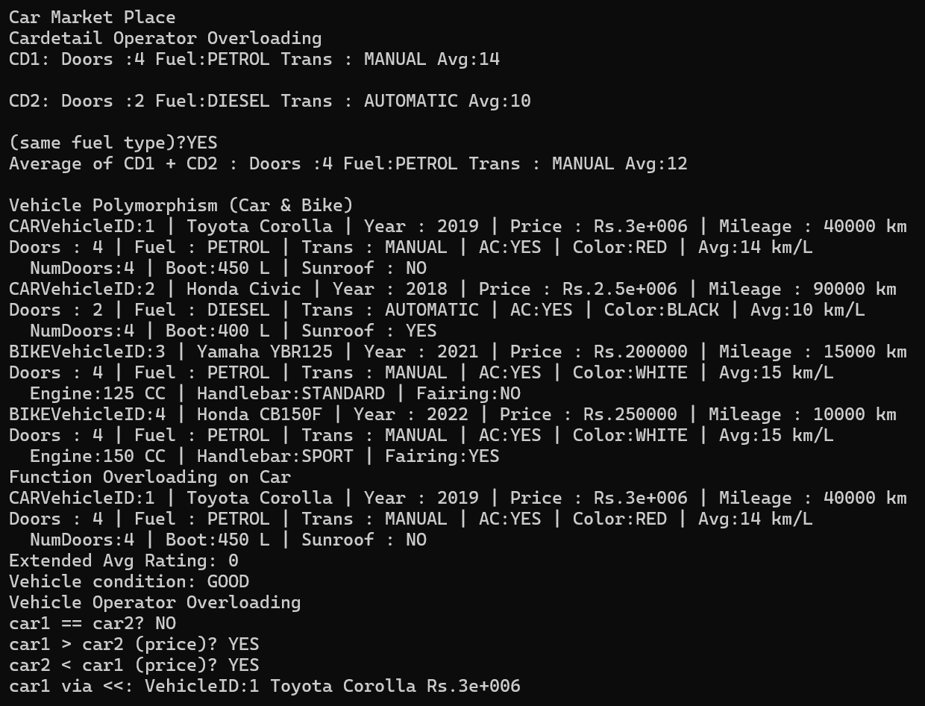
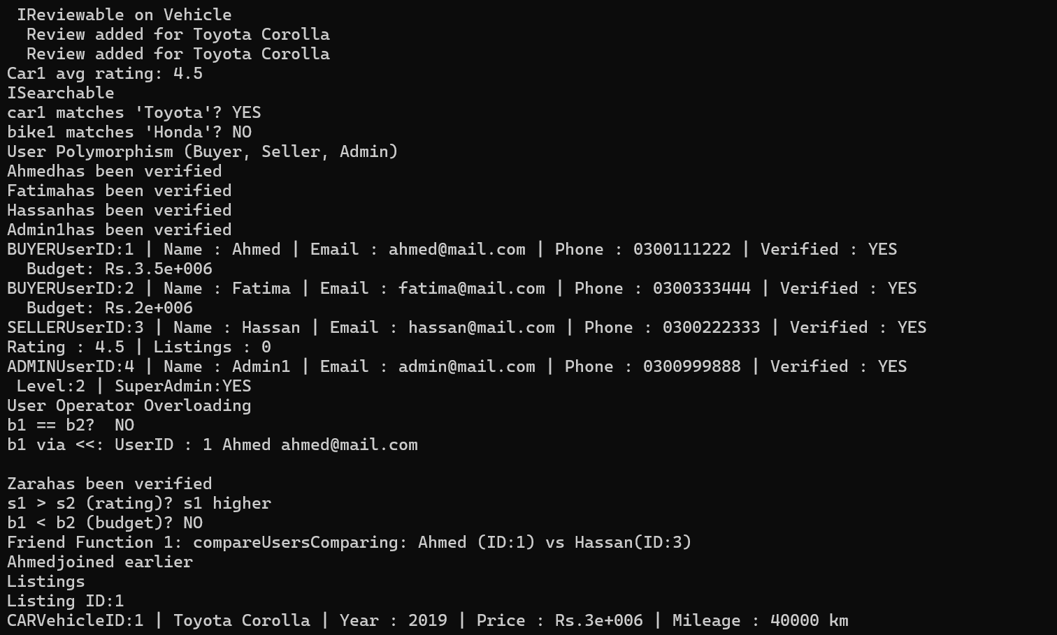
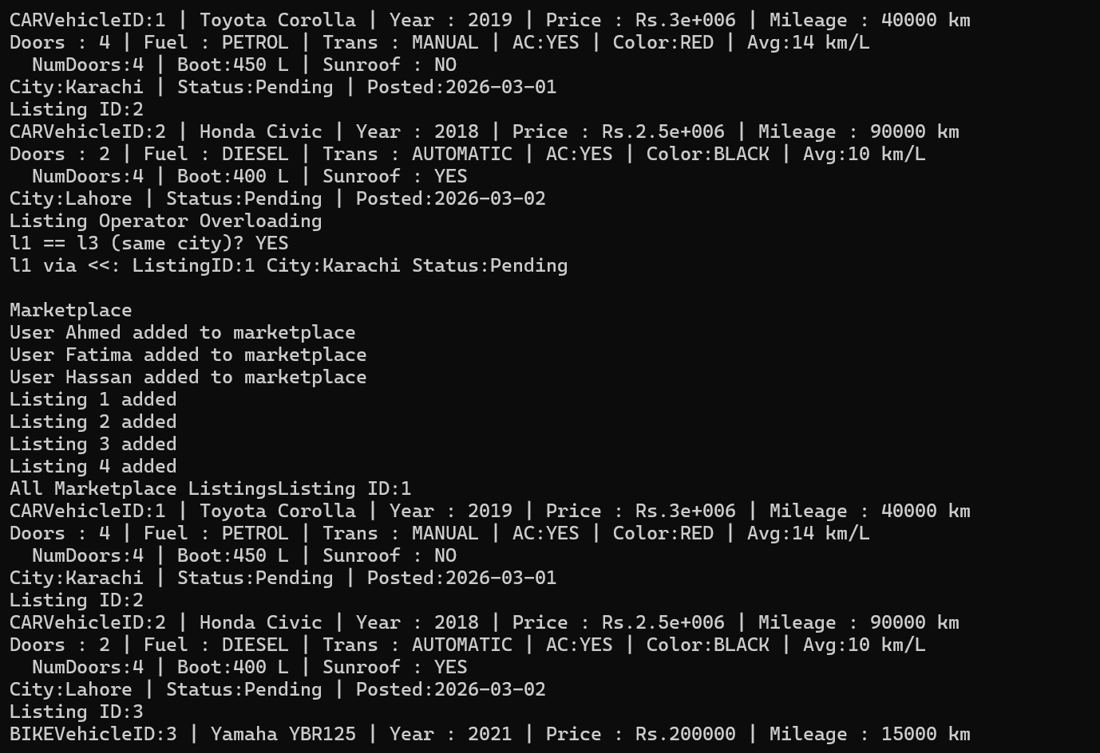
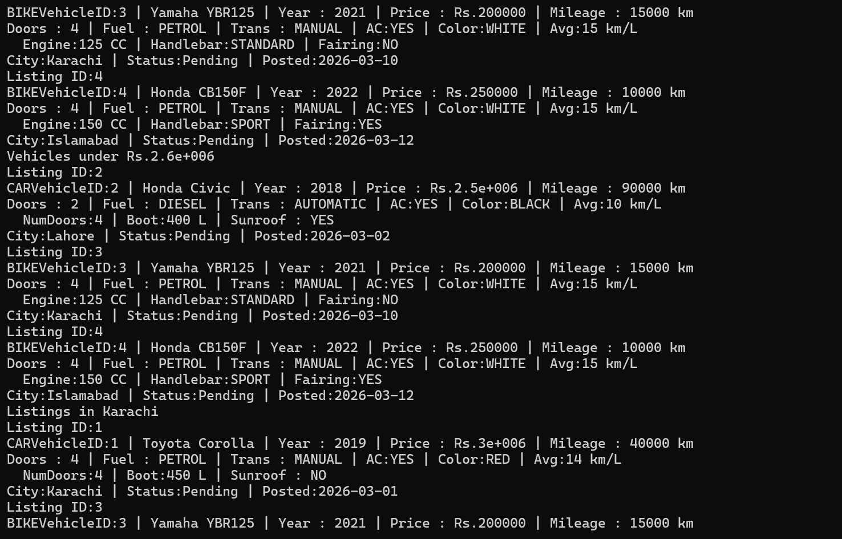
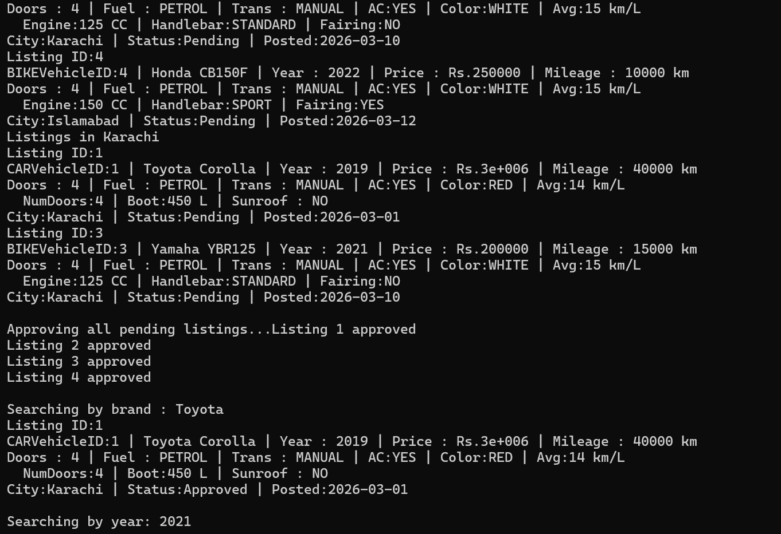
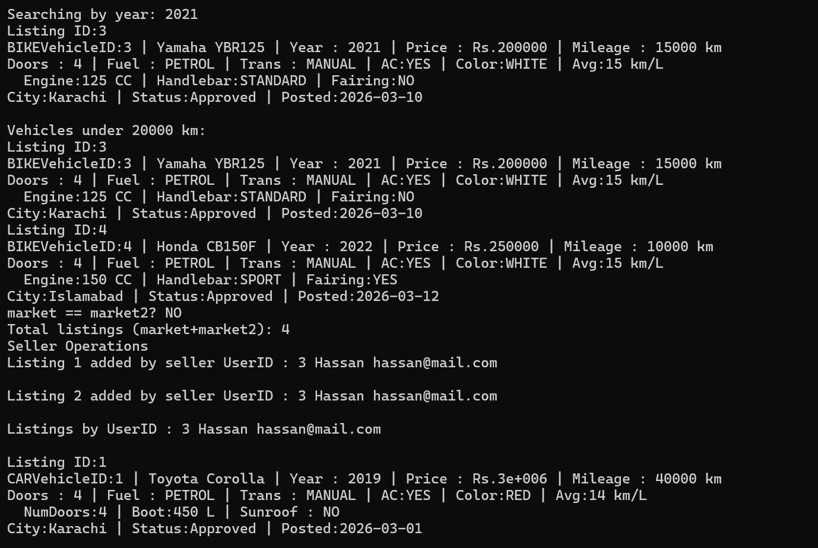
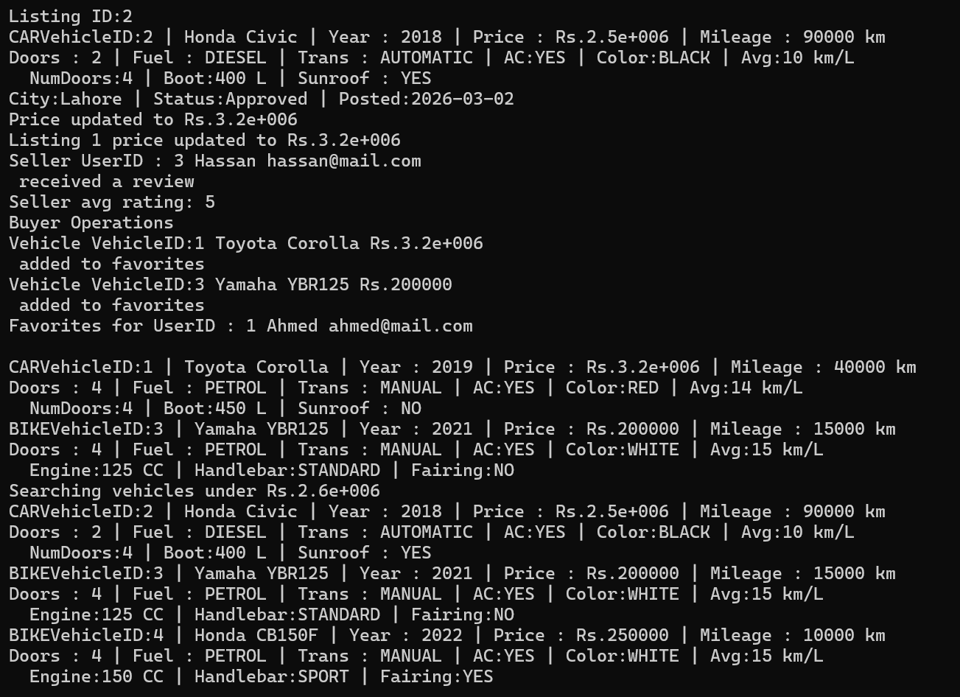
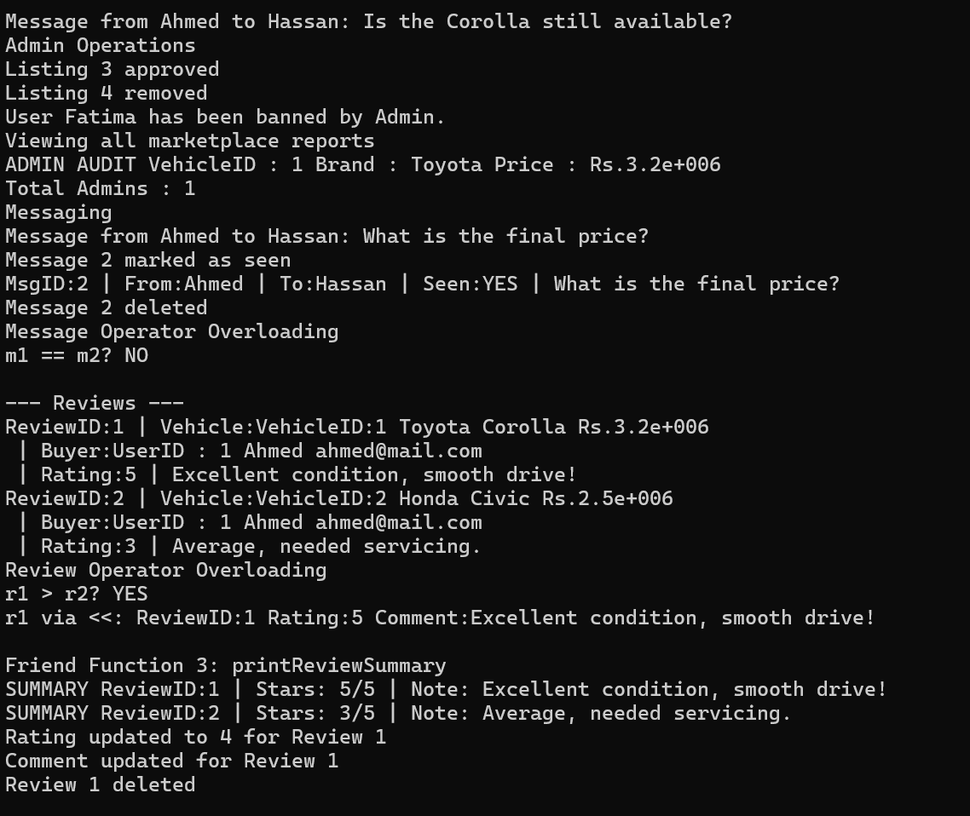
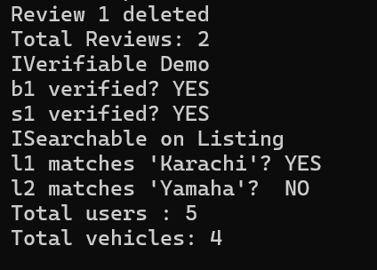

UML-DIAGRAM:
