NAME: Safiullah Khan
ID: 25K-0036
SECTION: BAI-1A

Computer Network:
A computer network is a group of computers connected so they can share information, files, and resources, such as printers or the internet.
Purpose: to facilitate quick and simple computer-to-computer communication and resource sharing.

Types Of Networks
- LAN (Local Area Network): Covers an area like a whole home, office, or school.

- MAN (Metropolitan Area Network): Covers a city, town or houses connecting multiple LANs.

- WAN (Wide Area Network): Covers vast areas, like entire countries or the globe such as Internet.

Five Network Topologies:

Bus Topology:
All computers are connected with a single cable
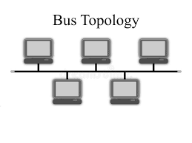

Star topology:
All computers are connected with central main server
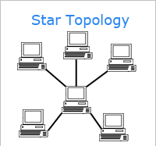

Ring Topology:
All devices are connected with a circular loop that formed a ring shape
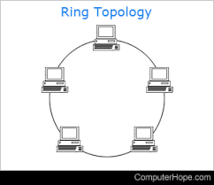

Mesh Topology:
Every device is connected to every other device in the network, helping in provision of multiple paths.
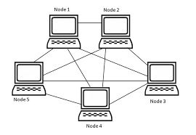

Hybrid Topology:
This is a combination of at least two or more different topologies.

