Github https://github.com/k256534/PF-labs

PF LAB 11

Lab Objective:
The main objective of this lab is to understand and implement recursion, structures, and nested structures in C programming. It focuses on writing recursive functions with proper base cases and call stacks, defining and using struct types with arrays, and embedding one structure inside another to model real world relationships.

TASK1: -
#include <stdio.h>

int floorPower(int f) { if (f == 1) return 100;
return 2 * floorPower(f - 1);
}

int totalPower(int floors) { if (floors == 1) return 100;
return floorPower(floors) + totalPower(floors - 1);
}
int main() { int n;

printf("Enter number of floors: "); scanf("%d", &n);

printf("Total power consumption: %d kWh\n", totalPower(n));

return 0;
}
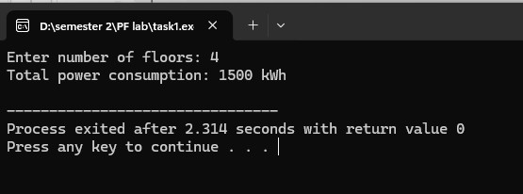
Task 1 Description: This program uses two recursive functions to calculate total power consumption of a building where the ground floor uses 100 kWh and each floor above uses double, floorPower computes the power for a single floor and totalPower adds up all floors recursively

TASK2: -
#include <stdio.h>
#include <ctype.h>

int countUpper(char *str) { if (str[0] == '\0') return 0; if (isupper(str[0])) return 1 + countUpper(str + 1); return countUpper(str + 1);
}

int countDigits(char *str) { if (str[0] == '\0') return 0; if (isdigit(str[0])) return 1 + countDigits(str + 1); return countDigits(str + 1);
}
int main() { char pass[50];

printf("Enter password: "); scanf("%s", pass);

printf("Uppercase letters: %d\n", countUpper(pass)); printf("Digits: %d\n", countDigits(pass));

return 0;
}
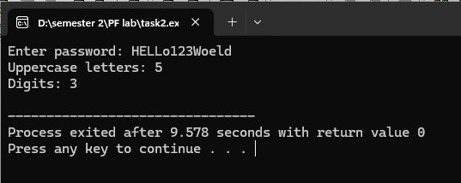
Task 2 Description: This program uses two recursive functions countUpper and countDigits that each examine one character at a time using str[0] and recurse into the rest of the string using str+1, counting uppercase letters and digits in a password

TASK3: -
#include <stdio.h>
#include <string.h>

int countWays(int n) { if (n == 0 || n == 1) return 1;
return countWays(n - 1) + countWays(n - 2);
}

void printPaths(int n, int moves[], int idx) { int i; if (n == 0) { for (i = 0; i < idx; i++) { if (i > 0) printf("+"); printf("%d", moves[i]);
} printf("\n"); return;
} if (n >= 1) { moves[idx] = 1; printPaths(n - 1, moves, idx + 1);
} if (n >= 2) { moves[idx] = 2; printPaths(n - 2, moves, idx + 1);
}
}
int main() { int n; int moves[20];

printf("Enter N (1-15): "); scanf("%d", &n);

printf("Number of ways: %d\n", countWays(n));

printf("\nPaths for N = %d:\n", n); printPaths(n, moves, 0);

return 0;
}
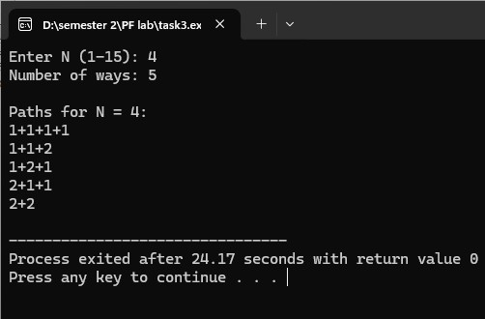
Task 3 Description: This program recursively counts the number of distinct ways to reach position N using moves of 1 or 2 steps which follows the Fibonacci pattern, and also prints each unique path as a sequence of moves like 1+1+2 using a helper function with an array to track moves

TASK4: -
#include <stdio.h>
#include <string.h>

struct Patient { char name[50]; int age; char bloodType[5]; int patientID; char diagnosis[100];
};

void displayAll(struct Patient p[], int n) { int i;
printf("\n%-5s %-20s %-5s %-6s %s\n", "ID", "Name", "Age", "Blood", "Diagnosis"); printf("-----------------------------------------------------------\n"); for (i = 0; i < n; i++) {
printf("%-5d %-20s %-5d %-6s %s\n", p[i].patientID, p[i].name, p[i].age, p[i].bloodType, p[i].diagnosis);
} }

void searchByID(struct Patient p[], int n, int id) { int i; for (i = 0; i < n; i++) { if (p[i].patientID == id) { printf("\nPatient Found:\n"); printf("ID: %d\n", p[i].patientID); printf("Name: %s\n", p[i].name); printf("Age: %d\n", p[i].age); printf("Blood Type: %s\n", p[i].bloodType); printf("Diagnosis: %s\n", p[i].diagnosis); return;
} }
printf("Patient not found\n");
}
int main() { struct Patient p[5]; int i, searchID;

for (i = 0; i < 5; i++) { printf("Patient %d:\n", i + 1); printf(" ID: "); scanf("%d", &p[i].patientID); getchar(); printf(" Name: "); fgets(p[i].name, 50, stdin); p[i].name[strlen(p[i].name) - 1] = '\0'; printf(" Age: "); scanf("%d", &p[i].age); getchar(); printf(" Blood Type: "); scanf("%s", p[i].bloodType); getchar(); printf(" Diagnosis: "); fgets(p[i].diagnosis, 100, stdin); p[i].diagnosis[strlen(p[i].diagnosis) - 1] = '\0'; printf("\n");
}
displayAll(p, 5);

printf("\nEnter Patient ID to search: "); scanf("%d", &searchID);
searchByID(p, 5, searchID);
return 0;
}
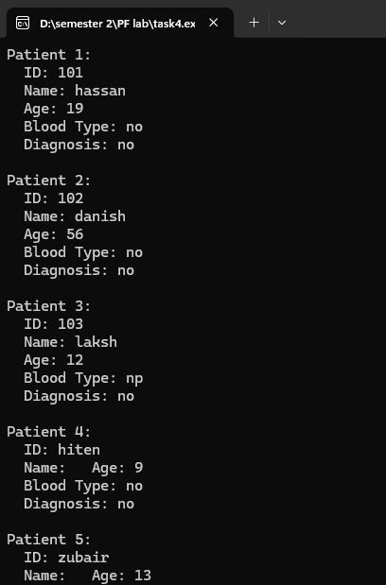
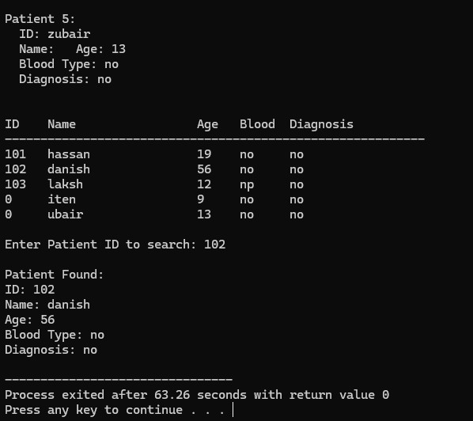
Task 4 Description: This program defines a struct Patient with fields for name age blood type ID and diagnosis, stores 5 patients in an array using user input, displays all records in a formatted table using displayAll, and searches by patient ID using searchByID

TASK5: -
#include <stdio.h>
#include <string.h>

struct Department { char deptCode[10]; char deptName[50];
};

struct Course { char courseCode[10]; char courseName[60]; int creditHours; struct Department dept;
};

void filterByDept(struct Course c[], int n, char *code) { int i, found = 0; for (i = 0; i < n; i++) { if (strcmp(c[i].dept.deptCode, code) == 0) {
printf(" %s - %s (%d credits)\n", c[i].courseCode, c[i].courseName, c[i].creditHours); found = 1;
} } if (found == 0)
printf(" No courses found for this department.\n");
}
int main() { struct Course c[3]; char searchCode[10]; int i;

for (i = 0; i < 3; i++) { printf("Course %d:\n", i + 1); printf(" Course Code: "); scanf("%s", c[i].courseCode); getchar();
printf(" Course Name: "); fgets(c[i].courseName, 60, stdin); c[i].courseName[strlen(c[i].courseName) - 1] = '\0'; printf(" Credit Hours: "); scanf("%d", &c[i].creditHours); printf(" Department Code: "); scanf("%s", c[i].dept.deptCode); getchar(); printf(" Department Name: "); fgets(c[i].dept.deptName, 50, stdin); c[i].dept.deptName[strlen(c[i].dept.deptName) - 1] = '\0'; printf("\n");
}

printf("--- All Courses ---\n"); for (i = 0; i < 3; i++) { printf("Course: %s - %s\n", c[i].courseCode, c[i].courseName); printf("Credits: %d\n", c[i].creditHours); printf("Dept: %s (%s)\n", c[i].dept.deptName, c[i].dept.deptCode); printf("\n");
}

printf("Enter department code to filter: "); scanf("%s", searchCode); printf("\nCourses in %s:\n", searchCode); filterByDept(c, 3, searchCode);

return 0;
}
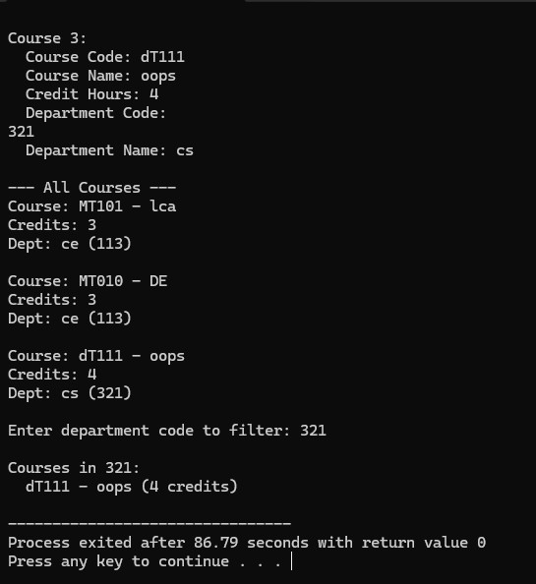
Task 5 Description: This program uses nested structures where a Department struct with deptCode and deptName is embedded inside a Course struct, stores 3 courses with user input, displays all details using dot-dot notation like c.dept.deptName, and filters courses by department code

TASK6: -
#include <stdio.h>
#include <string.h>
struct Order { int orderID; char customer[50]; char product[50]; int quantity; float unitPrice; char status[15];
};

float computeTotal(struct Order o) { return o.quantity * o.unitPrice;
}

void filterByStatus(struct Order orders[], int n, char *status) { int i, found = 0; for (i = 0; i < n; i++) { if (strcmp(orders[i].status, status) == 0) { printf(" Order %d: %s - %s (Qty: %d, Total: %.2f)\n", orders[i].orderID, orders[i].customer, orders[i].product, orders[i].quantity, computeTotal(orders[i])); found = 1;
} } if (found == 0)
printf(" No orders with status '%s'\n", status);
}
int main() { struct Order o[4]; char search[15]; int i;

for (i = 0; i < 4; i++) { printf("Order %d:\n", i + 1); printf(" Order ID: "); scanf("%d", &o[i].orderID); getchar(); printf(" Customer: "); fgets(o[i].customer, 50, stdin); o[i].customer[strlen(o[i].customer) - 1] = '\0'; printf(" Product: "); fgets(o[i].product, 50, stdin); o[i].product[strlen(o[i].product) - 1] = '\0'; printf(" Quantity: "); scanf("%d", &o[i].quantity); printf(" Unit Price: "); scanf("%f", &o[i].unitPrice); getchar(); printf(" Status (Pending/Shipped/Delivered): "); scanf("%s", o[i].status); printf("\n");
}

printf("--- Itemized Bills ---\n"); for (i = 0; i < 4; i++) { printf("Order %d: %s - %s | Qty: %d x %.2f = Rs. %.2f\n", o[i].orderID, o[i].customer, o[i].product, o[i].quantity, o[i].unitPrice, computeTotal(o[i]));
}

printf("\nEnter status to filter: "); scanf("%s", search); printf("\nOrders with status '%s':\n", search); filterByStatus(o, 4, search);
return 0;
}

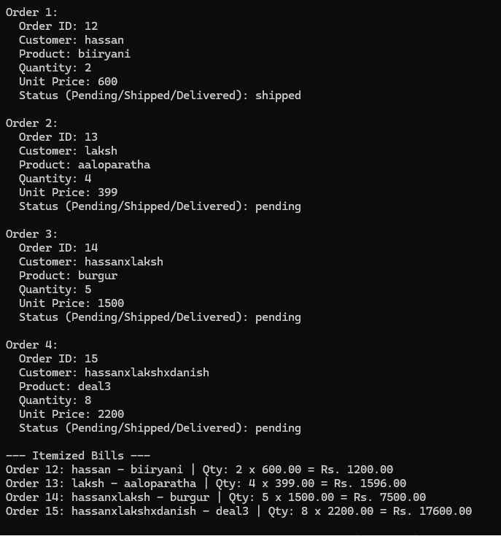
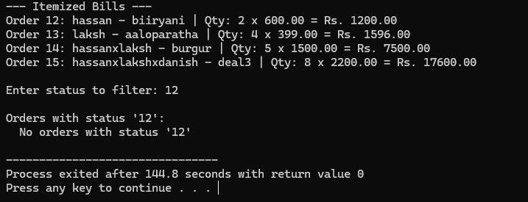
Task 6 Description: This program defines a struct Order with fields for order ID customer product quantity unit price and status, stores 4 orders from user input, computes the total bill for each order using computeTotal, and filters orders by status using strcmp in filterByStatus

