Github https://github.com/k256534/PF-labs

PF LAB 12

Lab Objective:
The main objective of this lab is to understand and implement dynamic memory allocation in C programming. It focuses on using malloc, realloc, calloc and free to manage memory at runtime, expanding data structures when requirements grow, and understanding issues such as memory leaks, dangling pointers and uninitialized memory.

TASK1: -
#include <stdio.h>
#include <stdlib.h>
int main() { int students, i; float *grades;

printf("Enter number of students: "); scanf("%d", &students);

if (students <= 0) {
printf("Invalid number of students.\n"); return 0;
}
grades = (float *)malloc(students * sizeof(float));

if (grades == NULL) {
printf("Memory allocation failed.\n"); return 0;
}
for (i = 0; i < students; i++) {
printf("Enter grade of student %d: ", i + 1); scanf("%f", &grades[i]);
}
printf("\n--- Student Grades ---\n"); for (i = 0; i < students; i++) {
printf("Student %d: %.2f\n", i + 1, grades[i]);
}
free(grades); grades = NULL;

return 0;
}
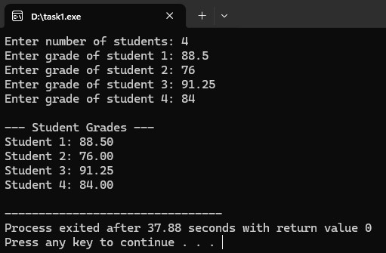
Task 1 Description: A static array is a poor choice here because its size is fixed at compile time, while the actual number of enrolled students is only known at runtime, which can either waste memory or become too small. This program uses malloc to allocate a float array after taking the student count from the user, stores all grades, prints them, and then releases the heap memory with free. If free() is forgotten, a memory leak occurs and the program keeps consuming heap memory over time.

TASK2: -
#include <stdio.h>
#include <stdlib.h>
int main() { int i; int *contactIDs; int *temp;

contactIDs = (int *)malloc(3 * sizeof(int));

if (contactIDs == NULL) {
printf("Initial memory allocation failed.\n"); return 0;
}
printf("Enter 3 contact IDs:\n"); for (i = 0; i < 3; i++) { printf("Contact %d: ", i + 1); scanf("%d", &contactIDs[i]);
}
temp = (int *)realloc(contactIDs, 5 * sizeof(int));

if (temp == NULL) {
printf("Memory reallocation failed. Old contact list is still safe.\n"); free(contactIDs); contactIDs = NULL; return 0;
}
contactIDs = temp;

printf("\nEnter 2 more contact IDs:\n"); for (i = 3; i < 5; i++) { printf("Contact %d: ", i + 1); scanf("%d", &contactIDs[i]);
}
printf("\n--- Updated Contact List ---\n"); for (i = 0; i < 5; i++) {
printf("Contact %d ID: %d\n", i + 1, contactIDs[i]);
}
free(contactIDs); contactIDs = NULL;

return 0;
}
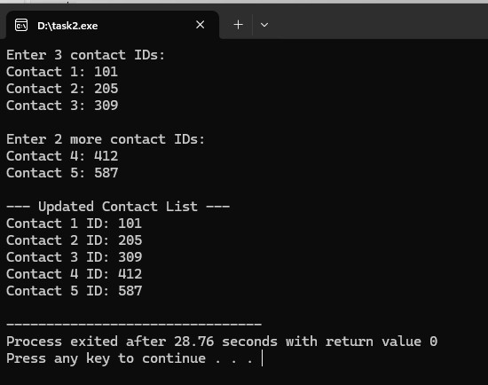
Task 2 Description: This program first uses malloc to store 3 contact IDs, then uses realloc to expand the same block to 5 contacts without losing the old data. A temporary pointer is used so the original memory block is not lost if realloc returns NULL. After free(), the old address would become a dangling pointer if used again, so the pointer is set to NULL as the safe practice.

TASK3: -
#include <stdio.h>
#include <stdlib.h>
int main() { int n, i; float *sensorData;

printf("Enter number of sensors: "); scanf("%d", &n);

if (n <= 0) {
printf("Invalid number of sensors.\n"); return 0;
}
sensorData = (float *)calloc(n, sizeof(float));

if (sensorData == NULL) {
printf("Memory allocation failed.\n"); return 0;
}
printf("\nInitial values after calloc:\n"); for (i = 0; i < n; i++) {
printf("Sensor %d: %.1f\n", i + 1, sensorData[i]);
}
printf("\nEnter temperature readings:\n"); for (i = 0; i < n; i++) {
printf("Sensor %d reading: ", i + 1); scanf("%f", &sensorData[i]);
}
printf("\n--- Final Sensor Readings ---\n"); for (i = 0; i < n; i++) {
printf("Sensor %d: %.2f\n", i + 1, sensorData[i]);
}
printf("\nComparison:\n");
printf("calloc initializes all values to 0.0.\n");
printf("malloc leaves indeterminate garbage values until they are assigned.\n");

free(sensorData); sensorData = NULL;

return 0;
}
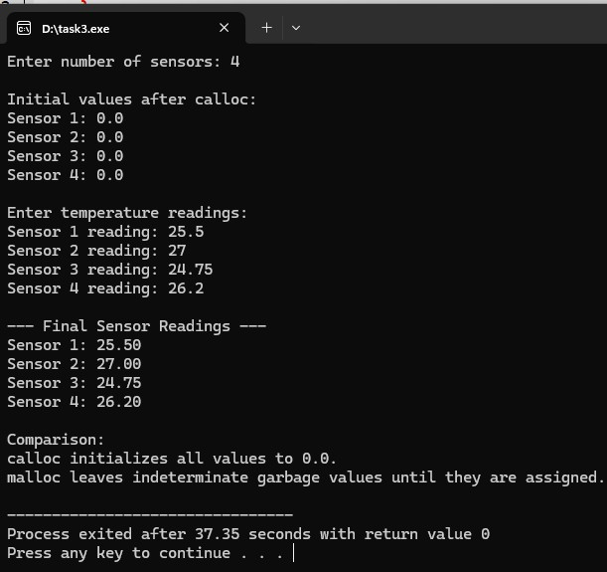
Task 3 Description: calloc is more suitable than malloc for this task because it allocates memory and initializes every float to 0.0, which prevents garbage values from being treated as real sensor readings. The program proves the zero initialization, accepts the actual temperature readings from the user, and prints the final buffer contents. In contrast, malloc leaves indeterminate values in memory, which can cause dangerous bugs if a sensor program reads those values before assigning real data.

