TASK: 01
#include<stdio.h>
int main(){
int per;
printf("Enter your attendence percentage: ");
scanf("%d", &per);
if(per >= 75){
printf("Eligible for Exams");
}
else{
printf("Not eligible for Exams");
}
return 0;
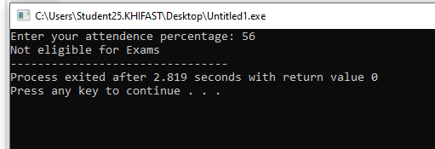
TASK: 02
#include <stdio.h>

int main() {
int totalunit;

printf("Enter the total units consumed: ");
scanf("%d", &totalunit);

if (totalunit <= 100) {
printf("Low Usage");
}
else if (totalunit >= 101 && totalunit <= 300) {
printf("Medium Usage");
}
else {
printf("High Usage");
}

return 0;
}
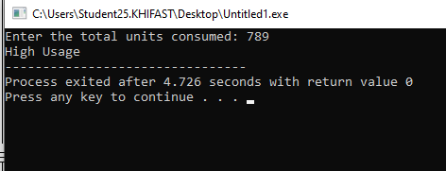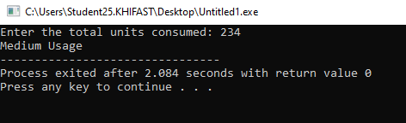
TASK: 03
#include <stdio.h>

int main() {
int num;
printf("Enter any number:");
scanf("%d", &num);
if(num>0){
printf("Positive");
}
else if(num<0){
printf("Negative");
}
else
printf("Zero");

return 0;
}
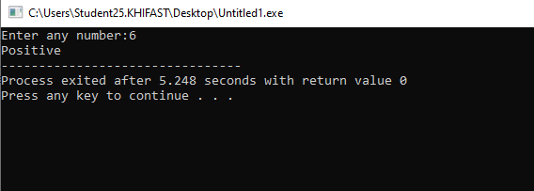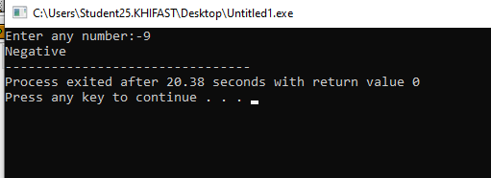
TASK: 04
#include <stdio.h>
#include <string.h>

int main() {
char username[20];
int password;

printf("Enter your Username and Password: ");
scanf("%s %d", username, &password);

if (strcmp(username, "admin") == 0 && password == 1234) {
printf("Login successful");
} else {
printf("Invalid Credentials");
}

return 0;
}
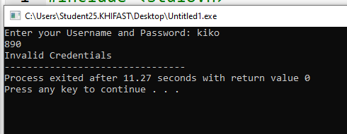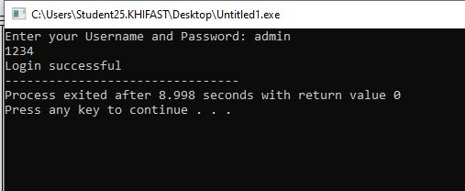
TASK: 05
#include <stdio.h>
int main(){
int choice;
printf("ATM Menu:\n");
printf("1. Balance Inquiry\n");
printf("2. Cash Withdrawal\n");
printf("3. Money Deposit\n");
printf("4. Exit\n");

printf("Enter your choice:");
scanf("%d", &choice);
switch(choice){
case 1:
printf("Balance Inquiry.");
break;
case 2:
printf("Cash Withdrawal.");
break;
case 3:
printf("Money deposit.");
break;
case 4:
printf("Thank you! Exiting the ATM.");
break;
default:
printf("Invalid choice");

}
return 0;
}
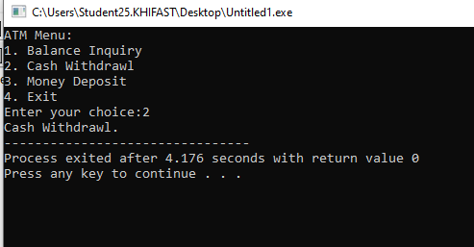
TASK: 06
#include <stdio.h>
int main(){
int sub1, sub2, sub3, sub4, sub5, totalmarks;
float per;
printf("Enter the marks(0-100) of sub1, sub2, sub3, sub4, sub5");
scanf("%d %d %d %d %d", &sub1, &sub2, &sub3, &sub4, &sub5);
totalmarks = (sub1 + sub2 + sub3 + sub4 + sub5);
per = (totalmarks / 500.0) * 100;
if(per >= 85){
printf("Grade 'A'");
}
else if(per >= 70){
printf("Grade 'B'");
}
else if(per >= 50){
printf("Grade 'C'");
}
else{
printf("Fail");
}

return 0;
}

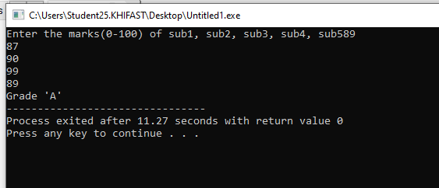
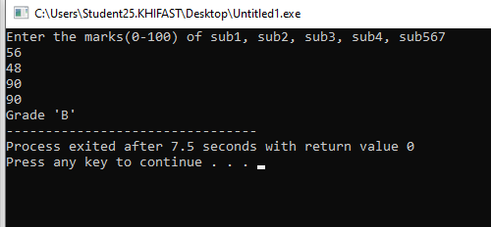
TASK: 07
#include <stdio.h>

int main() {
float total, discount, finalAmount;
printf("Enter the total bill amount: ");
scanf("%f", &total);
if (total >= 5000) {
discount = total * 0.20;
}
else if (total >= 3000) {
discount = total * 0.10;
}
else {
discount = 0;
}

finalAmount = total - discount;
printf("Discount: %.2f\n", discount);
printf("Amount to be paid: %.2f\n", finalAmount);

return 0;
}

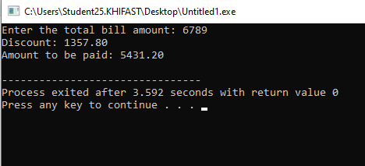
TASK: 08
#include <stdio.h>
#include <math.h>

int main() {
int choice;
double num1, num2, result;
printf("===== Scientific Calculator =====\n");
printf("1. Addition\n");
printf("2. Subtraction\n");
printf("3. Multiplication\n");
printf("4. Division\n");
printf("5. Square of a number\n");
printf("6. Cube of a number\n");
printf("7. Square Root of a number\n");
printf("8. Power (x^y)\n");
printf("9. Absolute Value\n");
printf("Enter your choice: ");
scanf("%d", &choice);

switch(choice) {

case 1:
printf("Enter two numbers: ");
scanf("%lf %lf", &num1, &num2);
result = num1 + num2;
printf("Result = %.2lf\n", result);
break;
case 2:
printf("Enter two numbers: ");
scanf("%lf %lf", &num1, &num2);
result = num1 - num2;
printf("Result = %.2lf\n", result);
break;

case 3:
printf("Enter two numbers: ");
scanf("%lf %lf", &num1, &num2);
result = num1 * num2;
printf("Result = %.2lf\n", result);
break;

case 4:
printf("Enter two numbers: ");
scanf("%lf %lf", &num1, &num2);

if (num2 == 0) {
printf("Error: Division by zero is not allowed.\n");
} else {
result = num1 / num2;
printf("Result = %.2lf\n", result);
}
break;

case 5: // Square
printf("Enter a number: ");
scanf("%lf", &num1);
result = num1 * num1;
printf("Result = %.2lf\n", result);
break;

case 6:
printf("Enter a number: ");
scanf("%lf", &num1);
result = num1 * num1 * num1;
printf("Result = %.2lf\n", result);
break;

case 7:
printf("Enter a number: ");
scanf("%lf", &num1);

if (num1 < 0) {
printf("Error: Square root of negative number is not allowed.\n");
} else {
result = sqrt(num1);
printf("Result = %.2lf\n", result);
}
break;

case 8:
printf("Enter base and exponent: ");
scanf("%lf %lf", &num1, &num2);
result = pow(num1, num2);
printf("Result = %.2lf\n", result);
break;

case 9:
printf("Enter a number: ");
scanf("%lf", &num1);
result = fabs(num1);
printf("Result = %.2lf\n", result);
break;

default:
printf("Invalid choice! Please select a valid option (1-9).\n");
}

return 0;
}
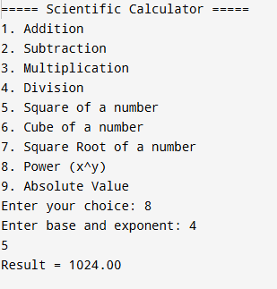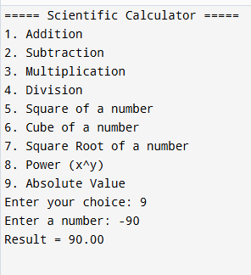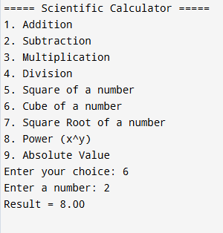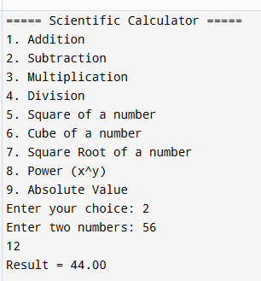
GITHUB LINK:

