Task: 01
#include <stdio.h>
int totalPower(int floors) {
// Base case
if (floors == 1) {
return 100;
}
return (100 * (1 << (floors - 1))) + totalPower(floors - 1);
}

int main() {
int floors;

printf("Enter number of floors: ");
scanf("%d", &floors);
int total = totalPower(floors);
printf("Total power consumption = %d kWh\n", total);
return 0;
}
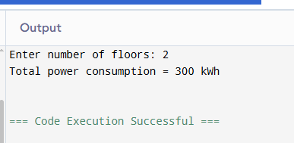

Task: 02
#include <stdio.h>
#include <ctype.h>
void countUpperAndDigits(char *str, int *upper, int *digits) {
// Base case
if (str[0] == '\0') {
return;
}
if (isupper(str[0])) {
(*upper)++;
}
if (isdigit(str[0])) {
(*digits)++;
}
countUpperAndDigits(str + 1, upper, digits);
}

int main() {
char password[100];
int upper = 0, digits = 0;

printf("Enter password: ");
scanf("%s", password);

countUpperAndDigits(password, &upper, &digits);

printf("Uppercase letters = %d\n", upper);
printf("Digits = %d\n", digits);

return 0;
}
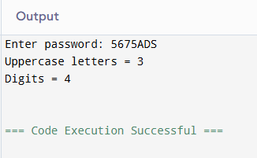
Task: 03
#include <stdio.h>
int countWays(int n) {
// Base cases
if (n == 0 || n == 1)
return 1;
return countWays(n - 1) + countWays(n - 2);
}
void printPaths(int n, char path[], int index) {
if (n == 0) {
path[index - 1] = '\0'; // remove last '+'
printf("%s\n", path);
return;
}
if (n < 0)
return;
path[index] = '1';
path[index + 1] = '+';
printPaths(n - 1, path, index + 2);
path[index] = '2';
path[index + 1] = '+';
printPaths(n - 2, path, index + 2);
}

int main() {
int n;
char path[50];

printf("Enter N (1 to 15): ");
scanf("%d", &n);
int ways = countWays(n);
printf("Total number of ways = %d\n", ways);
printf("All possible paths:\n");
printPaths(n, path, 0);

return 0;
}
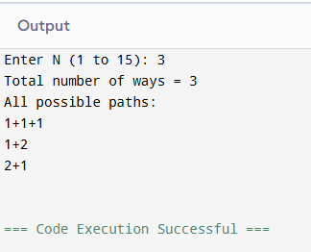
Task: 04
#include <stdio.h>
#include <string.h>
struct Patient {
char name[50];
int age;
char bloodType[5];
int patientID;
char diagnosis[100];
};
void displayAll(struct Patient p[], int n) {
printf("\n--- Patient Records ---\n");
printf("ID\tName\t\tAge\tBlood\tDiagnosis\n");
printf("-------------------------------------------------------------\n");

for (int i = 0; i < n; i++) {
printf("%d\t%-10s\t%d\t%-5s\t%s\n",
p[i].patientID,
p[i].name,
p[i].age,
p[i].bloodType,
p[i].diagnosis);
}
}

void searchByID(struct Patient p[], int n, int id) {
for (int i = 0; i < n; i++) {
if (p[i].patientID == id) {
printf("\nPatient Found:\n");
printf("ID: %d\n", p[i].patientID);
printf("Name: %s\n", p[i].name);
printf("Age: %d\n", p[i].age);
printf("Blood Type: %s\n", p[i].bloodType);
printf("Diagnosis: %s\n", p[i].diagnosis);
return;
}
}
printf("\nPatient not found\n");
}

int main() {
struct Patient p[5];
int n = 5;
for (int i = 0; i < n; i++) {
printf("\nEnter details for patient %d:\n", i + 1);

printf("Name: ");
getchar(); // clear buffer
gets(p[i].name);

printf("Age: ");
scanf("%d", &p[i].age);

printf("Blood Type: ");
scanf("%s", p[i].bloodType);

printf("Patient ID: ");
scanf("%d", &p[i].patientID);

printf("Diagnosis: ");
getchar(); // clear buffer
gets(p[i].diagnosis);
}

// Display all patients
displayAll(p, n);

int id;
printf("\nEnter Patient ID to search: ");
scanf("%d", &id);

searchByID(p, n, id);

return 0;
} 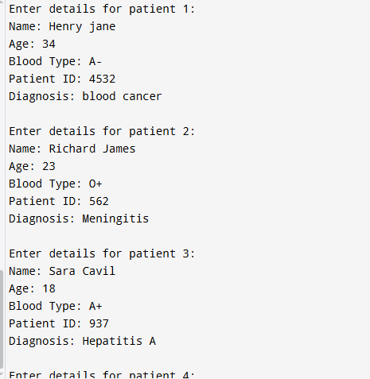
Task: 05
#include <stdio.h>
#include <string.h>

struct Department {
char deptCode[10];
char deptName[50];
};

struct Course {
char courseCode[10];
char courseName[60];
int creditHours;
struct Department dept;
};

void printByDept(struct Course c[], int n, char code[]) {
int found = 0;

printf("\nCourses in Department [%s]:\n", code);

for (int i = 0; i < n; i++) {
if (strcmp(c[i].dept.deptCode, code) == 0) {
printf("\nCourse Code: %s\n", c[i].courseCode);
printf("Course Name: %s\n", c[i].courseName);
printf("Credit Hours: %d\n", c[i].creditHours);
printf("Department: %s (%s)\n",
c[i].dept.deptName,
c[i].dept.deptCode);
found = 1;
}
}

if (!found) {
printf("No courses found in this department.\n");
}
}

int main() {
struct Course c[3];

for (int i = 0; i < 3; i++) {
printf("\nEnter details for course %d:\n", i + 1);

printf("Course Code: ");
scanf("%s", c[i].courseCode);

printf("Course Name: ");
getchar(); // clear buffer
fgets(c[i].courseName, sizeof(c[i].courseName), stdin);
c[i].courseName[strcspn(c[i].courseName, "\n")] = '\0';

printf("Credit Hours: ");
scanf("%d", &c[i].creditHours);

printf("Department Code: ");
scanf("%s", c[i].dept.deptCode);

printf("Department Name: ");
getchar(); // clear buffer
fgets(c[i].dept.deptName, sizeof(c[i].dept.deptName), stdin);
c[i].dept.deptName[strcspn(c[i].dept.deptName, "\n")] = '\0';
}

printf("\n--- All Courses ---\n");
for (int i = 0; i < 3; i++) {
printf("\nCourse Code: %s\n", c[i].courseCode);
printf("Course Name: %s\n", c[i].courseName);
printf("Credit Hours: %d\n", c[i].creditHours);
printf("Department: %s (%s)\n",
c[i].dept.deptName,
c[i].dept.deptCode);
}

char searchCode[10];
printf("\nEnter Department Code to search: ");
scanf("%s", searchCode);

printByDept(c, 3, searchCode);

return 0;
}
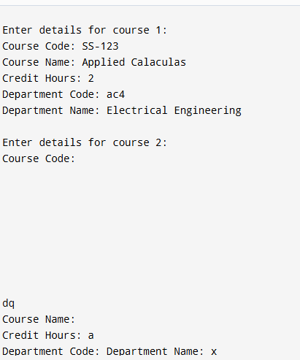
Task: 06
#include <stdio.h>
#include <string.h>

struct Order {
int orderID;
char customerName[50];
char productName[50];
int quantity;
float unitPrice;
char status[20];
};
float computeTotal(struct Order o) {
return o.quantity * o.unitPrice;
}
void filterByStatus(struct Order orders[], int n, char *status) {
printf("\n📦 Orders with status: %s\n", status);
printf("-----------------------------------\n");

for (int i = 0; i < n; i++) {
if (strcmp(orders[i].status, status) == 0) {
printf("Order ID: %d\n", orders[i].orderID);
printf("Customer: %s\n", orders[i].customerName);
printf("Product: %s\n", orders[i].productName);
printf("Quantity: %d\n", orders[i].quantity);
printf("Unit Price: %.2f\n", orders[i].unitPrice);
printf("Total Bill: %.2f\n", computeTotal(orders[i]));
printf("-----------------------------------\n");
}
}
}

int main() {
struct Order orders[4];

// Input data
for (int i = 0; i < 4; i++) {
printf("\nEnter details for Order %d:\n", i + 1);

printf("Order ID: ");
scanf("%d", &orders[i].orderID);

printf("Customer Name: ");
scanf(" %[^\n]", orders[i].customerName);

printf("Product Name: ");
scanf(" %[^\n]", orders[i].productName);

printf("Quantity: ");
scanf("%d", &orders[i].quantity);

printf("Unit Price: ");
scanf("%f", &orders[i].unitPrice);

printf("Status (Pending/Shipped/Delivered): ");
scanf(" %[^\n]", orders[i].status);
}

printf("\n📋 ALL ORDERS WITH TOTAL BILL\n");
printf("-----------------------------------\n");

for (int i = 0; i < 4; i++) {
printf("Order ID: %d\n", orders[i].orderID);
printf("Customer: %s\n", orders[i].customerName);
printf("Product: %s\n", orders[i].productName);
printf("Total Bill: %.2f\n", computeTotal(orders[i]));
printf("-----------------------------------\n");
}

char searchStatus[20];
printf("\nEnter status to filter (Pending/Shipped/Delivered): ");
scanf(" %[^\n]", searchStatus);

filterByStatus(orders, 4, searchStatus);

return 0;
}
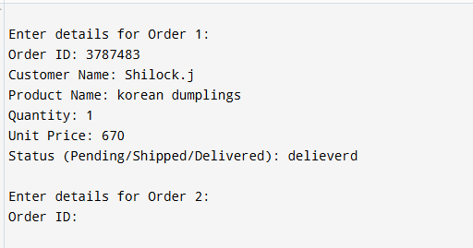

GITHUB LINK:

