TASK: 01
#include <stdio.h>

float triageScore(int severity, int age, int vitals)
{
float score;
score = (severity * 0.5) + (age * 0.3) + (vitals * 0.2);
return score;
}

int main()
{
int severity, age, vitals;
float result;

printf("Enter severity score: ");
scanf("%d", &severity);

printf("Enter age risk score: ");
scanf("%d", &age);

printf("Enter vitals stability score: ");
scanf("%d", &vitals);

result = triageScore(severity, age, vitals);

if(result > 7.0)
printf("Immediate attention required\n");
else if(result >= 4.0)
printf("Moderate priority\n");
else
printf("Can wait\n");

return 0;
}
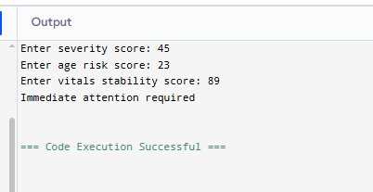
TASK: 02
#include <stdio.h>

float applyDiscount(float price, int tier)
{
float discount;

if(tier == 1)
discount = price * 0.05;
else if(tier == 2)
discount = price * 0.10;
else if(tier == 3)
discount = price * 0.20;
else if(tier == 4)
discount = price * 0.30;
else
discount = 0;

return price - discount;
}

void printInvoice(float original, float discounted)
{
float delivery = 0;

if(discounted < 2000)
delivery = 150;

printf("\nInvoice\n");
printf("Original Price: %.2f\n", original);
printf("Discount Amount: %.2f\n", original - discounted);
printf("Delivery Charge: %.2f\n", delivery);
printf("Final Total: %.2f\n", discounted + delivery);
}

int main()
{
float price, discounted;
int tier;

printf("Enter price: ");
scanf("%f", &price);

printf("Enter membership tier (1-4): ");
scanf("%d", &tier);

discounted = applyDiscount(price, tier);

printInvoice(price, discounted);

return 0;
}
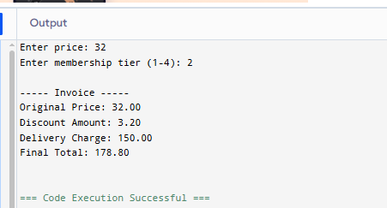
TASK: 03
#include <stdio.h>

int totalRuns(int arr[], int n)
{
int sum = 0;

for(int i=0;i<n;i++)
sum += arr[i];

return sum;
}

int highestScore(int arr[], int n)
{
int max = arr[0];

for(int i=1;i<n;i++)
{
if(arr[i] > max)
max = arr[i];
}

return max;
}

int aboveAverage(int arr[], int n, float avg)
{
int count = 0;

for(int i=0;i<n;i++)
{
if(arr[i] > avg)
count++;
}

return count;
}

int main()
{
int scores[10];
int total, highest, count;
float avg;

printf("Enter scores of 10 matches:\n");

for(int i=0;i<10;i++)
scanf("%d",&scores[i]);

total = totalRuns(scores,10);
avg = (float)total/10;

highest = highestScore(scores,10);
count = aboveAverage(scores,10,avg);

printf("\nTotal Runs: %d\n", total);
printf("Average: %.2f\n", avg);
printf("Highest Score: %d\n", highest);
printf("Matches above average: %d\n", count);

return 0;
}
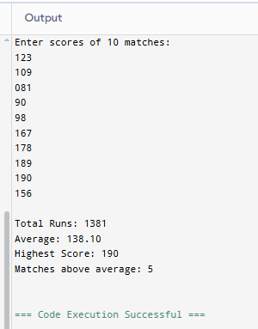
TASK: 04
#include <stdio.h>

int validatePIN(int storedPIN, int enteredPIN)
{
if(storedPIN == enteredPIN)
return 1;
else
return 0;
}

int main()
{
int storedPIN = 4729;
int entered;
int attempts;

for(attempts = 1; attempts <= 3; attempts++)
{
printf("Enter PIN: ");
scanf("%d",&entered);

if(validatePIN(storedPIN, entered))
{
printf("Access granted. Welcome!\n");
break;
}
else
{
printf("Wrong PIN\n");
printf("Attempts remaining: %d\n",3-attempts);
}
}

if(attempts > 3)
printf("Card blocked. Contact your bank.\n");

return 0;
}
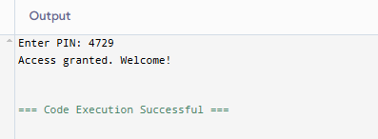
TASK: 05
#include <stdio.h>

float toMegajoules(float kwh)
{
return kwh * 3.6;
}

float toBTU(float kwh)
{
return kwh * 3412.14;
}

float toCalories(float kwh)
{
return kwh * 859845;
}

int main()
{
float kwh;

printf("Enter energy in kWh: ");
scanf("%f",&kwh);

printf("\nMegajoules: %.2f\n", toMegajoules(kwh));
printf("BTU: %.2f\n", toBTU(kwh));
printf("Calories: %.2f\n", toCalories(kwh));

printf("\nDirect function call example:\n");
printf("MJ directly: %.2f\n", toMegajoules(kwh));

return 0;}
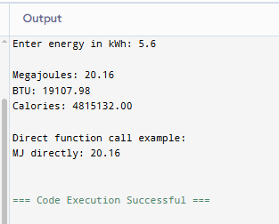
TASK: 06
#include <stdio.h>

float totalRevenue(float bills[], int n)
{
float sum = 0;

for(int i=0;i<n;i++)
sum += bills[i];

return sum;
}

int bestTable(float bills[], int n)
{
int maxIdx = 0;

for(int i=1;i<n;i++)
{
if(bills[i] > bills[maxIdx])
maxIdx = i;
}

return maxIdx;
}

int isProfitable(float total)
{
if(total > 10000)
return 1;
else
return 0;
}

int main()
{
float bills[5];
float total;
int best;

printf("Enter bills for 5 tables:\n");

for(int i=0;i<5;i++)
scanf("%f",&bills[i]);

total = totalRevenue(bills,5);
best = bestTable(bills,5);

printf("\nTotal Revenue: %.2f\n", total);
printf("Best Table: Table %d\n", best+1);

if(isProfitable(total))
printf("The night was profitable\n");
else
printf("The night was not profitable\n");

return 0;
}

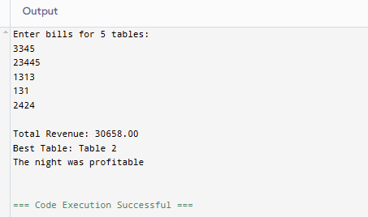
TASK: 07
#include <stdio.h>

int main()
{
int arr[6] = {45, 52, 38, 60, 49, 55};
int *p = arr;
int highest = *p;

printf("Original Marks:\n");

for(int i = 0; i < 6; i++)
{
printf("%d ", *(p + i));
}

for(int i = 0; i < 6; i++)
{
if(*(p + i) > highest)
highest = *(p + i);
}

for(int i = 0; i < 6; i++)
{
*(p + i) = (int)(((float)*(p + i) / highest) * 100);
}

printf("\n\nScaled Marks:\n");

for(int i = 0; i < 6; i++)
{
printf("%d ", *(p + i));
}

return 0;
}
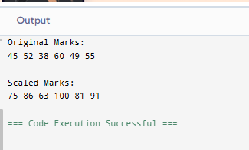
TASK: 08
#include <stdio.h>

int main()
{
void *sensor;

int vibrations = 847;
float temperature = 73.6;
char status = 'W';

sensor = &vibrations;
printf("Vibrations: %d\n", *(int *)sensor);
printf("Address: %p\n\n", (void *)sensor);

sensor = &temperature;
printf("Temperature: %.1f\n", *(float *)sensor);
printf("Address: %p\n\n", (void *)sensor);

sensor = &status;
printf("Status Code: %c\n", *(char *)sensor);
printf("Address: %p\n\n", (void *)sensor);

if(*(char *)sensor == 'N')
printf("System Normal\n");
else if(*(char *)sensor == 'W')
printf("Warning detected\n");
else if(*(char *)sensor == 'C')
printf("Critical alert!\n");

return 0;
}
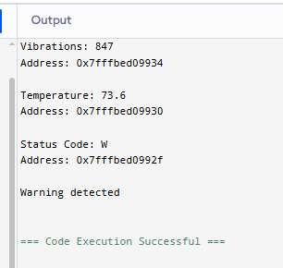
TASK: 09
#include <stdio.h>

int main()
{
int attendance[4][5] = {
{1,1,0,1,1},
{0,1,1,0,1},
{1,1,1,1,0},
{0,0,1,0,1}
};

int (*p)[5] = attendance;

for(int i = 0; i < 4; i++)
{
int total = 0;

printf("Student %d: ", i + 1);

for(int j = 0; j < 5; j++)
{
printf("%d ", (*(p + i))[j]);
total += (*(p + i))[j];
}

printf("| Total Present: %d", total);

if(total < 3)
printf(" (At risk)");

printf("\n");
}

return 0;
}
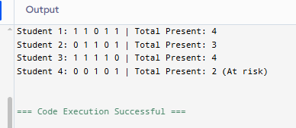
TASK: 10
#include <stdio.h>

int basicAttack(int dmg, int hp)
{
hp = hp - dmg;
printf("Basic attack used\n");
return hp;
}

int powerStrike(int dmg, int hp)
{
hp = hp - (int)(dmg * 2.5);
printf("Power strike used\n");
return hp;
}

int heal(int dmg, int hp)
{
hp = hp + 20;
printf("Heal used\n");
return hp;
}

int poisonAttack(int dmg, int hp)
{
hp = hp - (dmg / 2);
printf("Poison attack! Enemy poisoned\n");
return hp;
}

int main()
{
int hp = 100;
int dmg = 25;
int choice;

int (*action)(int, int);

for(int i = 1; i <= 3; i++)
{
printf("\nTurn %d\n", i);
printf("1. Basic Attack\n");
printf("2. Power Strike\n");
printf("3. Heal\n");
printf("4. Poison Attack\n");

printf("Enter choice: ");
scanf("%d", &choice);

if(choice == 1)
action = basicAttack;
else if(choice == 2)
action = powerStrike;
else if(choice == 3)
action = heal;
else if(choice == 4)
action = poisonAttack;

hp = action(dmg, hp);

printf("Updated HP: %d\n", hp);
}

return 0;
}
