TASK: 01
#include <stdio.h>
#include<string.h>
#include <ctype.h>
int main() {
char name[100] ;
int valid = 0;
printf("Student Name Validator\n");
printf("Enter the student name:");
scanf("%s", name);
int len = strlen(name);
if (len < 20 && len > 3) {
valid = 1;
}
else{
valid = 0;
}
for (int i = 0; name[i] != '\0'; i++) {
if (isdigit(name[i])) {
valid = 0;
break;
if(name[0] == ' '){
valid= 0;
break;}
if(name[len - 1] == ' ') {
valid = 0;
break;
}
}
}
if(valid == 0){
printf("Invalid Name");
}
else{
printf("valid Name");
}

return 0;
}
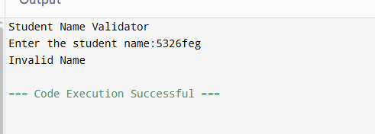
TASK: 02

#include <stdio.h>
#include <string.h>

int main() {
char password[] = "fast123";
char input[50];
int attempts = 0;

while (attempts < 3) {
printf("Enter password: ");
scanf("%s", input);

if (strlen(input) == 0) {
printf("Empty password!\n");
continue;
}

if (strcmp(password, input) == 0) {
printf("Access Granted\n");
return 0;
} else {
if (strcmp(input, password) < 0)
printf("Input is alphabetically before\n");
else
printf("Input is alphabetically after\n");
}

attempts++;

if (attempts == 2) {
if (strncmp(password, input, 3) == 0)
printf("Hint: First 3 characters match!\n");
}
}

printf("Account Locked\n");
return 0;
}
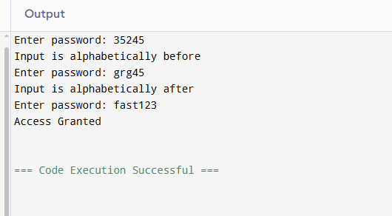
TASK: 03

#include <stdio.h>
#include <string.h>

int main() {
char email[50], copy[50], formatted[100] = "Email: ";

printf("Enter email: ");
scanf("%s", email);

strcpy(copy, email);

char *at = strchr(copy, '@');

if (at == NULL) {
printf("Invalid email (no @ found)\n");
return 0;
}

char *domain = at + 1;

if (strstr(domain, ".") == NULL) {
printf("Invalid domain\n");
return 0;
}

strcat(formatted, copy);

printf("%s\n", formatted);
printf("Domain: %s\n", domain);

return 0;
}
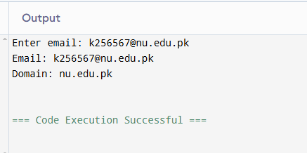
TASK: 04
#include <string.h>

int main() {
char names[5][30];
char search[30];
int found = 0;

for (int i = 0; i < 5; i++) {
printf("Enter name %d: ", i + 1);
fgets(names[i], 30, stdin);
names[i][strcspn(names[i], "\n")] = '\0';
}

printf("\nStudent List:\n");
for (int i = 0; i < 5; i++) {
printf("%s\n", names[i]);
}

printf("\nSearch name: ");
fgets(search, 30, stdin);
search[strcspn(search, "\n")] = '\0';

for (int i = 0; i < 5; i++) {
if (strcmp(names[i], search) == 0) {
printf("Found at position %d\n", i);
found = 1;
break;
}
}

if (!found)
printf("Student not found\n");

return 0;
}
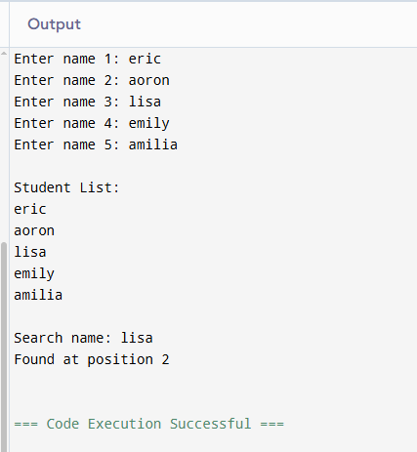
TASK: 05
#include <stdio.h>
#include <string.h>

int main() {
char words[6][20];
int seen[6] = {0};

for (int i = 0; i < 6; i++) {
scanf("%s", words[i]);
}

for (int i = 0; i < 6; i++) {
if (seen[i]) continue;

int count = 1;

for (int j = i + 1; j < 6; j++) {
if (strcmp(words[i], words[j]) == 0) {
count++;
seen[j] = 1;
}
}

printf("%s (%d): ", words[i], count);

for (int k = 0; words[i][k] != '\0'; k++) {
printf("%c ", words[i][k]);
}

printf("\n");
}

return 0;
}
TASK: 06
#include <stdio.h>

int main() {
FILE *fptr;
char name[20];
int grade;

fptr = fopen("grades.txt", "w");

if (fptr == NULL) {
printf("File error\n");
return 0;
}

for (int i = 0; i < 3; i++) {
scanf("%s %d", name, &grade);
fprintf(fptr, "%s %d\n", name, grade);
}

fclose(fptr);

fptr = fopen("grades.txt", "r");

while (fscanf(fptr, "%s %d", name, &grade) != EOF) {
printf("%s %d\n", name, grade);
}

fclose(fptr);
return 0;
}
TASK: 07
#include <stdio.h>

int main() {
FILE *fptr;
char product[20];
int qty;

fptr = fopen("inventory.txt", "a");

if (!fptr) {
printf("Error opening file\n");
return 0;
}

scanf("%s %d", product, &qty);
fprintf(fptr, "%s %d\n", product, qty);

fclose(fptr);

fptr = fopen("inventory.txt", "r");

while (fscanf(fptr, "%s %d", product, &qty) != EOF) {
printf("%s %d\n", product, qty);
}

fclose(fptr);
return 0;
}
TASK: 08
#include <stdio.h>

int main() {
FILE *fptr;
int score, sum = 0, val, count = 0;

fptr = fopen("survey.txt", "w");

for (int i = 0; i < 5; i++) {
scanf("%d", &score);
fprintf(fptr, "%d\n", score);
}

fclose(fptr);

fptr = fopen("survey.txt", "r");

while (fscanf(fptr, "%d", &val) != EOF) {
sum += val;
count++;
}

printf("Sum = %d\n", sum);
printf("Average = %.2f\n", (float)sum / count);

fclose(fptr);
return 0;
}
TASK: 09
#include <stdio.h>

int main() {
FILE *fptr = fopen("config.txt", "r");

if (fptr == NULL) {
printf("File not found. Creating default config...\n");

fptr = fopen("config.txt", "w");
fprintf(fptr, "max_users=50\n");
fprintf(fptr, "timeout=30\n");
fprintf(fptr, "mode=default\n");

fclose(fptr);
} else {
printf("Config file exists.\n");
fclose(fptr);
}

return 0;
}
TASK: 10
#include <stdio.h>

int main() {
FILE *fptr;
char name[20];
int s1, s2, s3;
float avg;

printf("Enter name and 3 scores: ");
scanf("%s %d %d %d", name, &s1, &s2, &s3);

avg = (s1 + s2 + s3) / 3.0;

fptr = fopen("report.txt", "w+");

fprintf(fptr, "Name: %s\n", name);
fprintf(fptr, "Scores: %d %d %d\n", s1, s2, s3);
fprintf(fptr, "Average: %.2f\n", avg);

if (avg >= 50)
fprintf(fptr, "Status: Pass\n");
else
fprintf(fptr, "Status: Fail\n");

rewind(fptr);

char line[100];
while (fgets(line, sizeof(line), fptr)) {
printf("%s", line);
}

fclose(fptr);
return 0;
}
GITHUB LINK

