TASK: 01
#include <stdio.h>
#include <stdlib.h>

int main() {
int n;
float *grades;

printf("Enter number of students: ");
scanf("%d", &n);

grades = (float*) malloc(n * sizeof(float));

if (grades == NULL) {
printf("Memory allocation failed!\n");
return 1;
}

// Input grades
for (int i = 0; i < n; i++) {
printf("Enter grade of student %d: ", i + 1);
scanf("%f", &grades[i]);
}
printf("\nStudent Grades:\n");
for (int i = 0; i < n; i++) {
printf("Student %d: %.2f\n", i + 1, grades[i]);
}

free(grades);
return 0;}
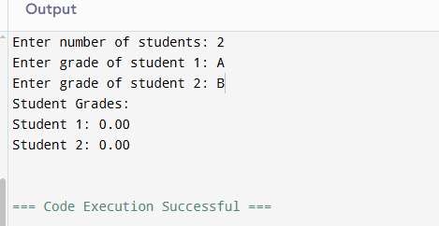
TASK: 02
#include <stdio.h>
#include <stdlib.h>

int main() {
int *contacts;

contacts = (int*) malloc(3 * sizeof(int));

if (contacts == NULL) {
printf("Allocation failed!\n");
return 1;
}

printf("Enter 3 contact IDs:\n");
for (int i = 0; i < 3; i++) {
scanf("%d", &contacts[i]);
}}
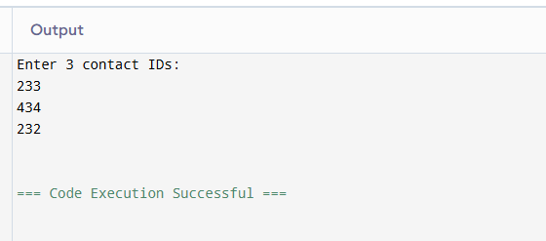
#include<stdio.h>
#include<stdlib.h>
int main(){
int *temp;

temp = (int*) realloc(contacts, 5 * sizeof(int));

if (temp == NULL) {
printf("Reallocation failed!\n");
free(contacts);
return 1;
}

contacts = temp;

printf("Enter 2 more contact IDs:\n");
for (int i = 3; i < 5; i++) {
scanf("%d", &contacts[i]);
}

printf("\nUpdated Contact List:\n");
for (int i = 0; i < 5; i++) {
printf("%d ", contacts[i]);
}

free(contacts);
return 0;
}
TASK: 03
#include <stdio.h>
#include <stdlib.h>

int main() {
int n;
float *buffer;

printf("Enter number of sensors: ");
scanf("%d", &n);

buffer = (float*) calloc(n, sizeof(float));

if (buffer == NULL) {
printf("Allocation failed!\n");
return 1;
}
printf("\nInitial values:\n");
for (int i = 0; i < n; i++) {
printf("%.2f ", buffer[i]);
}

printf("\n\nEnter sensor readings:\n");
for (int i = 0; i < n; i++) {
scanf("%f", &buffer[i]);
}

printf("\nSensor Data:\n");
for (int i = 0; i < n; i++) {
printf("%.2f ", buffer[i]);
}

free(buffer);
return 0;
}
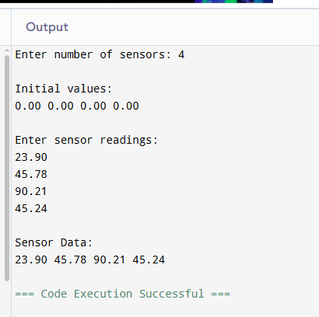
GITHUB LINK:

