X12 837P MASKING APPLICATION TECHNICAL SPECIFICATION
Version | 1.0
Date | April 14, 2026
Owner | Data Engineering / Integration Team

1. PURPOSE
This specification defines the end-to-end design and implementation of the X12 837P Masking Application.
The application processes inbound X12 files, stages canonical data in SQLite, retrieves masked data via K2view Fabric JDBC, and reconstructs masked X12 output.

2. SCOPE

2.1 In Scope
• Batch ingestion of X12 files from data/in.
• Parsing and extraction of canonical (biz_*) and mapping (map_*) datasets.
• Round-trip validation before staging.
• SQLite staging population in connector/x12-staging.db.
• K2view JDBC read for a specific transaction_id.
• Reconstruction of masked X12 using masked biz_* plus map_*.
• Artifact generation in data/trace and data/out.
• Operational scripts for compile, process, mask, and clear.
• Optional Docker copy of local staging DB into a local K2view container.

2.2 Out of Scope
• UI/dashboard features.
• Generalized multi-transaction-set X12 engine beyond current 837P model.
• Distributed orchestration and horizontal scaling.
• External API runtime mode for this release.

3. HIGH-LEVEL ARCHITECTURE
Data flow:
data/in/*.x12

-> Stage 1 (parse + extract + validate + trace)
-> SQLite staging (connector/x12-staging.db)
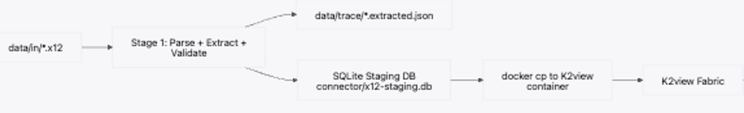
-> docker cp to K2view container
-> Stage 2 (JDBC read by transaction_id)
-> masked trace + reconstruction
-> data/out/*.masked.x12
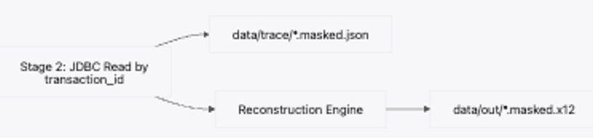

4. PROCESSING MODEL

4.1 Stage 1 (command: stage)
• Scan data/in for files matching app.file.pattern.
• Sort files deterministically.
• Assign transaction IDs sequentially as TXN-<n> from app.transaction.start.
• Parse and extract biz_* and map_*.
• Write extracted trace: data/trace/<root>.extracted.json.
• Execute mandatory round-trip validation.
• Stage extracted dataset into local SQLite.
• Persist transaction context files:
• data/trace/<transaction_id>.context.properties
• data/trace/<transaction_id>.source.x12
• Optionally copy SQLite DB to K2view container (docker cp).
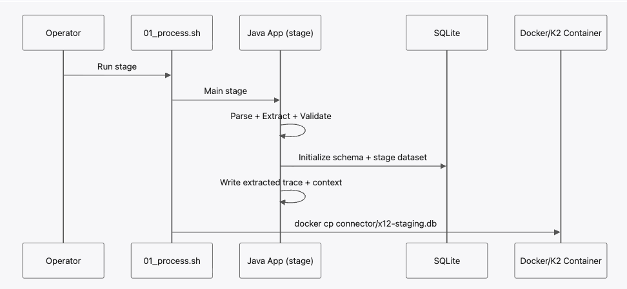

4.2 Stage 2 (command: mask <transaction_id>)
• Load transaction context file.
• Read source snapshot from trace folder.
• Initialize K2view session context using configured template.
• Read masked dataset from configured biz_* and map_* tables.
• Write masked trace: data/trace/<root>.masked.json.
• Reconstruct masked X12 preserving original structure and delimiters.
• Write artifacts:
• data/trace/<root>.reconstruct.trace.txt
• data/out/<root>.masked.x12
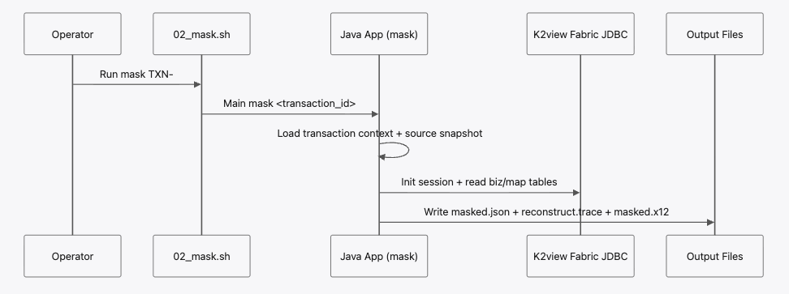

4.3 Clear/Reset (demo operations)
• Reset local staging DB.
• Reinitialize schema.
• Clear local trace and output artifacts.
• Copy clean DB to K2view container.

5. COMMAND-LINE INTERFACES

5.1 Java CLI
• Main stage [application.properties]
• Main mask <transaction_id> [application.properties]
• Main clear <transaction_id> [application.properties]

5.2 Operational Scripts
• 00_compile.sh
• 01_process.sh
• 02_mask.sh <transaction_id>
• 03_clear.sh

6. RUNTIME DIRECTORIES AND ARTIFACTS
• data/in: input X12 files
• data/out: masked X12 output
• data/trace: extracted/masked traces, reconstruction trace, transaction context
• connector/x12-staging.db: SQLite staging DB
• connector/schema.sql: SQLite schema bootstrap

Generated artifacts:
• <root>.extracted.json
• <root>.masked.json
• <root>.reconstruct.trace.txt
• <root>.masked.x12
• <transaction_id>.context.properties
• <transaction_id>.source.x12

7. DATA CONTRACTS
• Canonical masked domain data is read from biz_*.
• Mapping/control data is read from map_*.
• biz2_* tables are not part of this model.

7.1 Trace JSON Contract
Each trace JSON contains:
• meta.source_file
• meta.transaction_id
• meta.created_at
• tables: object keyed by table name with row arrays

8. CONFIGURATION SPECIFICATION

8.1 Property Reference (application.properties)
• app.input.dir: Directory scanned by Stage 1 for inbound X12 files.
• app.output.dir: Directory where masked X12 output files are written by Stage 2.
• app.trace.dir: Directory for extracted/masked JSON traces, reconstruction traces, and transaction context files.
• app.log.level: Application log verbosity (SEVERE, WARNING, INFO, FINE, or project-specific DEBUG mapping).
• app.pipeline.mode: Runtime path selector; use sqlite_staging for SQLite-first staging flow, direct_jdbc for legacy direct JDBC load.
• app.transaction.start: Starting numeric suffix used to generate transaction IDs as TXN-<n> during Stage 1 batch.
• app.connector.dir: Local connector directory that stores SQLite staging artifacts.
• app.jdbc.url: K2view Fabric JDBC connection string used for Stage 2 masked reads.
• app.jdbc.session.init.template: JDBC session initialization command template; %s is replaced by transaction_id.
• app.sqlite.jdbc.url: JDBC URL of the local SQLite staging database used in Stage 1.
• app.sqlite.schema.file: SQL schema file used to bootstrap/reinitialize the SQLite staging database.
• app.docker.k2.container: Docker container name for optional DB sync after process/clear scripts.
• app.docker.k2.db.dest: Destination DB file path inside the Docker container for staging DB copy.
• app.file.pattern: Regex filter applied to filenames in app.input.dir during Stage 1 batch discovery.
• app.batch.fail.fast: If true, Stage 1 stops on first file error; if false, it continues processing remaining files.
• app.read.tables: Comma-separated table list read from K2view JDBC in Stage 2 to build masked JSON and masked X12.
• app.clear.tables: Legacy direct-JDBC child->parent delete order for transaction-scoped clear utilities (not used by demo full-reset script).
• app.sqlite.clear.tables: SQLite-specific child->parent delete order for transaction-scoped clear operations.

8.2 Effective Runtime Defaults
• pipeline mode: sqlite_staging
• transaction start: TXN-1002
• local staging DB: connector/x12-staging.db
• docker target: masking-fabric:/opt/apps/fabric/data/x12-staging.db

9. VALIDATION AND ERROR HANDLING
• Validation runs before staging. Output must match original strictly.
• On mismatch, file is failed and validation diff is produced.
• Batch continues by default unless fail-fast is enabled.
• Stage 2 fails if context or source snapshot is missing for transaction.
• SQLite/JDBC operations use explicit transactions with rollback on fatal failures.

10. OBSERVABILITY
• Logs include stage name, transaction_id, and source file root.
• Row counts are logged per major table group during staging and read-back.
• Reconstruction trace reports replacement counts and samples.

11. SECURITY AND COMPLIANCE
• PHI-bearing artifacts may exist in data/trace and data/out.
• Restrict local access and enforce retention controls.
• Avoid verbose logging of sensitive values in production.

12. ACCEPTANCE CRITERIA
• Stage command processes all valid files and stages data into local SQLite.
• Transaction IDs increment deterministically from configured start value.
• Mask command generates masked trace and masked EDI for valid transaction_id.
• Runtime flow has no dependency on biz2_* tables.
• Clear/reset produces a clean local environment and optional container DB sync.

13. STANDARD RUNBOOK
./00_compile.sh
./01_process.sh
./02_mask.sh TXN-1002
./03_clear.sh

