# Digital Outputs – Driving High Current Loads Rev 1.0

## piRover warner worksheet:

1. The instructor will review the required hardware connections using the Digital Outputs – Driving High Current Loads document and the following images.

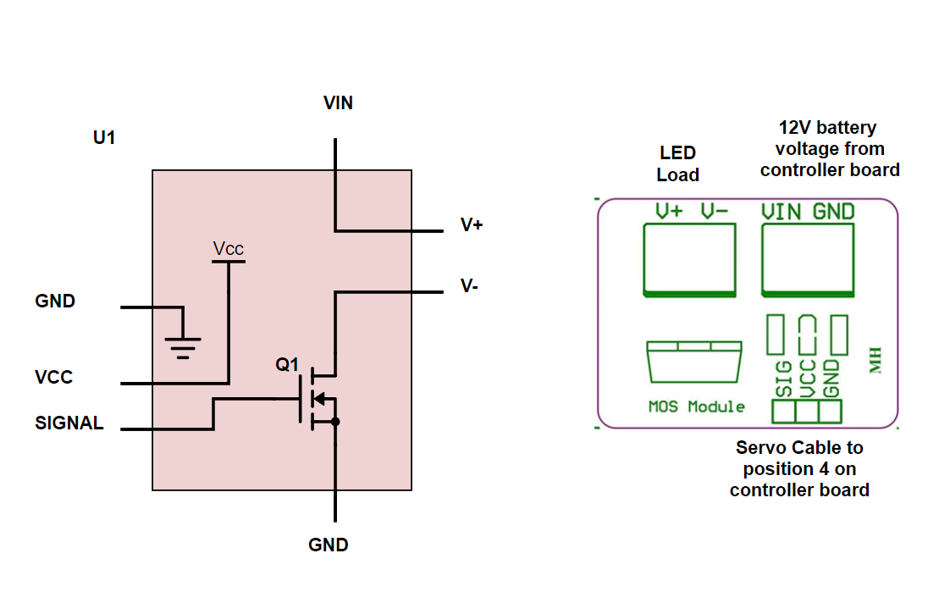

1. Run your blink code from the initial Digital Outputs – Introduction lesson. You are using the same servo port as in the initial blink example, so your code should execute and blink the amber LED.
2. Demonstrate the blink function to the instructor for a lab check. If you do not get an in-class lab check then you must submit a blink video with this week’s assignments.
3. Adjust the blink code so that the amber LED is off. Use your DVM to record the voltages specified in the table on the next page.
4. Follow along with the instructor to produce the following solution files.
   1. warning1.py
   2. warning2.py
   3. warning3.py
   4. warning4.py
   5. piRover_warner.py
5. Work with a partner to insert comments lines above each line of code produced. This is an in-class activity. The instructor will provide more detailed instruction.
6. Submit your revised code files from item 5 on the prior page with the zip file required for this week.
7. Record voltage on the MOSFET driver for both on and off conditions

Table

|  |  |  |
| --- | --- | --- |
| MOSFET Voltages | OFF | On |
| VIN |  |  |
| V+ |  |  |
| V+ to V- |  |  |
| Vsignal |  |  |
| Vcc |  |  |
|  |  |  |

## Assessment:

Demonstrate your warning system to the instructor during the next class period. Note that you will need a camera to demonstrate. If you cannot demonstrate during class, then submit a short video showing blink operation.

Submit this file with voltage levels in inserted into Table 1 above.

Submit code files as directed