# Disabling Yahboom Bluetooth Rev 2.0

## Overview:

This document provides the configuration changes required to disable the Yahboom Bluetooth service that typically runs in the background enabling the Smart Phone application. The service must be disabled prior to executing your Python control code. If you do not disable the service, then it will constantly work against any changes you try to make to the state of your piRover. If you turn the Red LED on, it will immediately turn it off.

## Prerequisites:

Prior to beginning the instruction provided in this lesson you must have completed the following:

1. piRover: Creating a Remote Connection

## Performance Outcomes:

1. Modify Raspberry Pi start up configuration

## Resources:

1. None

## Materials:

1. piRover

## Directions

1. With your system connected via the VNC Viewer, open a terminal window.
2. Enter the following commands to edit the **bluetooth.desktop** configuration file.

**cd .config/autostart**

**ls**

**mousepad bluetooth.desktop**

1. The mousepad editor will display showing the contents of the **bluetooth.desktop** configuration file.

#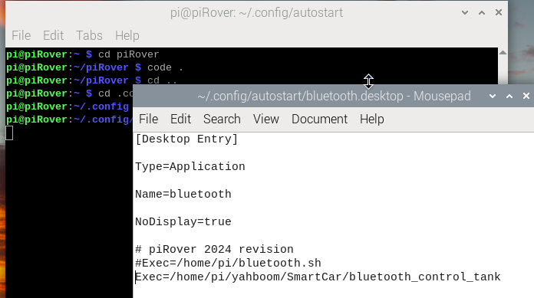

1. Add the hash # symbol to the start of each line. This “comments out” the line so that it will not be read as a command.

1. Save the file and reboot. The Smartphone functionality is disabled.
2. To use the Smartphone app again. Open the file, remove the # from each line, save, and reboot.