# Visual Studio Code – Getting Started Rev 1.2

## [Running Visual Studio Code on Raspberry Pi OS](https://code.visualstudio.com/docs/setup/raspberry-pi)

## Overview:

In the Python Getting Started activity you used the Thonny editor that was installed with the Raspian operating system to edit and run Python code. In this activity, you will install the Visual Studio Code integrated development environment (IDE) and use it to run code. We’ll write code using VS Code in later activities.

VS Code is a professional tool used by most developers. It is lightweight and can be configured for many different languages and tool extensions. Most professionals install the IDE on their workstation and develop on the Raspberry Pi remotely. In this course, you will install and run Visual Studio Code directly on the Raspberry Pi.

## Prerequisites:

Prior to beginning the instruction provided in this lesson you must have completed the following:

1. Python – Getting Started

## Performance Outcomes:

1. Install Visual Studio Code on a Raspberry PI.
2. Recognize components of the Visual Studio Code window.
3. Open and run a Python program using the VS Code debugger.

## Resources:

1. [Installing Visual Studio Code on the Raspberry Pi](https://pimylifeup.com/raspberry-pi-visual-studio-code/)
2. [Most Popular Development Environments](https://insights.stackoverflow.com/survey/2019#technology-_-most-popular-development-environments)
3. [Why VS Code?](https://code.visualstudio.com/Docs/editor/whyvscode)

## Materials:

1. piRover

## Introduction to Visual Studio Code

Visual Studio Code is a powerful code editor. It is a free, lightweight, open-source editor that helps you write professional code for Windows, Mac, and Linux platforms. It includes support for debugging, Git source control, and code completion. Its simplified edit, build, and debug cycle makes it ideal for both the beginner and the serious professional. VS Code comes with built-in support for JavaScript, TypeScript and Node.js, but you will be installing a Linux version that also has “extensions” providing support for Python.

### Review the Stack Overflow 2019 Survey at [https://insights.stackoverflow.com/survey/2019](https://insights.stackoverflow.com/survey/2019#technology-_-most-popular-development-environments) and you will see that it is one of the top, if not the top, editors used by developer. See additional information on why VS Code is preferred at this link - [Why VS Code?](https://code.visualstudio.com/Docs/editor/whyvscode) In short, this is a great tool. You will want to learn it well!

## Installing VS Code

### Visual Studio Code is now supported on ARM processors which means you can install it on a Raspberry Pi.

### *** Update – you can now install VS Code at the terminal prompt

### **sudo apt install code**

1. ~~Open the following link. The instructor will review features and work through the installation procedure outlined here.~~

[~~Installing Visual Studio Code on the Raspberry Pi - Pi My Life Up~~](https://pimylifeup.com/raspberry-pi-visual-studio-code/)

* 1. ~~On your Raspberry Pi browse to the following page.~~

[~~https://code.visualstudio.com/download~~](https://code.visualstudio.com/download)

* 1. ~~Select the ARM download for the Debian version of Linux.~~

~~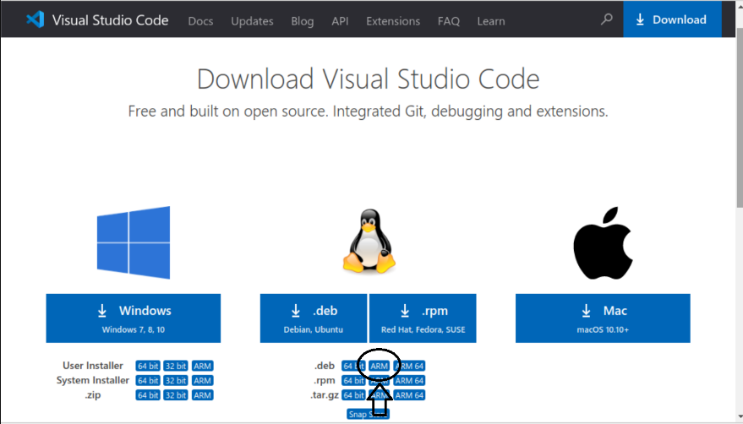~~

* 1. 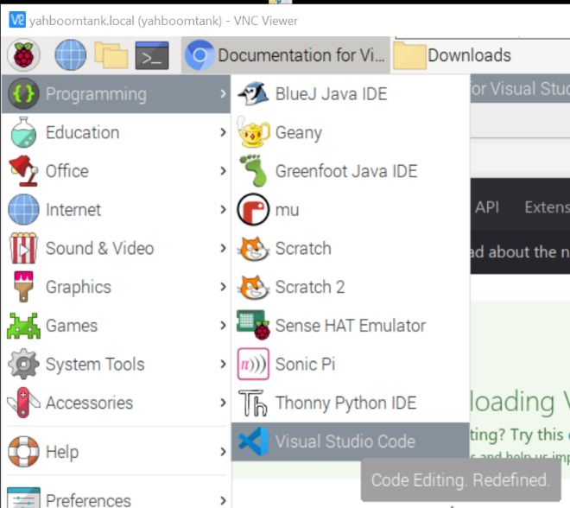Once the installation file has downloaded, open the download folder, and click on the file to install.

1. When the installation is complete, Visual Studio is available on the Programming menu.

1. You can also launch the VS Code environment from any terminal prompt by entering **code**. Let’s open VS Code and run the ColorLED_v3.py program introduced in the Python Getting Started activity.
2. Open the terminal window and launch VS Code using the **code** command. Note how the dot is added to specify that VS Code should open in the current directory.

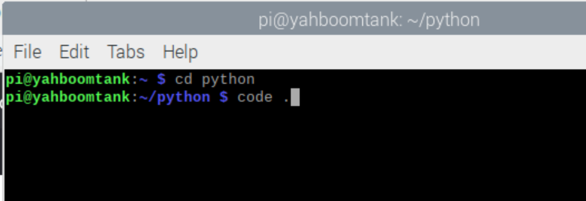

1. VS Code launches with the Welcome screen and current release notes visible. There is a lot of good information here but open the ColorLED.py file now.

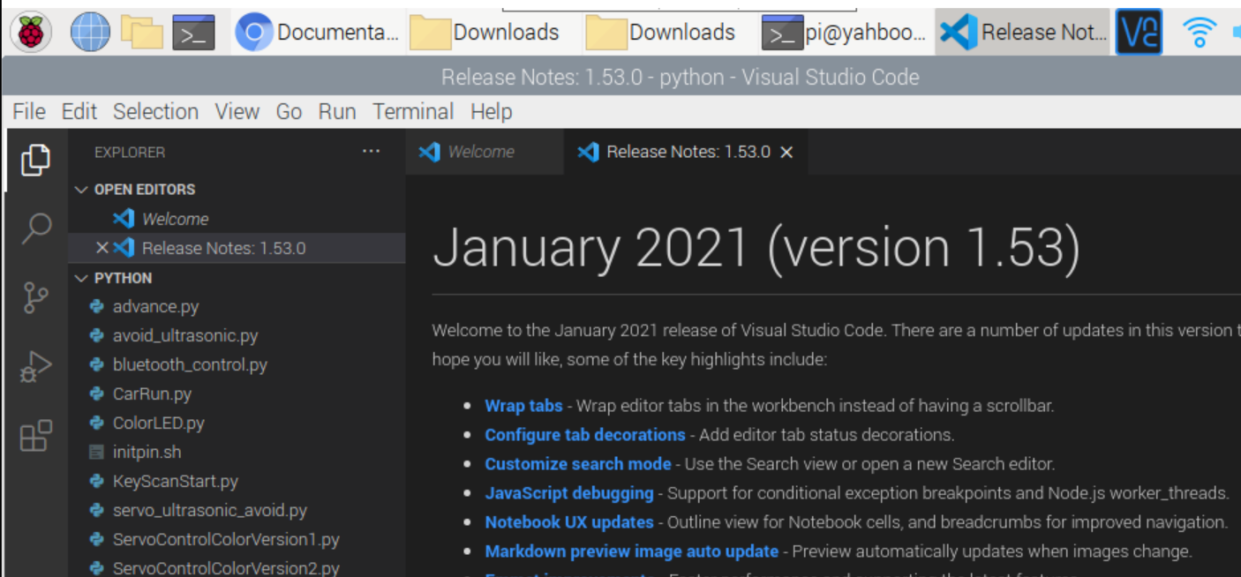

1. The ColorLED_V3.py file is open in the editor.

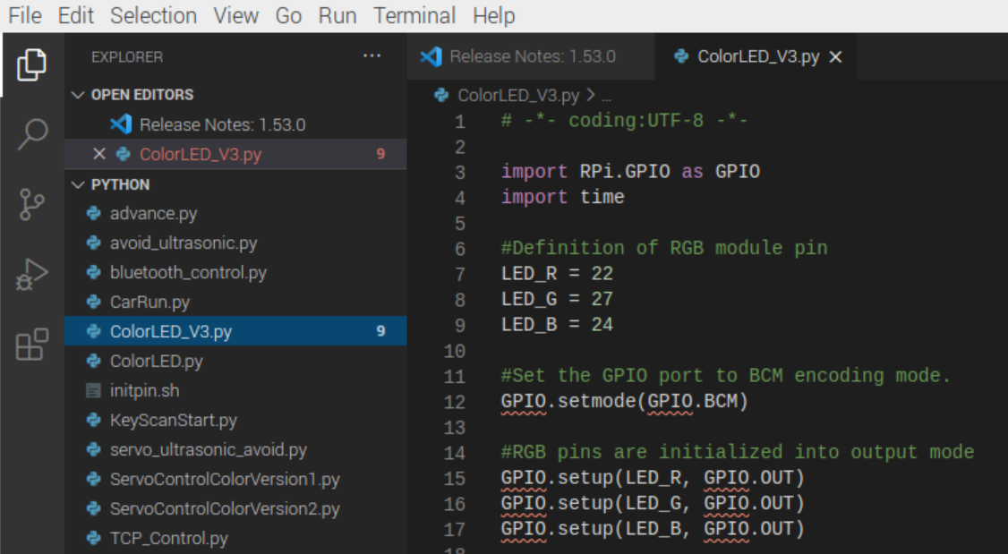

1. Use the Activity Bar to view the Extensions tool. Note that support for Python is already installed.

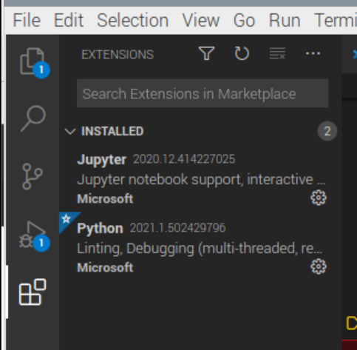

1. Now view the status bar at the bottom of the VS Code windows. This shows that you are currently operating in the version 3.7 environment.

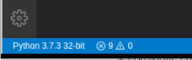

1. Run the ColorLED_v3.py program by selecting Run from the menu and then Start Debugging. Note that you can also use the F5 function key to start the program.

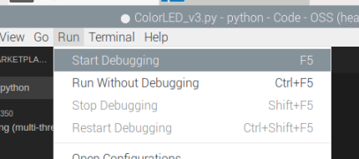

1. The Command Palette opens prompting for you to select a configuration for the debug session. Select the first option “Python File” and the program will run.

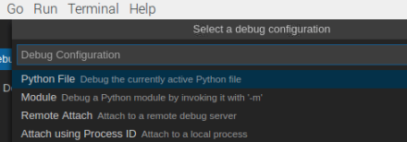

1. The output from the program is displayed in the terminal pane. You will review these warning statements later, but for now, the code runs and the LEDs flashes.

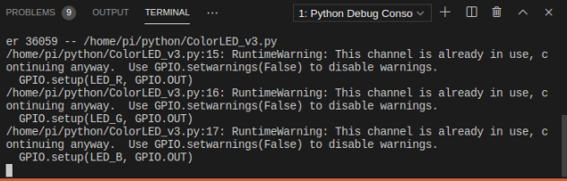

1. To stop the execution, click the red square icon in the debug tools at the top of the window.

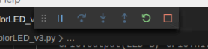

1. There is a lot more to investigate and learn both about Python and the Visual Studio Code environment. But, for now, you were able to load a Python file into the VS Code editor and run the program.
2. This activity is the final action in the first section (Sprint) in the course. At this point in the course, you must have the software and other tools installed so that you can write and execute Python code on your system. If you are having difficulty be sure that you are in contact with the instructor. Again, you must have a functional system as you move into the next section of the course.

## Assessment:

Run the ColorLED_v3.py file again in VS Code. Use a screen capture tool to record an image of the VS Code window with the Python code running. Save this file as **VSCodeWithPython.jpg**. Submit this file to Moodle using the link provided.