EET103 Electrical Circuits I

Final Project: 555 Timer Monostable Circuit with Relay Control – Part 1

Name: __________________________________

Introduction
This capstone project will guide students through the design and construction of a 555 timer monostable multivibrator circuit to control a relay that switches 120V AC to an off-the-shelf cup warmer. The project consists of three phases: breadboard build, perfboard build, and final assembly.
The introductory phase focuses on reviewing the schematic diagram, understanding the RC time constant and one-shot duration calculations, and setting up for a breadboard demonstration. The breadboard phase will use a 5V power supply, while the final perfboard build will transition to a 9V battery. Students will substitute specific resistor values during the breadboard phase to facilitate faster testing.
Key goals include:
- Reviewing the schematic diagram and design goals.
- Demonstrating the RC timing and digital trigger functionality on a breadboard.
- Preparing for safe handling of 120V AC power in the final assembly.

Theory of Operation
1. As a class, we will review the function of the 555 timer as an asynchronous multivibrator (one-shot).
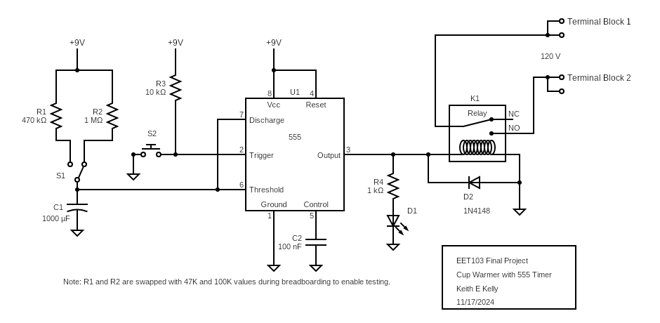
2. Complete the following Component Identification Table. R1 and D2 are provided as examples.
Designator | Component Name | Component Purpose
R1 | Charging Resistor | One of two resistors that along with C1 set up the RC timing for the one-shot.
R2
C1
S1
R3
S2
U1
D1
R4
K1
D2 | Flyback Diode | A semiconductor device connected across an inductor to protect other components from voltage spikes.

Breadboard Phase
The breadboard phase involves step-by-step assembly and validation of the circuit. Each stage includes an instructor check to evaluate functionality and professional construction techniques.

Step 1: Power Supply
- Place an 8-pin socket in the center section of the breadboard to ensure room for the RC and trigger circuits on the left side and the output circuit on the right side.
- Connect power from the +V rail to the Vcc supply pin 8 and the Reset pin 4.
- Connect ground from the ground rail to pin 1.
- Connect a 0.1 µF capacitor between the control input (pin 5) and ground.
- Energize the circuit and use a DMM to validate power is applied to pins 8 and 4.
__________ Instructor Check: Validate power connections, clean wiring practices, and correct placement in the center section.

Step 2: RC Timing Circuit
- Use a 100K resistor (R1) and a 47K resistor (R2) connected through an SPDT selector switch (S1) to the 1000 µF capacitor (C1).
- Build the RC timing circuit on the leftmost section of the breadboard.
- Apply the capacitor voltage to the 555 timer socket: threshold input (pin 6) and discharge (pin 7).
- Use a DMM to measure and display the voltage as the capacitor charges when power is applied.
- Demonstrate RC timing with S1 switched to both positions using the DMM:
  - When S1 connects the 47K resistor (R2) to the 1000 µF capacitor (C1):
    - τ = R * C = 47,000 * 0.001 = 47 seconds.
    - After 1 τ, the capacitor voltage will reach 63% of the supply voltage (just over 3V).
  - When S1 connects the 100K resistor (R1) to the 1000 µF capacitor (C1):
    - τ = R * C = 100,000 * 0.001 = 100 seconds.
    - After 1 τ, the capacitor voltage will reach 63% of the supply voltage.
- Students will measure and observe the capacitor voltage as it charges in each position of the S1 switch using the DMM, validating the RC timing behavior.
__________ Instructor Check: Validate RC timing functionality with DMM for both S1 positions.

Step 3: Digital Switch
- Connect a 10K pull-up resistor (R3) and a push button switch (S2) to pin 2 of the socket.
- Demonstrate the digital switch function.
- Explain the pull-up function of R3 and the active low trigger signal created when S2 is pressed.
__________ Instructor Check: Validate trigger functionality and student explanation.

Step 4: Output Circuit
- Connect the output (pin 3) to the relay coil: pin 1 of the coil to pin 3 and pin 8 of the coil to ground.
- Add an LED (D1) in parallel with the relay coil, using a 1K current limiting resistor.
- Connect a DMM across the N.O. relay output.
- Energize the output by connecting pin 3 of the socket to the supply voltage.
- Note: the relay will not close when a 5 volt source is applied. Use the bench supply to apply 9 volts to the output on pin 3. You should hear the relay activate and the N.O. relay outputs close. Use your DMM to validate that N.O. outputs are closed with 9 volts applied to the output pin.
_________ Instructor Check: Validate relay operation and LED indicator functionality.

Step 5: Final Integration and Testing
- Insert the 555 timer IC into the socket.
- Connect the DMM to measure continuity across the N.O. relay output.
- Move the S1 switch to both positions to demonstrate delay selection.
- Ensure the circuit layout follows a left-to-right flow: RC charging circuit on the left, trigger input in the center-left, 555 timer in the center-right, and output relay and LED on the far right.
- Check timing and recall that the relay is not “pulled in” with the 5-volt source provided on the breadboard. The final build uses the 9-volt battery as the source.
__________ Instructor Check: Validate functionality and professional organization of the breadboard layout.

