Project 03- Part 1 – piRover Keyboard App Rev F25

Goal:
The course started with you evaluating the piRover using the Yahboom smart phone app. You will complete the course by implementing your own version of this controller.
In Part 1, you will continue your development of the keyboard application that is used to emulate the eventual piRover Bluetooth app.
You’ll use the key definitions specified by you in the earlier requirements document and connect the various component modules so that the piRover system can be fully tested without use of the smartphone. Both fake and final modules are included in the solution folder and the import statements at the top of the keyboard file can easily be swapped to move between fake and final modules. This process was demonstrated during class sessions.
Component modules for the piRover were created during class session except for the piRover_led. In this final phase of the course, you will validate your existing keyboard solution and then extend it to include both RGB and LED functionality.
Use Table 1 of this document to record your results of both the fake and final tests. Review Table 1 carefully. Actions for each smartphone input are specified. Note that some functions are different than what Yahboom had originally programmed.
While select module functions are used in the keyboard interface specified in Table 1, component modules must be complete and include the member functions developed during class. Screen captures of each module are provided. Verify that your modules are complete.
The LED module was not completed during class, but the required methods are provided in Figure 4. Complete the implementation of the piRover_led.py module as the last step in this activity.
This is a final assessment of the course. Do your best and do your own work. Do not assist others.

Part A – Requirements
- Review the screen capture of the smartphone interface provided below. Each control is listed in Table 1 along with the required function. Note that some functions are different than what Yahboom had originally programmed. For example, you will use the X control for speed rather than servo position. Review the specified turn definitions. You must implement rover functionality as specified in Table 1.
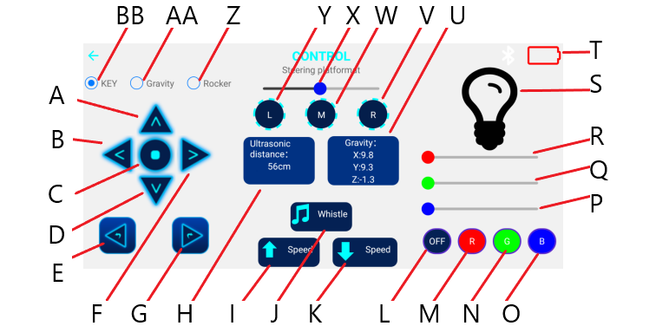
- Review your prior keyboard planning document. Enter your selected keystrokes from your earlier specification into the Keyboard Input column of Table 1 on the following page.
- Open your project. Enable all fakes. Run the keyboard application to verify that the keyboard inputs specified call the required fake method. Again, fake methods only need to produce an output to the terminal. No piRover functionality is required and there is no GPIO code included in any fake.
- Enter checks (Y for Yes, N for No) in the fake column of Table 1 indicating that the fake implementation is functional.
Table 1
Action ID | Action Name | Keyboard Input | Fake | Final
A | FORWARD
B | LEFT TURN
C | STOP
D | BACKWARD
E | LEFT ROTATE
F | RIGHT TURN
G | RIGHT ROTATE
I | SPEED UP
K | SPEED DOWN
J | BUZZER TOGGLE
L | RGB TOGGLE (All on/white, all off)
M | RED LED TOGGLE
N | GREEN LED TOGGLE
O | BLUE LED TOGGLE
P | BLUE DIM (values 0 to 100)
Q | GREEN DIM (values 0 to 100)
R | RED DIM (values 0 to 100)
V | SERVO RIGHT
W | SERVO CENTER
Y | SERVO LEFT
X | SET SPEED (values 0 to 100)

Part B – Implementations

- Buzzer: Open your piRover_buzzer.py module. Verify that you have the functions shown in figure 1 implemented.
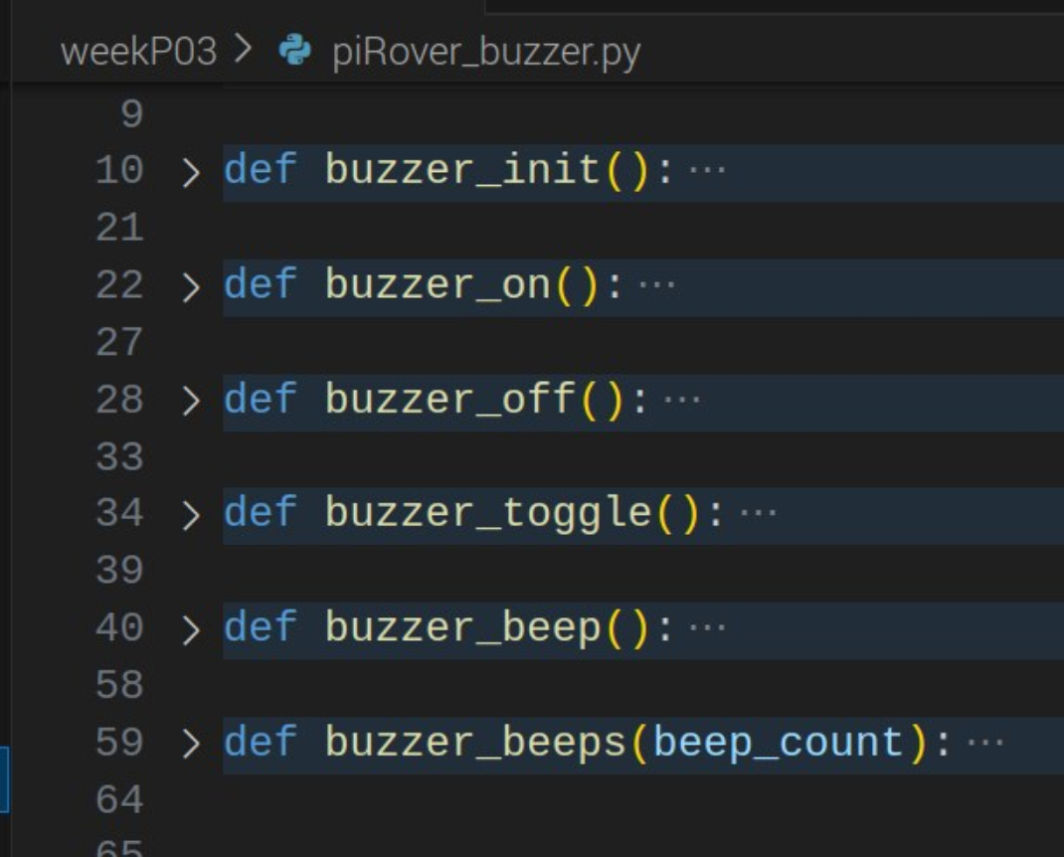
Figure 1
- Revise your keyboard file so that the final buzzer module is used. Test your buzzer functionality.
- Update the Final column of Table 1 based on your testing. Enter Y if this module is functional and N if there are open issues. Describe any issues or questions in the space provided below.

- Drive: Open your piRover_drive.py module. Verify that you have the functions shown in figure 2 implemented.
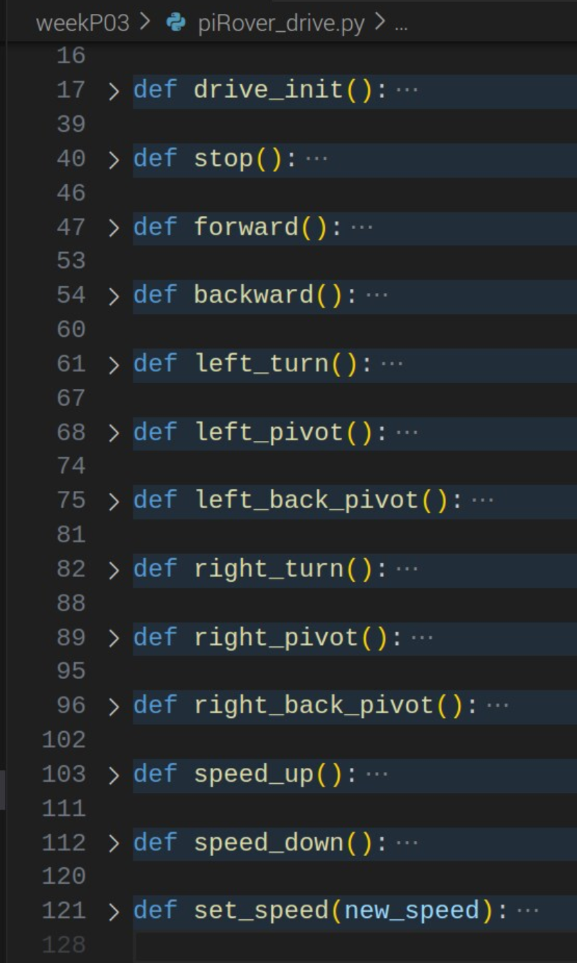
Figure 2
- Revise your keyboard file so that the final drive module is used. Test your drive functionality.
- Update the Final column of Table 1 based on your testing. Enter Y if this module is functional and N if there are open issues. Describe any issues or questions in the space provided below.

- Servo: Open your piRover_servo.py module. Verify that you have the functions shown in figure 3 implemented.
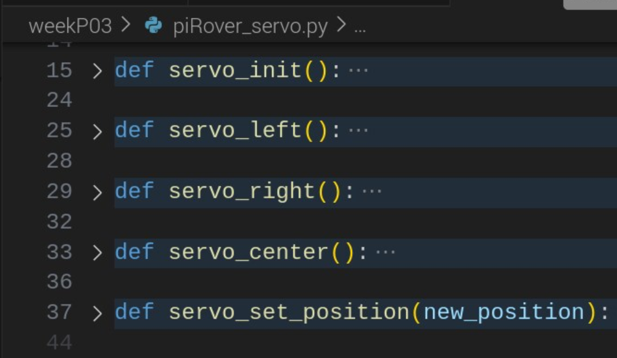
Figure 3
- Revise your keyboard file so that the final servo module is used. Test your servo functionality.
- Update the Final column of Table 1 based on your testing. Enter Y if this module is functional and N if there are open issues. Describe any issues or questions in the space provided below.

Part C – piRover_led Extension
- Review figure 4 on the following page. While you created an LED interface in your led_fake file. This project extends that initial attempt and provides additional RGB functionality in addition to on, off, and dim.
- Review your piRover_led_fake definitions. While red, green, and blue functions were created during earlier class sessions, RGB functions were not. Add RGB_on(), RGB_off() and RGB_toggle() to your fake definition.
- Test your fake and adjust entries in Table 1, Action ID L. Your earlier fake test for this action in Part A failed due to missing RGB definitions.
- Implement the final version of piRover_led.py that provides the features listed in Figure 4.
  - Each LED includes on, off, toggle, and dim functionality.
  - Review the use of PWM in other modules and lessons to implement dimming. Dim functions use a percent_on parameter that requires a value between 0 and 100 where 0 is off and 100 is fully on.
  - The RGB on, off, and toggle functions control all three LEDs
    - The on function turns all on resulting in a white light.
    - The off function turns all three LEDs off
    - The toggle function turns all off if any of the three are on. If all three are off, then all are turned on.
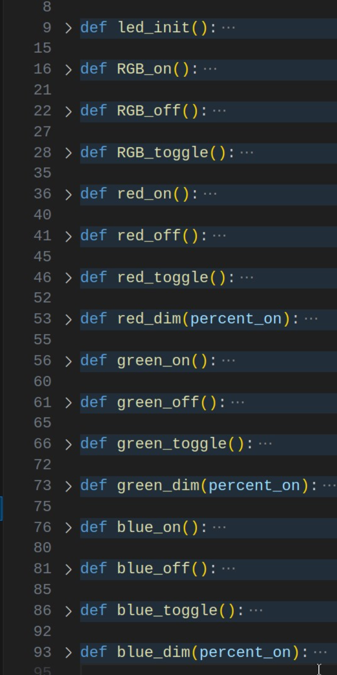
Figure 4
- Revise your keyboard file so that the final LED module is used. Test your RGB and LED functionality.
- Update the Final column of Table 1 based on your testing. Enter Y if this module is functional and N if there are open issues. Describe any issues or questions in the space provided below.

Part D – Submission/Evaluation
- Zip your weekP03 folder. Add this document to your zip file with Table 1 completed.
- If all are functional, then comments sections in the document can be blank. If your code has issues, comments must be provided describing the issue and steps taken to debug the code.
- Review the grading rubric on the prior page. Partial credit is awarded. Use comment lines to identify issues.
- Double-check your zip file to be sure all required files are included. This is the first part of the final assessment. You must submit the required files and code to receive credit.
- Submit your zip file to the Moodle link by the deadline specified. This is the final assessment of the course. No late work is accepted.

