Project 03- Part 2 – piRover Phone App Rev F25

Goal:
The course started with you evaluating the piRover using the Yahboom smart phone app. You will complete the course by implementing your own version of this controller.
In Part 2, you will finish your development of the piRover application by integrating the Bluetooth service and creating the final piRover phone app.
Review the requirements below, install the Bluetooth service modules, and implement the piRover_phone.py application. For a final assessment you will create a short demonstration video that validates the requirements listed on page 2. You must submit this Zoom video link to the course website by the deadline listed. No late work is accepted.

Part 2 – Requirements
- Review the screen capture of the smartphone interface provided below. Each control is listed in Table 1 along with the required function. Note that some functions are different than what Yahboom had originally programmed. For example, you will use the X control for speed rather than servo position. Review the specified turn definitions. You must implement rover functionality as specified in Table 1.
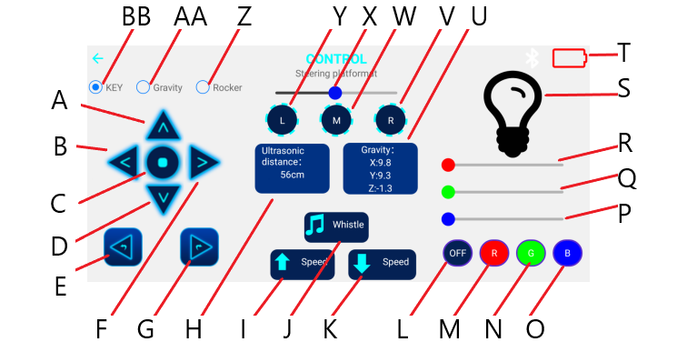
- Enter checks (Y for Yes, N for No) in the Student Eval column of Table 1 indicating that each requirement is met.
Table 1
Action ID | Action Name | Description/Requirement | Student Check | Instructor Check
N/A | ARM | The controller board start button is pressed to “Arm” the piRover. Armed status is indicated by 4 beeps.
A | FORWARD | Forward motion with latched operation. The Stop control (C) is required to stop motion.
B | LEFT TURN | Left rotate motion with latched operation. The Stop control (C) is required to stop motion.
C | STOP | Stop. This input is required for Forward, Backward, Left, and Right motion,
D | BACKWARD | Left rotate motion with latched operation. The Stop control (C) is required to stop motion.
E | LEFT PIVOT | Left pivot motion (no latch). Turn continues until button is released.
F | RIGHT TURN | Right rotate motion with latched operation. The Stop control (C) is required to stop motion.
G | RIGHT PIVOT | Right pivot motion (no latch). Turn continues until button is released.
I | SPEED UP | Speed is increased to a maximum value of 100.
K | SPEED DOWN | Speed is decreased to a minimum, value of 0.
J | BUZZER TOGGLE | Buzzer is toggled on and off.
L | RGB TOGGLE (All on/white, all off) | All LEDs are toggled on (white) and off.
M | RED LED TOGGLE | Red LED is toggled on and off. Other LEDs are not impacted.
N | GREEN LED TOGGLE | Green LED is toggled on and off. Other LEDs are not impacted
O | BLUE LED TOGGLE | Blue LED is toggled on and off. Other LEDs are not impacted
P | BLUE DIM (values 0 to 100) | Slider control dims blue led between 0 and 100 percent. (Blue toggle may not function once dim() is executed)
Q | GREEN DIM (values 0 to 100) | Slider control dims green led between 0 and 100 percent. (Green toggle may not function once dim() is executed)
R | RED DIM (values 0 to 100) | Slider control dims red led between 0 and 100 percent. (Red toggle may not function once dim() is executed)
V | SERVO RIGHT | Servo rotates right to 180 degrees.
W | SERVO CENTER | Servo centers right to 90 degrees.
Y | SERVO LEFT | Servo rotates left to 0 degrees.
X | SET SPEED (values 0 to 100) | Slider controls speed value between 0 and 100 percent.
N/A | Disarm | Two successive presses on LED on/off (L) exits the application. A long beep indicates exit status and rover no longer functions.

Part 2 – Submission/Evaluation
- Use the requirements listed on the prior page as a guide when creating your Zoom video.
- Submit your Zoom video link to the course website by the deadline provided. No late work is accepted.

