I thought the "wpa_supplicant" errors were resolved for the Yahboom SD configuration. See item 13 in the FAQ on this page.
G1 Tank-Rpi (yahboom.net)

- Verifying this is the issue
  - Connect to EngTech Wi-Fi (password is Skynet 2023)
  - Open a terminal window and enter the following:
    - ping 8.8.8.8
    - You should see a response. The Pi is connected to the Internet.
    - Now enter the following
    - ping google.com
    - This fails due to error in DNS (Domain Name Server) setting
- Here is the fix
  - Enter the following to make the resolv.conf file writable.
    - sudo chmod +w /etc/resolv.conf
    - If this is successful continue to step b below.
    - If not and you see the error “Operation not permitted”, then do the following:
      - sudo chattr -i /etc/resolve.conf
      - retry the command sudo chmod above. It should now work.
  - Edit the resolv.conf file
    - Enter the following
    - sudo leafpad /etc/resolv.conf
    - You should see this
    - 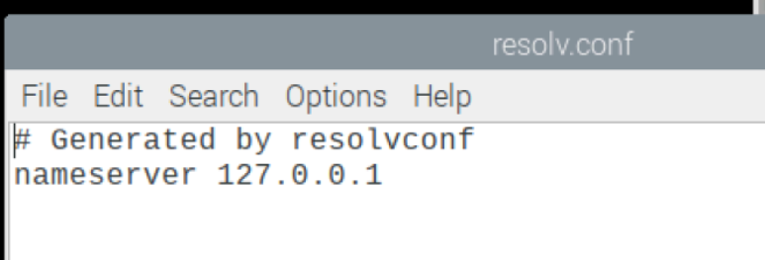
    - Edit to this, save, and close.
    - 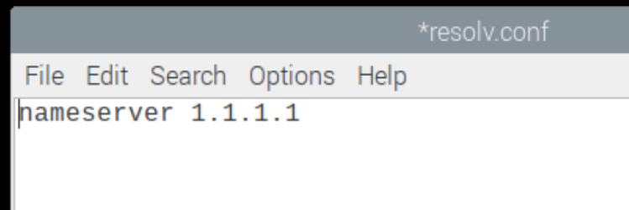
    - Restore to readonly
      - sudo chmod -w /etc/resolv.conf
    - Restore attribute
      - sudo chattr +i /etc/resolve.conf
    - reboot
    - Verify the fix by the following. You should see a response from google.com
      - ping google.com

