piRover – Pushbutton Rev 1.2

Overview:
In the last activity you learned to use a variable to hold a value that was entered by the user using an input() function. In this activity, you will again use a variable, but this time the value will come from reading a GPIO port configured as an input rather than an output.
When a GPIO port is configured as an input, an external circuit must provide a voltage level on this pin that can be read. In the case of the Raspberry PI, this voltage is either 0 volts or 3.3. volts. In this initial input activity, you will use the pushbutton that is located on the corner of the control board to apply a high or low (3.3V or 0V) signal onto a GPIO port. You will use the GPIO.input() function to read this voltage level. The result is a Boolean value, so a decision can be made based on the pushbutton switch state.
The requirements for the solution are listed below.
- The user will see a welcome message indicating that this is the Pushbutton Switch activity.
- The user will be prompted to press the pushbutton switch to light the LEDs to produce a white light.
- While loops will be used to sense a switch press and a switch release. Actions will occur on the switch release.
- Two additional solutions are provided
  - pushbutton_cycle.py - the LED light changes every time the switch is pressed.
  - pushbutton_toggle.py – the LED light will turn on and off each time the switch is pressed.

Prerequisites:
Prior to beginning the instruction provided in this lesson you must have completed the following:
- piRover Traffic Light

Performance Outcomes:
- Use the GPIO.input() function to read the logic level on a GPIO port configured as an input.
- Identify switch bounce
- Use a while statement to sense pushbutton press and release.
- Control code execution based on GPIO input.

Resources:
- Switch Basics

Materials:
- piRover

Part 1 – Set Up
- Prepare your workspace for this activity.
  - Connect to your piRover using VNC.
  - Access your piRover folder
  - Create a 04.PushButton directory
  - Change to the 04.PushButton directory
  - Download the starter files for Pushbutton the activity. Copy and paste the wget instructions below.

wget https://k2controls.github.io/piRoverBuilds/L26.PushButton/pushbutton.py
wget https://k2controls.github.io/piRoverBuilds/L26.PushButton/pushbutton_cycle.py
wget https://k2controls.github.io/piRoverBuilds/L26.PushButton/pushbutton_toggle.py

- Move back to the piRover parent directory using the cd .. command and launch VS Code.

Part 1 – Investigate the hardware
- In this activity you will be using a pushbutton switch as an input device. See this document for information on Switch Basics.
- In this GPIO activity, you will work with the GPIO port as an input. This means that external hardware will be applying either a high or low voltage onto the GPIO pin. In software you will be able to “read” this high or a low logic level on the pin and use it to make decisions in your code.
- The pushbutton switch is located in the front left corner of the controller board in front of the header used for servo connections.
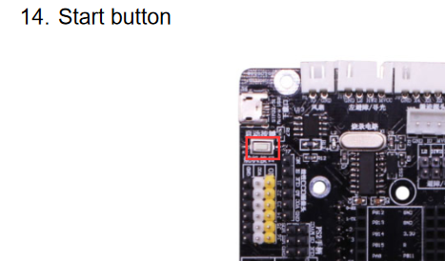
- Review the documentation in the Yahboom Expansion Board Manual to determine which GPIO pin is connected to the pushbutton switch on the GPIO board. You will find this on page 26.
- The start button K2 is connected to pin 24. See Table 1. Review Table 1 to be sure that you understand how this connection detail is determined. You will be expected to locate information on pinouts on your own in future activities.
Input | Board Pin | GPIO Reference
Start button | 24 | GPIO8
Table 1
- Your goal in this activity is use the GPIO.input() function to read the state of the push button switch and control the LED based on its value. You will need to configure pin 24 as a GPIO input.

Part 2 – Investigate the software – pushbutton.py
- Open the pushbutton.py in the VS Code editor.
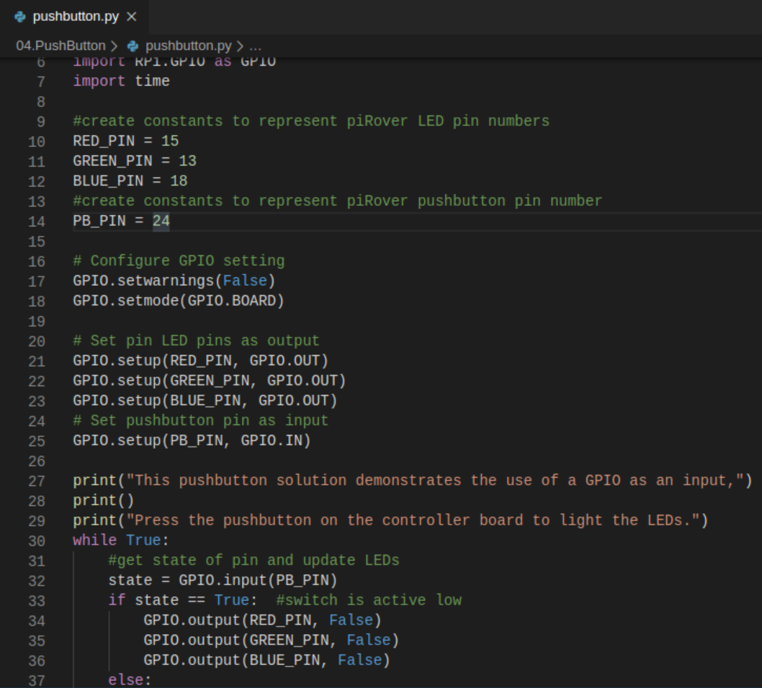
- Run the pushbutton.py code. Does it function?
- Note the new pin definition on line 14 and refer to table 1.
- Inspect line 25. Note that this is the same setup() function used for the LED outputs only the second parameter is changed to GPIO.IN.
- Inspect line 32. Is this similar to the input() function used in user_blink.py? What is the data type for the state variable?
- Inspect lines 33 through 40. What logic level is read by the GPIO.input() function when the switch is depressed?
- Insert a breakpoint on line 32.
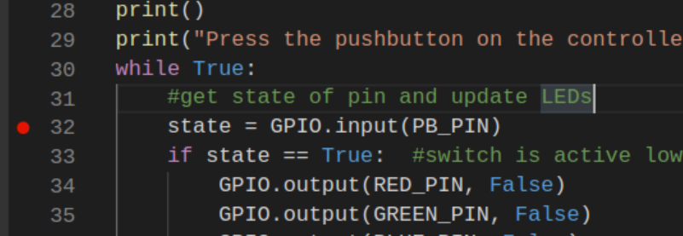
- Run the debugger (F5) and verify the value and data type of the state variable as you single step (F10) the program and press the pushbutton switch.
- Follow along with the instructor as he or she swaps out the code on lines 45 through 54. Do you understand why the switch variable can be eliminated from this revised code?
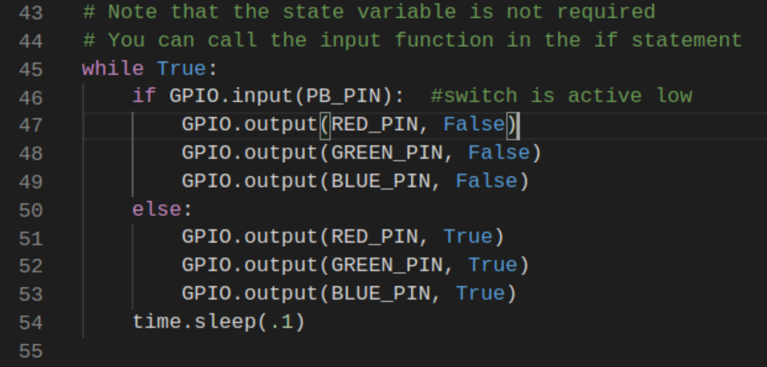
- Follow along with the instructor as she or he swaps out the code for lined 57 through 71. Run the code. Does it function as expected? Explain the behavior.
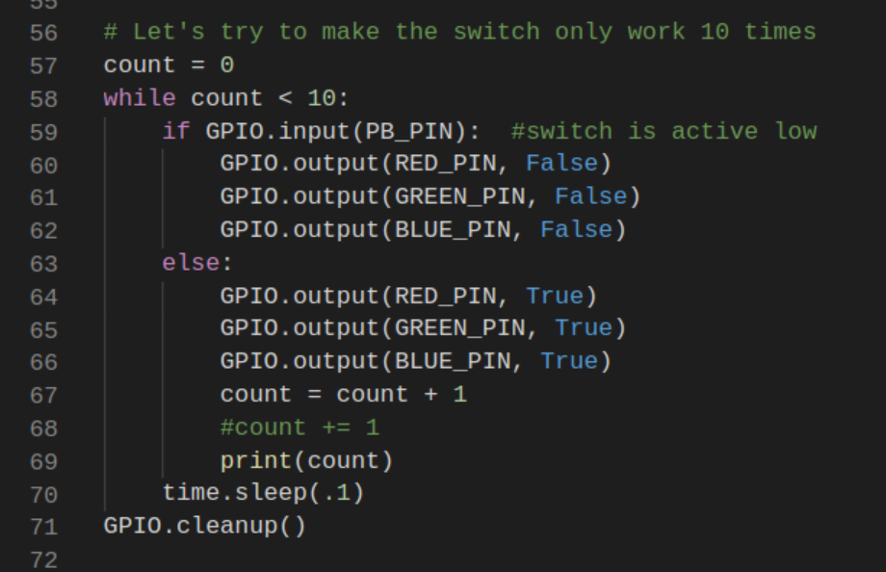
- The instructor will describe the purpose of the GPIO.cleanup() function on line 71. What happens if you make an error and indent line 71 so that it is part of the while loop?

Part 3 – Investigate the software – pushbutton_toggle.py
- Open the pushbutton_toggle.py file. Run the code to understand the function. How does this code differ from the prior pushbutton code as it cycles 10 times?
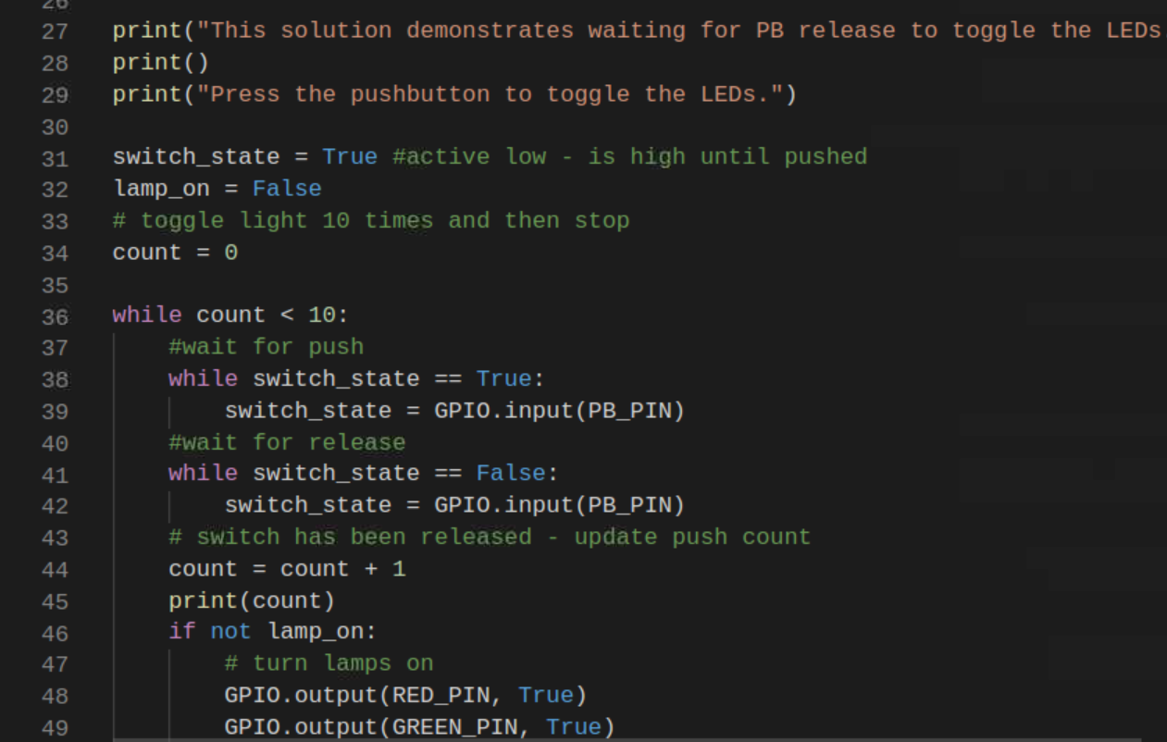
- In general, you should be very cautious about using while loops in your code. They can produce infinite loops that lock up the execution of your code.
- Review the while loops on lines 38 through 42. Can you describe the function of this code? Set a breakpoint at line 38 and test.
- Use your mouse to click on a button or item on any menu in your system How does this code duplicate the function that you experience with your computer mouse?

Part 4 – Investigate the software – pushbutton_cycle.py
- Open the pushbutton_cycle.py file. Run the code to understand the function.
- Note the use of the f-string in the print() function on line 31. Use the debugger to determine the data type of the state variable on line 28. The f-string format allows this non-string data to be easily combined to create a string message.
- Read the comment on line 33. Which lines of code constrain the value of the I variable to 0, 1, 2, and 3?
- Modify the code so that the counter I goes from 0 to 5. Add an else condition at the end of the selection structure (if) starting on line 50 so that white light is on for counts 4 and 5.
- Comment out the code starting at line 33 “### i controls LED cycle”. Replace the code by uncommenting the block of code starting around line 75.
- Run the revised code. How does this code differ from the prior toggle code?
- The wait for push and release code is at the bottom of this loop. Does this change the behavior of the code?
- Examine the push and release code in this loop and compare it to the earlier code. What changes have been made? What does the “pass” statement due? Can this line just be eliminated? Try commenting the “pass” statement out and run the code. What error occurs and why?

- Once you completed the investigating the three solutions, copy your 04.PushButton folder up to your cloud service as a backup (OneDrive, Google Drive, or DropBox)

Assessment:
Download the PushButtonActivity.docx file from the Moodle section. Complete this document by entering your responses in the spaces provided. Submit your completed activity document as either a .docx or a .pdf file to Moodle along with any other files in this week’s zip file.

