Line Follower Prep Activity Rev 1.1

Directions:
The activity is a preparation for later coding activities that use the piRover line follower sensor as an input to control the piRover Drive. In this activity you will identify the line follower inputs and associate specific drive and LED actions to specific line follower input signals. Later coding assignments will use this information to create selection structures that implement this line follower behavior. This activity requires no Python coding.
The line follower inputs are labeled as follows. Review the images below to be sure that you can identify each sensor and its physical position in the tracking module.
LF_L2 – Far left sensor
LF_L1 – Near left sensor
LF_R1 – Near right sensor
LF_R2 – Far right sensor

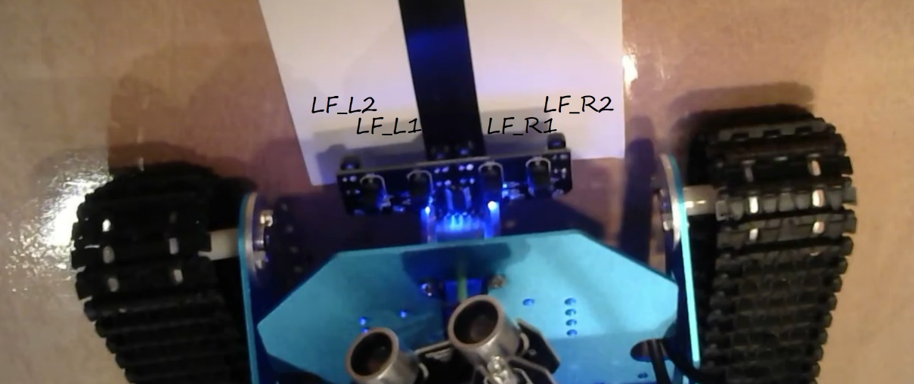

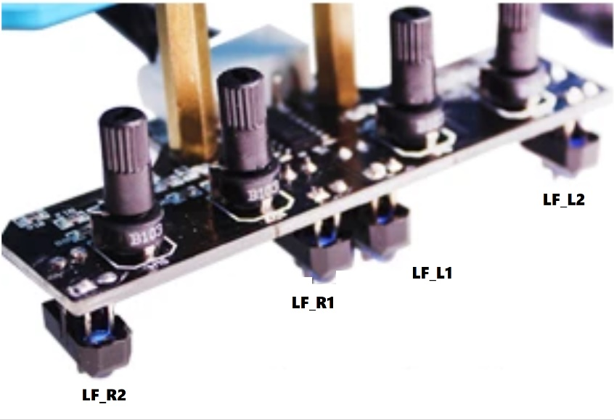
Next, review the K2 Line Follower Video to determine the basic line following function. As you do, consider the following output states that you will implement for the drive – STOP, GO, RIGHT, LEFT, HARD_RIGHT, HARD_LEFT. You will also code the LED module on the top of the piRover to indicate drive state with Red and Green for stop and go, Blue for soft turns, and Yellow for hard turns.
The table on the following page uses a binary progression to indicate all possible states for line follower sensors. Line follower sensors are active low inputs just as the Start Switch was in your push button code. A zero value indicates an “on” condition. An “on” condition indicates that the line (tape) is under the sensor and small LED just above the sensor lights (assuming the sensitivity is adjusted correctly – see video).
Complete the function table indicating the correct drive and LED states for each signal combination. If the line is not “seen” by any of the sensors, the piRover should stop and the LED module updated to show Red. If a specific combination is not possible or indicates something more complex than a soft or hard turn, enter N/A in both the Drive and LED columns. (Note: there are a significant number of unused/not-possible combinations)
You must include the following use cases in your table.
- The piRover is centered on the line and moving forward
- The piRover is totally lost the line. The piRover must stop
- The piRover veers slightly to the left and a corrective action is required to follow a straight line.
- The piRover veers slightly to the right and a corrective action is required to follow a straight line.
- The line takes a slight turn to the left and a corrective action is required.
- The line takes a slight turn to the right and a corrective action is required.
- The line takes a significant bend to the left and a corrective action is required.
- The line takes a significant bend to the right and a corrective action is required.

INPUTS |  |  |  | OUTPUTS
LF_L2 | LF_L1 | LF_R1 | LF_R2 | DRIVE STATE  (Stop, Go, etc) | LED COLOR | Explanation/Reason  (this section expands)
0 | 0 | 0 | 0
0 | 0 | 0 | 1
0 | 0 | 1 | 0
0 | 0 | 1 | 1
0 | 1 | 0 | 0
0 | 1 | 0 | 1
0 | 1 | 1 | 0
0 | 1 | 1 | 1
1 | 0 | 0 | 0
1 | 0 | 0 | 1
1 | 0 | 1 | 0
1 | 0 | 1 | 1
1 | 1 | 0 | 0
1 | 1 | 0 | 1
1 | 1 | 1 | 0
1 | 1 | 1 | 1

Use prior lessons and links to review the piRover controller board hardware. Determine which GPIO pins are connect to the line follower sensors. Record your findings below. See prior lessons for examples.

Sensors | Yahboom ID | Pin | GPIO
LF_L2 | IN2
LF_L1 | IN1
LF_R1 | IN3
LF_R2 | IN4

Assessment:
This assignment is difficult by design. It is an NMC Critical Thinking assessment. Course grading will be based on completion and effort. Do your best work and do not get assistance from others. We will review all in class after this submission to NMC. Submit as directed.

