# IP Configure and Connect Rev 1.0

## Overview:

## With the piRover.

## Resources:

1. [Bonjour Print Services for Windows](https://support.apple.com/kb/DL999?locale=en_US)
2. [VNC Viewer](https://www.realvnc.com/en/connect/download/viewer/)

## Overview:

In this activity, you will connect to your Raspberry Pi and complete configuration steps so that you will have exclusive access to your piRover. These steps are critical if you are in a classroom environment where there are multiple Yahboom G1 Tank robots being used at the same time. You want to be sure that you’re working with your device and not your neighbors!

Your goal is to give your device a unique name and a unique IP address for your Wi-Fi access point. With this configuration, you’ll be able to connect to your piRover from a remote device and connect to the Internet as well.

Option 1 – Classroom environment with multiple piRover devices.

1. This option assumes that there are multiple piRover in the room and connecting to the Yahboom_Tank server is not possible because each device in the room is broadcasting the same service. Rather than use Wi-Fi to connect, you will use the Ethernet cable provided in your kit to create a wired connection.
2. You will create a peer-to-peer wired connection between your workstation and the piRover. If you are on a Windows workstation, you will need to download and install Apple’s Bonjour Print Services from the link below. This step is not required if you are on a Mac – the service is already available.

[Bonjour Print Services for Windows](https://support.apple.com/kb/DL999?locale=en_US)

1. If you are on a Windows workstation, complete the installation of the Bonjour Print Services. If you are working in a classroom or school lab, this installation is likely completed for you. Check if the service is installed by typing bonjour into the Windows Search on your taskbar. If it is installed, the Print Wizard application will be displayed as shown below.

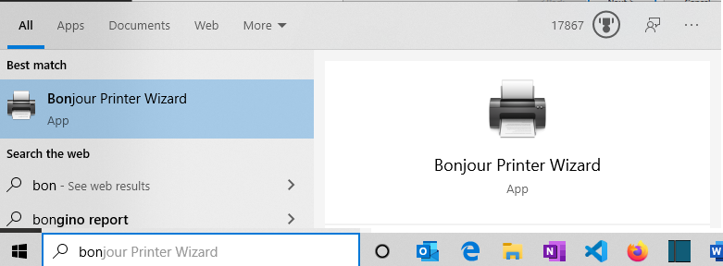

1. If the service is not installed, follow the link provided in step 2 to complete the download and installation. Again, this installation is not required if you are on a Mac workstation. You can uncheck the shortcut and update options on the last screen of the installer.

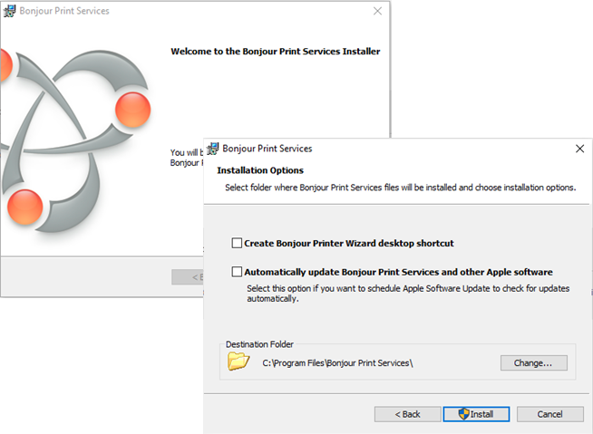

1. Connect the Ethernet cable between your workstation and the Raspberry Pi. Restart the Raspberry Pi by cycling the power. A peer to peer network is created due to the Bonjour discovery service.

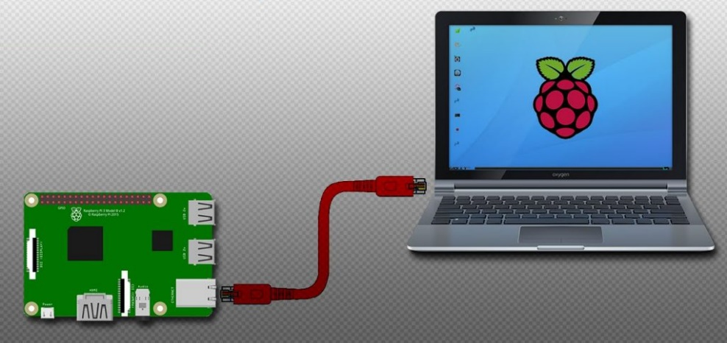

1. Download and install VNC Viewer. This application enables you to connect to the Raspberry Pi remotely providing you with a virtual desktop of the Raspberry Pi’s Raspian operating system. Again, if you are working in a classroom or school lab, this installation is likely completed for you. Type VNC into the Search to check.

[VNC Viewer](https://www.realvnc.com/en/connect/download/viewer/)

1. Launch VNC Viewer and connect to your device using the name shown below. The “.local is added due to the peer to peer connection being used. With a normal Ethernet or Wi-Fi connection you will use just “yahboomtank”, dropping the “.local” at the end.

**yahboomtank.local**

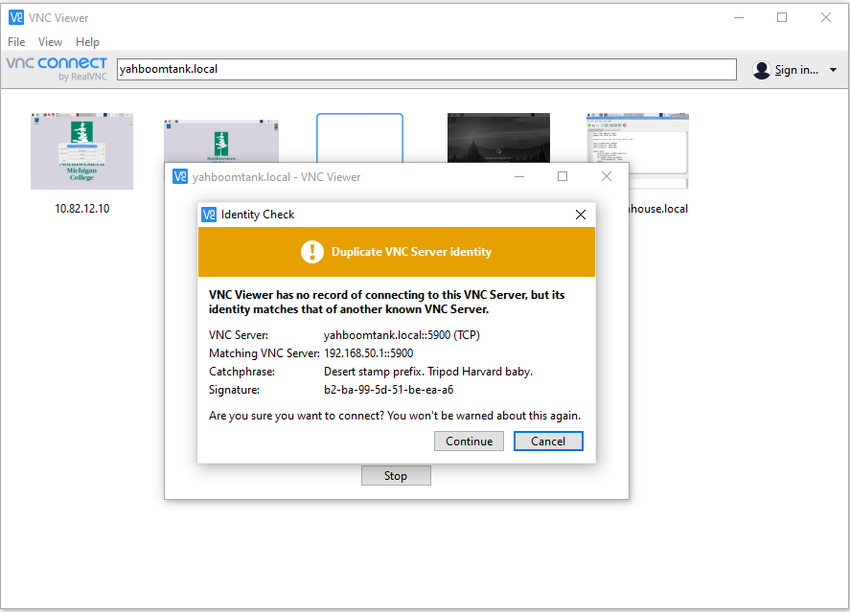

1. Ignore the initial message on duplicate identity. Enter the username **pi** and the default password **yahboom** as shown below.

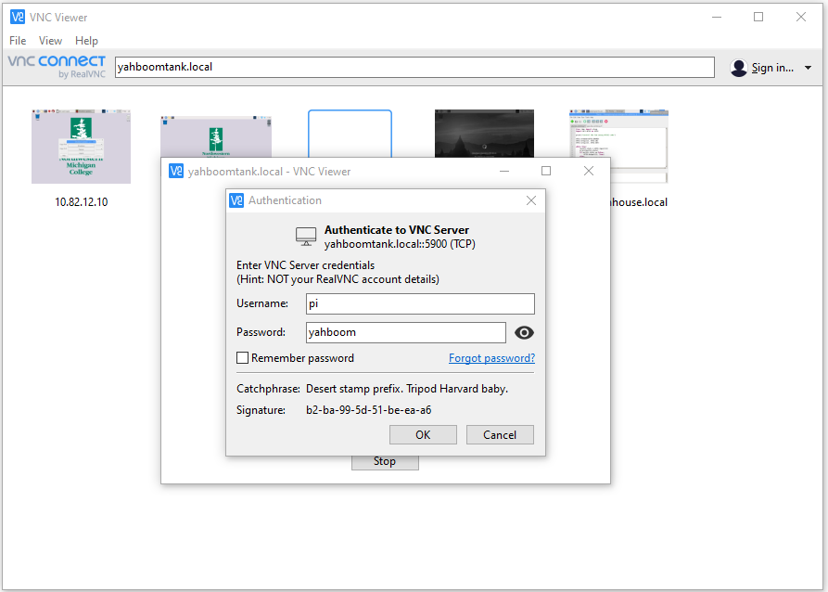

1. The remote viewer is launched with the virtual desktop showing the Raspberry Pi’s Raspian interface.



1. This wired connect Download A wired connect is requiredthere are multiple services being broadcast by the Install VNC Viewer
2. Boot rover and connect to piRover Wi-Fi access point.
3. 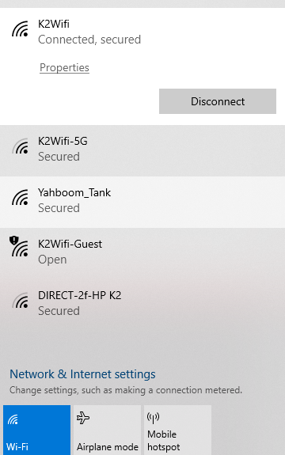
4. 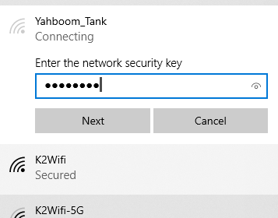

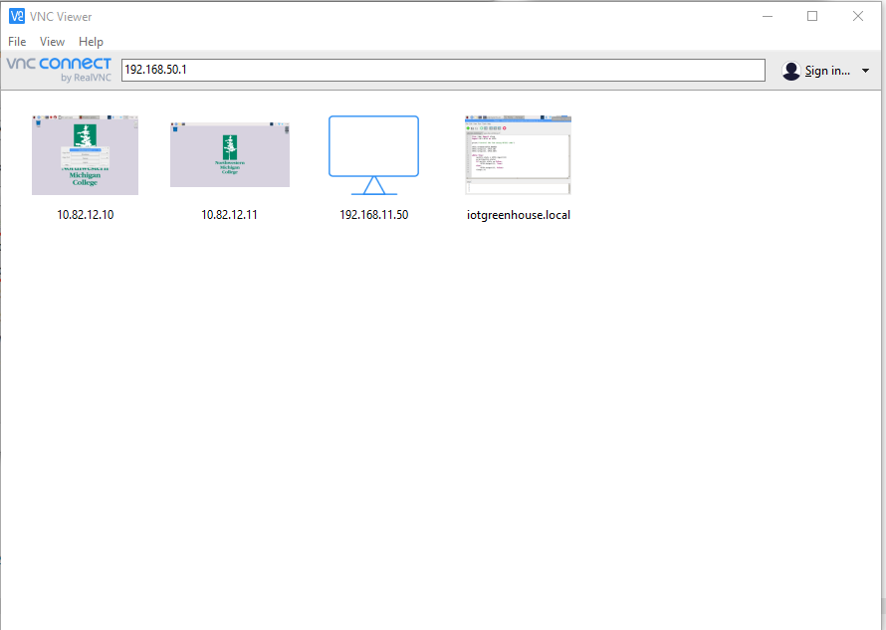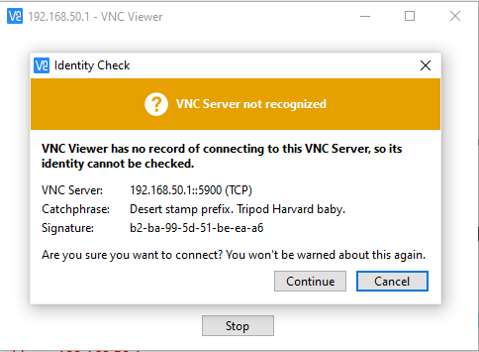

1. 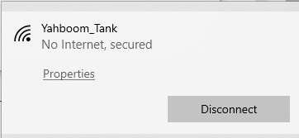
2. 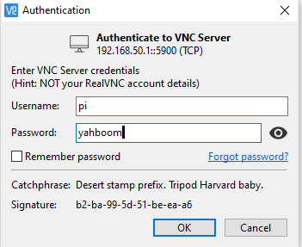
   1. Connect with VNC Viewer
   2. User name: pi
   3. Password: yahboom
   4. Port: 22
   5. IP address: 192.168.50.1
3. Issues with other users
4. Determine a st

|  |
| --- |
|  |

Submit your completed assignment to the Moodle site. The class will reconvene and discuss responses.