# Line Follower Prep Activity Rev 1.2

## Directions:

The activity is a preparation for later coding activities that use the piRover line follower sensor as an input to control the piRover Drive. In this activity you will identify the line follower inputs and associate specific drive and LED actions to specific line follower input signals. Later coding assignments will use this information to create selection structures that implement this line follower behavior. This activity requires no Python coding.

The line follower inputs are labeled as follows. Review the images below to be sure that you can identify each sensor and its physical position in the tracking module.

**LF_L2 – Far left sensor**

**LF_L1 – Near left sensor**

**LF_R1 – Near right sensor**

**LF_R2 – Far right sensor**

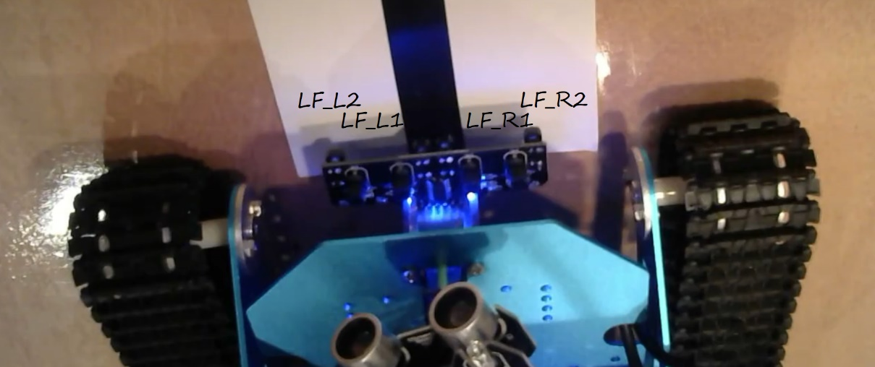

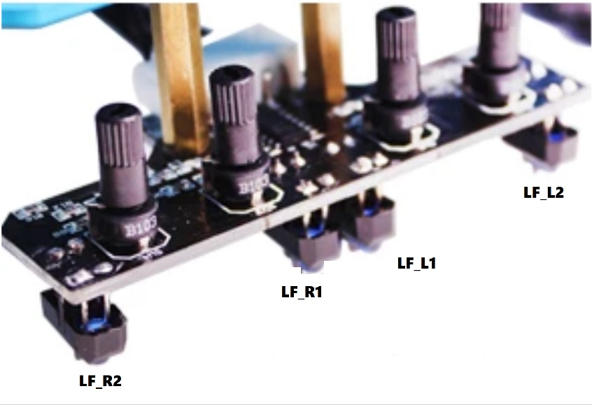

Next, review the [K2 Line Follower Video](https://www.youtube.com/watch?v=k2n6r7ibBpA&list=PLMdErdlfK4GY1BXI7GbWIMjTCYjoVWa1S&index=11) to determine the basic line following function. As you do, consider the following output states that you will implement for the drive – **STOP, GO, RIGHT, LEFT, HARD_RIGHT, HARD_LEFT**. You will also code the LED module on the top of the piRover to indicate drive state with **Red** and **Green** for stop and go, **Blue** for soft turns, and **Yellow** for hard turns.

The table on the following page uses a binary progression to indicate all possible states for line follower sensors. **Line follower sensors are active low inputs** just as the Start Switch was in your push button code. A zero value indicates an “on” condition. An “on” condition indicates that the line (tape) is under the sensor and small LED just above the sensor lights (assuming the sensitivity is adjusted correctly – see video).

Complete the function table indicating the correct drive and LED states for each signal combination. If the line is not “seen” by any of the sensors, the piRover should stop and the LED module updated to show Red. If a specific combination is not possible or indicates something more complex than a soft or hard turn, enter **N/A** in both the Drive and LED columns. Enter a complete sentence or sentences in the Explanation/Reason column that describes why you selected the Drive State and LED Color for that input combination.

You must include the following use cases in your table.

* The piRover is centered on the line and moving forward.
* The piRover has totally lost the line. The piRover must stop.
* The piRover veers slightly to the left and corrective action is required to follow a straight line.
* The piRover veers slightly to the right and corrective action is required to follow a straight line.
* The line takes a slight turn to the left and corrective action is required.
* The line takes a slight turn to the right and corrective action is required.
* The line takes a significant bend to the left and corrective action is required.
* The line takes a significant bend to the right and corrective action is required.

|  |  |  |  |  |  |
| --- | --- | --- | --- | --- | --- |
| **INPUTS** | | | | **OUTPUTS** | |
| **LF_L2** | **LF_L1** | **LF_R1** | **LF_R2** | **DRIVE STATE**  **(Stop, Go, etc.)** | **LED COLOR** | **Explanation/Reason**  **(this section expands)** |
| 0 | 0 | 0 | 0 |  |  |  |
| 0 | 0 | 0 | 1 |  |  |  |
| 0 | 0 | 1 | 0 |  |  |  |
| 0 | 0 | 1 | 1 |  |  |  |
| 0 | 1 | 0 | 0 |  |  |  |
| 0 | 1 | 0 | 1 |  |  |  |
| 0 | 1 | 1 | 0 |  |  |  |
| 0 | 1 | 1 | 1 |  |  |  |
| 1 | 0 | 0 | 0 |  |  |  |
| 1 | 0 | 0 | 1 |  |  |  |
| 1 | 0 | 1 | 0 |  |  |  |
| 1 | 0 | 1 | 1 |  |  |  |
| 1 | 1 | 0 | 0 |  |  |  |
| 1 | 1 | 0 | 1 |  |  |  |
| 1 | 1 | 1 | 0 |  |  |  |
| 1 | 1 | 1 | 1 |  |  |  |

Use prior lessons and links to review the piRover controller board hardware. Determine which GPIO pins are connected to the line follower sensors. Record your findings below. See prior lessons for examples.

|  |  |  |  |
| --- | --- | --- | --- |
| **Sensors** | **Yahboom ID** | **Pin** | **GPIO** |
| **LF_L2** | IN2 |  |  |
| **LF_L1** | IN1 |  |  |
| **LF_R1** | IN3 |  |  |
| **LF_R2** | IN4 |  |  |

## Assessment:

This assignment is difficult by design. It is an NMC Critical Thinking assessment. Course grading will be based on completion and effort. Do your best work and do not get assistance from others. We will review all in class after this submission to NMC. Submit as directed.