Power Sources - Introduction Rev 1.0

Overview:
In this virtual lab, the instructor will lead you through theory and analysis of power supplies. You review basics of voltage sources and then use the piRover power supply as a real-life example. You measure terminal voltage and load characteristics to determine the internal resistance of the source, enabling you to evaluate quality of the source.

Prerequisites:
Prior to beginning the instruction provided in this lesson you must have completed the following:
- piRover build and test

Performance Outcomes:
- Recognize current limitation of voltage sources
- Visualize a real voltage source as an ideal voltage source with an internal resistance, Rs.
- Determine Rs by measure terminal voltage and load voltage and current.
- Evaluate battery quality by comparing internal resistance values

Resources:
- Electronics: Internal Resistance of a Voltage Source
- Comparison between internal resistance and capacity test

Materials:
- piRover with fully charged battery
- RAM155 Digital Multimeter
- RAM205 Parts Kit

Directions:
- The instructor will review basic electronics and Ohm’s Law.
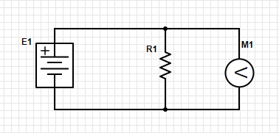
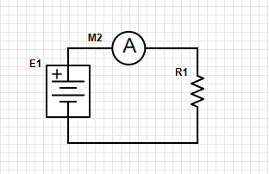
- Student will identify the ideal internal resistance of the voltmeter and the ammeter.
- The class will discuss the effects of the load on the voltage source increasing. What is the relationship of resistance and load? What happens to current in the circuit as the load on the circuit is increased? Is there a limit?
- The instructor will present the concept of a real voltage source consisting of an ideal voltage source and internal series resistance Rs.
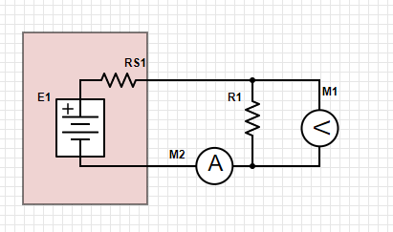
- Student will calculate the value of Rs given the following.
  - Terminal voltage = 12.5 V
  - Load voltage = 12 V
  - Load current = 10mA
- Follow along with the instructor as the test leads are connected to the piRover to measure voltage and current characteristics. Record your findings below and capture images of your measurements.
  - Terminal voltage = ______
  - Load voltage = ________
  - Load current = _______
- Calculate Rs for your battery and report out to the class.
  - Calculated Rs = _______
- Based on results reported out by your classmates, can you make a statement concerning the quality of your battery?
- Repeat the same process for the wall mount power supply. How do these values compare?
- Research the battery included in your kit. Based on the load created by the piRover, how long would you expect to operate the piRover with a fully charged battery?
- Discuss with the class how you would test battery capacity? Could this be automated using Python code?

Assessment:
Follow along with the instructor as the activity/test is documented. Include purpose, procedure, images, data, and summary. Save as .docx or .pdf
Submit with other required files in your weekly submission at the bottom of this week’s Moodle section.

