Digital Outputs – Driving High Current Loads Rev 1.1

piRover warner worksheet:
- The instructor will review the required hardware connections using the Digital Outputs – Driving High Current Loads document and the following images.
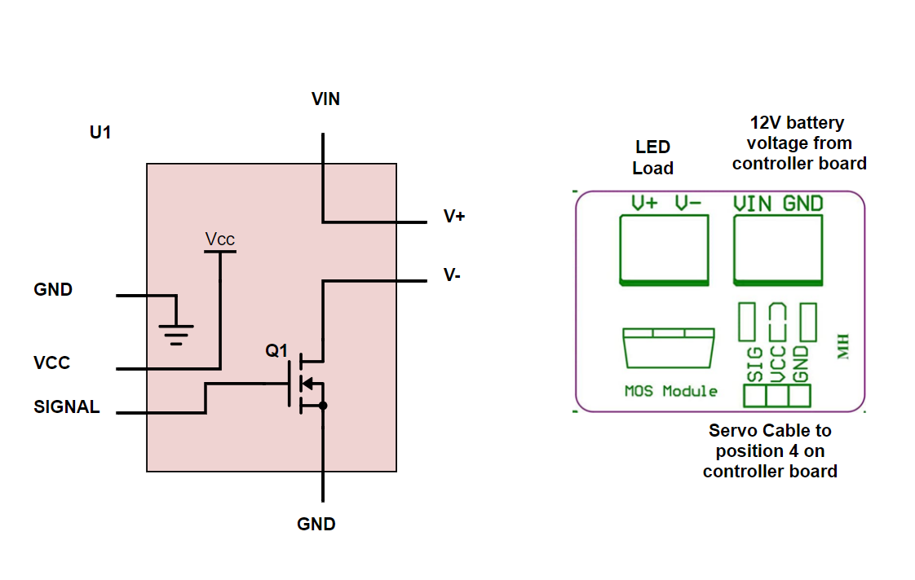
- Run your blink code from the initial Digital Outputs – Introduction lesson. You are using the same servo port as in the initial blink example, so your code should execute and blink the amber LED.
- Create a short video and submit with this week’s assignments.
- Adjust the blink code so that the amber LED is off. Use your DVM to record the voltages specified in the table on the next page.
- Follow along with the instructor to produce the following solution files.
  - warning1.py
  - warning2.py
  - warning3.py
  - warning4.py
  - piRover_warner.py
- Work with a partner to insert comments lines above each line of code produced. This is an in-class activity. The instructor will provide more detailed instruction.
- Submit your revised code files from item 5 on the prior page with the zip file required for this week.
- Record voltage on the MOSFET driver for both on and off conditions
Table 1
MOSFET Voltages | OFF | On
VIN
V+
V+ to V-
Vsignal
Vcc

Assessment:
Submit a short video showing blink operation. Submit this file with voltage levels inserted into Table 1 above. Submit code files as directed. Coding will continue in the next session.

