Digital Inputs – signal conditioning worksheet Rev 1.0
Name: __
Follow along with the instructor’s presentation and complete the following.

Resources:
- Protecting Inputs in Digital Electronics | DigiKey
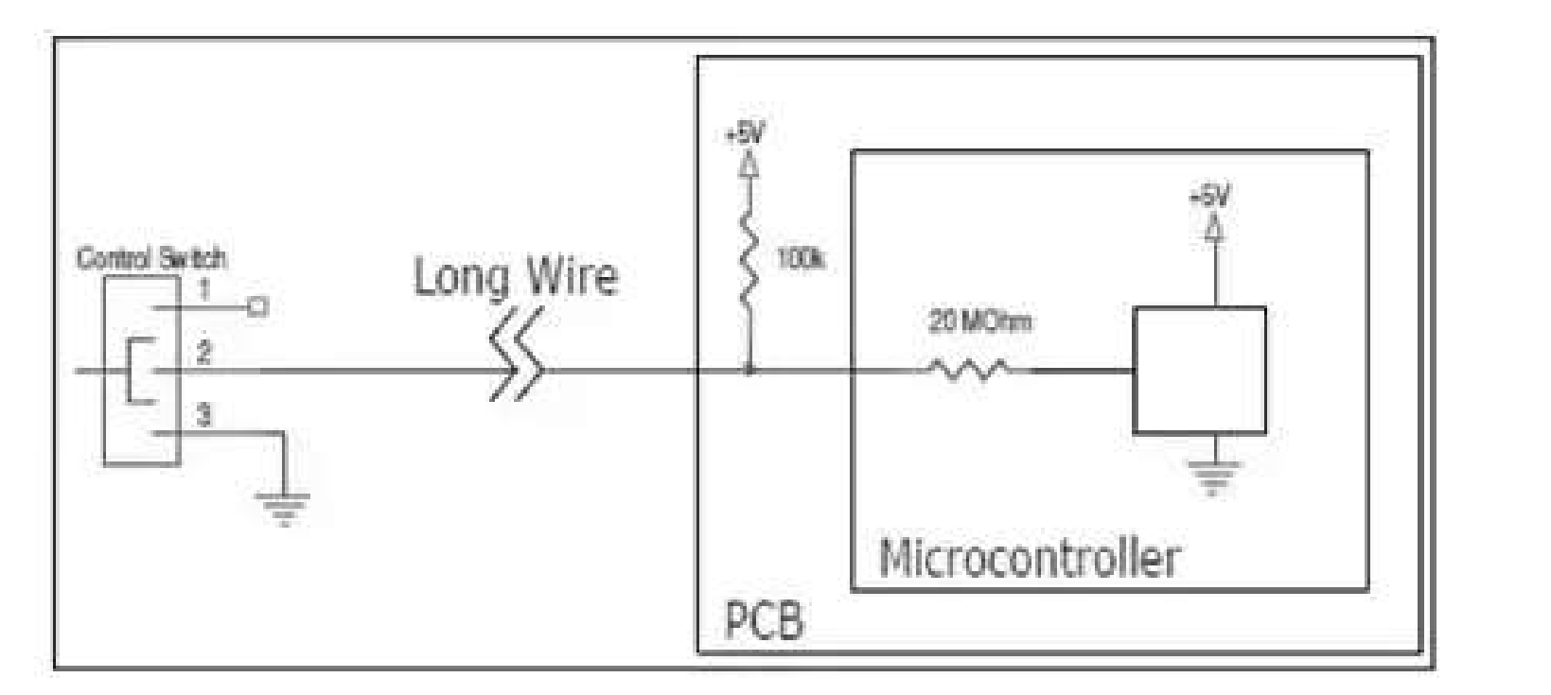
Figure 1
- Review the control system diagram copied above from the Digi-key resource
S1 Control | Vin at Controller | Current in “Long Wire”
Open
Closed

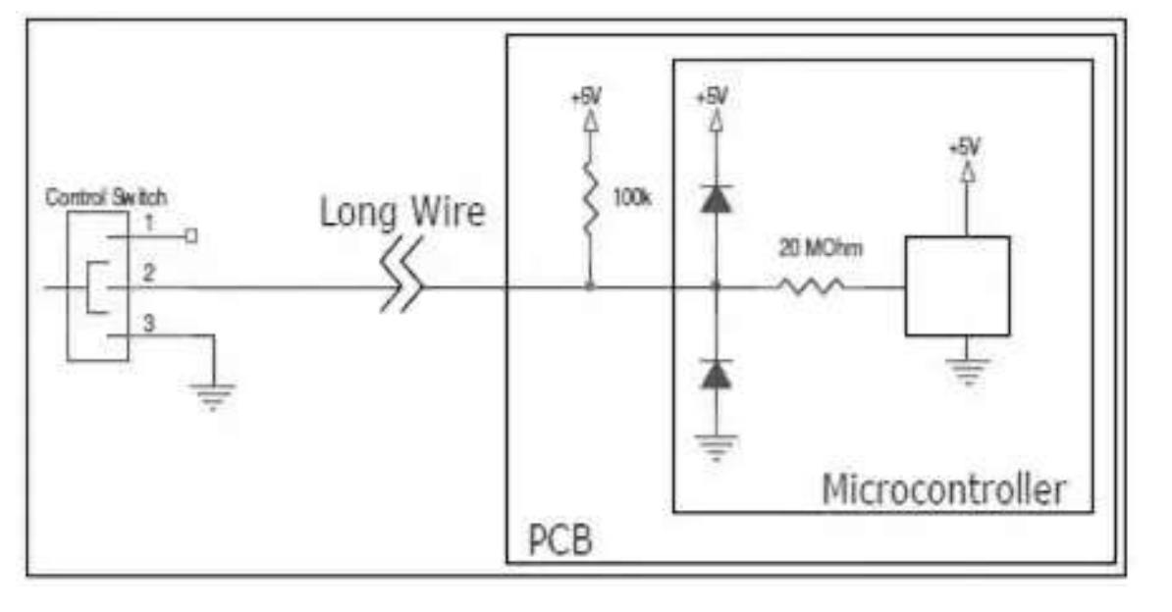
D1

D2
Figure 2
- Clipper diodes are added in Figure 2
A large positive voltage (>6V) is induced on the signal wire. Which component will likely fail? Why?

A negative voltage (< -1V) is induced on the signal wire. Which component will likely fail? Why?

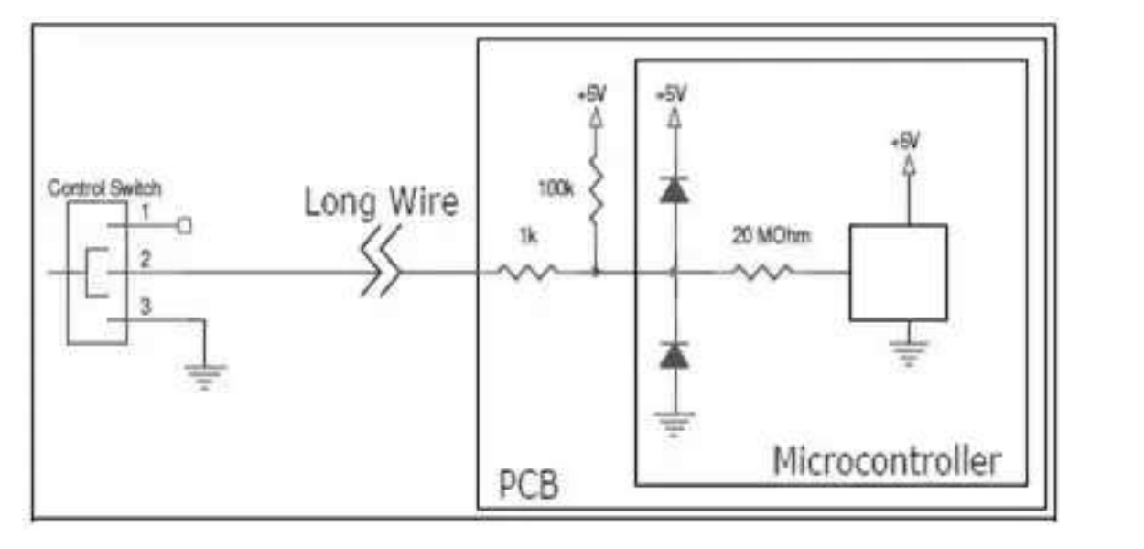
D1

Rs
D2
- A series current limiting resistor Rs is added.
What is the input voltage to the controller with the switch open? Is this a valid logic level?
What is the input voltage to the controller with the switch open? Is this a valid logic level?
A 6-volt signal is induced on the wire due to noise. Which components are conducting current? How much current is flowing through the Rs resistor?
A negative 1-volt signal is induced on the wire due to noise. Which components are conducting current? How much current is flowing through the 1K resistor?

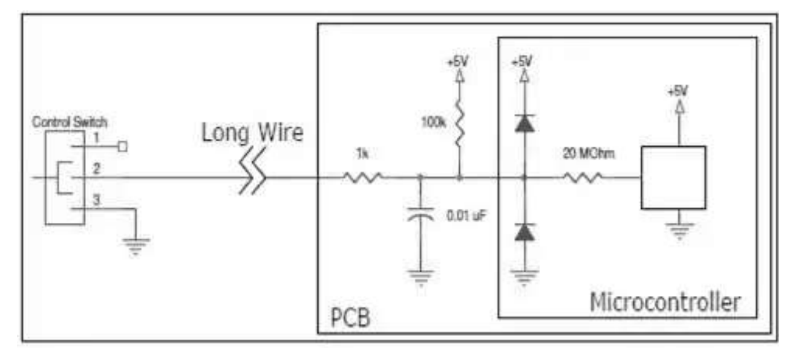
Figure 3
- A low-pass filter is added.
A 1-volt peak to peak, 1KHz noise signal is induced onto the long wire. What is the impedance of the .01uF capacitor?
How much AC noise is seen at the input of the microcontroller? Explain.
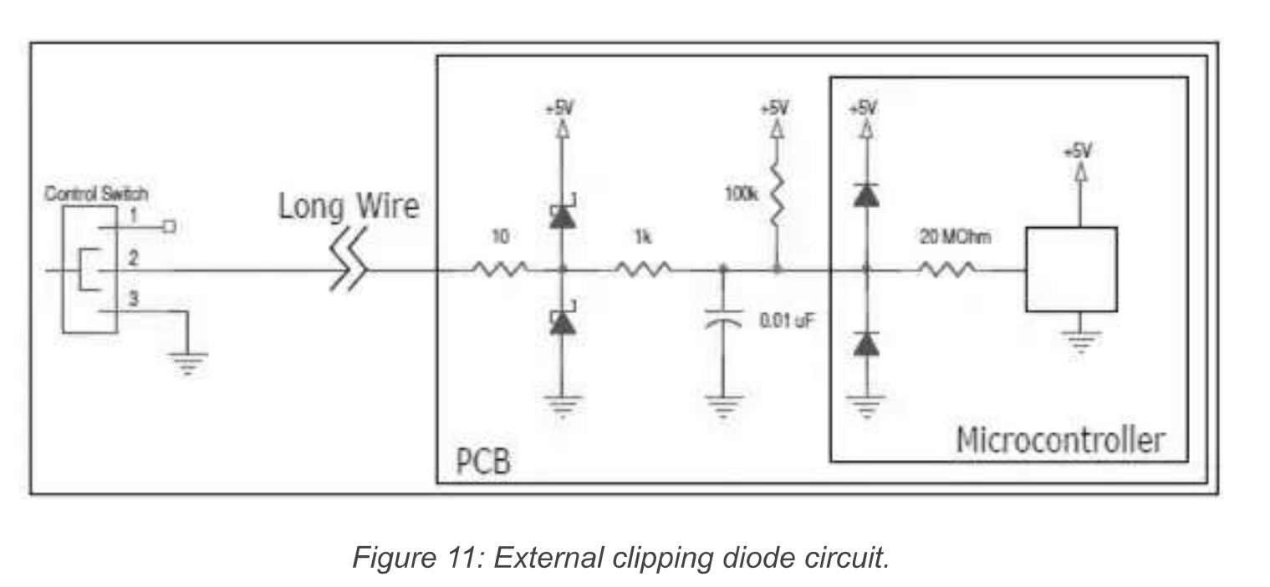
Figure 4
- External Schottky diodes are added.
Research Schottky diodes. What is the typical forward voltage drop?
What is the maximum voltage applied to the microcontroller with these external clippers inserted? Explain.
What is the minimum voltage applied to the microcontroller with these external clippers inserted? Explain.

