Digital Outputs – Driving High Current Loads Rev 1.0

piRover warner worksheet:
- The instructor will review the required hardware connections using the Digital Outputs – Driving High Current Loads document and the following images.
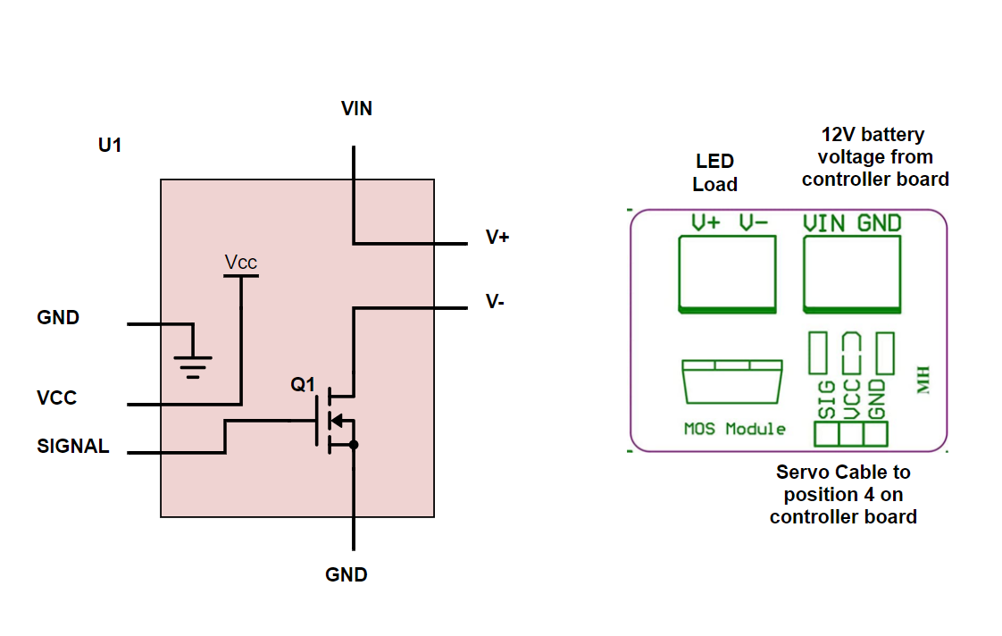
- Run your blink code from the initial Digital Outputs – Introduction lesson. You are using the same servo port as in the initial blink example, so your code should execute and blink the amber LED.
- Demonstrate the blink function to the instructor for a lab check. If you do not get an in-class lab check then you must submit a blink video with this week’s assignments.
- Adjust the blink code so that the amber LED is off. Use your DVM to record the voltages specified in the table on the next page.
- Follow along with the instructor to produce the following solution files.
  - warning1.py
  - warning2.py
  - warning3.py
  - warning4.py
  - piRover_warner.py
- Work with a partner to insert comments lines above each line of code produced. This is an in-class activity. The instructor will provide more detailed instruction.
- Submit your revised code files from item 5 on the prior page with the zip file required for this week.
- Record voltage on the MOSFET driver for both on and off conditions
Table 1
MOSFET Voltages | OFF | On
VIN
V+
V+ to V-
Vsignal
Vcc

Assessment:
Demonstrate your warning system to the instructor during the next class period. Note that you will need a camera to demonstrate. If you cannot demonstrate during class, then submit a short video showing blink operation.
Submit this file with voltage levels in inserted into Table 1 above.
Submit code files as directed

