# Power Sources - Introduction Rev 1.1

## Overview:

In this virtual lab, the instructor will lead you through theory and analysis of power supplies. You review basics of voltage sources and then use two AA batteries as a real-life example. You will measure terminal voltage and load characteristics to determine the internal resistance of the source, enabling you to evaluate the quality of the source.

## Prerequisites:

Prior to beginning the instruction provided in this lesson you must have completed the following:

1. piRover build and test

## Performance Outcomes:

1. Recognize current limitation of voltage sources.
2. Visualize a real voltage source as an ideal voltage source with an internal resistance, Rs.
3. Determine Rs by measuring terminal voltage and load voltage and current.
4. Evaluate battery quality by comparing internal resistance values.

## Resources:

1. [Electronics: Internal Resistance of a Voltage Source](https://k2controls.github.io/piRover02/sprint1/week02/intresbeam.pdf)
2. [Comparison between internal resistance and capacity test](https://k2controls.github.io/piRover02/sprint1/week02/internalRvsCapacityTest.pdf)
3. [UNI-T Digital Multimeter User Manual](https://k2controls.github.io/piRover02/sprint1/week02/UNI-T_documentation.pdf)

## Materials:

1. AA batteries provided by in kit (X2)
2. Wire strippers
3. Jumper wires
4. RAM155 Digital Multimeter

### **Directions:**

1. The instructor will review basic electronics and Ohm’s Law.

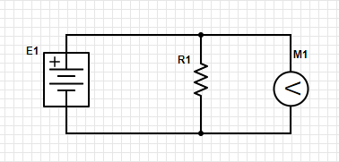

Figure

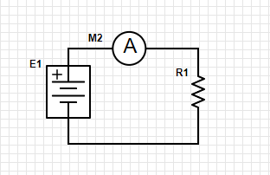

Figure

1. Students will identify the ideal internal resistance of the voltmeter and the ammeter.
2. The class will discuss the effects of the load on the voltage source increasing. What is the relationship between resistance and load? What happens to current in the circuit as the load on the circuit is increased? Is there a limit?
3. The instructor will present the concept of a real voltage source consisting of an ideal voltage source and internal series resistance Rs.

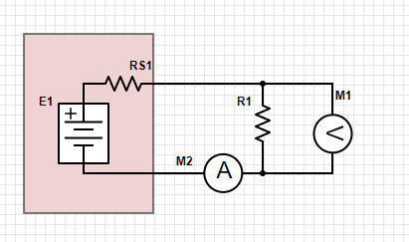

Figure

1. Follow along with the instructor and connect the multimeter as a voltmeter across the AA batteries from your parts kit. Record your voltage readings below.
   1. Battery 1
      1. Terminal voltage ___
   2. Battery 2
      1. Terminal voltage ___
2. Use the Multimeter’s User Manual provided in the resource section to determine the input impedance of the voltmeter.
   1. Meter input impedance _____
3. Review the “real” circuit of Figure 3. Assume R1 represents the input impedance of the meter and assume RS1 is zero. Calculate how much current is pulled from the AA battery when the terminal voltage is measured.
   1. Battery current with meter as load ___
4. Based on your voltage measurements are the AA batteries “good” or “bad”?
   1. Battery Number ___ Good or Bad
   2. Battery Number ___ Good or Bad
5. Review the battery measurement section of the user manual. See page 17.
6. What is the input resistance/impedance when the battery measurement setting is used?
   1. Meter resistance with Battery Test mode ___
7. Based on this test, are the batteries good or bad?
   1. Battery Number 1 state? ____
   2. Battery Number 2 state? ____
8. Review figure 3 again.
   1. Assume E1 is the ideal voltage of the battery and is equal to the open circuit voltage that you measured in step 5.
   2. V is the reading shown on the meter when the Battery Test mode is used
   3. R1 represents the resistance of the meter when Battery Test mode is used. See step 10.
   4. Using the above information, calculate the value of Rs for each battery.
   5. Battery Number 1
      1. Load current ___
      2. VTERMINAL - VLOAD ______
      3. Rs ______
   6. Battery Number 2
      1. Load current ___
      2. VTERMINAL - VLOAD ______
      3. Rs ______
9. In the space provided below, enter your observations concerning the value of Rs and the quality of the battery. As a battery is “used” what is the impact to the internal resistance Rs of the battery?

|  |
| --- |
|  |

## Assessment:

Follow along with the instructor as the activity/test is documented. Include required data and observation in this document and submit.