# Digital Outputs - Introduction Rev 1.2

## Overview:

In this virtual lab, the instructor will review lessons from the prior power sources activity. You’ll then connect a simple LED circuit to an output port on the piRover controller board and consider this as a power source. What is the open circuit terminal voltage? What is the load voltage with the LED circuit energized and how can you determine the load current?

## Prerequisites:

Prior to beginning the instruction provided in this lesson you must have completed the following:

1. Power Sources

## Performance Outcomes:

1. Identify voltage and current limitation of digital outputs.
2. Construct basic LED digital output circuits using both high-side and low-side switching
3. Measure and evaluate digital output voltage, current, and power.

## Resources:

1. [High-side versus low-side switching](http://lednique.com/gpio-tricks/interfacing-with-logic/)
2. [How to Choose Between High-side and Low-side Switching](https://www.elektormagazine.com/news/high-side-low-side-switching)
3. [Raspberry Pi GPIO Electrical Specification](http://www.mosaic-industries.com/embedded-systems/microcontroller-projects/raspberry-pi/gpio-pin-electrical-specifications)

## Materials:

1. piRover with fully charged battery
2. RAM155 Digital Multimeter
3. RAM205 Parts Kit

### **Directions:**

1. The instructor will review the concepts of a real voltage source consisting of an ideal voltage source and internal series resistance Rs. This was the central topic of the prior Power Sources activity.

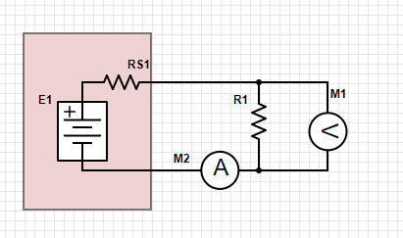

1. In this activity, you will connect LEDs to a digital output on the piRover controller board. The instructor will use the [High-side versus low-side switching](http://lednique.com/gpio-tricks/interfacing-with-logic/) resource to discuss high-side and low-side switching.
2. Specified voltage and current parameters for the ATmega328P shared in the above document will be discussed. The electrical specification for the piRover controller board is not available but values are likely similar to those presented in this reference.
3. Electrical characteristics for the controller above will be compared to estimates provided in the [Raspberry Pi GPIO Electrical Specification](http://www.mosaic-industries.com/embedded-systems/microcontroller-projects/raspberry-pi/gpio-pin-electrical-specifications)
4. Locate the short male to female servo extension cable in your RAM205 parts kit. Also locate two LEDs and two 330-ohm resistors. An image of the required parts is shown below.

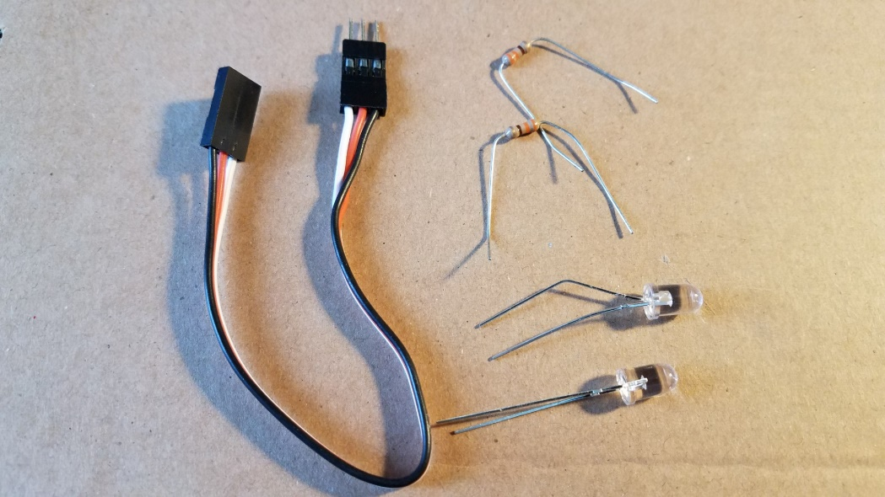

1. Connect the servo extension cable to the fourth position on the servo header located on the piRover controller board. Use your needle nose pliers to assist with inserting the servo cable connector onto the controller board header.

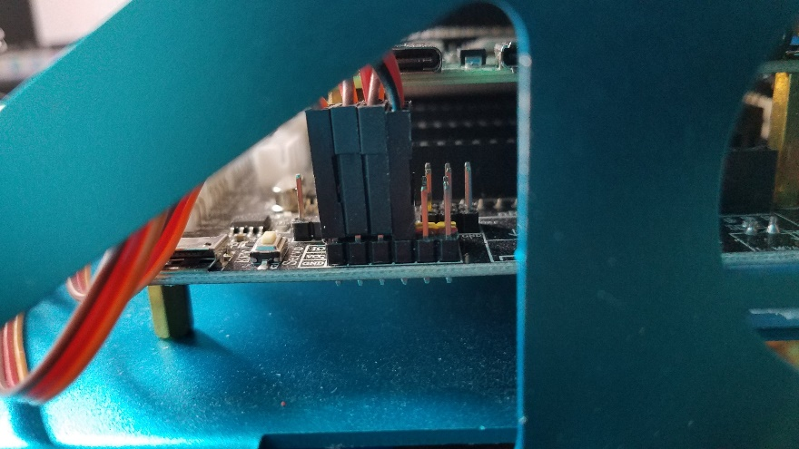

1. Attach the 400-point breadboard to your piRover in the position shown below using the adhesive backing. Insert the three pins of the servo cable extension into the breadboard.

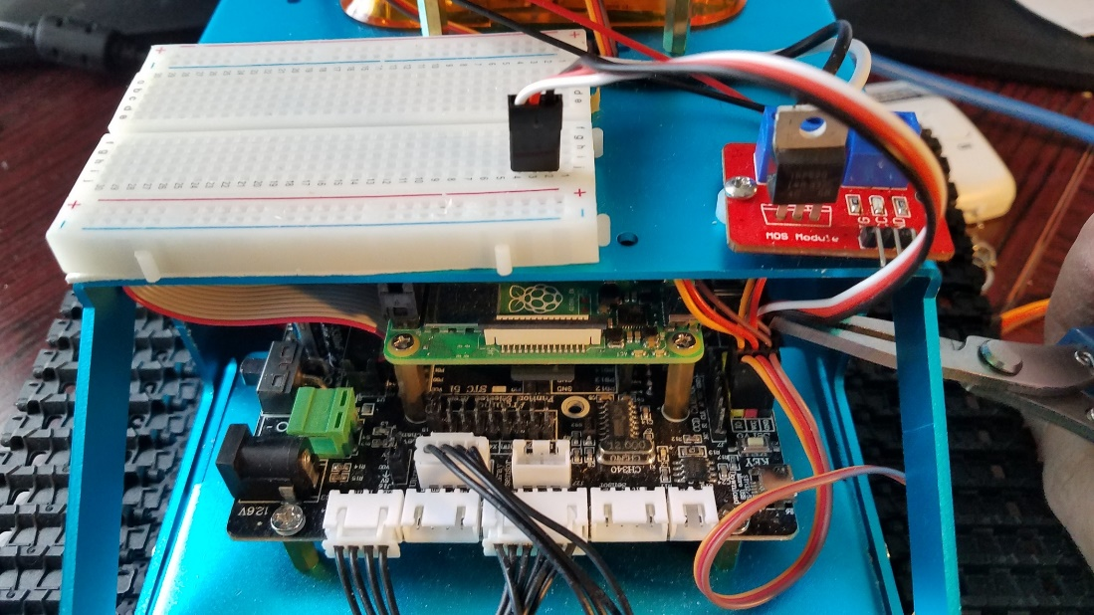

1. Connect the LED using a high-side configuration as shown in the LEDnique reference.

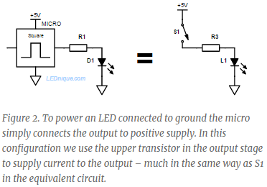

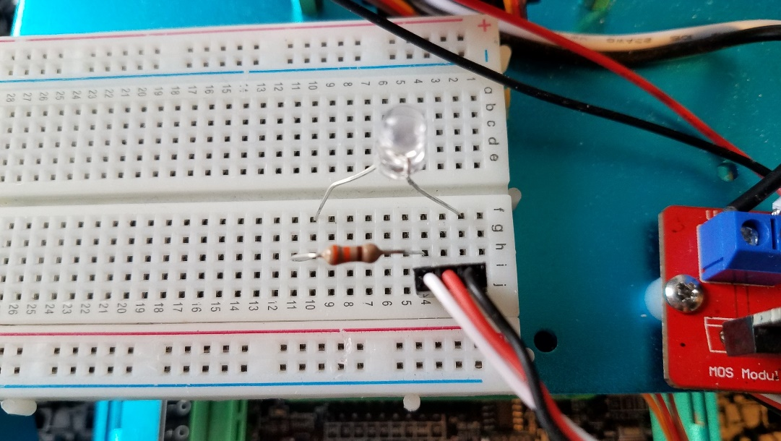

1. Locate the expansion board manual or GPIO documentation for the controller board. What GPOI pin will be configured as an output to control the LED?
2. Boot the piRover. Open your connection and launch VS Code.
3. Create a week04 folder and copy the blink.py code from week03 to week04.

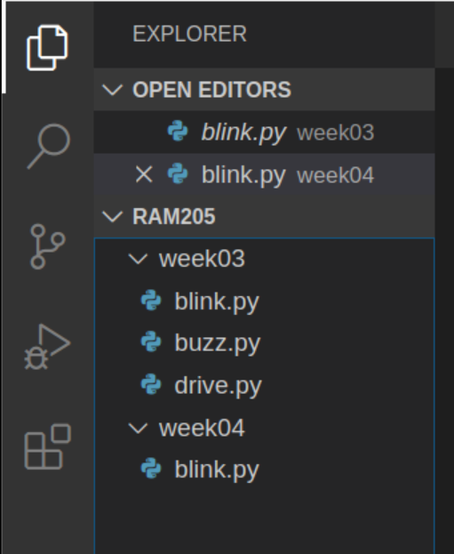

1. Rename the file in week04 to digital_out1.py

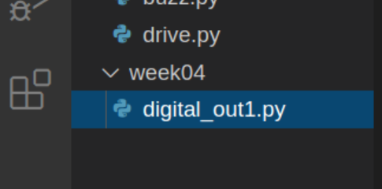

1. Modify the code as required including the docstring and pin number. Run the code to test.
2. Once you have verified the circuit and the code functions, modify the code so that the LED remains on for a long time.
3. Use your multimeter to measure the following values.
   1. Terminal voltage (open circuit, output high) = _____
   2. Output voltage = ________
   3. Resistor voltage drop = _________
   4. Output current (calculated) = _______
4. The selector switch on the controller board is set to 3.3V for Raspberry Pi compatibility. What if the selector switch was moved to the 5V setting? Would you need to modify the resistor value? Explain.
5. Place the second 330-ohm resistor in parallel with the first. What is the effect on the LED? Measure the electrical characteristics of the output again. How have things changed?
   1. Terminal voltage (open circuit) = _____
   2. Output voltage = ________
   3. Resistor voltage drop = _________
   4. Output current (calculated) = ______
6. Modify the circuit to use low-side switching as shown in the LEDnique reference.

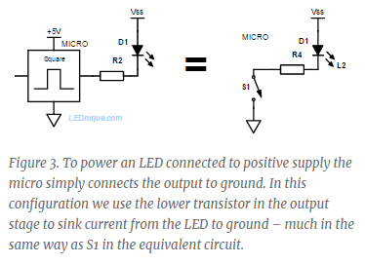

1. Repeat the steps above using this modified circuit. Record the output terminal and load voltage. Record on the following page.
2. Use your multimeter to measure the following values.
   1. Terminal voltage (open circuit, output low) = ____
   2. Output voltage = _______
   3. Resistor voltage drop = _________
   4. Output current (calculated) = ______
3. Place the second 330-ohm resistor in parallel with the first. What is the effect on the LED? Measure the electrical characteristics of the output again. How have things changed?
   1. Terminal voltage (open circuit) = _____
   2. Output voltage = ________
   3. Resistor voltage drop = _________
   4. Output current (calculated) = ______
4. Record your results in the following table.

|  |  |  |  |  |  |
| --- | --- | --- | --- | --- | --- |
| Config | Vt | Vout | R | Vr | Iout (calc) |
| High-side |  |  |  |  |  |
| High-side |  |  |  |  |  |
| low-side |  |  |  |  |  |
| low-side |  |  |  |  |  |
|  |  |  |  |  |  |
|  |  |  |  |  |  |

1. The class will review the results. When is low-side switching used? When is high-side switching used? The instructor will review the [How to Choose Between High-side and Low-side Switching](https://www.elektormagazine.com/news/high-side-low-side-switching) resource.
2. Summarize this activity and results below. What did you learn? **Be specific.** Your response should be multiple paragraphs. Review the outcomes listed at the top of this document.

|  |
| --- |
|  |

## Assessment:

Record all measurements in the space provided. Prove a complete summary and takeaways in the space above. Submit with other required files in your weekly submission at the bottom of this week’s Moodle section.