# Digital Inputs – signal conditioning worksheet Rev 1.1

**Name: __**

Follow along with the instructor’s presentation and complete the following.

## **Resources:**

1. [Protecting Inputs in Digital Electronics | DigiKey](https://www.digikey.com/en/articles/protecting-inputs-in-digital-electronics)

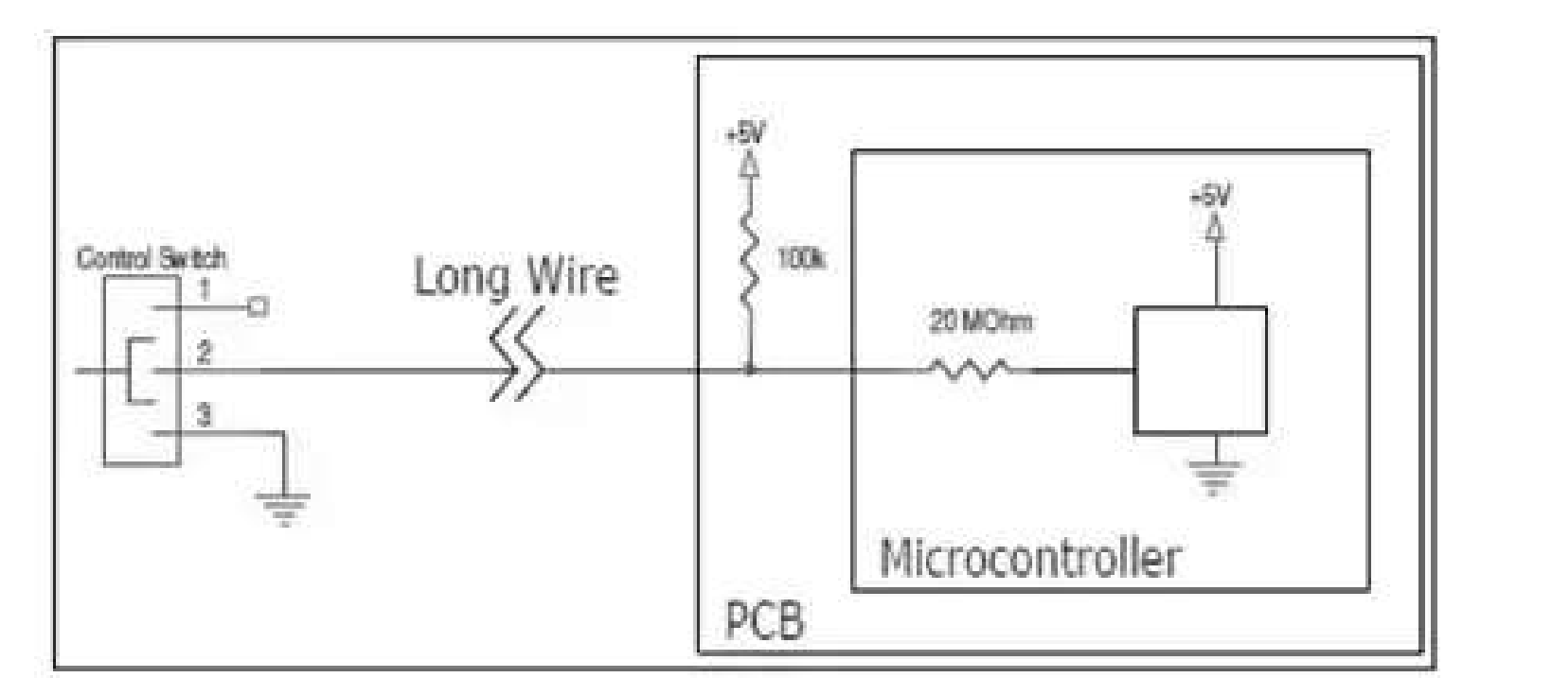

Figure

1. Review the control system diagram copied above from the Digi-key resource

|  |  |  |
| --- | --- | --- |
| S1 Control | Vin at Controller | Current in “Long Wire” |
| Open |  |  |
| Closed |  |  |

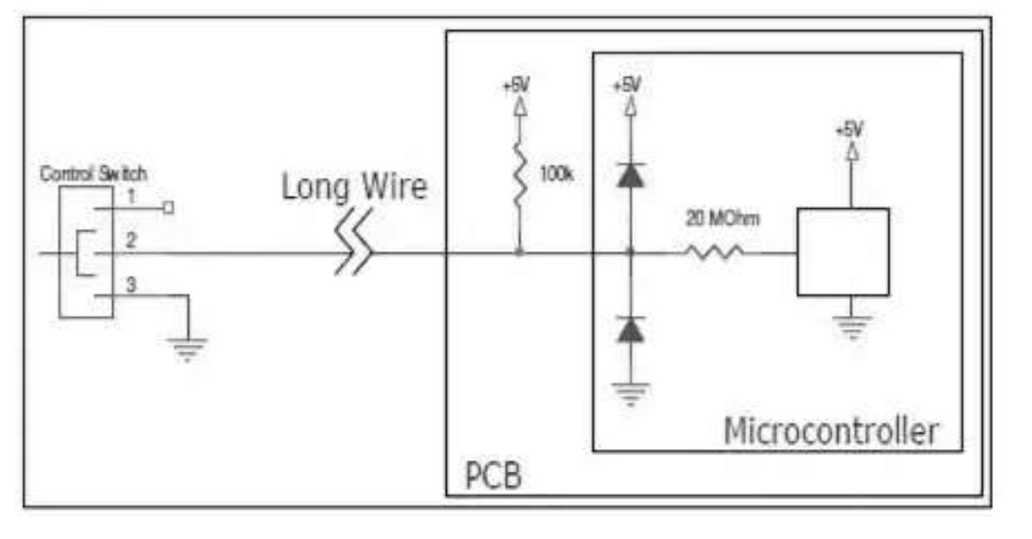

D1

D2

Figure

1. Clipper diodes are added in Figure 2

|  |
| --- |
| A large positive voltage (>6V) is induced on the signal wire. Which component will likely fail? Why? |
|  |

|  |
| --- |
| A negative voltage (< -1V) is induced on the signal wire. Which component will likely fail? Why? |
|  |

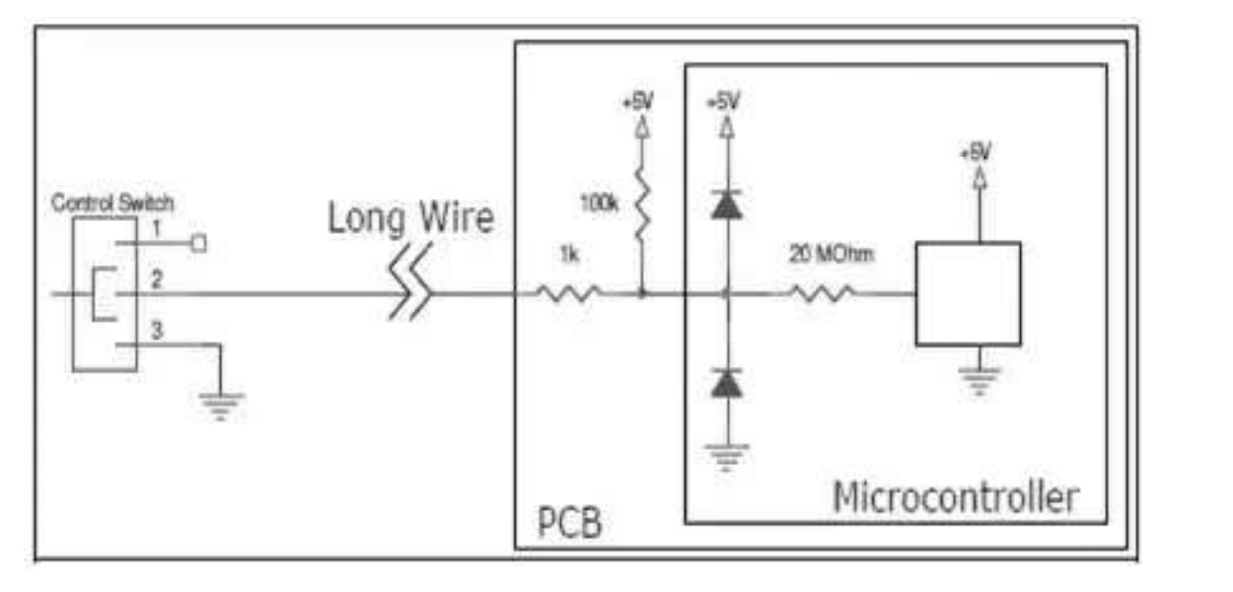

D1

Rs

D2

1. A series current limiting resistor Rs is added.

|  |
| --- |
| What is the input voltage to the controller with the switch open? Is this a valid logic level? |
|  |
| What is the input voltage to the controller with the switch open? Is this a valid logic level? |
|  |
| A 6-volt signal is induced on the wire due to noise. Which components are conducting current? How much current is flowing through the Rs resistor? |
|  |
| A negative 1-volt signal is induced on the wire due to noise. Which components are conducting current? How much current is flowing through the 1K resistor? |

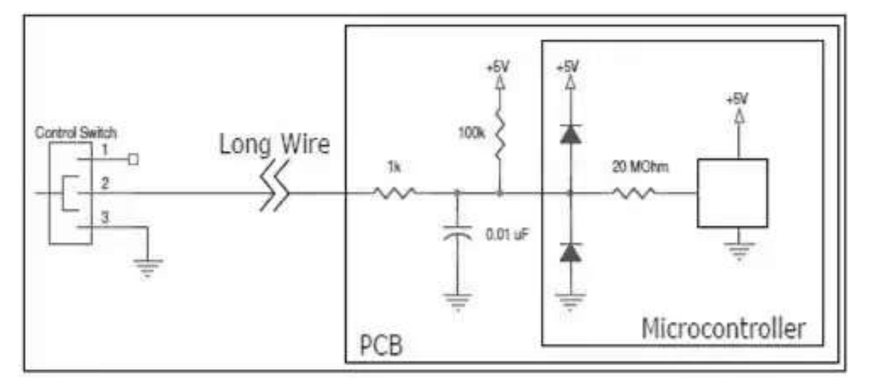

Figure

1. A low-pass filter is added.

|  |
| --- |
| A 1-volt peak to peak, 1KHz noise signal is induced onto the long wire. What is the impedance of the .01uF capacitor? |
|  |
| How much AC noise is seen at the input of the microcontroller? Explain. |
|  |

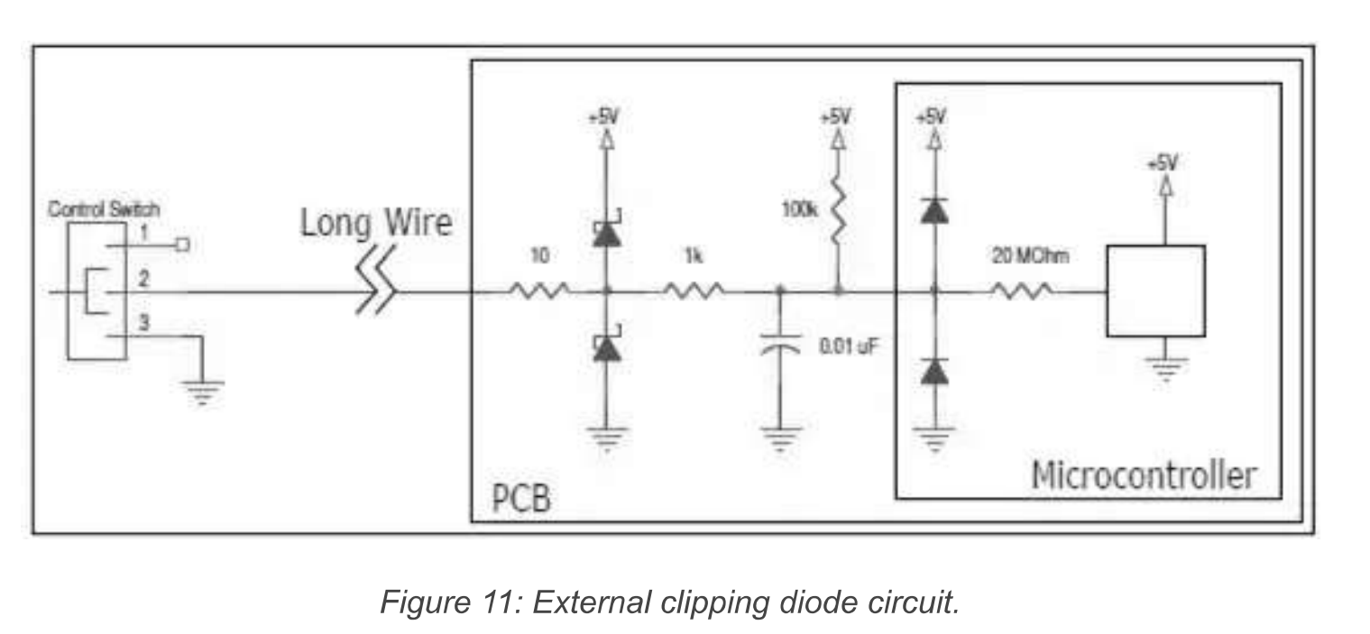

Figure

1. External Schottky diodes are added.

|  |
| --- |
| Research Schottky diodes. What is the typical forward voltage drop? |
|  |
| What is the maximum voltage applied to the microcontroller with these external clippers inserted? Explain. |
|  |
| What is the minimum voltage applied to the microcontroller with these external clippers inserted? Explain. |
|  |