# Raspberry Pi 4 Getting Started Activity Rev 1.0

## Name ____________

## Resources:

1. [Raspberry Pi Getting Started](https://k2controls.github.io/piRoverBuilds/L02.RPiGettingStarted)

## Task:

Review Raspberry Pi resources provided in the associated lesson document and complete this worksheet.

1. What version of the Raspberry Pi is used for this course?

|  |
| --- |
|  |

1. This Raspberry Pi comes in three memory options. List each option along with its current price. Search Amazon for current pricing. Try to locate a link for only the Pi computer and not the CanaKit solution discussed in the video.

|  |
| --- |
|  |

1. What does NOOBS stand for?

|  |
| --- |
|  |

1. What is the minimum size MicroSD card recommended in the video? What Class of card is recommended?

|  |
| --- |
|  |

1. What is the name of the utility that the presenter recommends for formatting your microSD card?

|  |
| --- |
|  |

1. Why is it important to “double and triple-check” when you are using the card formatter?

|  |
| --- |
|  |

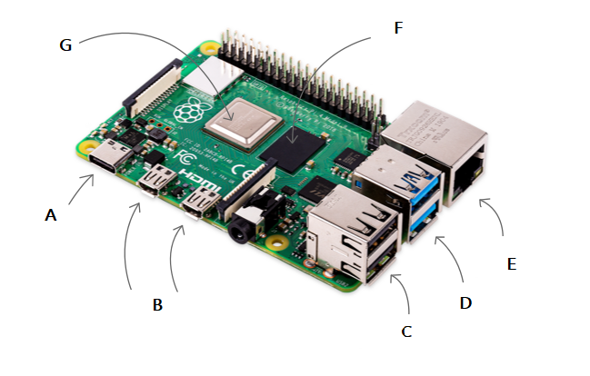

**Figure 1**

1. Refer to Figure 1. What is item A?

|  |
| --- |
|  |

1. Refer to Figure 1. What is item B?

|  |
| --- |
|  |

1. Refer to Figure 1. What is item C?

|  |
| --- |
|  |

1. Refer to Figure 1. What is item D?

|  |
| --- |
|  |

1. Refer to Figure 1. What is item E?

|  |
| --- |
|  |

1. Refer to Figure 1. What is item F?

|  |
| --- |
|  |

1. Refer to Figure 1. What is item G?

|  |
| --- |
|  |

1. What version of Linux is installed in the video and in this course?

|  |
| --- |
|  |

1. What is the default username assigned to the Pi?

|  |
| --- |
|  |

1. What is the default password for the default user?

|  |
| --- |
|  |

1. Why is it crucial to create a new password for your device during setup?

|  |
| --- |
|  |

1. What does the acronym CLI refer to? You may need to do additional research to answer?

|  |
| --- |
|  |

1. What two interfaces does the presenter enable to allow remote access?

|  |
| --- |
|  |

Use the Web to research Raspberry Pi projects. Find one that interests you or that you think is cool. Briefly describe the project below. Paste a link and an image. Be prepared to share your findings during the next week’s class session

1. Describe your Pi project

|  |
| --- |
|  |

1. Insert a link below

|  |
| --- |
|  |

1. Insert (paste) an image or screen capture below of the project below. If you do not know how to capture an image of your screen, see the “Take a Screenshot” resources in the Tools section of Moodle.

|  |
| --- |
|  |

Submit your completed assignment by zipping it along with other assigned work and post to the Moodle site using the weekly assignment link provided at the bottom of the week’s section.