# Build Validation – Part 1 Rev 1.0

## Overview:

## During this activity you will power up the piRover, connect to your iPhone or Android device via a Bluetooth connection, and validate your system build. Document procedure, results, and observations in the form provided. Be sure to complete drive test safely as discussed in the prior Test and Deploy activity.

## Resources:

1. piRover – completed with OS installed
2. iPhone or Android mobile phone. (note: Contact the instructor if you do not have a mobile phone available for testing.)
3. [App download](http://www.yahboom.net/study/G1-T-PI)
4. K2 Build Validation Videos – see links on Moodle

## Task:

1. Open the [App download](http://www.yahboom.net/study/G1-T-PI) link and follow the instructions to install either the Android or iPhone YahboomRobot application.
2. Place the piRover on the box as shown or other stand to prevent motion during testing.

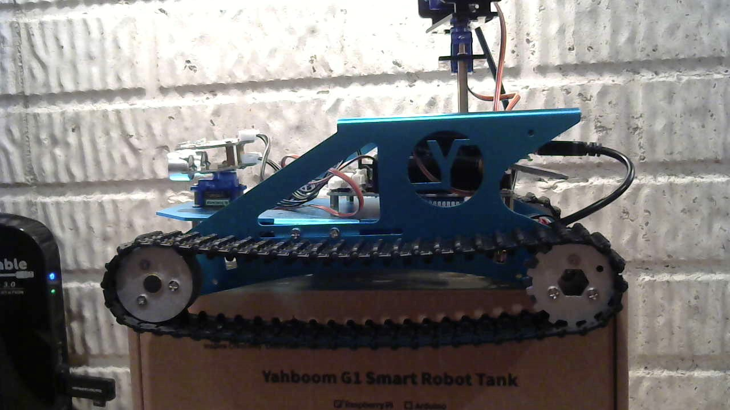

1. Turn on the piRover using the switch on the expansion board. Be sure that you have fully charged your piRover battery and that the battery pack’s barrel connector is plugged into the expansion board.
2. The red power led should light on the Raspberry Pi and the green led should blink showing activity. The system will boot and then beep three times when ready.
3. Open the app and note the Bluetooth icon in the upper right-hand corner indicating that the device is not connected.

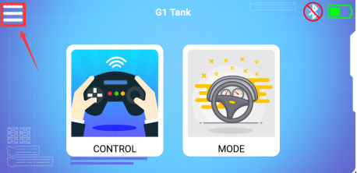

1. Press the Bluetooth icon and the following Bluetooth connection screen appears.

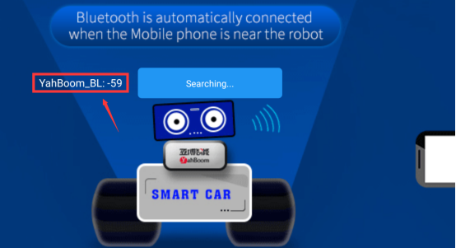

1. Place your phone near the device. A PairConnect button will display. Press the PairConnect button to make the Bluetooth connection. A “Bluetooth connect successful” message is displayed and clicking OK returns to the connection screen. The “Searching…” message is now updated to “Disconnect”. Use the arrow in the upper left-hand corner to return to the main screen.
2. Click the menu icon in the upper right-hand corner of the main screen. Describe the function of this control. What operation or value does it provide?

|  |
| --- |
|  |



1. The Battery indicator is shown on the main screen. Is this control functioning properly? Explain.

|  |
| --- |
|  |

1. Click the CONTROL icon to move to the Control screen shown below. Review the controls provided along with Yahboom documentation to determine basic functions.

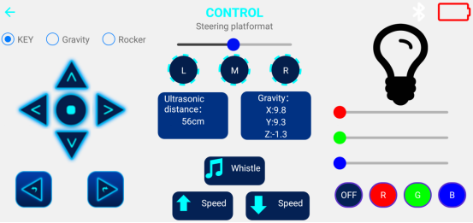

1. Complete the UI and validation testing form on the following page.

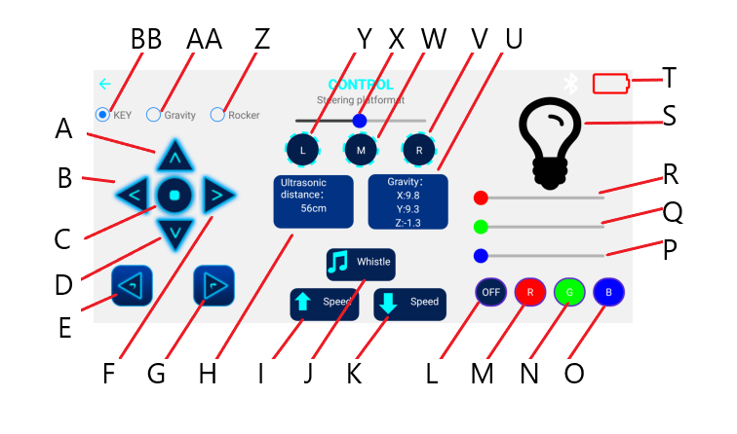

Figure 1

|  |  |  |
| --- | --- | --- |
| **Main Control Testing** (refer to designators in Figure 1 when responding) | | |
| 1. | Drive Test | |
| 1.1.1 | Which buttons provide forward and backward motion? |  |
| 1.1.2 | Does forward and backward motion function as expected? (note: keep BB “KEY” selected for now) |  |
| 1.1.3 | Record observations, notes, and evaluation of forward and backward motion. |  |
| 1.2.1 | Which buttons provide left and right turning? |  |
| 1.2.2 | Does left and right turning function as expected? (note: keep BB “KEY” selected for now) |  |
| 1.2.3 | Record observations, notes, and evaluation of left and right turning. |  |
| 1.2.4 | Compare the function of controls B, E and F, G. |  |
| 1.2.5 | Describe how a turn is executed. What is the direction of wheel rotation when a turn is made? |  |
| 1.2.5 | Describe a least one other mode or method or rotation that could be implemented to make the piRover turn. |  |
| 1.3.1 | What is the function of control C? When is it used? |  |
| 1.4.1 | What functions do I and K provide? |  |
| 1.4.2 | Describe the operation of I and K. Do they function as expected? |  |
| 1.5.1 | Switch to Gravity mode using control AA. Record your observation of the drive and compare to KEY mode. |  |
| 1.5.2 | Switch to Rocker mode using control Z. Record your observation of the drive and compare to KEY and Gravity mode. |  |
| 1.5.3 | Reflect on Key, Gravity, and Rocker drive modes. Which do you prefer? Why? |  |
| 2. | Sensor and actuator Test | |
| 2.1.1 | What is the function of H? Is this a control or an indicator? |  |
| 2.1.2 | Describe a procedure for testing H. |  |
| 2.1.3 | Does H function as expected? Explain. |  |
| 2.2.1 | What is the function of J? Is this a control or an indicator? |  |
| 2.2.2 | Describe a procedure for testing J. |  |
| 2.2.3 | Does J function as expected? Explain. |  |
| 2.3.1 | What is the function of L, M, N, and O? Are these controls or indicators? |  |
| 2.3.2 | Describe a procedure for testing L, M, N, and O. |  |
| 2.3.3 | Do L, M, N, and O function as expected? Explain. |  |
| 2.4.1 | What is the function of P, Q, R, and S? Are these controls or indicators? |  |
| 2.4.2 | Describe a procedure for testing P, Q, R, and S. |  |
| 2.4.3 | Do P, Q, R, and S function as expected? Explain. |  |
| 2.5.1 | What is the function of T? Is this a control or indicator? |  |
| 2.5.2 | Does T function as expected? Explain. |  |
| 2.6.1 | What is the function of U? Is this a control or indicator? |  |
| 2.6.2 | Does U function as expected? Explain. |  |
| 2.6.3 | Describe the X value shown in U. What does this indicate? What are possible values? |  |
| 2.6.4 | Describe the Y value shown in U. What does this indicate? What are possible values? |  |
| 2.6.5 | Describe the Z value shown in U. What does this indicate? What are possible values? |  |
| 2.7.1 | What is the function of V, W, and Y? Are these controls or indicators? |  |
| 2.7.2 | Describe a procedure for testing V, W, and Y. |  |
| 2.7.3 | Do V, W, and Y function as expected? Record any adjustments or modifications that are required. |  |
| 2.7.4 | What is the function of X? Is this a control or indicator? |  |

1. Continue to test the piRover and application interface. When you are ready, remove the piRover from the stand and further test the drive operation and functionality. See Part 2 document for additional testing procedures.

Submit your completed assignment to the Moodle site. The class will discuss results and responses during the next class session.