**Motor Speed Introduction**

1. Copy your **motor_control_intro.py** file to **motor_control_speed_intro.py**
2. Create global speed variables.

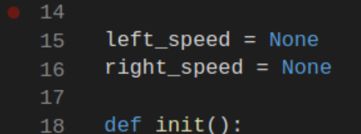

1. Create PWM speed variables in the init() function. These must be flagged as globals (line 19)

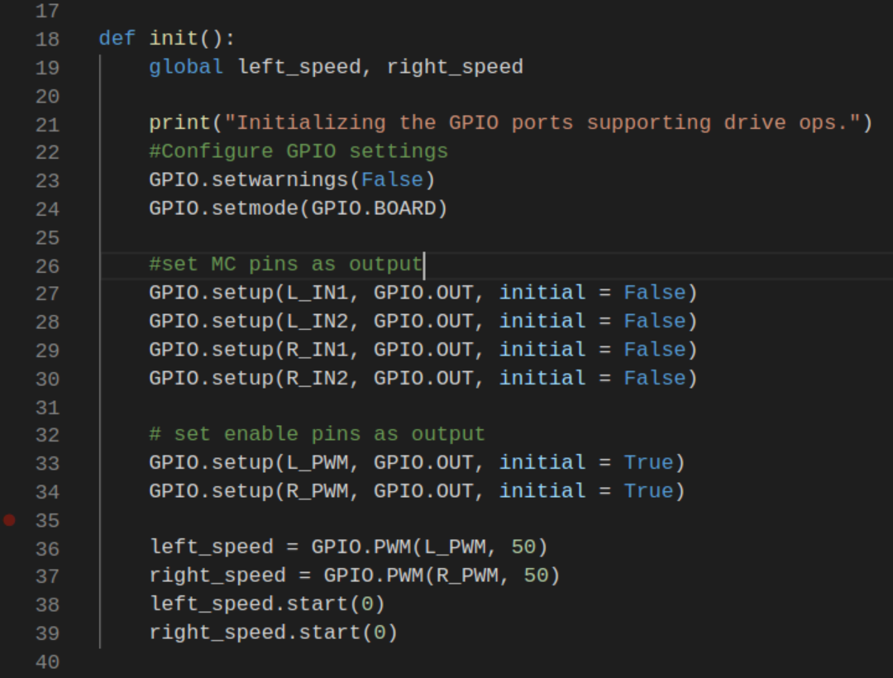

1. Test the code by setting the speed value before calling a move.

