Table of contents
4. 1 Revisiting Limits - L'Hôpital's Rule
4. 2 Extremum Problem (Extremum)
4. 3 Linear Approximation (Linear Approximation)
4. 4 Crossing the River by Feeling the Stones - Newton's Method
Limit problems are central to calculus. Two particularly difficult indeterminate forms arise frequently:
4. 6 Finding one's roots - antiderivative(Antiderivative)
Comparing two expressions of the form ∞/∞ offers no obvious starting point — and this observation is correct.

Consider two quantities, each so large as to be practically incomparable to a third party. Determining which will ultimately be greater requires further analysis.
To determine which of two competing quantities will dominate in the long run, the relevant factor is not the current magnitude but the rate of growth. If Party A holds 1 billion units growing at 7% per year while Party B holds 5 billion units growing at 10% per year, then Party B will ultimately surpass Party A.

Party B prevails because its growth rate of 10% exceeds Party A's rate of 7%. Rate of growth is precisely rate of change — that is, the derivative.

This suggests that when two ∞ quantities yield no conclusion upon direct comparison, the ratio of their derivatives may nevertheless be determinate. This idea was proved rigorously by the French mathematician L’Hôpital more than 300 years ago.
L’Hôpital’s Rule (L’Hospital’s Rule)
Suppose f(x) and g(x) are differentiable in a region containing a (though not necessarily at a itself), and g(x) ≠ 0. If:

4. 1 Discussing limits again - L'Hôpital's Law(L'Hôpital's Rule)
As mentioned before, limit problems are the core problem of calculus. When we deal with limit problems, we often encounter two kinds of thorny limit problems:

$$\frac{∞}{∞} 型 和 \frac{0}{0} 型$$

L’Hôpital’s Rule resolves both indeterminate forms simultaneously. Several remarks are in order.
Just like when we read a martial arts novel, two heroes compete with each other. They both possess unique skills. It is really difficult to judge who will have the last laugh. Let's think about it again. If two heroes compete for a long time, which one will have the upper hand? For another example, A has 10billion and growing every year7%; Although B only has 5 billion, but B’s wealth growth rate is10%. If you think about it carefully, it is not difficult to come to the conclusion: In the long run, B will definitely defeat A. The reason why we come to the conclusion that Y wins is because of his10%The growth rate is actually higher than7%The growth rate is much greater. What is growth rate, isn’t it just the rate of change? What is the rate of change? Derivative!
From this we think that if two$∞$There is no conclusion in comparison, but if the ratio of their derivatives is higher or lower, then the ratio itself will have results. This simple idea, in 300Many years ago, the French mathematician Robita（L'Hôpital）Sir proved。

L'Hôpital's Law(L'Hôpital's Rule)
hypothesis function $f(x)$and$g(x)$, at point containing acan be differentiated within a certain region of (it does not require that it must be in a Derivable），and $g(x) ≠ 0$. if:

$$\lim_{x→a}f(x) = 0 且 \lim_{x→a}g(x) = 0$$
or：
$$\lim_{x→a}f(x) = ∞ 且 \lim_{x→a}g(x) = ∞$$

So：
$$\frac{\lim_{x→a}f(x)}{\lim_{x→a}g(x)} = \frac{\lim_{x→a}f'(x)}{\lim_{x→a}g'(x)}$$

Of course, the premise is that the limit on the right exists.
L'Hôpital's Law kills two birds with one stone and solves two difficult problems at the same time. Regarding this rule, let's highlight a few points.

This result may be accepted without proof. Attention should be directed toward correct application of the rule.

First of all, when $x → ±∞$ The same rule applies when。
Secondly, if the limit of the ratio of the derivatives of two functions is still $\frac{∞}{∞}$ type and $0/0$ type, you can use this rule again to second derivatives or even $n$ on the first derivative。
Finally, the proof of this law requires more advanced mathematical knowledge.
For now, we can treat it as an axiom, think it is self-evident, and knowing how to use the rules is the last word.

Example 4-1) find
$$\lim_{x→1}\frac{ln x}{x-1}$$
Solution: According to L'Hôpital's law, we have:

$$\lim_{x→1}\frac{ln x}{x-1} = \frac{\lim_{x→1}(ln x)'}{\lim_{x→1}(x-1)'} = \frac{\lim_{x→1}\frac{1}{x}}{\lim_{x→1}1} = \lim_{x→1}\frac{1}{x} = 1$$

Example 4-2) find
$$\lim_{x→∞}\frac{2^{x}}{8x}$$
Consider the following two limits:

$$\lim_{x→∞}\frac{2^{x}}{8x} = \lim_{x→∞}\frac{(2^{x})'}{(8x)'} = \lim_{x→∞}\frac{2^{x}·ln 2}{8} = ∞$$

Fun, right? Let’s look at two more limits.

Example 4-3) find
$$\lim_{x→∞}\frac{3^{x}}{x^{3}}$$
Solution: To find this limit, compute the numerator and denominator separately. Only by taking the second derivative can we see the result clearly:

$$\lim_{x→∞}\frac{3^{x}}{x^{3}} = \lim_{x→∞}\frac{(3^{x})'}{(x^{3})'} = \lim_{x→∞}\frac{3^{x}·ln 3}{3x^{2}} = \lim_{x→∞}\frac{(3^{x}·ln 3)'}{(3x^{2})'} = \lim_{x→∞}\frac{3^{x}·{\left(ln 3\right)}^{2}}{6x}$$
$$= \lim_{x→∞}\frac{(3^{x}·{\left(ln 3\right)}^{2})'}{(6x)'} = \lim_{x→∞}\frac{3^{x}·{\left(ln 3\right)}^{3}}{6} = ∞$$

It can be seen from the problem-solving process of this problem that even if the denominator is not $x³$, but$x¹⁰⁰$ or higher powers will not change the result of the limit. Similarly, as long as the molecule $aˣ$ in $a > 1$, the result will not change, it is all$∞$。
This also confirms what we said before：$aˣ$ type $∞$ The most powerful, follow $xⁿ$ type $∞$ There is no comparison. Let's take another look $xⁿ$ type $∞$ meet $logᵦ x$ type $∞$,what happens.

This confirms that exponential growth (ax type, a > 1) dominates polynomial growth (xn type), which in turn dominates logarithmic growth (ln x type). The following example examines polynomial against logarithmic growth:
$$\lim_{x→∞}\frac{\sqrt{x}}{{\left(ln x\right)}^{2}}$$
untie:

$$\lim_{x→∞}\frac{\sqrt{x}}{{\left(ln x\right)}^{2}} = \lim_{x→∞}\frac{(\sqrt{x})'}{({\left(ln x\right)}^{2})'} = \lim_{x→∞}\frac{\sqrt{x}}{4·ln x}$$
$$= \lim_{x→∞}\frac{(\sqrt{x})'}{(4·ln x)'} = \lim_{x→∞}\frac{\sqrt{x}}{8} = ∞$$

Even with a fractional power in the numerator and a squared logarithm in the denominator, the result remains ∞.

this time，$xⁿ$ type $∞$and$logᵦ x$ type $∞$ The comparison result is also $∞$！
Again, if you encounter $∞/∞$ Type limit problem, leaving only the highest level in the numerator and denominator $∞$"on duty"That’s it, the result won’t be wrong。
When evaluating limits of the ∞/∞ type, retaining only the highest-order term in each of the numerator and denominator yields the correct result.

$$\lim_{x→0}\frac{sin x}{x} = 1$$

$$\lim_{x→0}\frac{1-cos x}{x} = 0$$

Applying L’Hôpital’s Rule to the two standard limits yields the following intuitive results:
Mathematical proficiency increases with practice. Further applications of the derivative are examined in the sections that follow.

Further applications of the derivative are examined below.
People always like to pay attention to things that are a little far away from themselves and more extreme.
Extreme values arise naturally as subjects of study. Optimization problems are of broad practical importance.
For the functions under study, maximum and minimum value problems are of considerable practical relevance, since resource optimization is a fundamental objective.
local maximum（Local Maximum）：If the pair contains c All points in an open interval x value, inequality $f(x) ≤ f(c)$ are established, then $f(c)$ It's a function $f(x)$ a local maximum of . local maximum, sometimes also called relative maximum（Relative Maximum）。
Derivatives are instrumental in solving extreme value problems. The relevant concepts are introduced below.
global maximum（Global Maximum）：If for all x value, inequality $f(x) ≤ f(c)$ are established, then $f(c)$ It's a function $f(x)$ the global maximum value. Global maximum, sometimes called absolute maximum（Absolute Maximum）。
Next, let’s talk about our understanding of these two concepts. The so-called local means that as long as the inequality $f(x) ≤ f(c)$ holds true within even a small interval，$f(c)$ is the local maximum。
Definition (Local Maximum): If there exists an open interval containing c such that f(x) ≤ f(c) for all x in that interval, then f(c) is a local maximum of f(x). A local maximum is equivalently referred to as a relative maximum.
The concept of a global maximum follows naturally.

Definition (Global Maximum): If f(x) ≤ f(c) holds for all x in the domain, then f(c) is the global maximum of f(x). The global maximum is sometimes

local minimum（Local Minimum）：If the pair contains c All points in an open interval x value, inequality $f(x) ≥ f(c)$ are established, then $f(c)$ It's a function $f(x)$ a local minimum of . local minimum, sometimes also called relative minimum（Relative Minimum）。
global minimum（Global Minimum）：If for all x value, inequality $f(x) ≥ f(c)$ are established, then $f(c)$ It's a function $f(x)$ the global minimum of . Global minimum, sometimes called absolute minimum（Absolute Minimum）。
Once you understand the concept of extreme values, you can discuss how to find extreme values.
equivalently termed the absolute maximum.
Extreme Value Theorem: If function $f(x)$ in closed interval [a, b] is continuous, then there must be two points on this intervalc and d,make $f(c)$ is the absolute maximum，$f(d)$ is the absolute minimum。
To clarify the distinction: the term 'local' indicates that the inequality f(x) ≤ f(c) need only hold within an arbitrarily small open interval containing c.
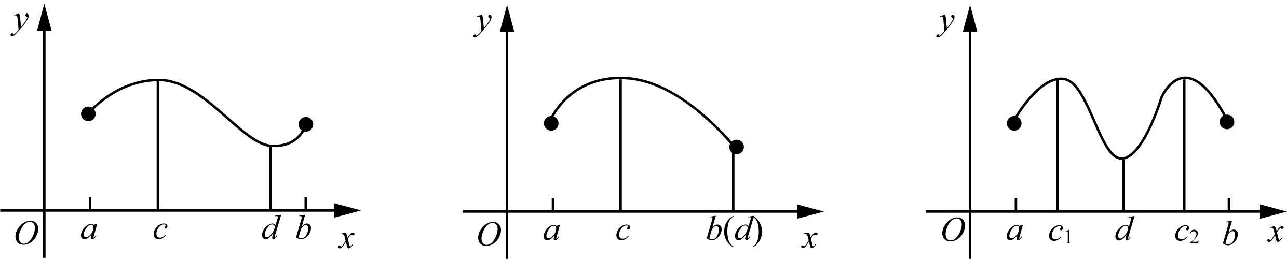
For example, if elevation is regarded as a function defined on Earth's surface, then the summits of the Five Sacred Mountains are each local maxima. Any local high point, regardless of scale, constitutes a local maximum. Mount Everest is the unique global maximum of this function.
Consider official rank as a function. A provincial governor and a village chief are both local maximum officials within their respective jurisdictions. Only the head of state constitutes the global maximum.
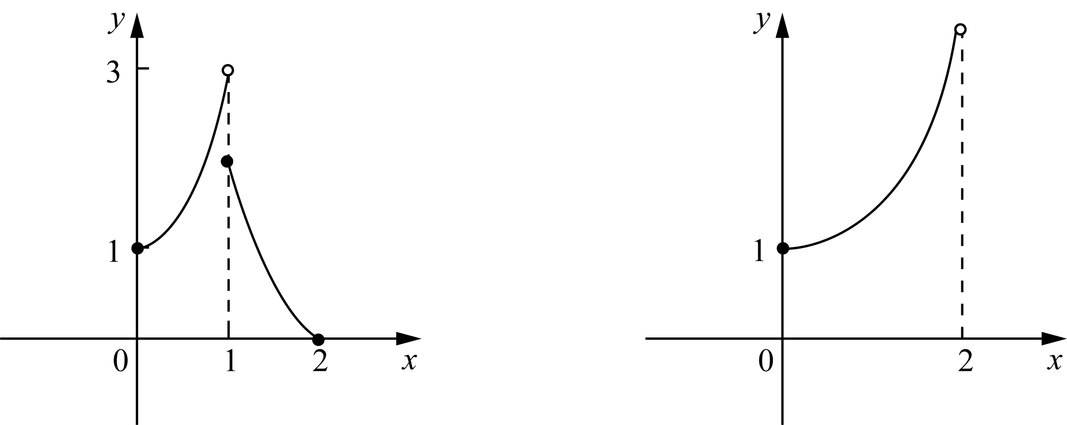
A clear distinction must be maintained between local and global extrema. Numerous errors in judgment arise from treating a local optimum as a global one. Maintaining appropriate perspective regarding position within a broader context is therefore advisable.
The concept of minimum follows from the concept of maximum.

Definition (Local Minimum): If there exists an open interval containing c such that f(x) ≥ f(c) for all x in that interval, then f(c) is the local minimum of f(x). A local minimum is equivalently referred to as a relative minimum.

Definition (Global Minimum): If f(x) ≥ f(c) holds for all x in the domain, then f(c) is the global minimum of f(x). The global minimum is sometimes also called the absolute minimum.
The concepts of extreme values having been established, the methods for finding them are now examined.
if c Point is a function $f(x)$ the local extreme point of , and $f'(c)$ exists, then：
$$f'(c) = 0$$
Proof: Let’s assume first $f(c)$yes$f(x)$ The local maximum and minimum values ​​of can also be proved in the same way。$f(c)$ is a local maximum, which means: within c Within a small area of ​​, the following inequalities hold：
$$f(x) ≤ f(c)$$
So, we have:
$${f'}^{-}(c) = \lim_{h→0⁻}\frac{f(c+h)-f(c)}{h}$$
In the above formula, since the numerator is not positive and the denominator is negative, therefore $f'(c) ≥ 0$. In the same way, we have:
$${f'}^{+}(c) = \lim_{h→0⁺}\frac{f(c+h)-f(c)}{h} ≤ 0$$
So far, we have the function in c The conclusion that the left and right derivatives of a point are non-negative on one side and non-positive on the other. now that $f'(c)$ exists, its left and right derivatives must be equal. Then there is only：$f'(c) = 0$。
The Extreme Value Theorem: If f(x) is continuous on the closed interval [a, b], then there exist two
points c and d such that f(c) is the absolute maximum and f(d) is the absolute minimum. The figure below illustrates the Extreme Value Theorem.
The geometric interpretation is illustrated in the figure below.
So, how to judge whether the critical point of the function we have worked hard to find is a local maximum or a local minimum? To solve this problem, we have to ask small trends - Derivatives come into play. As we introduced in the previous chapter, the positive or negative value of the derivative at each point of the function determines the upward or downward trend of the function at this point. Depend on

Two conditions of the theorem — continuity and a closed interval — are both necessary. The figures below show cases in which each condition is violated, causing the Extreme Value Theorem to fail.

As shown: the function on the left attains no maximum value, and the function on the right attains neither a maximum nor a minimum. The left function is discontinuous; the right function's domain is not a closed interval.
The existence of extreme values having been established, attention turns to methods for locating them based on the properties of extreme points.
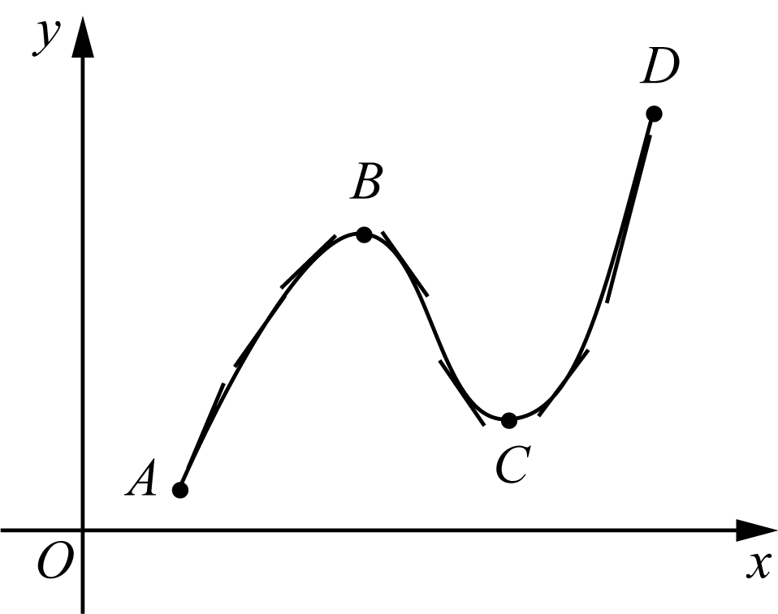
For a continuous function on a closed interval, global extreme points exist. In general, global extreme points are selected from among the local extreme points; identifying local extreme points is therefore the primary task.
Fermat's Theorem: If c is a local extreme point of f(x) and f'(c) exists, then f'(c) = 0.
Proof: Assume c is a local maximum of f(x); the case of a local minimum is proved analogously. The local maximum condition states that within some open interval containing c, the following inequality holds:
And the function goes through C point, its derivative goes through a process from negative to zero, and then to positive. Correspondingly, the function is derived from C The decreasing function before the point becomes C The increasing function after the point. so, C A point is the relative minimum point of a function.
Conclusion: If the derivative around the critical point of the function changes from positive to negative, then the critical point is a local maximum point. On the contrary, if the derivative around the critical point of the function changes from negative to positive, then the critical point is the local minimum point of the function.
In the expression above, since the numerator is non-negative and the denominator is negative: f'(c-) >= 0. Similarly:

Example 4-5） Find function $f(x) = 2x^{3} - 3x^{2} - 12x$ in the interval [−2, 3] The absolute extreme value of。
Solution: We play according to the routine and first find the critical point:
$$f'(x) = 6x² - 6x - 12 = 6(x² - x - 2) = 6(x - 2)(x + 1)$$
It has thus been established that f at c has one-sided derivatives that are non-negative on one side and non-positive on the other. Since f'(c) exists, the left-hand and right-hand derivatives must be equal. The only value satisfying both inequalities is zero; hence f'(c) = 0.
$$f(-1) = 7, f(2) = -20, f(-2) = -4, f(3) = -9$$
Remark: Fermat's Theorem asserts only that a local extreme point at which the derivative exists must have derivative equal to zero. It does not assert that every local extreme point has derivative zero, since some local extreme points have no derivative.
$$f_{max} = f(-1) = 7, f_{min} = f(2) = -20$$
Points at which the derivative does not exist and points at which the derivative equals zero are collectively called critical points of the function.
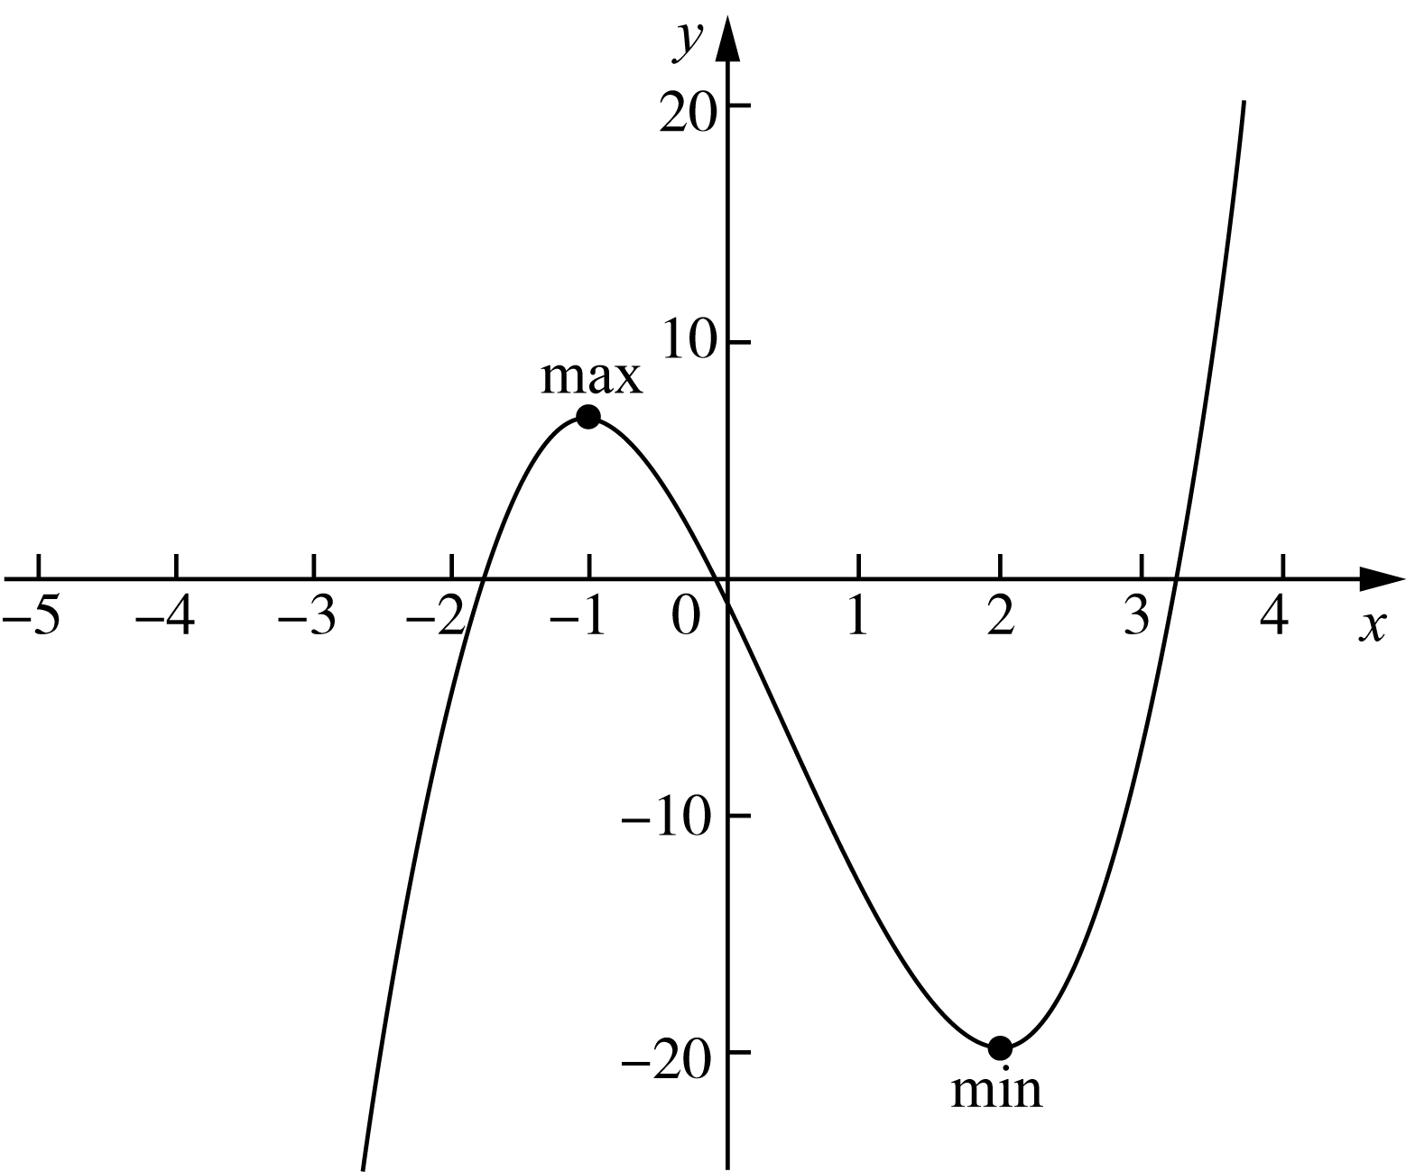

A systematic method for locating extreme values is now available. Step 1: identify the critical points -- those at which the derivative either does not exist or equals zero. Step 2: compare the function values at the critical points and at the interval endpoints to determine the global and local extreme values.

The function values at the interval endpoints must be examined separately because, although endpoints do not satisfy the definition of local extreme points, they may nonetheless be global extreme points. A strictly monotonic function attains its global extreme values exclusively at the endpoints.
It remains to determine whether a given critical point corresponds to a local maximum or a local minimum.
$$f'(x) = 4x³ - 16x = 4x(x² - 4) = 4x(x + 2)(x - 2)$$
This determination relies on the sign of the derivative in the vicinity of the critical point. The sign of the derivative on an interval determines whether the function is increasing or decreasing: a positive derivative implies an increasing function; a negative derivative implies a decreasing function.
Next, examine the positive and negative derivatives around the critical point. It can be seen from observation: in −2 To the left of the point, the derivative is negative; at (−2, 0) above, the derivative is positive; at (0, 2) The upper derivative is negative; in 2 To the right of the point, the derivative is positive.
It can be seen that point−2 and 2is the relative minimum point of the function, point 0 is the relative maximum point of the function. The function values ​​are：$f(-2) = f(2) = -16$，$f(0) = 0$。
A closer look shows that: function $f(x)$ There is no absolute maximum, but there is an absolute minimum. The relative minimum in this question happens to be the absolute minimum. By extension, all 4 There is no absolute maximum value for a subfunction, but there must be an absolute minimum value. Of course, except for the case of closed intervals。
The picture below is the graph of this question:
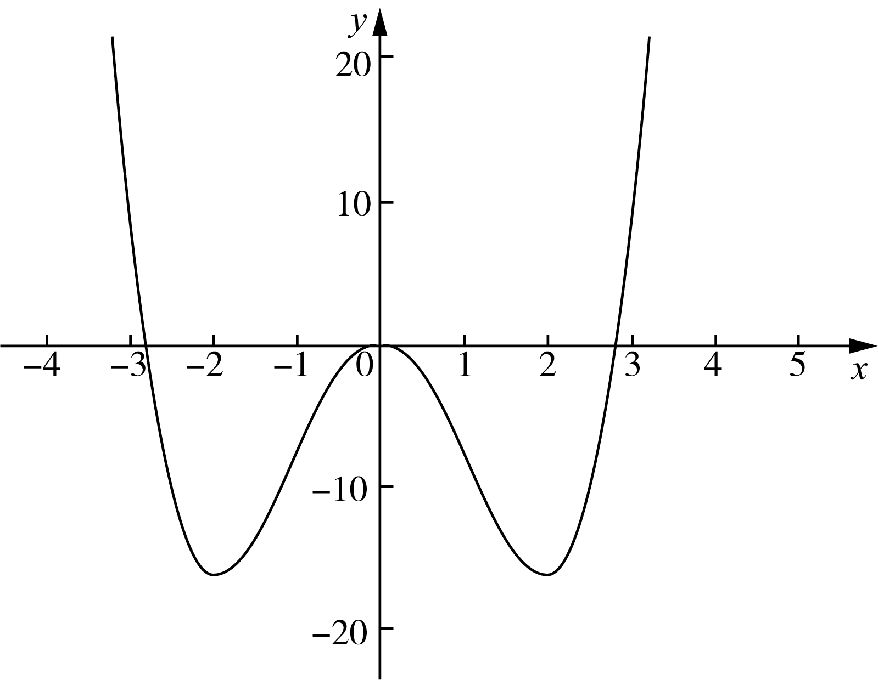

It has thus been established that f at c has one-sided derivatives that are non-negative on one side and non-positive on the other. Since f'(c) exists, the left-hand and right-hand derivatives must be equal, and the only admissible value is zero. Hence f'(c) = 0.

Remark: Fermat's Theorem asserts only that a local extreme point at which the derivative exists must have derivative equal to zero. It does not assert that every local extreme point has derivative zero, since some local extreme points have no derivative.
Points at which the derivative does not exist and points at which the derivative equals zero are collectively called critical points of the function.
A systematic method for locating extreme values is now available. Step 1: identify the critical points -- those at which the derivative does not exist or equals zero. Step 2: compare the function values at the critical points and at the interval endpoints to determine the global and local extreme values.
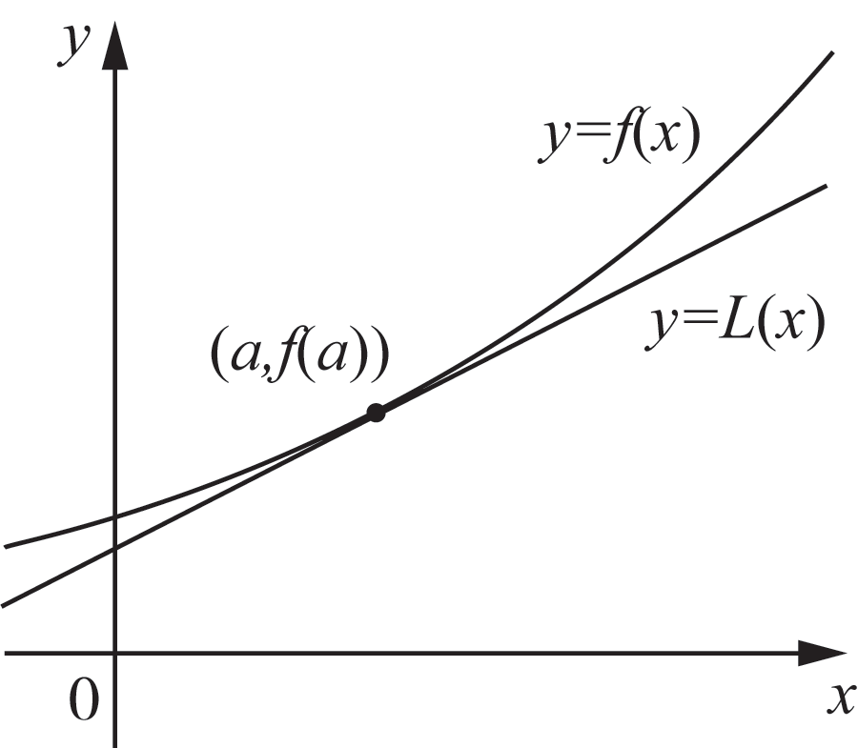
As shown in the figure above, the so-called linear approximation is a near the point, represented approximately by a linear function $f(x)$. past aThe tangent equation of is：
$$y = f(a) + f'(a)(x - a)$$
The function values at the interval endpoints must be examined separately because, although endpoints do not satisfy the definition of local extreme points, they may nonetheless be global extreme points. A strictly monotonic function attains its global extreme values exclusively at the endpoints.
$$L(x) = f(a) + f'(a)(x - a)$$
It remains to determine whether a given critical point is a local maximum or a local minimum.
This determination relies on the sign of the derivative in the vicinity of the critical point. A positive derivative on an interval implies an increasing function; a negative derivative implies a decreasing function.

Example 4-7） Find function $f(x) = \sqrt[3]{x}$exist$x = 27$ linear approximation at and use it to estimate $\sqrt[3]{28}$(accurate to four decimal places), compare this estimate with the exact value.
Solution: It can be seen from the meaning of the question f(27) = 3, The derivative function of the function is:
$$f'(x) = \frac{1}{3\sqrt[3]{x^{2}}}, f'(27) = \frac{1}{3\sqrt[3]{{27}^{2}}} = \frac{1}{27}$$

92 Play with calculus

So, the required linear approximation is:
$$L(x) = 3 + \frac{1}{27}(x - 27)$$
$$∴ L(28) = 3 + \frac{1}{27} ≈ 3.037$$
$$∴ ∛28 ≈ 3.0370$$
On the other hand, using a calculator to directly calculate：$∛28 ≈ 3.0366$. It can be seen that the estimated value is slightly larger than the precise value. After calculation, it can be seen that the accuracy$< 1.3 × 10⁻⁴$。
Now, let’s connect the two knowledge points in series - Linear approximation and differentiation. Let’s take a look at the diagram introducing function differentiation:
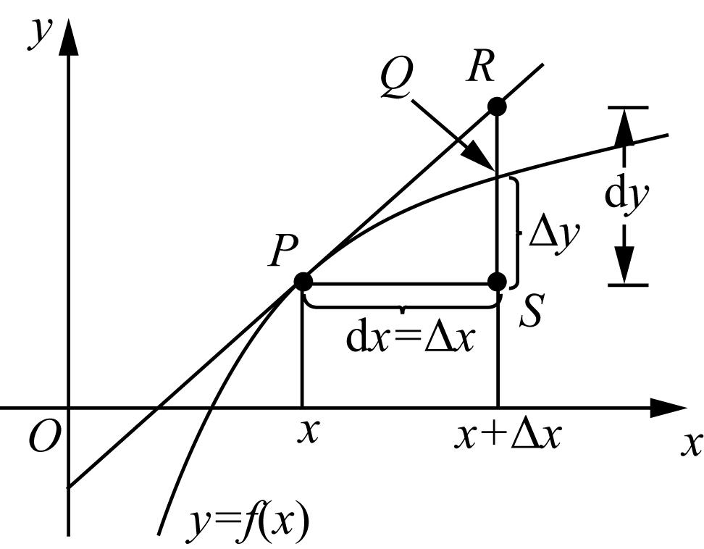
we know, P Point linear approximation is:
$$L(x) = f(x) + f'(x)dx = f(x) + dy$$
The corresponding point is R. The exact value is:
$$y = f(x) + Δy$$
Its corresponding point on the diagram is Q point. The difference between the approximate value and the exact value is (dy − Δy).obviously, dx The smaller it is, the smaller the error will be.
Linear approximation does not seem complicated, but sometimes it is not so convenient, and with the rapid development of computer technology, its practicality will be further reduced. But we still introduce it in a separate section. First, because its method of solving complex problems by simplifying it is not only the basic method of calculus, but also can be used to guide our daily work; second, because this seemingly simple method was once very effective and was the result of the hard work of many predecessors. I pay tribute to them!

Chapter 4 | What is the use of derivatives? 93

4. 4 Crossing the river by feeling the stones - Newton's Method
When it comes to linear equations of one variable, many primary school students may be able to solve them decently. As for the quadratic equation, almost every high school student can write its root formula. But what about something a little more complicated? For example:
$$ax³ + bx² + cx + d = 0$$
A little dizzy, right? What if it was more complicated? For example:
$$2x³ - 3x·sin(x) - 5lnx = 0$$
Who wants you to give the formula to solve such an equation? Who are you in a hurry with? Don't worry, if you really want to write the formula for finding the roots of this kind of equation, not only you can't do it, but you can't find any mathematician to do it either! Most of the equation problems encountered in various applied sciences cannot be written down the root formula.
Mathematics predecessors have long discovered that many equations cannot yield accurate solutions. But they were not discouraged. They could not get an accurate solution, so they tried every means to find an approximate solution. Taking a step back, embracing imperfection, and reconciling with reality is also the great wisdom of life!
The master Newton adopted a very elegant method to find approximate solutions to equations. The method adopted by Newton is the standard method of calculus: using the straight line method to solve non-straight line problems.
Here's the idea:
1）As shown in the figure on the right, assuming that our task is to find $f(x)$ the root of r。We who have no clue can only make a fool of ourselves first. x₁。Of course, it is almost certain，x₁ Not what we asked for r。
2) Next, we find the point where the curve is x₁ tangent L. Since it is a straight line, it is easy for us to find the straight lineL and xaxis intersection x₂.
3）naturally，x₂ Most likely not either r。However, since the tangent direction is the minor trend of the function, it means that the curve is at the point x₁ of $f(x)$ direction. Therefore we know that although x₂ Neither r，But it should be better thanx₁ away from rcloser。
4) Find the point where the curve is x₂ tangent to, and find it and x axis intersectionx₃. x₃ to x₂closer r.
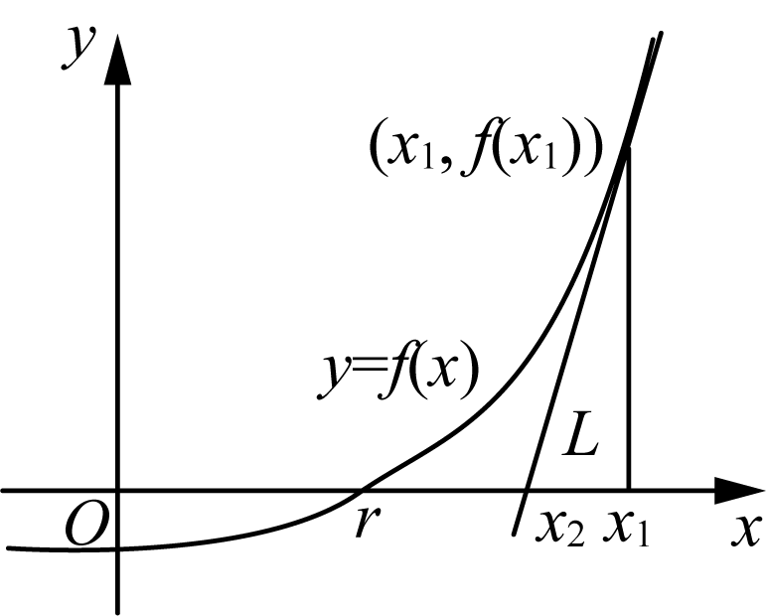
5) Repeat the above steps to get x₁, x₂, x₃, …, xₙ, …
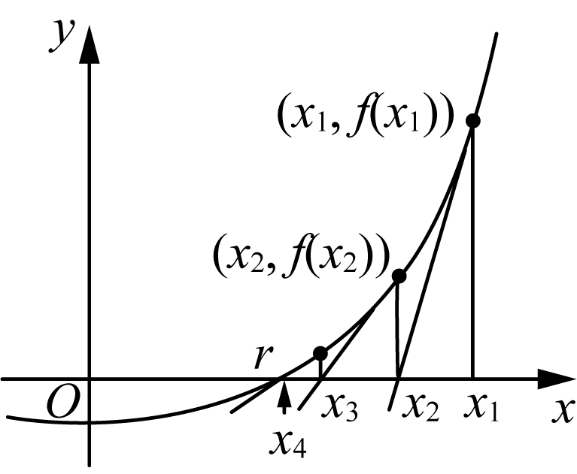

94 Play with calculus

It is easy to see from the above picture:
$$f'(x₁) = \frac{f(x₁)}{x₁ - x₂}$$
$$f'(x₂) = \frac{f(x₂)}{x₂ - x₃}$$
By extension:
$$f'(xₙ) = \frac{f(xₙ)}{xₙ - xₙ₊₁}$$
Right now:
$$xₙ₊₁ = xₙ - \frac{f(xₙ)}{f'(xₙ)}$$
4. 3 Linear Approximation (linear approximation)
$$\lim_{n→∞}xₙ = r$$
Don't feel troublesome when you see the limit. This mathematical idea is worth pondering. Okay, next, apply what you have learned.

Example 4-8) Starting from x₁ = 2, find the approximate root of x³ − 2x − 5 = 0 (accurate to four decimal places).
Solution: Assume $f(x) = x³ - 2x - 5$
$$∴ f'(x) = 3x² - 2$$
So, following Newton's method, we have:
$$xₙ₊₁ = xₙ - \frac{xₙ³ - 2xₙ - 5}{3xₙ² - 2}$$
thus：
$$x₂ = 2 - \frac{2³ - 2×2 - 5}{3×2² - 2} = 2.1$$
$$x₃ = 2.1 - \frac{2.1³ - 2×2.1 - 5}{3×2.1² - 2} ≈ 2.0946$$
x₃ How accurate is it? You can calculate it with a calculator：$f(2.0946) ≈ 5.4 × 10⁻⁴$. It can be seen that x₃The accuracy is quite impressive. So, why this example? Remember, this question is the original question in Mr. Newton's paper introducing Newton's method！
Although Newton's method is very easy to use, if it is used in a haphazard way, sometimes it will lead to mistakes.

Chapter 4 | What is the use of derivatives? 95

area and cannot achieve the desired effect. Please see the picture below:
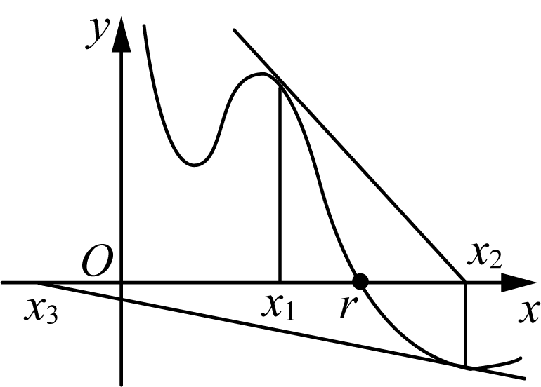
x₁ It still looks like that, but since x₂ later, and r It's drifting away. Why? Because the first step in Newton's method, x₁ The choice is a technical job!
Just like the example in the master's manuscript, he chose x₁ = 2, why not choose 0, 1, −1 Woolen cloth? Just compare it and you will know. obviously, f(0) = −5, f(1) = −6, f(−1) = −4, whilef(2) = −1. Even if you were given a choice, you would choose the function value distance 0 latest 2 asx₁ bar.
The idea of ​​Newton's method can be summarized by a classic saying of the great man: Cross the river by feeling for the stones. But which stone to touch first is a matter of wisdom.
Today, with the gradual development of AI technology, Newton's method has great practical significance. Nowadays, many advanced calculators used by students can solve various unconventional equations, and their core principles are mostly Newton's method.
Let’s take another example to familiarize ourselves with the process.

Example 4-9） Find equations using Newton's method $cos x - sin x = x$ The root of is required to be accurate to four decimal places.。
Solution: Let’s draw first $f(x) = cos x - sin x$ as well as $g(x) = x$ sketch of：
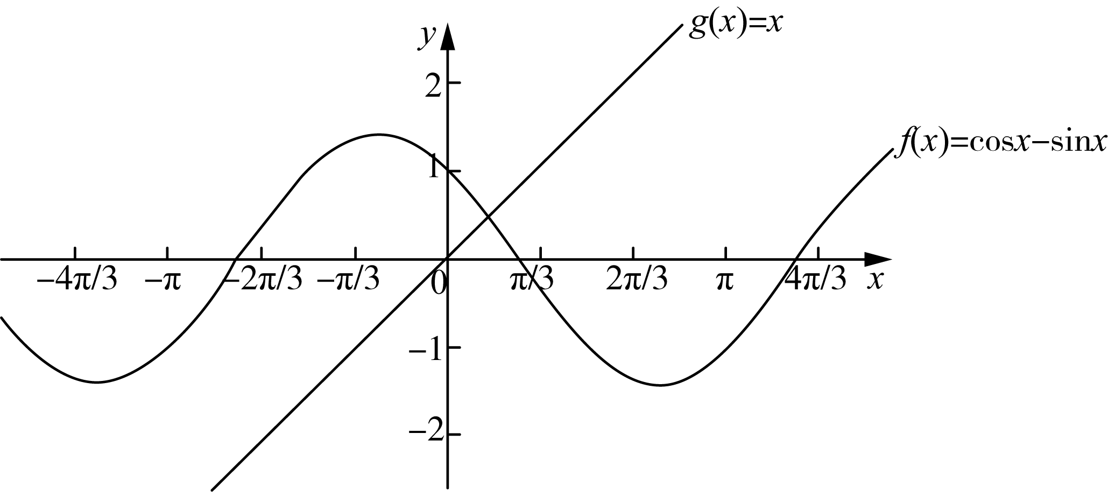
As can be seen from the figure, roughly x less than 1 where the two lines intersect. Therefore we choose $x₁ = 0.75$ to find the equation $h(x) = cos x - sin x - x = 0$ the root of。
because $h'(x) = -sin x - cos x - 1$,so:
$$xₙ^{+1}= xₙ+ \frac{cos xₙ - sin xₙ - xₙ}{sin xₙ+ cos xₙ+ 1}$$

96 Play with calculus

Let x₁ = 0. 75. Substituting into the formula above and computing step by step, we get:
x₂ = 0. 159965
x₃ = 0. 456646
x₄ = 0. 456625
because x₃、x₄ The first four decimal places of have overlapped, so the root we require is: x = 0. 4566.
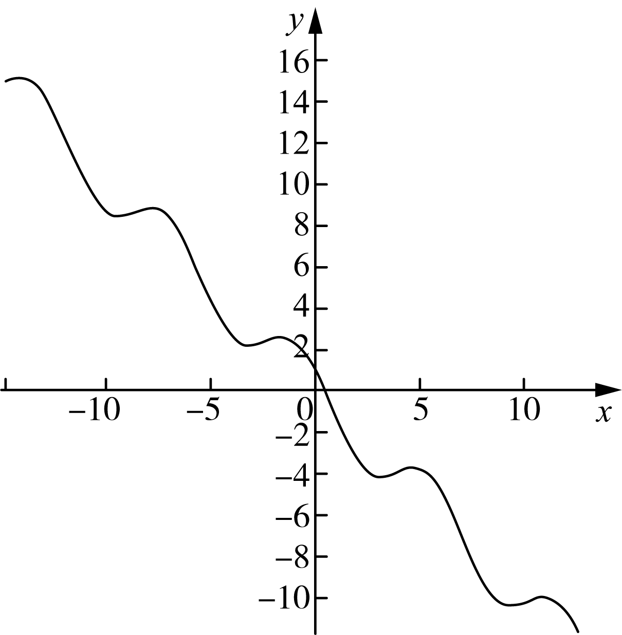
At this point, derivatives have come in many uses. Let's see again, what else is the derivative used for.

4. 5 The Mean Value Theorem and the Shape of Function Graphs
In the process of studying functions, it will be of great benefit if you can accurately grasp the shape of the function graph! As a small trend in the direction of a function, the derivative certainly plays a key role in the shape of the function graph. Understanding these effects helps to grasp the overall trend of the function.
First introduce:
Rolle's theorem(Rolle's Theorem)
hypothesis function $f(x)$ satisfy：
1) in the interval [a, b] continuous
2) in the interval (a, b) Derivable
3）$f(a) = f(b)$
Then, in the interval (a, b) There must be a real number on c, make:
$$f'(c) = 0$$
Proof of theorem: We might as well prove Rolle’s theorem in three situations.

Chapter 4 | What is the use of derivatives? 97

Scenario 1: If for the interval [a, b] on any x value, all $f(x) = f(a) = f(b)$, then the function f(x)The image is a line parallel to x The straight line of the axis, this time the interval (a, b) The tangent of any point that is internally differentiable is parallel to x axis. Just find one c All satisfied：$f'(c) = 0$。
Scenario 2: If in the interval (a, b) Within , there is a function value at a certain point greater than the function value at the endpoint, then according to the extreme value theorem, the interval (a, b) within, there must be a c point, making $f(c)$ is a functionf(x) in [a, b]the maximum value on. By definition, this $f(c)$ At the same time, it is also a relative maximum value, plusf(x) in cThe point is differentiable, so according to Fermat's theorem, we know：$f'(c) = 0$。
Scenario 3: If in the interval (a, b) Within , there is a point whose function value is smaller than the function value of the endpoint. According to the proof method in case 2, we can also get the conclusion: interval (a, b) memory at a point c，satisfy：$f'(c) = 0$。
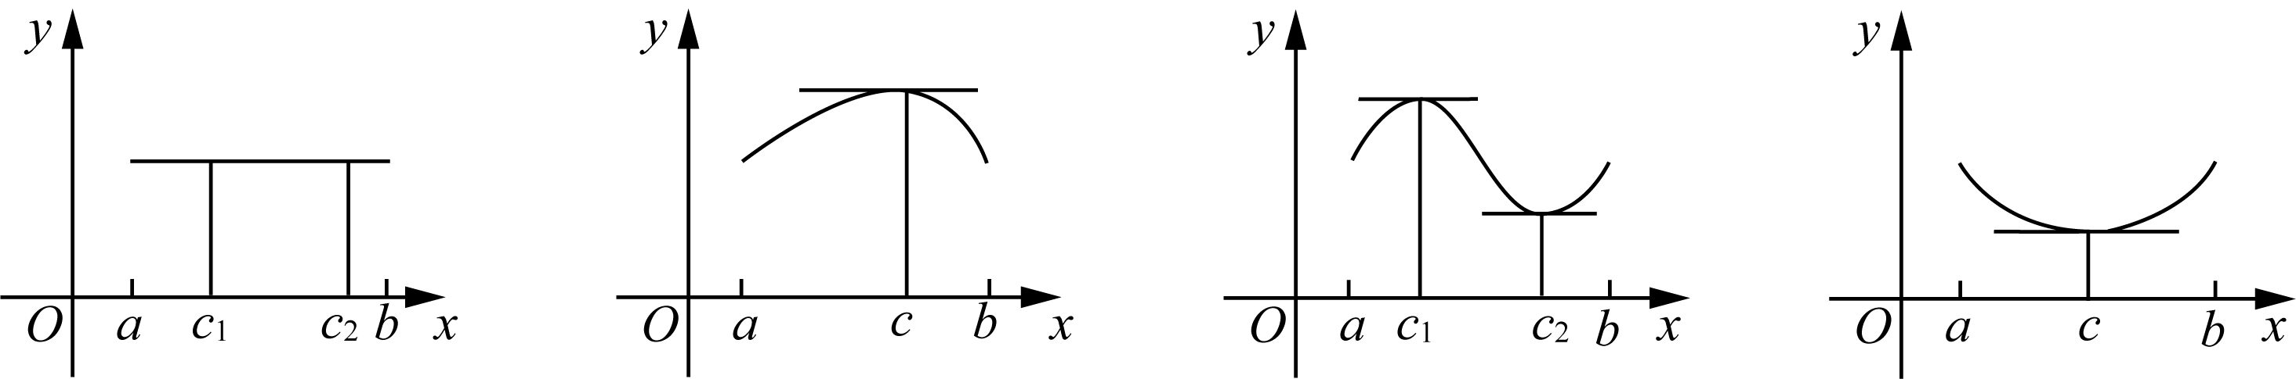
The figure above shows several situations in which Rolle's theorem holds. As can be seen from the figure, the geometric meaning of Rolle's theorem is that when the function values ​​at the endpoints of the interval are equal, the interval (a, b) memory at a point c, The tangent through this point is parallel tox-axis.
Since the endpoint function values ​​of the intervals are equal, their connecting lines are also parallel to x axis, Rolle's theorem is equal to, in the interval (a, b) memory at a point c, The tangent line of the function through this point is parallel to the line connecting the endpoints of the interval. We naturally have to ask, does this conclusion hold true when the function values ​​at the endpoints are not equal? The answer is yes!
Lagrange's mean value theorem(Lagrange's Mean Value Theorem)
hypothesis function $f(x)$ satisfy：
1) in the interval [a, b] continuous
2) in the interval (a, b) Derivable
Then, in the interval (a, b) There must be a real number on c, make:
$$f'(c) = \frac{f(b) - f(a)}{b - a}$$
Theorem Proof: Idea: Since Rolle’s theorem has just been proved, and the right side of the formula we need to prove is the endpoint of the interval.

98 Play with calculus

The slope of the connecting line. Therefore, we specifically want to find a function that is both related to the endpoint and $f(x)$ related, and preferably the function values ​​at both endpoints are equal。
If the function $f(x)$ on the straight line connecting the endpoints y The difference in values, defined as a new function $g(x)$, then the endpoint value of this new function must be 0.How about applying Rolle's theorem to it?？
We know: Connect two endpoints $(a, f(a))$、$(b, f(b))$ The straight line equation of：
$$y = f(a) + \frac{f(b) - f(a)}{b - a}(x - a)$$
So, we have:
$$g(x) = f(x) - \left(f(a) + \frac{f(b) - f(a)}{b - a}(x - a)\right)$$
This new baby g(x) What are its characteristics? It is not only in the interval [a, b] continuous, in interval (a, b) Derivable, and more importantly：$g(a) = g(b) = 0$, now the conditions for the establishment of Rolle's theorem are complete. Therefore, in the interval (a, b)There must be a little bit inside c，make：$g'(c) = 0$. Substituting this conclusion into the above definition:
$$g'(c) = f'(c) - \frac{f(b) - f(a)}{b - a} = 0$$
$$∴ f'(c) = \frac{f(b) - f(a)}{b - a}$$
In this theorem proving process, functions are tailored to apply Rolle's theorem $g(x)$ The technique is a common technique used by mathematical masters in the past generations in their creative work, and it has a very high technical content.。
The algebraic meaning of the mean value theorem is that in the interval (a, b) existence point c，Make the function $f(x)$ at point c The instantaneous rate of change of is equal to the function $f(x)$ the entire interval [a, b] average rate of change on。
The geometric meaning of the mean value theorem is that on the interval (a, b) point of existence c, Make the function pass c The tangent to a point is parallel to the line connecting the endpoints. Please refer to the picture below:
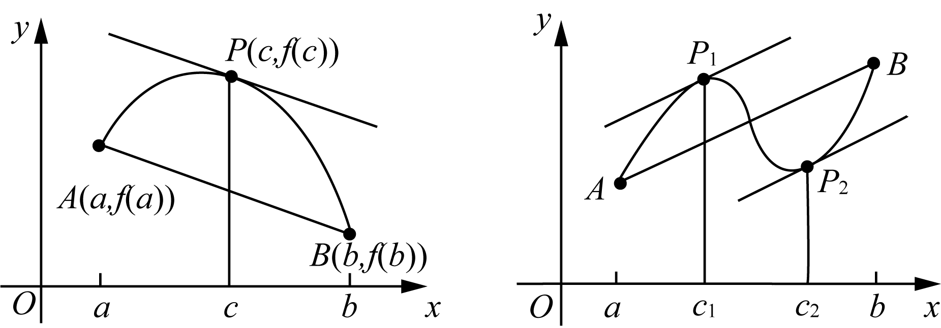
As shown in the figure above, in the figure on the left there is a value that satisfies the mean value theorem. c In the case of points, the picture on the right shows that there are two points that satisfy the mean value theorem. c point situation.

Chapter 4 | What is the use of derivatives? 99

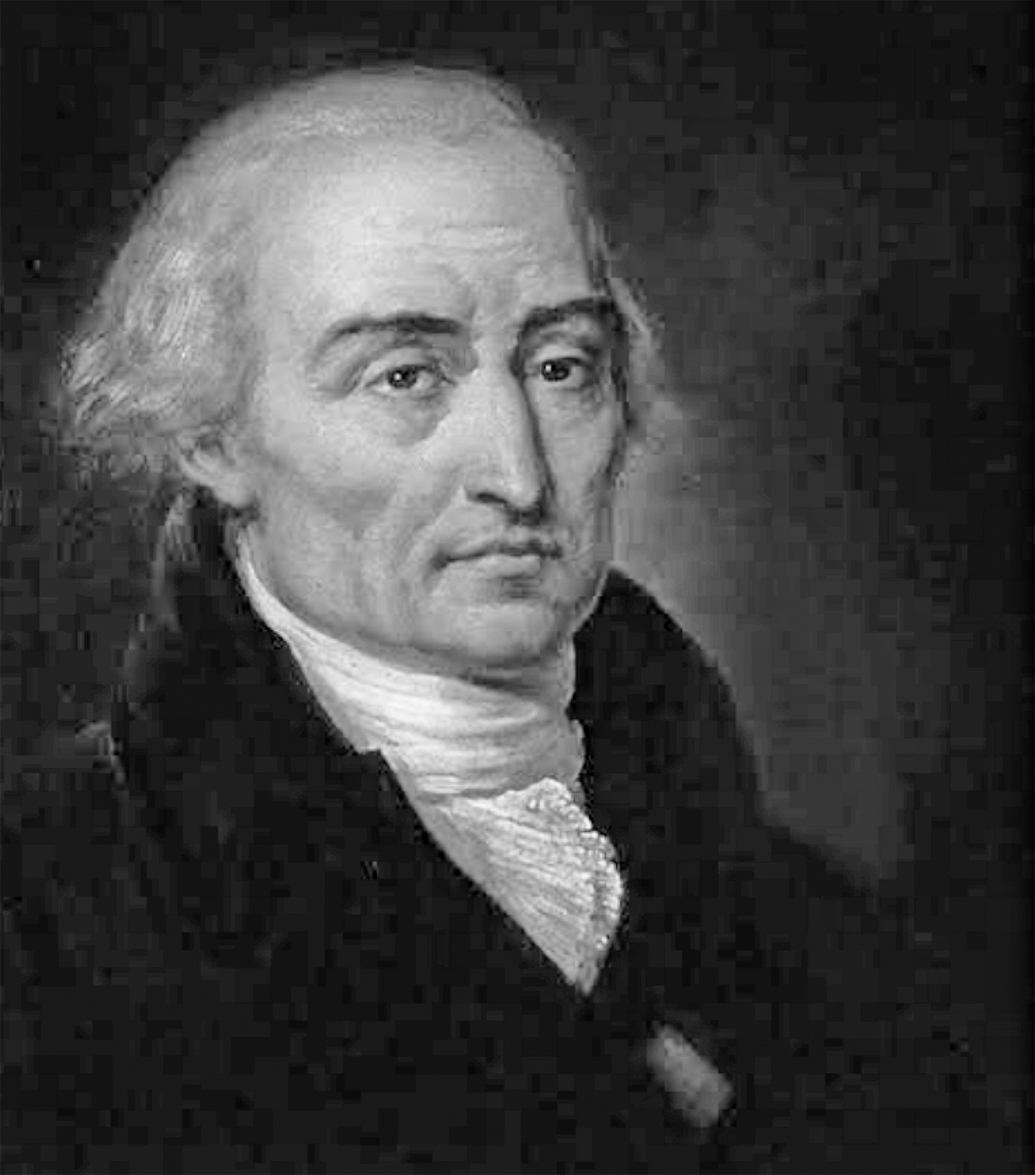
Take two questions to get a feel for it:

Example 4-10) Verification function f(x) = 2x² − 3x + 1 in the interval [0, 2] satisfies the mean value theorem.
Solution: Our task is to be in the interval [0, 2] Find one on c, make:
$$f'(c) = \frac{f(2) - f(0)}{2 - 0} = 1$$
noticed：$f'(x) = 4x - 3$, so, as long as the following about cIf the equation has a solution, our task is completed：
$$4c - 3 = 1$$
The above equation obviously has a solution: c = 1.
Sometimes, the question can be twisted, please see the following example question.

Example 4-11) Given a differentiable function f(x) on the whole interval, satisfying f′(x) ≤ 9 and f(1) = −8, find the maximum possible value of f(3).
Solution: According to the mean value theorem, we know that in the interval (1, 3) There must be something c make:
$$f'(c) = \frac{f(3) - f(1)}{3 - 1}$$
And because $f'(x) ≤ 9$,so:
$$\frac{f(3) - f(1)}{3 - 1} ≤ 9$$

100 Play with calculus

have to:$f(3) + 8 ≤ 18$,Right now$f(3) ≤ 10$. Therefore, what is sought$f(3)$ The maximum possible value is 10。
On the one hand, we can prove Lagrange's theorem through Rolle's theorem; on the other hand, Rolle's theorem can be used as a special case of Lagrange's theorem. In fact, Lagrange's theorem can also be used as a special case of another theorem, which is the famous Cauchy's mean value theorem.
Cauchy(Cauchy) mean value theorem
Let function $f(x)、g(x)$in [a, b]continuous，(a, b) can be derived, and $g'(x) ≠ 0$, then there must be a$c ∈ (a, b)$ satisfy：
$$\frac{f(b) - f(a)}{g(b) - g(a)} = \frac{f'(c)}{g'(c)}$$
Cauchy's mean value theorem can also be derived from Rolle's theorem by proving Lagrange's theorem. In fact, the application of Cauchy's mean value theorem is more about the application of curves expressed by the following parametric equations:
$$x = x(t), t ∈ (a, b)$$
$$y = y(t)$$
So, we can say that Lagrange's theorem and Cauchy's mean value theorem are both generalizations and developments of Rolle's mean value theorem. In fact, Cauchy's mean value theorem is not tested frequently. So, as a candidate, it is enough to know what this theorem looks like.
Rolle's theorem and Lagrange's theorem both explain some forms of function graphs within a certain interval to a certain extent. For example, the direction of the tangent. According to the sign of the derivative of the function in a certain interval, it can be judged whether the function is an increasing function or a decreasing function in this interval.
However, they are also increasing functions. The two increasing functions in the figure $f(x)$and$g(x)$ There is a clear difference：
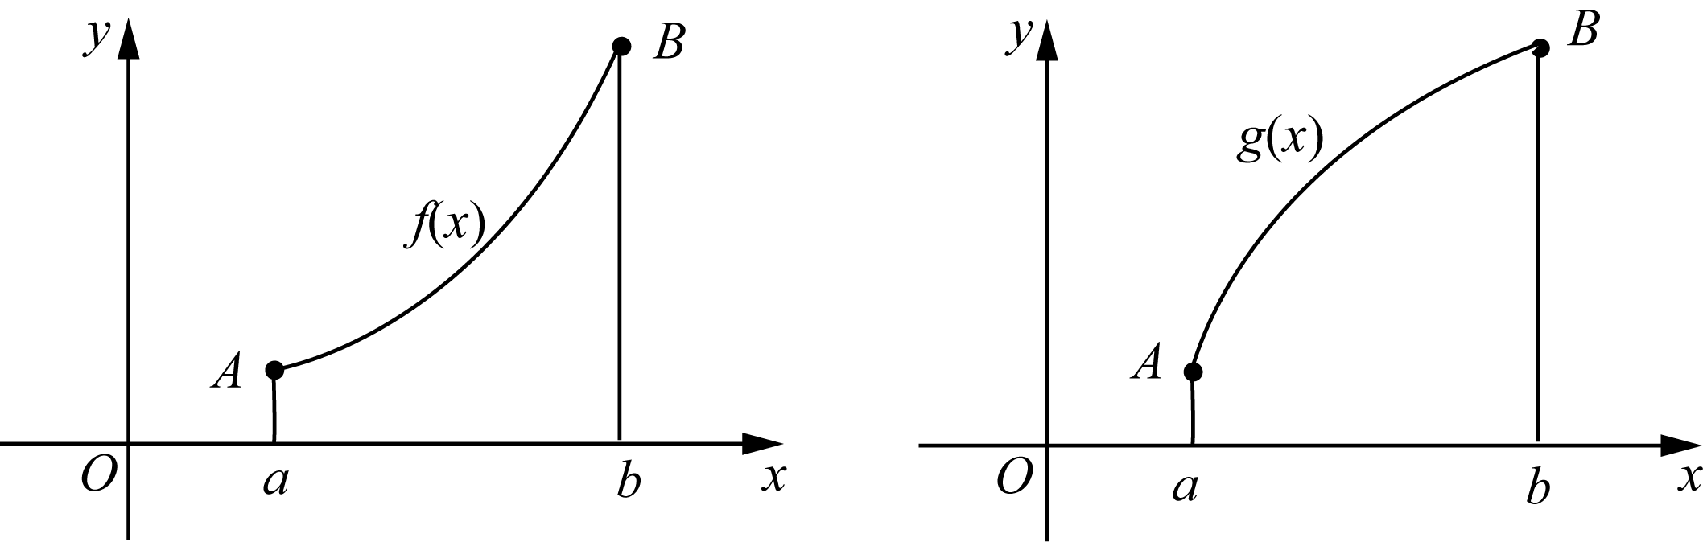
We usually call the figure with the upward opening on the left in the picture above called a convex figure, while the figure with the opening on the right is downward.

Chapter 4 | What is the use of derivatives? 101

The figure is called a convex figure. In mathematical jargon, it is: function $f(x)$ in the interval (a, b) Convex, function $g(x)$ in the interval (a, b) convex upward。
It's worth noting that there are differences between Chinese and foreign expressions of the concavity and convexity of function graphs. The Chinese method is based on"Which side is bulging?", Just say which way it bulges. In Western expressions, emphasis is placed on the direction of the opening, which is exactly the same as the direction of the opening."drum up"in the opposite direction. So, what we call an upward convex function can be expressed in English as Concave Down. And what we call the downward convex function, the corresponding English is Concave Up.
An obvious geometric meaning of upward convex functions and downward convex functions is that the tangent lines of all upward convex functions are located above the function graph; while the tangent lines of all downward convex functions are below the function graph.
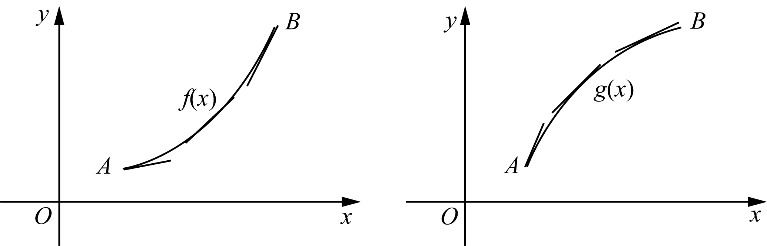
So how to determine whether the graph of a function is convex upward or downward? The magic weapon is the second-order derivative discrimination method.
if in range (a, b)，function f(x) satisfy：$f″(x) > 0$, then the function f(x)Convex downward in this interval; if in the interval (a, b)，function f(x) satisfy：$f″(x) < 0$, then the function f(x)Convex in this interval。
This discriminant method can be proved with the help of the mean value theorem. Due to space limitations, this book will not introduce it in detail.
With the help of the second-order derivative discrimination method, we have a new starting point for dealing with extremum problems. According to the sign of the second derivative, we can easily draw the conclusion:
if function $f(x)$ The second derivative of is at the point c nearby is continuous, then：
1）if $f'(c) = 0$，$f″(c) > 0$,but$f(c)$ Must be the relative minimum of the function；
2）if $f'(c) = 0$，$f″(c) < 0$,but$f(c)$ Must be the relative maximum value of the function。
The above conclusion is very intuitive geometrically. Now briefly explain the first case, since the second derivative is positive, the curve is convex downward. Therefore in c The tangent line of the function near the point is below the function graph, and because the function is c The tangent line to a point is a horizontal tangent line, so $f(c)$ becomes the relative minimum of the function。

102 Play with calculus

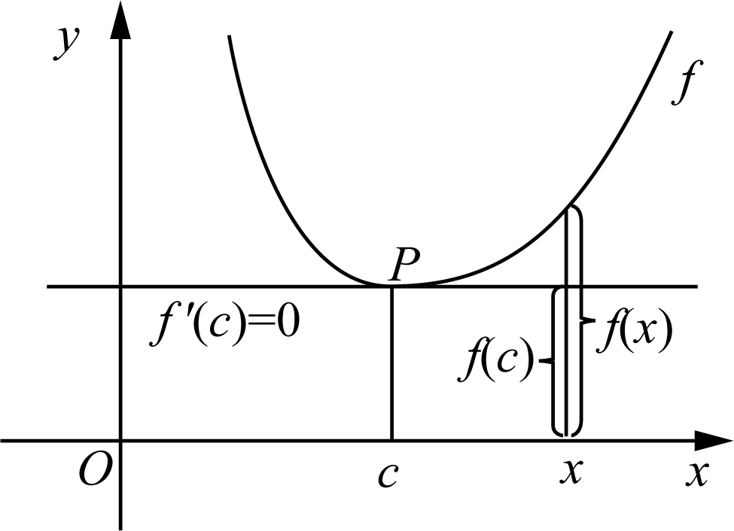
On the one hand, if the function is convex downward, the tangent line is below the function graph, and the extreme point of the function convex downward is the relative minimum point, which is consistent; on the other hand, the function is convex upward, the tangent line is above the function graph, and the extreme point of the function convex upward is the relative maximum point, which is also consistent.
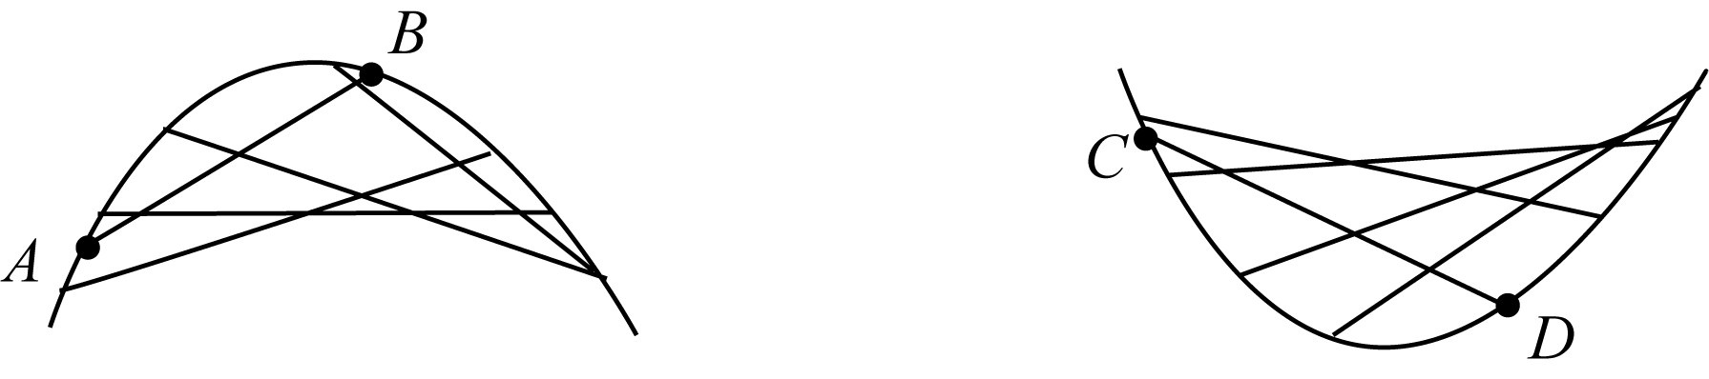
In order to observe concavity from a broader perspective, I would like to draw your attention to another fact, that is, the secant line connecting any two points of an upper convex function must be below the function graph. On the contrary, the secant line of a downward convex function must be above the function graph.
After learning the contents of this section, when we find the extreme value of a function in the future, we can either determine the increase or decrease properties of the function around the extreme point based on the sign change of the first-order derivative around the critical point, thereby determining whether the extreme point of the function is a maximum or minimum value; we can also directly determine the properties of the extreme point simply based on the sign of the second-order derivative of the function.
Now, we can look at the familiar quadratic function $y = ax² + bx + c$ Let’s give a more advanced summary：
Depend on$y' = 0$, we can find yThe critical point is $\frac{-b}{2a}$（$a ≠ 0$). So, when$a > 0$ time, due to $y″ = 2a > 0$，y It is the minimum value at the critical point; otherwise, when $a < 0$ time, due to $y″ = 2a < 0$，y The critical point is the maximum value。
Please see examples.

Example 4-12) known function f(x) Derivative of f′(x) = (x − 1) eˣ, Find the critical point of the function and explain the properties of the critical point.
Solution: Let’s use the old trick and let the derivative be 0，It can be concluded that $f(x)$ The critical point is 1 and only。
Solution 1: When $x < 1$hour,$f'(x) = (x - 1)e^{x} < 0$, so the function f(x)is a decreasing function; when $x > 1$hour,$f'(x) = (x - 1)e^{x} > 0$, so the function f(x)is an increasing function。

Chapter 4 | What is the use of derivatives? 103

so c = 1 This critical point is the minimum point.
Solution 2: Find the second derivative to get $f″(x) = xe^{x}$,so$f″(1) = e > 0$. Therefore, point 1is the minimum point。
Since x3 and x4 agree to four decimal places, the root is r = 0. 4566.
inflection point(Point of Inflection)
if function $f(x)$ The second derivative of is a continuous function, and at the point a If the left and right symbols are different, it is called a point a is a function $f(x)$ turning point。
Learning experience of turning point concept:
1) The function around the inflection point changes from an upper convex function to a lower convex function or vice versa.;
2) The second derivative of the inflection point is either 0, or does not exist.
I learned a critical point before, and now I learned an inflection point. Compare them: the critical point is where the guideline number is 0 Or non-existent points, critical points are suspected points of extreme points. The inflection point is the point where the second derivative of the function changes sign, but it should be noted that the second derivative is 0 Or it does not exist. It is only a necessary condition for this point to become an inflection point, but it is not a sufficient condition. Just as continuity is a necessary condition for differentiability, but it is not a sufficient condition for differentiability.
At this point, we should be able to explain more clearly the direction of the graph of the function near a point. The evolution of graphics is a bit like the basic strokes of Chinese writing. The strokes of writing Chinese are nothing more than horizontal and vertical strokes. The graph of a function is nothing more than the following basic forms: straight up (down) like "/"shape, the curve rises (falls) convexly like"∩"the left half of the shape (right half), The convex descending (rising) curve is like"∪"the left half of the shape (right half).
With the help of derivatives, we will have an understanding of the basic forms of functions such as increase and decrease, concavity and convexity. If we consider asymptotes again, we can draw a more realistic graph even for a more complex function.
Based on what you have learned, here is a summary of the standard steps for drawing a solid function graph:
1) Pay attention to the function domain;
2) Find the intersection of the function and the coordinate axis;
3) Pay attention to parity or symmetry;
4) Observe whether there is an asymptote;
5) Find relative extreme points;
6) Pay attention to the increase and decrease of functions and the bumps and convexities.

Example 4-13) Graph the following functions:
$$y = f(x) = \frac{3x²}{2x² - 5}$$

104 Play with calculus

Solution: First pay attention to the following five points:
1）The domain of the function is $x ≠ ±\frac{\sqrt{10}}{2}$。
2) Obviously, the intersection point of the function and the coordinate axis is the origin.
3）because $f(-x) = f(x)$, so the function is an even function, about yAxisymmetric。
4) because:
$$\lim_{x→∞}f(x) = \frac{3}{2}$$
So, the function has a horizontal asymptote y = 3/2. And because:
$$\lim_{x→\frac{\sqrt{10}}{2}⁺}f(x) = +∞, \lim_{x→\frac{\sqrt{10}}{2}⁻}f(x) = -∞$$
Therefore, the function has two vertical asymptotes：$x = ±\frac{\sqrt{10}}{2}$。
5）Find the critical point，$f'(x) = 0$：
$$f'(x) = \frac{-30x}{{\left(2x² - 5\right)}^{2}}$$
It can be seen that，0 Point is a function $f(x)$ is the only critical point. It is not difficult to know from observation that the derivative of the function changes from positive to negative at this point, that is to say 0 The point is the relative maximum point of the function。
Next, study the concavity and convexity:
The first step is to find the second derivative:
$$f''(x) = \frac{-180x² + 150}{{\left(2x² - 5\right)}^{3}}$$
The second step is in the interval ($-\frac{\sqrt{10}}{2}$, $\frac{\sqrt{10}}{2}$)，$f″(x) < 0$, so the function f(x)is an upward convex function；

Chapter 4 | What is the use of derivatives? 105

And in the interval (−∞, $-\frac{\sqrt{10}}{2}$) and ($\frac{\sqrt{10}}{2}$, +∞)，$f″(x) > 0$, so the function is a downward convex function.
To sum up, we can draw the graph of this function, roughly as follows:
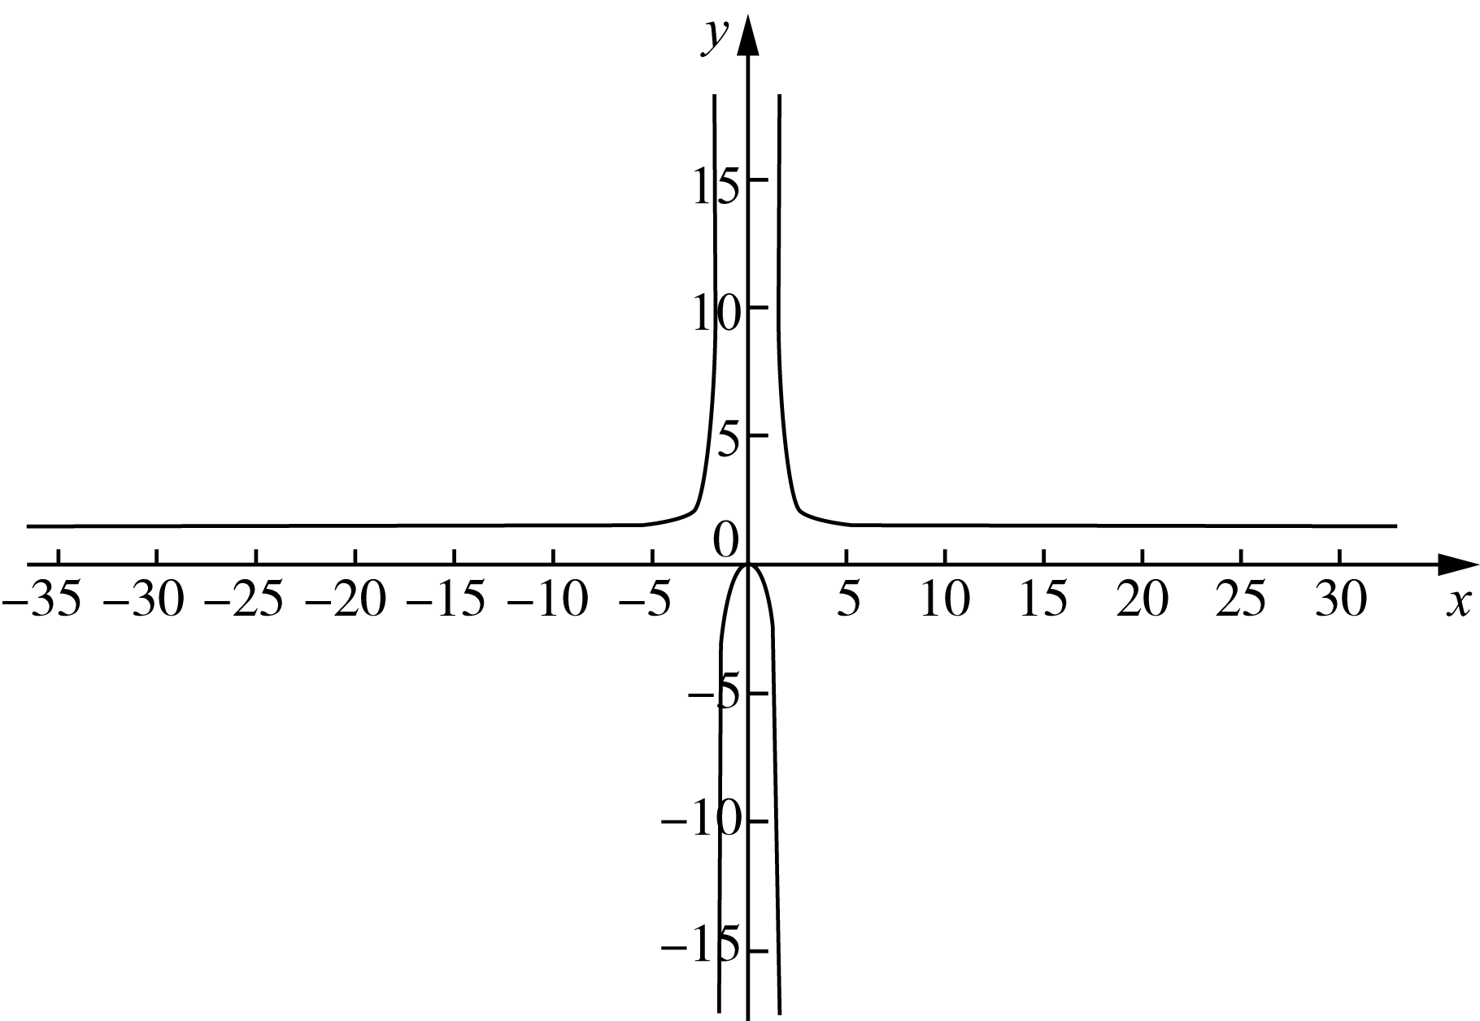

4. 6 The way to find your roots - antiderivative(Antiderivative)
When we describe someone's familiarity with an article, we often use"Memorize backwards and forwards"the word. If you are given the derivative formula of a function, you can"Memorize backwards and forwards", It is equivalent to finding out whose derivative it is based on the derivative. Put another way, if you see one on the street"unclaimed"The derivative of, you can quickly solve it based on the skills you have learned"Whose derivative is this?"This question. In calculus, this basic ability is needed.
For example, according to the formula $(x²)' = 2x$, you can easily say$2x$yes$x²$ Derivative of。
Since the action of finding the root of the original function based on the derivative is completely opposite to the process of derivation, it has a name that is reminiscent of - antiderivative.
For example, saying that 2x is the derivative of x² is equivalent to saying that x² is an antiderivative of 2x.
Generally speaking, we describe $F(x)$yes$f(x)$ When anti-derivative, it refers to：
$$F'(x) = f(x)$$
If you are proficient in derivatives, you will naturally know that not only $(x²)' = 2x$, all shapes like$x² + C$(where Cis a function of constant), its derivatives are all $2x$. In other words, the function$2x$ The antiderivative of is not unique. Therefore, our previous sentence should be changed to: function $2x$ is a function $x² + C$ Derivative of。

106 Play with calculus

Obviously, here x² + C Not a function, but a set of functions. Thus, the following conclusion is self-evident.
if, function $F(x)$and$G(x)$ All $f(x)$ The antiderivative of , then：
$$F(x) - G(x) = C，其中 C 为常数$$
Example 4-14) Find function xⁿ antiderivative of F(x), in n is a real number.
Solution: We must do it in two steps.
First, if $n = -1$，because $(ln x)' = x^{-1}$,so$ln x + C$ is the antiderivative sought；
Secondly, if $n ≠ -1$,because:
$$\left(\frac{x^{n+1}}{n+1}\right)' = xⁿ$$
so $\frac{x^{n+1}}{n+1} + C$ is the desired antiderivative. Right now：
$$F(x) = \left(ln x + C (n = -1)\right)$$
$$F(x) = \frac{x^{n+1}}{n+1} + C (n ≠ -1)$$
Although we have been saying that the antiderivative of a function usually refers to a set of functions, if certain constraints are added, a definite function can generally be obtained.

Example 4-15） known：$f″(x) = 2x^{3} + 3x^{2} - 4x + 5$，$f(0) = 2$，$f'(1) = 0$, find the function$f(x)$。
Solution: We know，$f'(x)、f(x)$ respectively：
$$f'(x) = 2 \frac{x^{4}}{4} + 3 \frac{x^{3}}{3} - 4 \frac{x^{2}}{2} + 5x + C₁$$
$$= \frac{1}{2}x^{4} + x^{3} - 2x^{2} + 5x + C₁$$
$$f(x) = \frac{1}{10}x^{5} + \frac{1}{4}x^{4} - \frac{2}{3}x^{3} + \frac{5}{2}x^{2} + C₁x + C₂$$
Bundle$f(0) = 2，f'(1) = 0$ Substituting into the above equation, we get：
$$C₂ = 2$$
$$\frac{1}{10} + \frac{1}{4} - \frac{2}{3} + \frac{5}{2} + C₁ + C₂ = 0$$
Solve the equation to get:
$$C₁ = -\frac{251}{60}$$
$$C₂ = 2$$
$$∴ f(x) = \frac{x^{5}}{10} + \frac{x^{4}}{4} - \frac{\left(2x^{3}\right)}{3} + \frac{\left(5x^{2}\right)}{2} - \frac{251}{60}x + 2$$

Chapter 4 | What is the use of derivatives? 107

To make it easier for you to play this section, I will pull out the basic functions and their corresponding antiderivatives to make you familiar with them. Welcome to take it with you!

function | antiderivative
$$x^{n} (n ≠ -1)$$ | $$\frac{x^{n+1}}{n+1} + C$$
$$\frac{1}{x}$$ | $$ln|x| + C$$
$$e^{x}$$ | $$e^{x} + C$$
$$sin x$$ | $$-cos x + C$$
$$cos x$$ | $$sin x + C$$
$$\sec^{2} x$$ | $$tan x + C$$
$$sec x · tan x$$ | $$sec x + C$$
$$\frac{1}{\sqrt{1 - x^{2}}}$$ | $$arcsin x + C$$
$$\frac{-1}{\sqrt{1 - x^{2}}}$$ | $$arccos x + C$$
$$\frac{1}{1 + x^{2}}$$ | $$arctan x + C$$

A total of ten"King Kong", As long as you memorize them backwards and forwards, you will be able to travel in the world of antiderivatives.
In the following chapters, you will see that these seemingly ordinary antiderivatives have remarkable origins.
Next, let’s meet the definite integral! Of course, before setting off, you must first consolidate your learning achievements - do exercises.

108 Play with calculus

Exercise 4
4-1) Find the critical point of the following function:
（1）$y = x⁴ + x³ + x² + 1$；
（2）$y = |x² - 1|$；
（3）$y = \frac{x+ 1}{x^{2}-x+1}$；
（4）$y = 2cos x + sin²x$。

4-2) Find the absolute extreme value of the following function in the specified interval:
（1）$y = x³ - 2x² - x + 1，x ∈ [0, 5]$；
（2）$y = 5 + 6x - 2x3，x ∈ [0, 8]$；
（3）$y = 2x³ - 3x² - 12x + 1，x ∈ [-2, 3]$；
（4）$y = \frac{x}{x^{2}-x+ 1}，x ∈ [0, 3]$；
（5）$y = x√(4 - x²)，x ∈ [1, 2]$；
（6）$y = x + cos(\frac{x}{2})，x ∈ [\frac{π}{4}, \frac{7π}{4}]$。

4-3) Use the linear approximation method to estimate the following values:
（1）$(2.999)⁴$；
（2）$sin 1°$；
（3）$∛1001$。

4-4) Use Newton's method to find the roots of each of the following equations (accurate to the decimal point) 6 digits):
（1）$3cos x = x + 1$；
（2）$∛x= x² - 1$；
（3）$cos(x² - 1) = x^{4}$。

4-5) Please verify that the following functions satisfy Lagrange's mean value theorem in the specified interval:
（1）$f(x) = 2x³ - 3x + 1，x ∈ [0, 2]$；
（2）$f\left(x\right)=\frac{1}{x}，x ∈ [1, 3]$

4-6）Proof: Eq. $x^{3}-15x+c=0$in the interval$[-2, 2]$ Within, there is at most one root。

4-7）if $f(1) = 10，f'(x) > 2（1 < x < 4），$Excuse me$f(4)$ Is there a lower limit?？

4-8) For each of the following functions: a) Find the rising and falling intervals of each function; b) Find the relative extreme values ​​of each function; c) Find the inflection point and upper or lower convex interval of each function.
（1）$y = x³ - 12x + 3$；
（2）$y = -x³ + 2x² + 2$；
（3）$y = (x + 1)⁵ - 5x - 2$；
（4）$y = √(6 - x)$；
（5）$y = 2cos x + cos²x，x ∈ (0, 2π)$。

4-9) Find the antiderivative of each of the following functions:
（1）$y = 2x³ - 3x² + x + 1$；
（2）$y = \frac{x^{2} + x + 2}{\sqrt[4]{x}}$；
（3）$y = 4sec²x - 5x^{4}$；
（4）$y = e^{3}$。

