Table of contents
4. 1 Re-discussing limits - L'Hôpital's Rule
4. 2 Extreme value problem (Extremum)
4. 3 Linear Approximation
4.4 Newton's method
4. 5 Mean value theorem and the shape of function graphs
4.6 Antiderivative
Exercise 4

Chapter 4
Applications of derivatives

84 Play with calculus

In the first two chapters, the fundamental concept of limit in calculus was established, the concept of slope learned in middle school was elevated, and derivatives were introduced.
Considerable effort was also devoted to determining derivatives of various functions. These derivatives are expected to have important applications.
Indeed, derivatives are highly useful.

4. 1 Re-discussing limits - L'Hôpital's Rule
As mentioned before, limit problems are the core problem of calculus. When we deal with limit problems, we often encounter two kinds of thorny limit problems:

$\frac{∞}{∞} 型 和 \frac{0}{0} 型$

Two infinity-over-infinity forms were encountered, and the starting point was not immediately clear.
In long-term comparisons, the decisive factor is the growth rate. Since growth rate is a rate of change, and rate of change is measured by derivatives, derivatives provide the key analytic tool.
From this we think that if two$∞$There is no conclusion in comparison, but if the ratio of their derivatives is higher or lower, then the ratio itself will have results. This simple idea was proved by the French mathematician Mr. L'Hôpital more than 300 years ago.

L'Hôpital's Rule
hypothesis function$f(x)$and$g(x)$, is differentiable in a region containing point a (it is not required to be differentiable in a), and$g(x) ≠ 0$. if:

$\lim_{x→a}f(x) = 0 且 \lim_{x→a}g(x) = 0$
or:
$\lim_{x→a}f(x) = ∞ 且 \lim_{x→a}g(x) = ∞$

So:
$\frac{\lim_{x→a}f(x)}{\lim_{x→a}g(x)} = \frac{\lim_{x→a}f′(x)}{\lim_{x→a}g′(x)}$

Of course, the premise is that the limit on the right exists.
L'Hôpital's Rule resolves both types of indeterminate forms effectively. Several points concerning this rule should be noted.

Chapter 4 | What is the use of derivatives? 85

First of all, when$x → ±∞$, the same rule applies.
Secondly, if the limit of the ratio of the derivatives of two functions is still$\frac{∞}{∞}$type and$\frac{0}{0}$type, you can use this rule again to second derivatives or even$n$On the first derivative.
Finally, the proof of this law requires more advanced mathematical knowledge.
At present, this result may be accepted directly and applied when needed.

Example 4-1) begin
$\lim_{x→1}\frac{ln x}{x−1}$
Solution: According to L'Hôpital's Rule, we have:

$\lim_{x→1}\frac{ln x}{x−1} = \frac{\lim_{x→1}(ln x)′}{\lim_{x→1}(x−1)′} = \frac{\lim_{x→1}\frac{1}{x}}{\lim_{x→1}1} = \lim_{x→1}\frac{1}{x} = 1$

Example 4-2) begin
$\lim_{x→∞}\frac{2^{x}}{8x}$
Solution: Using L'Hôpital's Rule, we obtain:

$\lim_{x→∞}\frac{2^{x}}{8x} = \lim_{x→∞}\frac{(2^{x})′}{(8x)′} = \lim_{x→∞}\frac{2^{x}·ln 2}{8} = ∞$

Two additional limits are considered below.

Example 4-3) begin
$\lim_{x→∞}\frac{3^{x}}{x^{3}}$
Solution: To evaluate this limit, derivatives of the numerator and denominator are computed three times before the result becomes explicit:

$\lim_{x→∞}\frac{3^{x}}{x^{3}} = \lim_{x→∞}\frac{(3^{x})′}{(x^{3})′} = \lim_{x→∞}\frac{3^{x}·ln 3}{3x^{2}} = \lim_{x→∞}\frac{(3^{x}·ln 3)′}{(3x^{2})′} = \lim_{x→∞}\frac{3^{x}·{\left(ln 3\right)}^{2}}{6x}$
$= \lim_{x→∞}\frac{(3^{x}·{\left(ln 3\right)}^{2})′}{(6x)′} = \lim_{x→∞}\frac{3^{x}·{\left(ln 3\right)}^{3}}{6} = ∞$

It can be seen from the problem-solving process of this problem that even if the denominator is not$x³$, but$x¹⁰⁰$or higher powers will not change the result of the limit. Similarly, as long as the molecule$aˣ$in$a > 1$, the result will not change, it is all$∞$。
This also confirms what we said before:$aˣ$type$∞$The most powerful, follow$xⁿ$type$∞$There is no comparison. Let's take another look$xⁿ$type$∞$meet$logᵦ x$type$∞$,what happens.

Example 4-4) begin
$\lim_{x→∞}\frac{\sqrt{x}}{{\left(ln x\right)}^{2}}$
untie:

$\lim_{x→∞}\frac{\sqrt{x}}{{\left(ln x\right)}^{2}} = \lim_{x→∞}\frac{(\sqrt{x})′}{({\left(ln x\right)}^{2})′} = \lim_{x→∞}\frac{\sqrt{x}}{4·ln x}$
$= \lim_{x→∞}\frac{(\sqrt{x})′}{(4·ln x)′} = \lim_{x→∞}\frac{\sqrt{x}}{8} = ∞$

86 Play with calculus

This time,$xⁿ$type$∞$and$logᵦ x$type$∞$The comparison result is also$∞$！
Again, if you encounter$\frac{∞}{∞}$Type limit problem, leaving only the highest level in the numerator and denominator$∞$Just "on duty" and the result will not be wrong.
With L'Hôpital's Rule, the two classical limits in Chapter 2 can be interpreted directly:

$\lim_{x→0}\frac{sin x}{x} = 1$

$\lim_{x→0}\frac{1−cos x}{x} = 0$

As study proceeds, previously encountered results become increasingly transparent.
Additional applications of derivatives are examined next.

4. 2 Extreme value problem (Extremum)
Attention is often directed toward extreme cases.
Likewise, maximum and minimum values of functions are of substantial interest because extrema are broadly useful in applications.
Derivatives provide an effective method for solving extremum problems. Several foundational concepts are introduced first.
Local Maximum: If for all x values ​​in an open interval including point c, the inequality$f(x) ≤ f(c)$are established, then$f(c)$It's a function$f(x)$a local maximum of . Local maximum, sometimes also called relative maximum (Relative Maximum).
Local behavior and global behavior should be considered separately.
Global Maximum: If for all values ​​of x, the inequality$f(x) ≤ f(c)$are established, then$f(c)$It's a function$f(x)$the global maximum value. The global maximum is sometimes called the absolute maximum.
Next, let’s talk about our understanding of these two concepts. The so-called local means that as long as the inequality$f(x) ≤ f(c)$holds true within even a small interval,$f(c)$It's the local maximum.
For example, if altitude on Earth is treated as a function, mountain summits provide local maxima, whereas the summit of Mount Everest represents the global maximum.
The concept of minimum value is opposite to the concept of maximum value.

Chapter 4 | What is the use of derivatives? 87

Local Minimum: If for all x values ​​in an open interval including point c, the inequality$f(x) ≥ f(c)$are established, then$f(c)$It's a function$f(x)$a local minimum of . Local minimum, sometimes also called relative minimum (Relative Minimum).
Global Minimum: If for all values ​​of x, the inequality$f(x) ≥ f(c)$are established, then$f(c)$It's a function$f(x)$the global minimum of . The global minimum is sometimes called the absolute minimum (Absolute Minimum).
Once we understand the concept of extreme values, we can discuss how to find extreme values.
To study how to find the extreme value, we must first determine its existence. Therefore, it is necessary to understand the extreme value theorem.
Extreme Value Theorem: If function$f(x)$is continuous on the closed interval [a, b], then there must be two points c and d on this interval, such that$f(c)$is the absolute maximum value,$f(d)$is the absolute minimum.
The figure below is a schematic diagram of the extreme value theorem.
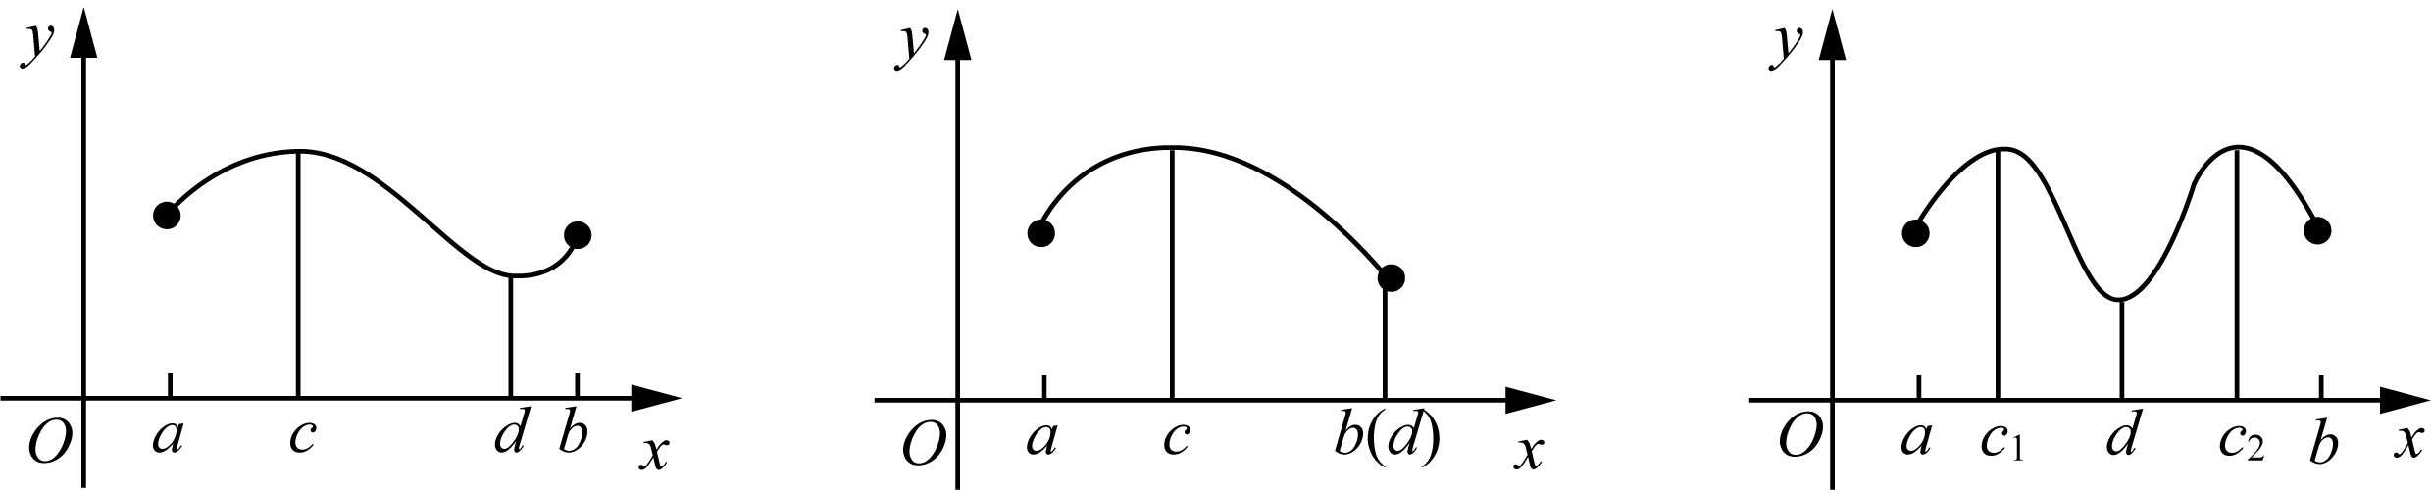
Two points are emphasized: (1) an absolute extremum on a closed interval is guaranteed to exist but need not be unique; (2) continuity and interval closedness are both essential hypotheses of the extreme value theorem.
The figure below shows the situation where the two conditions of continuity and interval closure are missing respectively, and the extreme value theorem does not hold.
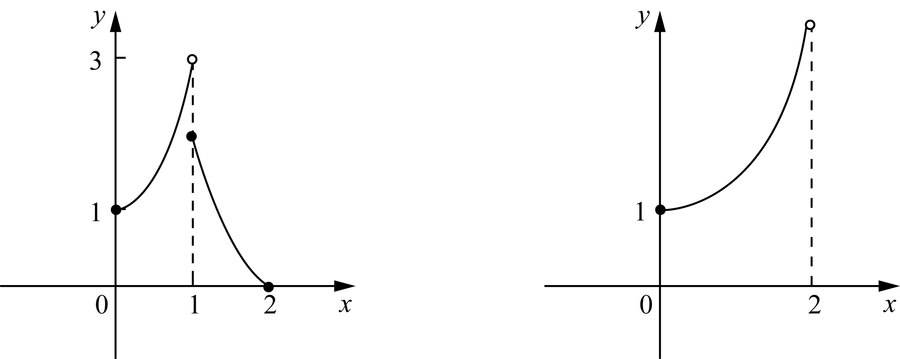
As shown above, the function on the left has no maximum because continuity fails, while the function on the right has no maximum because the domain interval is not closed.
After existence is established, methods for locating extrema can be developed from their defining properties. For a continuous function on a closed interval, global extrema exist. In general, global extrema are selected from local extrema and endpoint values, so local extrema are located first.

88 Play with calculus

The question then becomes: what characterizes a local extremum? The following theorem gives the criterion:
Fermat's Theorem
If point c is a function$f(x)$the local extreme point of , and$f′(c)$exists, then:
$f'(c) = 0$
Proof: Let’s assume first$f(c)$yes$f(x)$The local maximum and minimum values ​​of can also be proved in the same way.$f(c)$is a local maximum, which means: in a small area containing c, the following inequality holds:
$f(x) ≤ f(c)$
So, we have:
$f′(c^{−}) = \lim_{h→0⁻}\frac{f(c+h)−f(c)}{h} ≥ 0$
In the above formula, since the numerator is not positive and the denominator is negative, therefore$f′(c) ≥ 0$. In the same way, we have:
$f′(c^{+}) = \lim_{h→0⁺}\frac{f(c+h)−f(c)}{h} ≤ 0$
So far, we have reached the conclusion that one side of the left and right derivatives of the function at point c is non-negative and the other side is non-positive. now that$f′(c)$exists, its left and right derivatives must be equal. Then there is only:$f′(c) = 0$。
Note: Fermat's Theorem states only that if a local extremum is differentiable, then its derivative is 0. It does not assert that every local extremum is differentiable. Some local extrema occur where the derivative does not exist. Points where the derivative is 0 or undefined are collectively called critical points.
A practical procedure for extrema is obtained: first determine all critical points, that is, points where the derivative is 0 or undefined; then compare function values at critical points and interval endpoints to determine local and global extrema.
Endpoint values must be examined separately because endpoints may be global extrema even though they do not satisfy the definition of local extrema. For example, a strictly monotone function attains global extrema only at endpoints and has no interior local extrema.
How is each critical point classified as a local maximum or local minimum? This classification is determined by the derivative. As introduced previously, the sign of the derivative determines local monotonic behavior.

Chapter 4 | What is the use of derivatives? 89

It is not difficult to deduce that if the derivative of a function is positive within a certain interval, then the function is an increasing function in this interval. On the contrary, if the derivative is negative, the function is a decreasing function.
Equivalently, the sign of the tangent slope determines whether the function is increasing or decreasing.
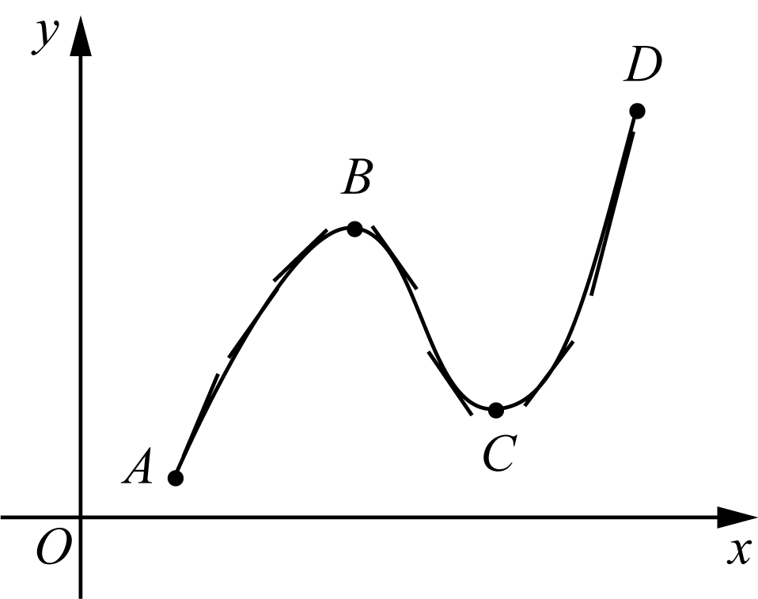
As shown in the figure above, the function is an increasing function in the AB segment and the CD segment, and its tangent slope or derivative is positive. The derivative of the function in segment BC is negative, so segment BC is a decreasing function.
Obviously, the derivative of the function at points B and C is 0, that is to say, B and C are both relative extreme points of the function.
When the function passes through B, its derivative goes through a process from positive to zero, and then to negative. Correspondingly, the function changes from an increasing function to a decreasing function. Therefore, point B is the relative maximum point.
When the function passes through point C, its derivative undergoes a process from negative to zero, and then to positive. Correspondingly, the function changes from a decreasing function before point C to an increasing function after point C. Therefore, point C is the relative minimum point of the function.
Conclusion: If the derivative around the critical point of the function changes from positive to negative, then the critical point is a local maximum point. On the contrary, if the derivative around the critical point of the function changes from negative to positive, then the critical point is the local minimum point of the function.
At this stage, the procedure for finding extrema is established. The method is now applied in examples.

Example 4-5)Find function$f(x) = 2x^{3} − 3x^{2} − 12x$The absolute extreme value in the interval [−2, 3].
Solution: Proceed systematically by first finding the critical points:
$f'(x) = 6x² − 6x − 12 = 6(x² − x − 2) = 6(x − 2)(x + 1)$
It follows that 2 and −1 are critical points of the function. Comparing the function values ​​at critical points and endpoints, we find:
$f(−1) = 7, f(2) = −20, f(−2) = −4, f(3) = −9$
therefore:
$f_{max} = f(−1) = 7, f_{min} = f(2) = −20$
The graph of this function is shown below:
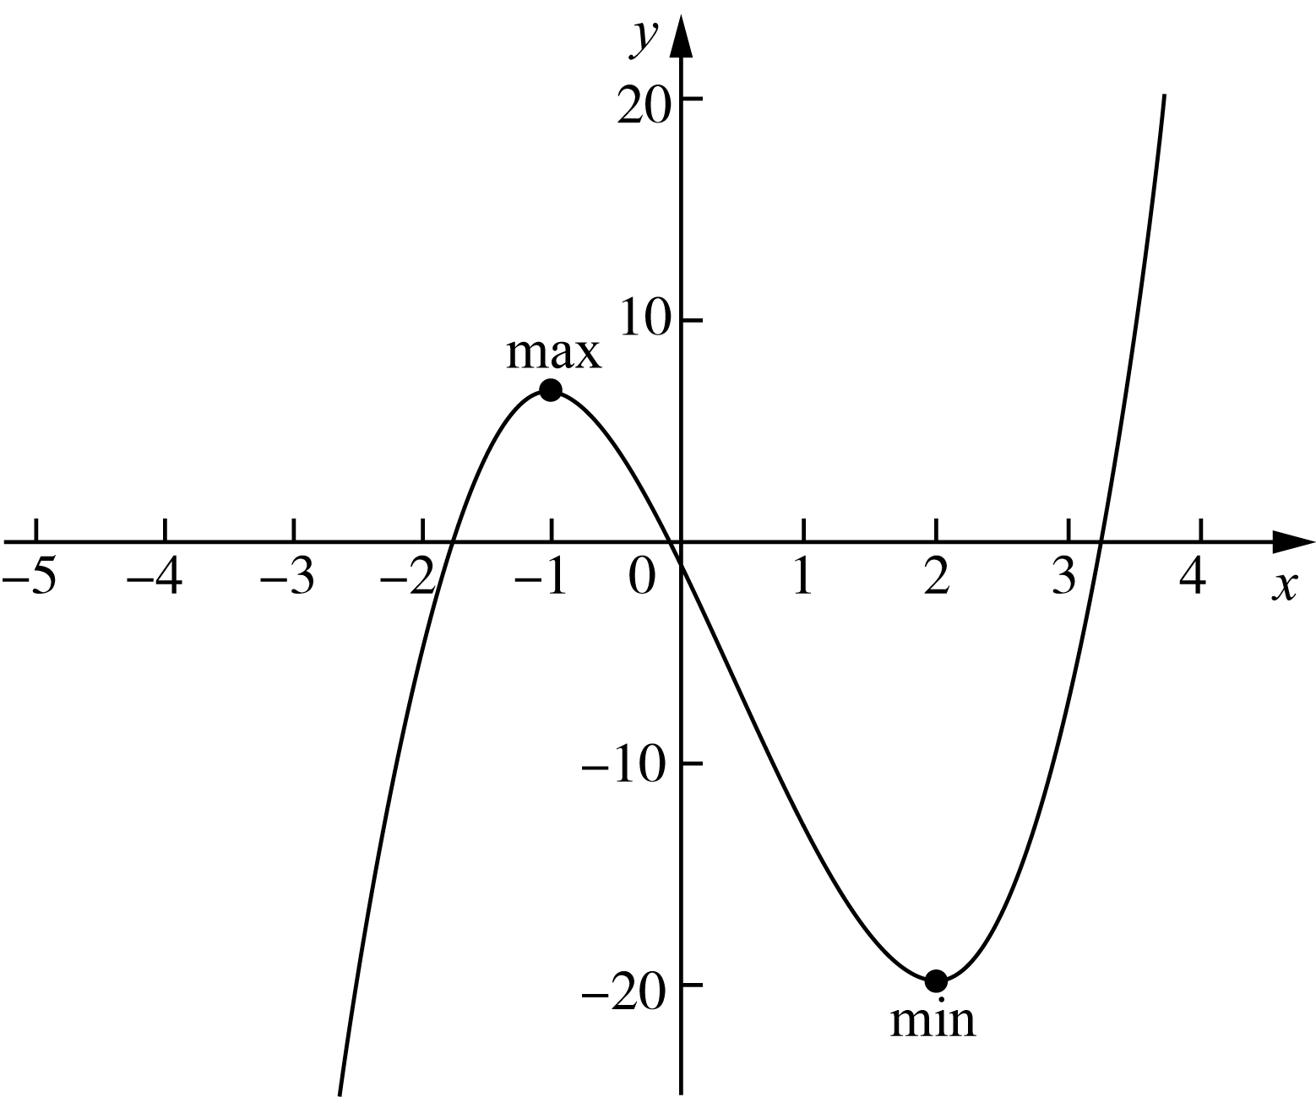

90 Play with calculus

Example 4-6)Find the function$f(x) = x⁴ − 8x²$All extreme points and corresponding function values.
Solution: First find the critical point:
$f'(x) = 4x³ − 16x = 4x(x² − 4) = 4x(x + 2)(x − 2)$
The critical points are −2, 0, 2.
Next, examine the positive and negative derivatives around the critical point. Observation shows that: to the left of point −2, the derivative is negative; on (−2, 0), the derivative is positive; on (0, 2), the derivative is negative; to the right of point 2, the derivative is positive.
It can be seen that points −2 and 2 are the relative minimum points of the function, and point 0 is the relative maximum point of the function. The function values ​​are:$f(−2) = f(2) = −16$，$f(0) = 0$。
A closer look shows that: function$f(x)$There is no absolute maximum, but there is an absolute minimum. The relative minimum in this question happens to be the absolute minimum. By extension, all 4th degree functions have no absolute maximum, but there must be an absolute minimum. Of course, except for the case of closed intervals.
The graph for this problem is shown below:
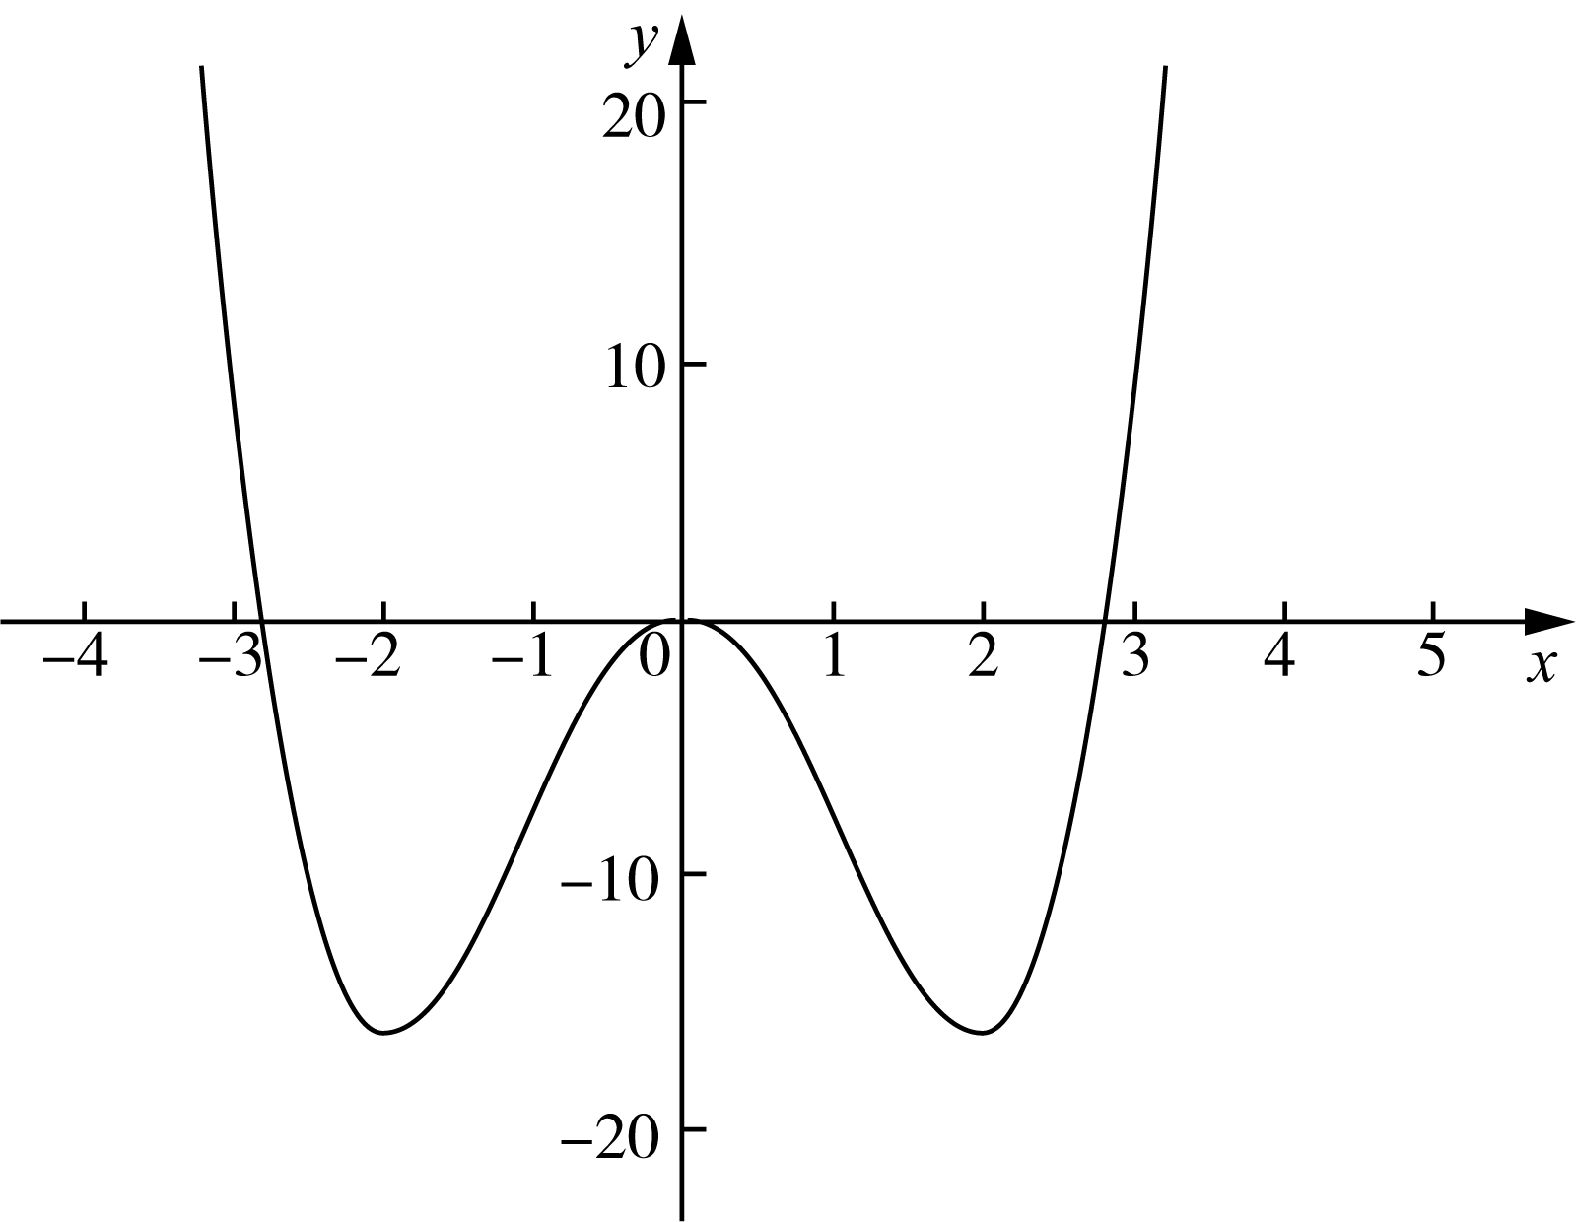

Chapter 4 | What is the use of derivatives? 91

4. 3 Linear Approximation
As introduced earlier, calculus addresses curves through local linearization. A curve is treated as composed of small segments, each approximated by a line. Although each approximation is inexact, accuracy improves as segment length decreases indefinitely.
Which line should represent the curve locally? Since local behavior at a point is determined by the tangent direction, the tangent line at that point is selected. In general, approximation improves as one moves closer to the point of tangency.
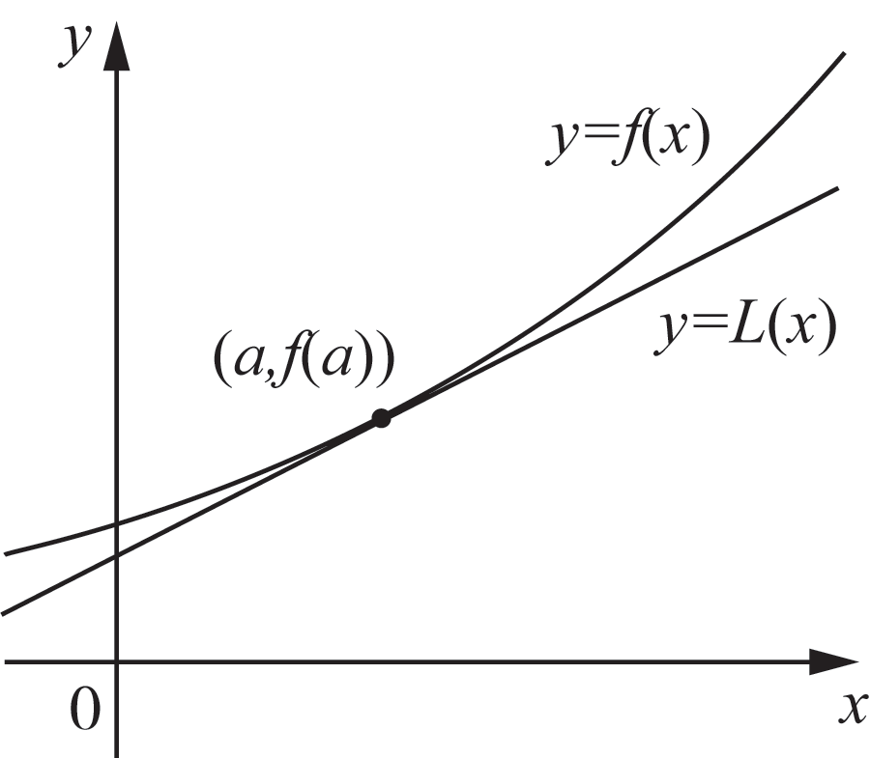
As shown in the figure above, the so-called linear approximation means that it is approximately represented by a linear function near point a.$f(x)$. The equation of the tangent line passing through point a is:
$y = f(a) + f'(a)(x − a)$
Therefore, the linear approximation near point a is:
$L(x) = f(a) + f'(a)(x − a)$
Linear approximation is concise and computationally efficient. Approximations based on quadratic or higher-order functions are typically more accurate but require substantially more computation. Despite its limitations, linear approximation remains practically important.
An example is now given to illustrate linear approximation.

Example 4-7)Find function$f(x) = \sqrt[3]{x}$exist$x = 27$linear approximation at and use it to estimate$\sqrt[3]{28}$(accurate to four decimal places), compare this estimate with the exact value.
Solution: From the meaning of the question, we know that f(27) = 3, and the derivative of the function is:
$f'(x) = \frac{1}{3\sqrt[3]{x^{2}}}, f'(27) = \frac{1}{3\sqrt[3]{{27}^{2}}} = \frac{1}{27}$

92 Play with calculus

Therefore, the required linear approximation is:
$L(x) = 3 + \frac{1}{27}(x − 27)$
$∴ L(28) = 3 + \frac{1}{27} ≈ 3.037$
$∴ ∛28 ≈ 3.0370$
On the other hand, using a calculator directly calculates:$∛28 ≈ 3.0366$. It can be seen that the estimated value is slightly larger than the precise value. After calculation, it can be seen that the accuracy$< 1.3 × 10⁻⁴$。
Next, linear approximation is connected with differential calculus. Consider the diagram introducing function differentials:
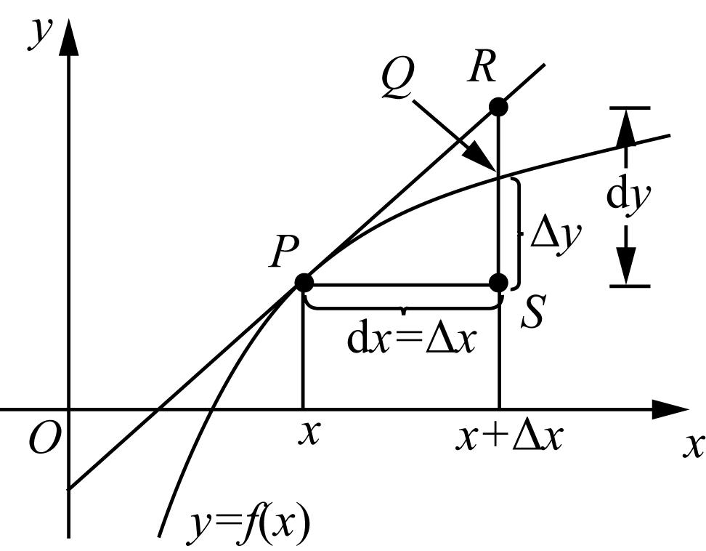
We know that the linear approximation of point a is:
$L(x) = f(a) + f'(a)dx = f(a) + dy$
Its corresponding point is R. And the exact value is:
$y = f(x) + Δy$
Its corresponding point on the graph is point Q. The difference between the approximate value and the exact value is (dy − Δy). Obviously, the smaller dx is, the smaller this error will be.
Linear approximation is conceptually straightforward but not always computationally convenient. It is presented separately because it exemplifies the fundamental calculus strategy of simplifying complex problems and because it has substantial historical importance.

Chapter 4 | What is the use of derivatives? 93

4.4 Newton's method
Linear equations in one variable are elementary, and quadratic equations admit explicit root formulas. For more complicated equations, consider the following example:
$ax³ + bx² + cx + d = 0$
A more complicated example is given below:
$2x³ − 3x·sin(x) − 5lnx = 0$
For equations of this type, no general closed-form root formula is available. Most equations arising in applications likewise do not admit explicit root formulas.
It was established long ago that many equations cannot be solved exactly in closed form. Consequently, systematic methods were developed to obtain approximate solutions.
Newton introduced an elegant method for approximating equation roots. The method applies linearization to nonlinear equations.
The idea is as follows:
1) As shown in the figure on the right, assuming that our task is to find$f(x)$The root r. We who have no clue can only guess an x₁ first. Of course, it is almost certain that x₁ is not the r we require.
2) Next, we find the curve at the point$x₁$The tangent line L. Since it is a straight line, we can easily find the intersection point of the straight line L and the x-axis$x₂$。
3) Naturally, x₂ is not r with high probability. However, since the tangent direction is the minor trend of the function, it represents the curve at point x₁$f(x)$direction. Thus we know that although x₂ is not r, it should be closer to r than x₁.
4) Find the point of the curve$x₂$tangent to , and find its intersection with the x-axis$x₃$。$x₃$Compare$x₂$closer to r.
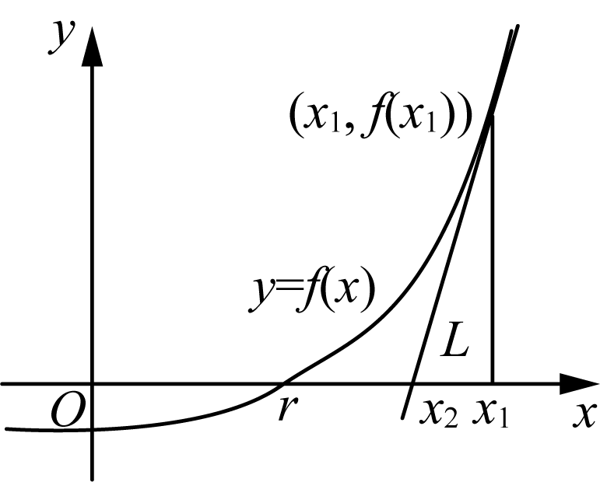
5) Repeat the above steps to get$x₁, x₂, x₃, …，xₙ, …$
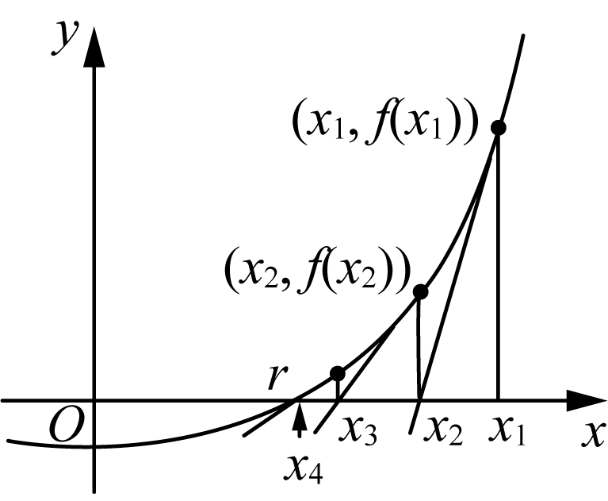

94 Play with calculus

From the figure above, the following relation is obtained:
$f'(x₁) = \frac{f(x₁)}{x₁ − x₂}$
$f'(x₂) = \frac{f(x₂)}{x₂ − x₃}$
By iteration:
$f'(xₙ) = \frac{f(xₙ)}{xₙ − xₙ₊₁}$
At this point:
$xₙ₊₁ = xₙ − \frac{f(xₙ)}{f'(xₙ)}$
7) Conclusion: The larger the value of n, the closer xₙ is to r. That is:
$\lim_{n→∞}xₙ = r$
Although expressed using a limit, the underlying idea is fundamental. The method is now applied.

Example 4-8)from$x₁ = 2$Let’s start and find the equation$x³ − 2x − 5 = 0$Approximate value of the root of (accurate to four decimal places).
Solution: Assume$f(x) = x³ − 2x − 5$
$∴ f′(x) = 3x² − 2$
So, following Newton's method, we have:
$xₙ₊₁ = xₙ − \frac{xₙ³ − 2xₙ − 5}{3xₙ² − 2}$
thus:
$x₂ = 2 − \frac{2³ − 2×2 − 5}{3×2² − 2} = 2.1$
$x₃ = 2.1 − \frac{2.1³ − 2×2.1 − 5}{3×2.1² − 2} ≈ 2.0946$
How accurate is x₃? Use a calculator to calculate:$f(2.0946) ≈ 5.4 × 10⁻⁴$. It can be seen that the accuracy of x₃ is quite impressive. So, why this example? Remember, this question is the original question in Mr. Newton’s paper introducing Newton’s method!
Although Newton's method is effective, inappropriate initial choices may lead to incorrect outcomes.

Chapter 4 | What is the use of derivatives? 95

region and may fail to achieve the desired result. See the figure below:
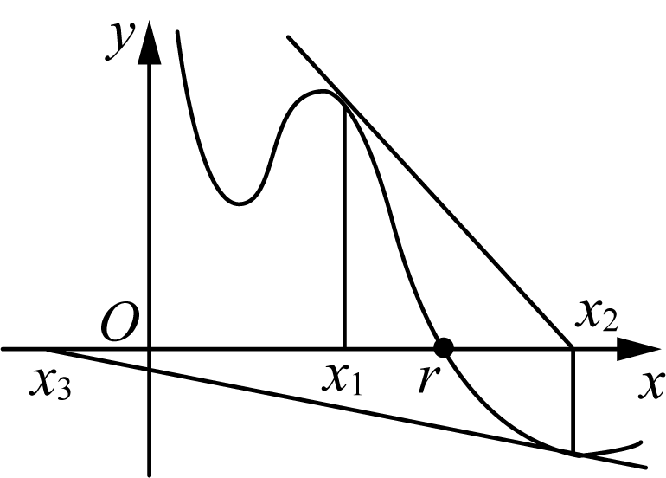
$x₁$It still looks like that, but since$x₂$From now on, I will gradually drift away from r. Why? Because the first step in Newton's method,$x₁$The choice is a technical job!
Just like the example in the master's manuscript, he chose$x₁ = 2$, why not choose 0, 1, −1? Just compare it and you will know. Obviously,$f(0) = −5，f(1) = −6，f(−1) = −4，而 f(2) = −1$. Even if you were given a choice, you would choose the function value 2 closest to 0 as$x₁$Bar.
The idea of Newton's method is often summarized as proceeding step by step. However, selection of the initial iterate requires careful judgment.
With continuing advances in numerical computing and AI, Newton's method remains of substantial practical significance. Many advanced calculators solve nonstandard equations primarily through Newton-type iterations.
Another example is provided to reinforce the procedure.

Example 4-9)Find equations using Newton's method$cos x − sin x = x$The root of is required to be accurate to four decimal places.
Solution: Let’s draw first$f(x) = cos x − sin x$as well as$g(x) = x$Sketch of:
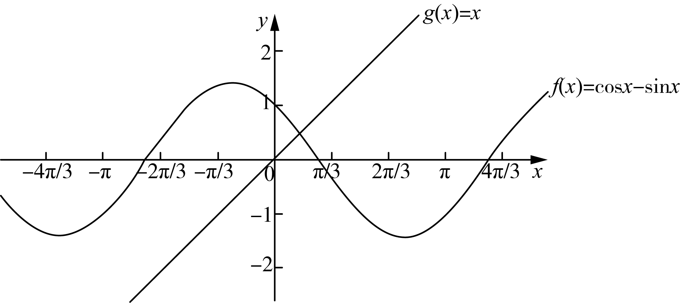
As can be seen from the figure, the two lines intersect roughly where x is less than 1. Therefore we choose$x₁ = 0.75$to find the equation$h(x) = cos x − sin x − x = 0$of roots.
because$h′(x) = −sin x − cos x − 1$,so:
$xₙ₊₁ = xₙ − \frac{cos xₙ − sin xₙ − xₙ}{−sin xₙ − cos xₙ − 1}$

96 Play with calculus

Bundle$x₁ = 0.75$Substituting into the above formula and calculating in sequence, we can get:
$x₂ = 0.159965$
$x₃ = 0.456646$
$x₄ = 0.456625$
because$x₃、x₄$The first four decimal places of have overlapped, so the root we require is:$x = 0.4566$。
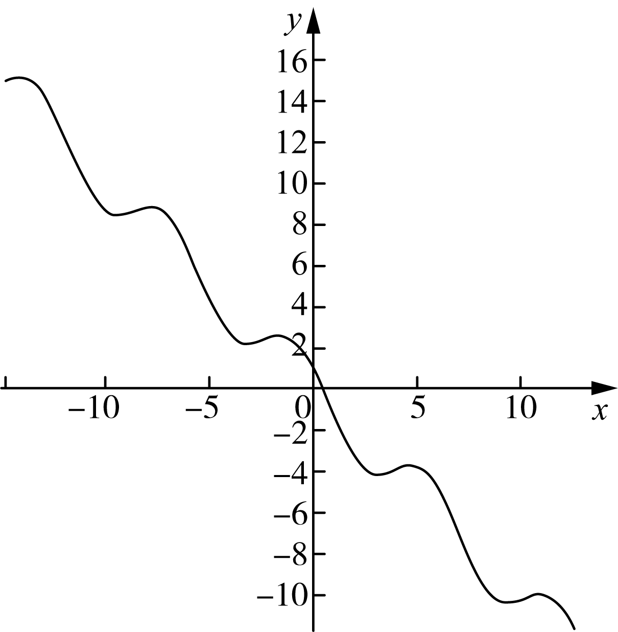
At this point, several applications of derivatives have been developed. Additional applications are considered next.

4. 5 Mean value theorem and the shape of function graphs
In function analysis, accurate characterization of graph shape is highly beneficial. As a local rate-of-change descriptor, the derivative plays a central role in determining graph shape and overall trend.
First, the following theorem is introduced:
Rolle's Theorem
hypothesis function$f(x)$satisfy:
1) Continuous in the interval [a, b]
2) Differentiable in the interval (a, b)
3）$f(a) = f(b)$
Then, there must be a real number c on the interval (a, b) such that:
$f'(c) = 0$
Proof: Rolle's Theorem is proved by considering three cases.

Chapter 4 | What is the use of derivatives? 97

Case 1: If for any x value on the interval [a, b], there is$f(x) = f(a) = f(b)$, then the image of the function f(x) is a straight line parallel to the x-axis. At this time, the tangent of any point that is derivable in the interval (a, b) is parallel to the x-axis. Just find any point c and it will satisfy:$f′(c) = 0$。
Case 2: If the function value of a certain point in the interval (a, b) is greater than the function value of the endpoint, then according to the extreme value theorem, there must be a point c in the interval (a, b), such that$f(c)$is the maximum value of function f(x) on [a, b]. By definition, this$f(c)$It is also a relative maximum value, and f(x) is differentiable at point c. Therefore, according to Fermat’s theorem, we know:$f′(c) = 0$。
Case 3: If the function value of a certain point in the interval (a, b) is smaller than the function value of the endpoint, according to the proof method of case 2, we can also get the conclusion: there is a point c in the interval (a, b), which satisfies:$f′(c) = 0$。
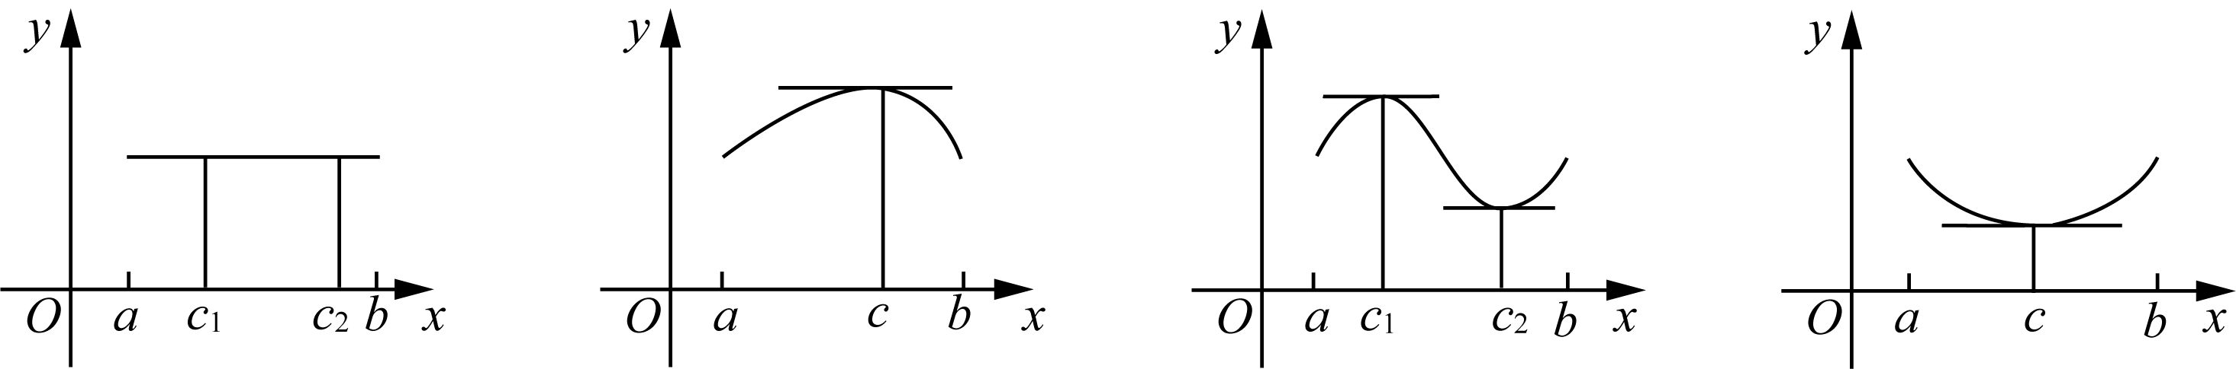
The figure above shows several cases in which Rolle's Theorem holds. Geometrically, when endpoint function values are equal, there exists c in (a, b) such that the tangent at c is parallel to the x-axis.
Since endpoint function values are equal, the secant through the endpoints is parallel to the x-axis. Thus, Rolle's Theorem is equivalent to the existence of c in (a, b) where the tangent is parallel to that secant. This idea extends to unequal endpoint values via the Mean Value Theorem.
Lagrange's Mean Value Theorem
hypothesis function$f(x)$satisfy:
1) Continuous in the interval [a, b]
2) Differentiable in the interval (a, b)
Then, there must be a real number c on the interval (a, b) such that:
$f'(c) = \frac{f(b) − f(a)}{b − a}$
Proof idea: Rolle's Theorem has just been established, and the right-hand side of the target formula depends on endpoint values.

98 Play with calculus

The slope of the connecting line. Therefore, we specifically want to find a function that is both related to the endpoint and$f(x)$related, and preferably the function values ​​at both endpoints are equal.
If the function$f(x)$The difference between the y value on the straight line and the endpoint connecting line is defined as a new function$g(x)$, then the endpoint value of this new function must be 0. How about applying Rolle's theorem to it?
We know: Connect two endpoints$(a, f(a))$、$(b, f(b))$The straight line equation of is:
$y = f(a) + \frac{f(b) − f(a)}{b − a}(x − a)$
So, we have:
$g(x) = f(x) − \left(f(a) + \frac{f(b) − f(a)}{b − a}(x − a)\right)$
What are the characteristics of this new g(x)? It is not only continuous in the interval [a, b], but also differentiable in the interval (a, b), and more importantly:$g(a) = g(b) = 0$, now the conditions for the establishment of Rolle's theorem are complete. Therefore, in the interval (a, b), there must be a point c such that:$g′(c) = 0$. Substituting this conclusion into the above definition:
$g'(c) = f'(c) − \frac{f(b) − f(a)}{b − a} = 0$
$∴ f'(c) = \frac{f(b) − f(a)}{b − a}$
In this theorem proving process, functions are tailored to apply Rolle's theorem$g(x)$The technique is a common technique used by mathematical masters in the past generations in their creative work, and it has a very high technical content.
The algebraic meaning of the mean value theorem is that there is a point c on the interval (a, b) such that the function$f(x)$The instantaneous rate of change at point c is equal to the function$f(x)$The average rate of change over the entire interval [a, b].
The geometric meaning of the mean value theorem is that there is a point c on the interval (a, b) such that the tangent line of the function passing through point c is parallel to the line connecting the endpoints. Please refer to the picture below:
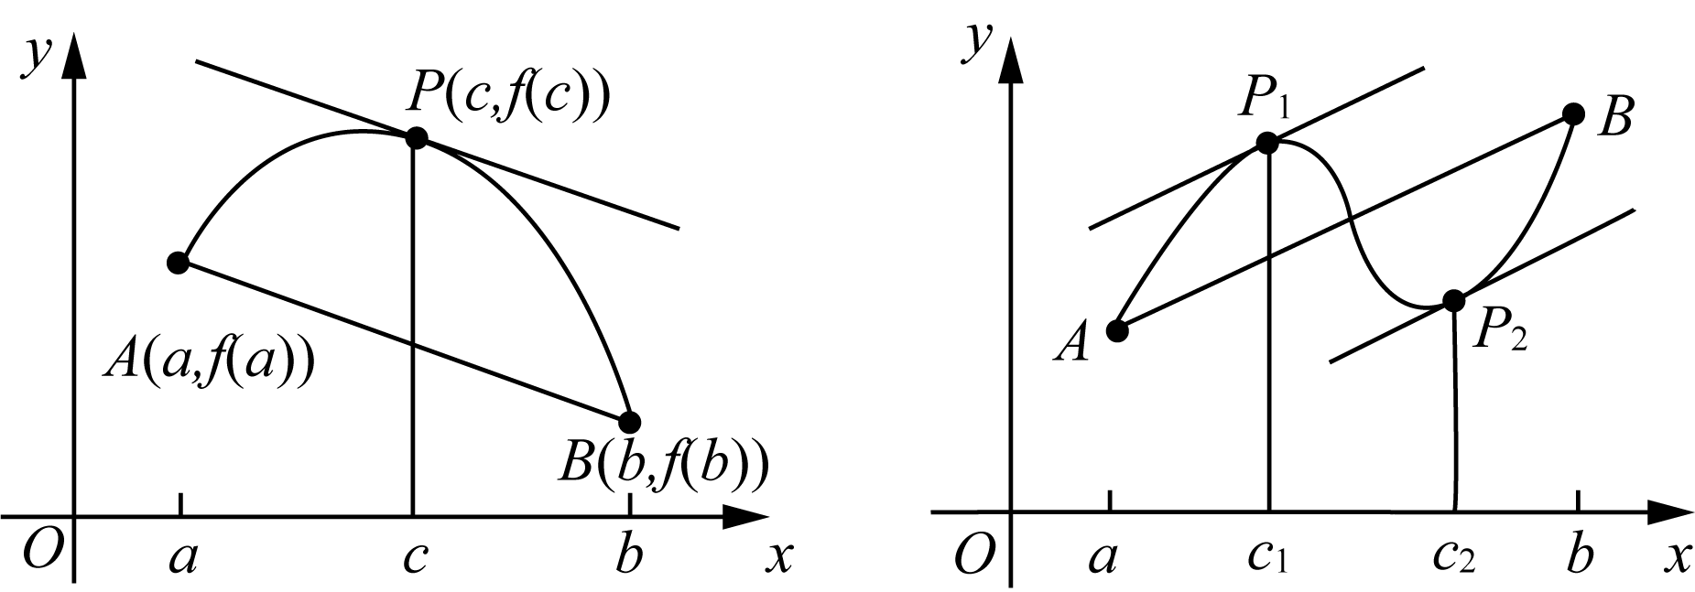
As shown above, the left panel illustrates a case with one point c satisfying the mean value theorem, while the right panel illustrates a case with two such points.

Chapter 4 | What is the use of derivatives? 99

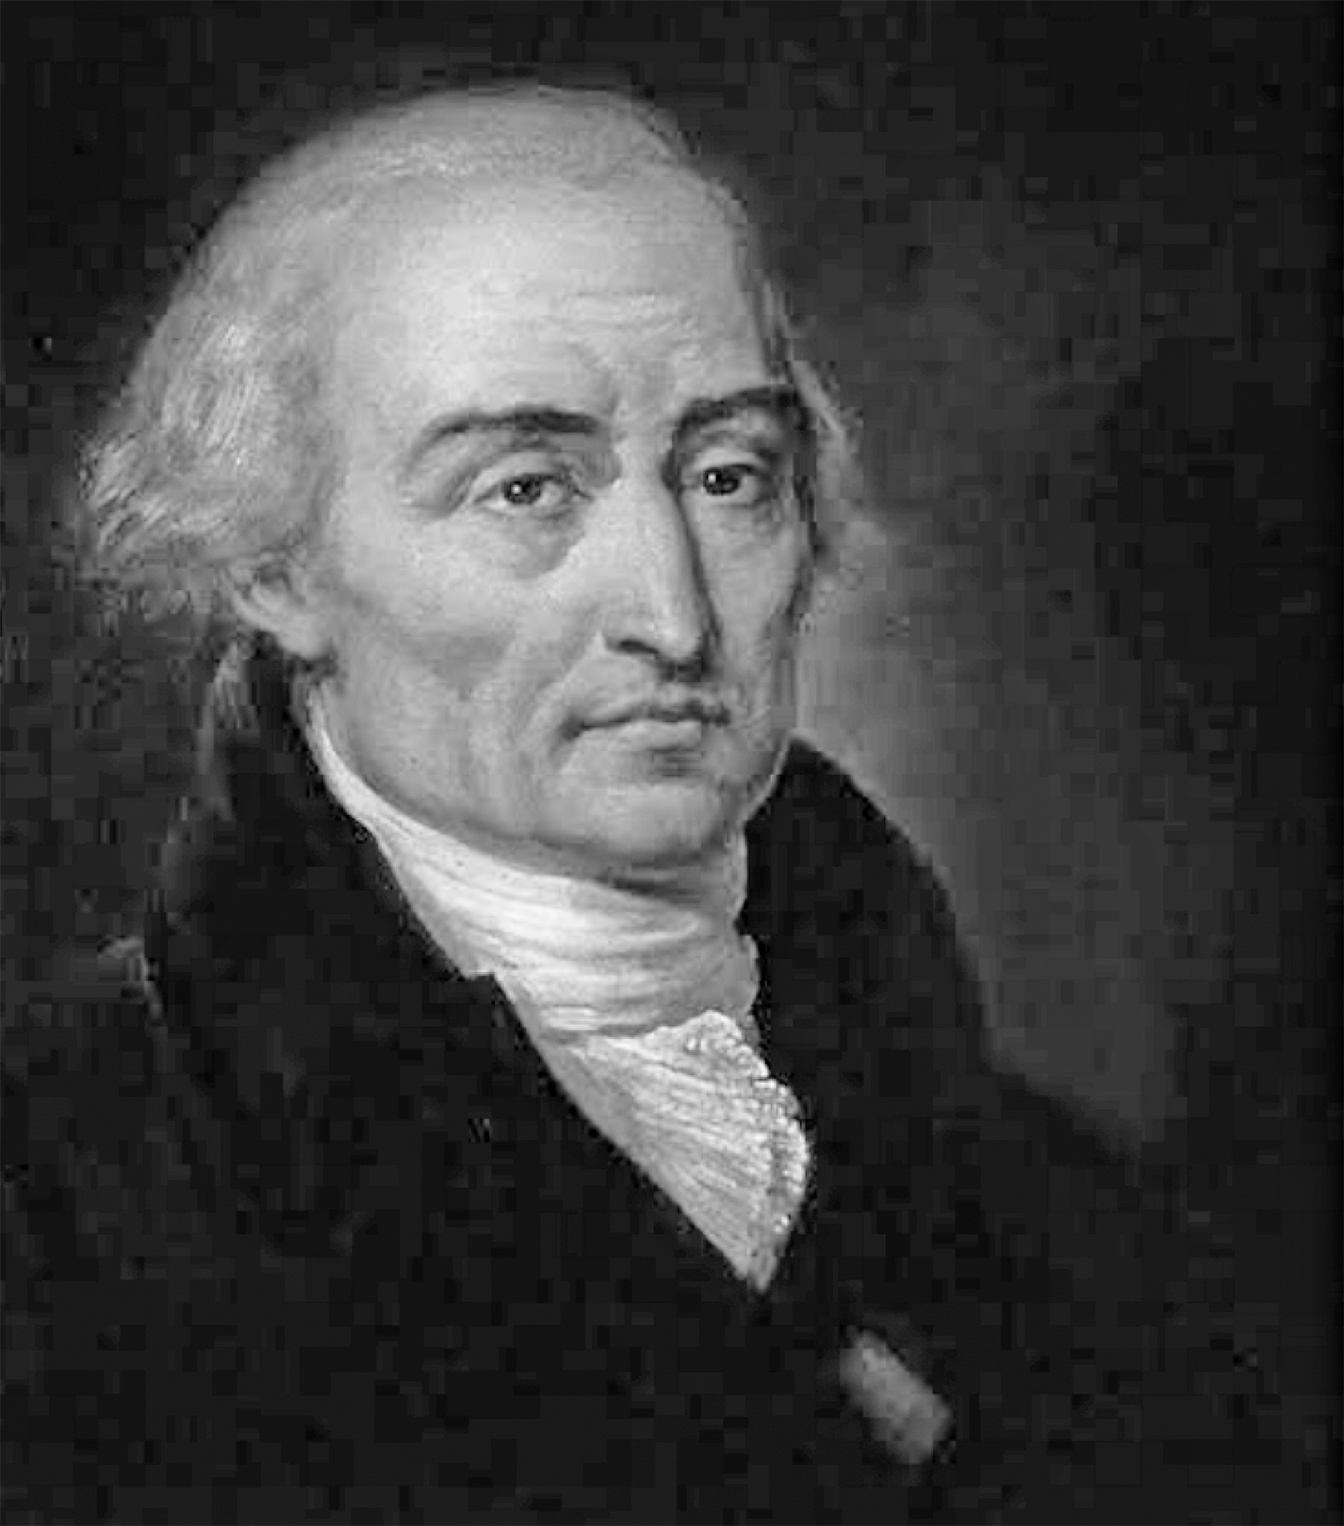
Two examples are provided for illustration:

Example 4-10)Verification function$f(x) = 2x² − 3x + 1$The mean value theorem is satisfied on the interval [0, 2].
Solution: Our task is to find a c on the interval [0, 2] such that:
$f'(c) = \frac{f(2) − f(0)}{2 − 0} = 1$
Note:$f′(x) = 4x − 3$, so as long as the following equation about c has a solution, our task is completed:
$4c − 3 = 1$
The above equation obviously has a solution: c = 1.
In some problems, the formulation is less direct. Consider the following example.

Example 4-11)It is known that the whole region differentiable function$f(x)$,satisfy$f′(x) ≤ 9$and$f(1) = −8$. beg$f(3)$The maximum possible value.
Solution: According to the mean value theorem, we know that on the interval (1, 3), there must be a point c such that:
$f'(c) = \frac{f(3) − f(1)}{3 − 1}$
And because$f′(x) ≤ 9$,so:
$\frac{f(3) − f(1)}{3 − 1} ≤ 9$

100 Play with calculus

have to:$f(3) + 8 ≤ 18$,Right now$f(3) ≤ 10$. Therefore, what is sought$f(3)$The maximum possible value is 10.
On one hand, Lagrange's Mean Value Theorem can be derived from Rolle's Theorem; on the other hand, Rolle's Theorem is a special case of Lagrange's theorem. In turn, Lagrange's theorem is a special case of Cauchy's Mean Value Theorem.
Cauchy's mean value theorem
Let function$f(x)、g(x)$is continuous in [a, b], (a, b) is differentiable, and$g′(x) ≠ 0$, then there must be a$c ∈ (a, b)$satisfy:
$\frac{f(b) − f(a)}{g(b) − g(a)} = \frac{f'(c)}{g'(c)}$
Cauchy's mean value theorem can also be derived from Rolle's theorem by proving Lagrange's theorem. In fact, the application of Cauchy's mean value theorem is more about the application of curves expressed by the following parametric equations:
$x = x(t), t ∈ (a, b)$
$y = y(t)$
Therefore, both Lagrange's theorem and Cauchy's Mean Value Theorem can be regarded as extensions of Rolle's Theorem. Because Cauchy's theorem is tested less frequently, familiarity with its statement is generally sufficient.
Rolle's theorem and Lagrange's theorem describe important local geometric features of function graphs on intervals, particularly tangent behavior. The sign of the derivative on an interval determines monotonicity.
However, they are also increasing functions. The two increasing functions in the figure$f(x)$and$g(x)$There is a clear difference:
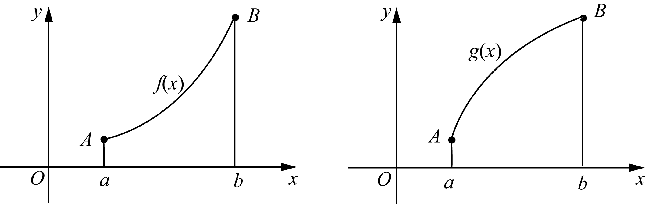
In the figure above, the left graph is concave down, whereas the right graph is concave up.

Chapter 4 | What is the use of derivatives? 101

The figure is called a convex figure. In mathematical jargon, it is: function$f(x)$Convex under the interval (a, b), the function$g(x)$Convex on the interval (a, b).
Terminology for concavity differs between Chinese and English usage. In this text, standard English terminology is adopted.
A basic geometric property is that tangents to concave-up functions lie below the graph, whereas tangents to concave-down functions lie above the graph.
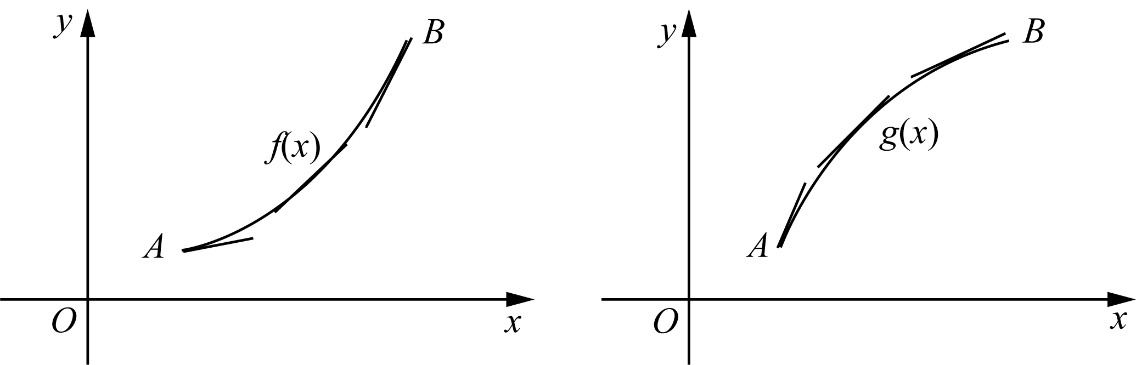
How can graph concavity be determined? The principal tool is the second-derivative test.
If in the interval (a, b), the function f(x) satisfies:$f″(x) > 0$, then the function f(x) is convex in this interval; if in the interval (a, b), the function f(x) satisfies:$f″(x) < 0$, then the function f(x) is convex on this interval.
This criterion can be proved using the mean value theorem. The proof is omitted due to space limitations.
Using the second-derivative test, extrema can be analyzed from a new perspective. The following conclusion is immediate from the sign of the second derivative:
if function$f(x)$The second derivative of is continuous near point c, then:
1) if$f′(c) = 0$，$f″(c) > 0$,but$f(c)$Must be the relative minimum value of the function;
2) if$f′(c) = 0$，$f″(c) < 0$,but$f(c)$It must be the relative maximum value of the function.
The above conclusion is very intuitive geometrically. Now briefly explain the first case, since the second derivative is positive, the curve is convex downward. Therefore, the tangent line of the function near point c is below the function graph, and since the tangent line of the function at point c is a horizontal tangent line, so$f(c)$It becomes the relative minimum value of the function.

102 Play with calculus

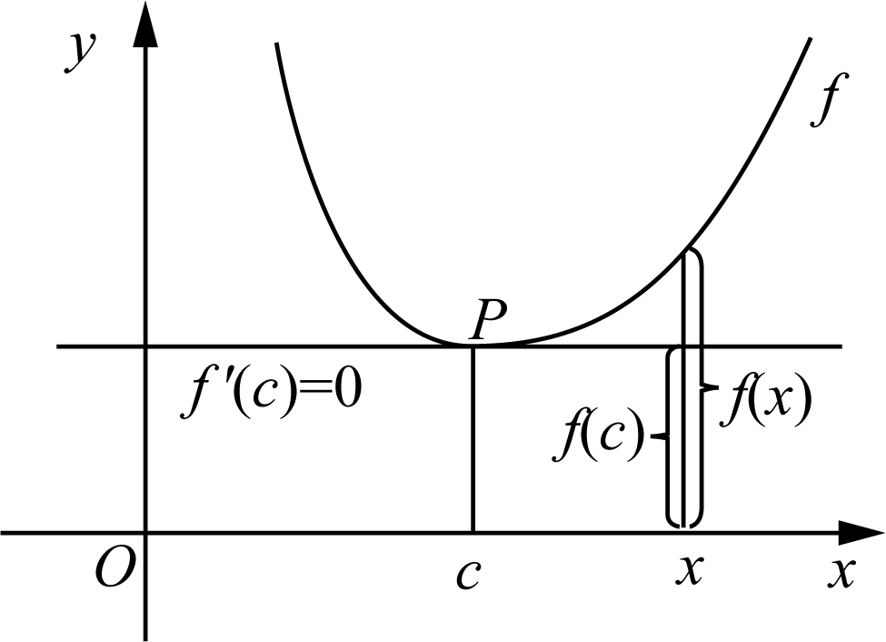
If a function is concave up, its tangent lies below the graph and an extremum is a relative minimum; if a function is concave down, its tangent lies above the graph and an extremum is a relative maximum.
From a broader geometric viewpoint, for a concave-up function the secant through any two points lies above the graph, while for a concave-down function it lies below the graph.
After this section, extrema may be determined either by sign changes of the first derivative near critical points or by the sign of the second derivative.
Now, we can look at the familiar quadratic function$y = ax² + bx + c$Here’s a more advanced summary:
Depend on$y′ = 0$, the critical point of y can be found to be$\frac{−b}{2a}$（$a ≠ 0$). So, when$a > 0$time, due to$y″ = 2a > 0$, y is the minimum value at the critical point; otherwise, when$a < 0$time, due to$y″ = 2a < 0$, y is the maximum value at the critical point.
Examples are given below.

Example 4-12)known function$f(x)$Derivative of$f′(x) = (x − 1)eˣ$, find the critical point of the function, and explain the properties of the critical point.
Solution: You might as well use the old routine and set the derivative to 0, you can get$f(x)$The critical point is 1 and unique.
Solution 1: When$x < 1$hour,$f′(x) = (x − 1)e^{x} < 0$, so the function f(x) is a decreasing function; when$x > 1$hour,$f′(x) = (x − 1)e^{x} > 0$, so the function f(x) is an increasing function.
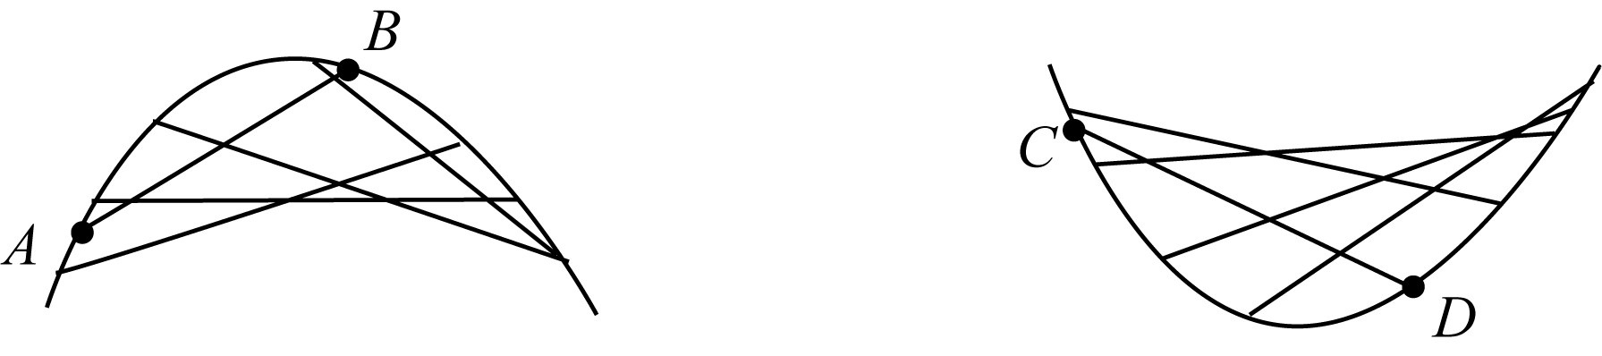

Chapter 4 | What is the use of derivatives? 103

So the critical point c = 1 is the minimum point.
Solution 2: Find the second derivative to get$f″(x) = xe^{x}$,so$f″(1) = e > 0$. Therefore, point 1 is the minimum point.
Another concept concerning graph concavity is now introduced.
Point of Inflection
if function$f(x)$The second derivative of is a continuous function and has different signs around point a, then point a is called a function$f(x)$the turning point.
Remarks on inflection points:
1) Near an inflection point, the function changes from concave up to concave down, or from concave down to concave up;
2) At an inflection-point candidate, the second derivative is 0 or does not exist.
Critical points and inflection points should be distinguished. A critical point is where the first derivative is 0 or does not exist and is a candidate extremum. An inflection point is where concavity changes sign. The condition that the second derivative is 0 or undefined is necessary but not sufficient for an inflection point.
These concepts provide a clear local description of graph behavior near a point, including monotonicity and changes in concavity.
Using derivatives, basic structural features of functions, including monotonicity and concavity, can be determined. Together with asymptotic analysis, this supports realistic sketches of complex functions.
Based on the preceding material, the following standard steps are used to sketch a function graph:
1) Pay attention to the function domain;
2) Find the intersection point of the function and the coordinate axis;
3) Pay attention to parity, which is symmetry;
4) Observe whether there is an asymptote;
5) Find the relative extreme points;
6) Determine intervals of increase and decrease, as well as intervals of concavity.

Example 4-13)Sketch the graph of the following function:
$y = f(x) = \frac{3x²}{2x² − 5}$

104 Play with calculus

Solution: First, note the following five points:
1) The domain of the function is$x ≠ ±\frac{\sqrt{10}}{2}$。
2) Obviously, the intersection of the function and the coordinate axis is the origin.
3) Due to$f(−x) = f(x)$, so the function is an even function, symmetric about the y-axis.
4) Because:
$\lim_{x→∞}f(x) = \frac{3}{2}$
Therefore, the function has a horizontal asymptote$y = \frac{3}{2}$. And because:
$\lim_{x→{\frac{\sqrt{10}}{2}}^{+}}f(x) = +∞, \lim_{x→{\frac{\sqrt{10}}{2}}^{−}}f(x) = −∞$
Therefore, the function has two vertical asymptotes:$x = ±\frac{\sqrt{10}}{2}$。
5) Find the critical point,$f′(x) = 0$：
$f'(x) = \frac{−30x}{{\left(2x² − 5\right)}^{2}}$
$∴ x = 0$
It can be seen that the 0 point is the function$f(x)$is the only critical point. It is not difficult to know from observation that the derivative of the function changes from positive to negative at this point, which means that point 0 is the relative maximum point of the function.
Next, analyze concavity:
The first step is to find the second derivative:
$f''(x) = \frac{180x² + 150}{{\left(2x² − 5\right)}^{3}}$
In the second step, in the interval ($−\frac{\sqrt{10}}{2}$, $\frac{\sqrt{10}}{2}$)，$f″(x) < 0$, so the function f(x) is an upward convex function;

Chapter 4 | What is the use of derivatives? 105

And in the interval (−∞,$−\frac{\sqrt{10}}{2}$) and ($\frac{\sqrt{10}}{2}$, +∞)，$f″(x) > 0$, so the function is a downward convex function.
In summary, the graph of this function can be sketched approximately as follows:
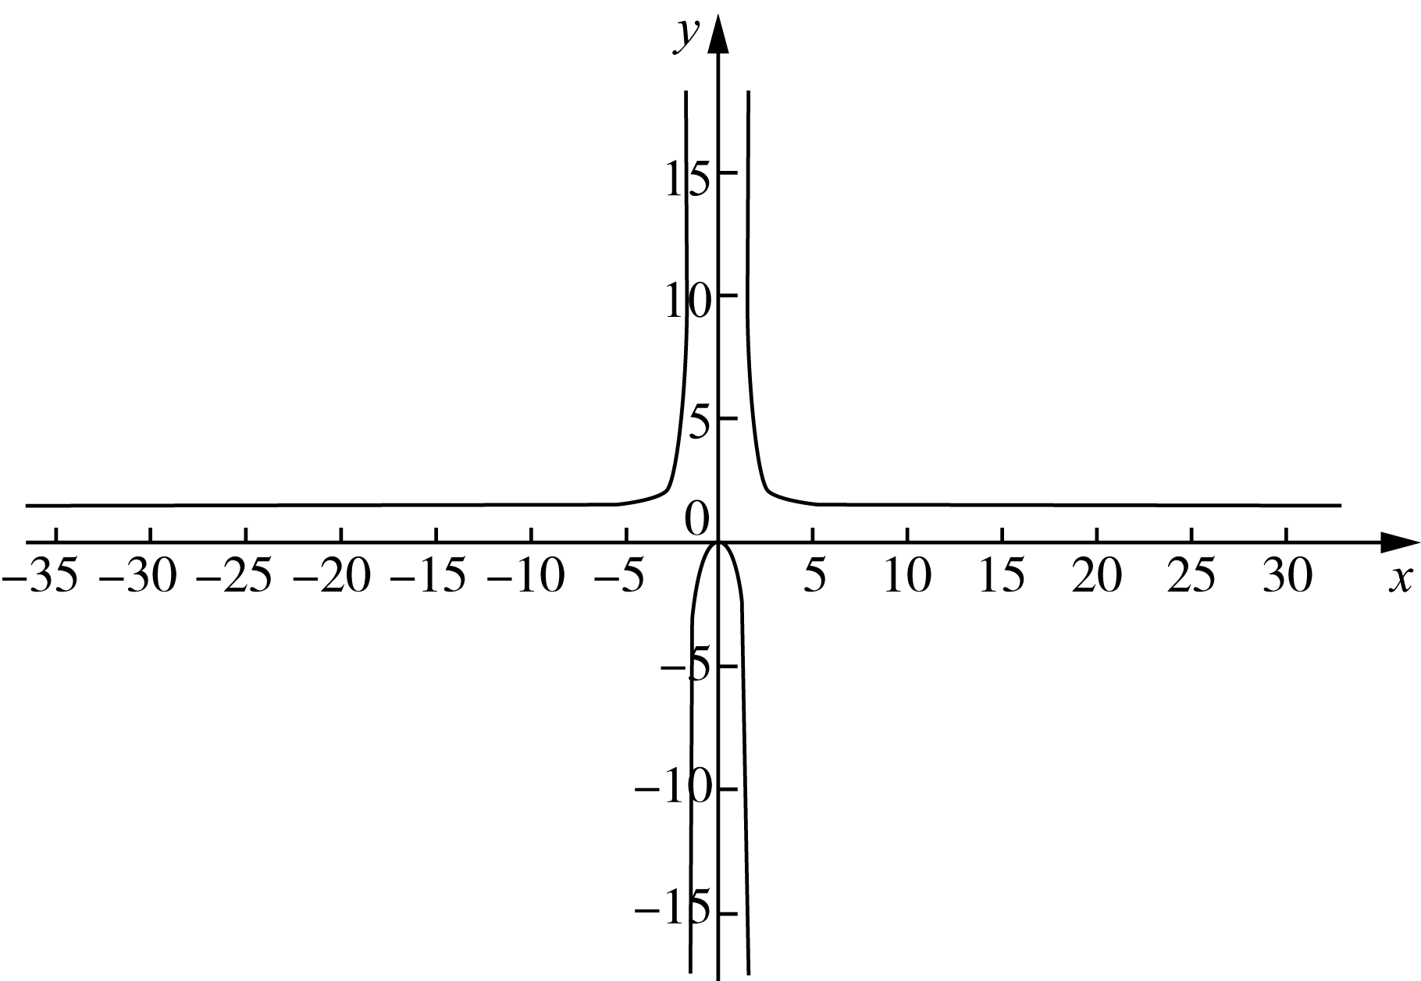

4.6 Antiderivative
If the derivative of a function is given, the corresponding original function is sought. Determining a function from its derivative is a fundamental skill in calculus.
For example, according to the formula$(x²)′ = 2x$, you can easily say$2x$yes$x²$the derivative of.
Because recovering the original function from its derivative reverses differentiation, this process is called antidifferentiation, and the resulting functions are antiderivatives.
For example, when saying$2x$yes$x²$When using derivatives, it is equivalent to saying:$x²$yes$2x$antiderivative of .
Generally speaking, we describe$F(x)$yes$f(x)$When antiderivative, it refers to:
$F'(x) = f(x)$
If you are proficient in derivatives, you will naturally know that not only$(x²)′ = 2x$, all shapes like$x² + C$(where C is a constant), its derivatives are all$2x$. In other words, the function$2x$The antiderivative of is not unique. Therefore, our previous sentence should be changed to: function$2x$is a function$x² + C$the derivative of.

106 Play with calculus

Obviously, here$x² + C$Not a function, but a set of functions. Thus, the following conclusion is self-evident.
if, function$F(x)$and$G(x)$All$f(x)$The antiderivative of , then:
$F(x) − G(x) = C，其中 C 为常数$
Example 4-14)Find function$xⁿ$antiderivative of$F(x)$, where n is a real number.
Solution: The procedure is carried out in two steps.
First, if$n = −1$,because$(ln x)′ = \frac{1}{x}$,so$ln x + C$is the antiderivative sought;
Secondly, if$n ≠ −1$,because:
$\left(\frac{x^{n+1}}{n+1}\right)′ = xⁿ$
so$\frac{x^{n+1}}{n+1} + C$is the desired antiderivative. Right now:
$F(x) = \left(ln x + C (n = −1)\right)$
$F(x) = \frac{x^{n+1}}{n+1} + C (n ≠ −1)$
Although an antiderivative generally denotes a family of functions, additional constraints typically determine a unique function.

Example 4-15)Known:$f″(x) = 2x^{3} + 3x^{2} − 4x + 5$，$f(0) = 2$，$f′(1) = 0$, find the function$f(x)$。
Solution: We know,$f′(x)、f(x)$They are:
$f'(x) = 2 \frac{x^{4}}{4} + 3 \frac{x^{3}}{3} − 4 \frac{x^{2}}{2} + 5x + C₁$
$= \frac{1}{2}x^{4} + x^{3} − 2x^{2} + 5x + C₁$
$f(x) = \frac{1}{10}x^{5} + \frac{1}{4}x^{4} − \frac{2}{3}x^{3} + \frac{5}{2}x^{2} + C₁x + C₂$
Bundle$f(0) = 2，f′(1) = 0$Substituting into the above equation, we get:
$C₂ = 2$
$\frac{1}{10} + \frac{1}{4} − \frac{2}{3} + \frac{5}{2} + C₁ + C₂ = 0$
Solving the equation we get:
$C₁ = −\frac{251}{60}$
$C₂ = 2$
$∴ f(x) = \frac{x^{5}}{10} + \frac{x^{4}}{4} − \frac{\left(2x^{3}\right)}{3} + \frac{\left(5x^{2}\right)}{2} − \frac{251}{60}x + 2$

Chapter 4 | What is the use of derivatives? 107

For convenient review, basic functions and their corresponding antiderivatives are listed below.

function | antiderivative
$x^{n} (n ≠ −1)$ | $\frac{x^{n+1}}{n+1}$
$\frac{1}{x}$ | $ln|x|$
$e^{x}$ | $e^{x}$
$sin x$ | $−cos x$
$cos x$ | $sin x$
$\sec^{2} x$ | $tan x$
$sec x · tan x$ | $sec x$
$\frac{1}{\sqrt{1 − x^{2}}}$ | $arcsin x$
$\frac{−1}{\sqrt{1 − x^{2}}}$ | $arccos x$
$\frac{1}{1 + x^{2}}$ | $arctan x$

There are ten fundamental forms in total. Once these are mastered, many antiderivative problems can be solved efficiently.
In later chapters, these basic antiderivatives will be seen to play an important role.
Next, the definite integral is introduced. Before proceeding, the material should be consolidated through exercises.

108 Play with calculus

Exercise 4
4-1)Find the critical points of the following functions:
（1）$y = x⁴ + x³ + x² + 1$；
（2）$y = |x² − 1|$；
（3）$y = \frac{x − 1}{x + 1}$；
（4）$y = 2cos x + sin²x$。

4-2)Find the absolute extreme value of the following function in the specified interval:
（1）$y = x³ − 2x² − x + 1，x ∈ [0, 5]$；
（2）$y = 5 + 6x − x²，x ∈ [0, 8]$；
（3）$y = 2x³ − 3x² − 12x + 1，x ∈ [−2, 3]$；
（4）$y = \frac{x}{x^{2} + 1}，x ∈ [0, 3]$；
（5）$y = x\sqrt{4 − x^{2}}，x ∈ [1, 2]$；
（6）$y = x + cos(x)，x ∈ [−\frac{π}{2}, \frac{π}{2}]$。

4-3)Use the linear approximation method to estimate the following values:
（1）$(2.999)⁴$；
（2）$sin 1°$；
（3）$∛1001$。

4-4)Use Newton's method to find the roots of each of the following equations (accurate to 6 decimal places):
（1）$3cos x = 2x + 1$；
（2）$eˣ = x² − 1$；
（3）$cos(x² − 1) = x$。

4-5) Please verify that the following functions satisfy Lagrange's Mean Value Theorem in the specified interval:
（1）$f(x) = 2x³ − 3x + 1，x ∈ [0, 2]$；
（2）$f(x) = ln x，x ∈ [1, 3]$。

4-6）Proof: Eq.$x³ − 15x + c = 0$In the interval [−2, 2], there is at most one root.

4-7）if$f(1) = 10$，$f′(x) > 2$(1 < x < 4), please$f(4)$Is there a lower limit?

4-8) For each of the following functions: a) find the increasing and decreasing intervals; b) find the relative extrema; c) find the inflection points and concavity intervals.
（1）$y = x³ − 12x + 3$；
（2）$y = −x³ + 2x² + 2$；
（3）$y = (x + 1)⁵ − 5x − 2$；
（4）$y = \sqrt{6 − x}$；
（5）$y = 2cos x + cos²x，x ∈ (0, 2π)$。

4-9) Find an antiderivative of each of the following functions:
（1）$y = 2x³ − 3x² + x + 1$；
（2）$y = \frac{x^{2} + x + 2}{x}$；
（3）$y = 4sec²x − 5sin x$；
（4）$y = eˣ$。

