Table of contents
4.1 Revisiting limits - L'Hôpital's Rule
4.2 Extreme value problems (Extrema)
4.3 Linear approximation
4.4 Crossing the river by feeling for the stones - Newton's method
4.5 Mean value theorem and the shape of function graphs
4.6 The way to find roots - Antiderivative
Exercise 4

Chapter 4
What is the use of derivatives?

84 Play with calculus

In the first two chapters, we clarified the core concept of limits in calculus, elevated the slope concept learned in middle school, and introduced derivatives.
We also spent a lot of effort figuring out how to compute derivatives for various functions. Derivatives must have a special purpose to be worth all this effort, right?
Yes, derivatives are really useful!

4.1 Revisiting limits - L'Hôpital's Rule
As mentioned before, limit problems are at the core of calculus. When we work on limits, we often encounter two kinds of thorny problems:

$\frac{∞}{∞} 型 和 \frac{0}{0} 型$

When we see two sideways "8" symbols, we often feel at a loss about where to start.
Just like in a martial arts novel, two heroes compete, each with unique skills, and it is hard to tell who will have the last laugh. Let's think one more step: if they compete for a long time, who will gain the upper hand? For another example, A has 1 billion yuan with an annual growth rate of 7%; although B has only 500 million yuan, B's wealth grows at 10%. If you think about it carefully, the conclusion is clear: in the long run, B will definitely defeat A. The reason is simple: 10% growth is much stronger than 7% growth. And what is a growth rate? Isn't it a rate of change? And what is the rate of change? The derivative!
From this we think that if two$∞$There is no conclusion in comparison, but if the ratio of their derivatives is higher or lower, then the ratio itself will have results. This simple idea was proved by the French mathematician Mr. L'Hôpital more than 300 years ago.

L'Hôpital's Rule
hypothesis function$f(x)$and$g(x)$, is differentiable in a region containing point a (it is not required to be differentiable in a), and$g(x) ≠ 0$. if:

$\lim_{x→a}f(x) = 0 且 \lim_{x→a}g(x) = 0$
or:
$\lim_{x→a}f(x) = ∞ 且 \lim_{x→a}g(x) = ∞$

So:
$\frac{\lim_{x→a}f(x)}{\lim_{x→a}g(x)} = \frac{\lim_{x→a}f′(x)}{\lim_{x→a}g′(x)}$

Of course, the premise is that the limit on the right exists.
L'Hôpital's Rule kills two birds with one stone and solves two difficult problems at the same time. About this rule, we'd like to remind you of a few points.

Chapter 4 | What is the use of derivatives? 85

First of all, when$x → ±∞$, the same rule applies.
Secondly, if the limit of the ratio of the derivatives of two functions is still$\frac{∞}{∞}$type and$\frac{0}{0}$type, you can use this rule again to second derivatives or even$n$On the first derivative.
Finally, the proof of this law requires more advanced mathematical knowledge.
For now, we can treat it as an axiom, accept it as self-evident, and focus on using the rule correctly as needed.

Example 4-1) begin
$\lim_{x→1}\frac{ln x}{x−1}$
Solution: According to L'Hôpital's Rule, we have:

$\lim_{x→1}\frac{ln x}{x−1} = \frac{\lim_{x→1}(ln x)′}{\lim_{x→1}(x−1)′} = \frac{\lim_{x→1}\frac{1}{x}}{\lim_{x→1}1} = \lim_{x→1}\frac{1}{x} = 1$

Example 4-2) begin
$\lim_{x→∞}\frac{2^{x}}{8x}$
Solution: Using L'Hôpital's Rule, we get:

$\lim_{x→∞}\frac{2^{x}}{8x} = \lim_{x→∞}\frac{(2^{x})′}{(8x)′} = \lim_{x→∞}\frac{2^{x}·ln 2}{8} = ∞$

Fun, right? Let's look at two more limits.

Example 4-3) begin
$\lim_{x→∞}\frac{3^{x}}{x^{3}}$
Solution: To find this limit, you have to find three derivatives of the numerator and denominator to see the result clearly:

$\lim_{x→∞}\frac{3^{x}}{x^{3}} = \lim_{x→∞}\frac{(3^{x})′}{(x^{3})′} = \lim_{x→∞}\frac{3^{x}·ln 3}{3x^{2}} = \lim_{x→∞}\frac{(3^{x}·ln 3)′}{(3x^{2})′} = \lim_{x→∞}\frac{3^{x}·{\left(ln 3\right)}^{2}}{6x}$
$= \lim_{x→∞}\frac{(3^{x}·{\left(ln 3\right)}^{2})′}{(6x)′} = \lim_{x→∞}\frac{3^{x}·{\left(ln 3\right)}^{3}}{6} = ∞$

It can be seen from the problem-solving process of this problem that even if the denominator is not$x³$, but$x¹⁰⁰$or higher powers will not change the result of the limit. Similarly, as long as the molecule$aˣ$in$a > 1$, the result will not change, it is all$∞$。
This also confirms what we said before:$aˣ$type$∞$The most powerful, follow$xⁿ$type$∞$There is no comparison. Let's take another look$xⁿ$type$∞$meet$logᵦ x$type$∞$,what happens.

Example 4-4) begin
$\lim_{x→∞}\frac{\sqrt{x}}{{\left(ln x\right)}^{2}}$
untie:

$\lim_{x→∞}\frac{\sqrt{x}}{{\left(ln x\right)}^{2}} = \lim_{x→∞}\frac{(\sqrt{x})′}{({\left(ln x\right)}^{2})′} = \lim_{x→∞}\frac{\sqrt{x}}{4·ln x}$
$= \lim_{x→∞}\frac{(\sqrt{x})′}{(4·ln x)′} = \lim_{x→∞}\frac{\sqrt{x}}{8} = ∞$

86 Play with calculus

This time,$xⁿ$type$∞$and$logᵦ x$type$∞$The comparison result is also$∞$！
Again, if you encounter$\frac{∞}{∞}$Type limit problem, leaving only the highest level in the numerator and denominator$∞$Just "on duty" and the result will not be wrong.
With L'Hôpital's Rule in mind, the two famous limits from Chapter 2 become much more intuitive:

$\lim_{x→0}\frac{sin x}{x} = 1$

$\lim_{x→0}\frac{1−cos x}{x} = 0$

When we climb mountains, we find that the higher we go, the better the view. Mathematics is similar: the more you explore, the clearer your understanding becomes.
Let's see what else derivatives are used for.

4.2 Extreme value problems (Extrema)
People are naturally drawn to things that are a bit distant from daily life and a bit more extreme.
Likewise, the maximum and minimum value problems of functions naturally attract attention, because extreme values are very useful in life.
To solve extreme value problems, derivatives can be of great help. Let's first clarify a few concepts about extreme value problems.
Local Maximum: If for all x values ​​in an open interval including point c, the inequality$f(x) ≤ f(c)$are established, then$f(c)$It's a function$f(x)$a local maximum of . Local maximum, sometimes also called relative maximum (Relative Maximum).
Where there is a local viewpoint, there is also a global viewpoint.
Global Maximum: If for all values ​​of x, the inequality$f(x) ≤ f(c)$are established, then$f(c)$It's a function$f(x)$the global maximum value. The global maximum is sometimes called the absolute maximum.
Next, let’s talk about our understanding of these two concepts. The so-called local means that as long as the inequality$f(x) ≤ f(c)$holds true within even a small interval,$f(c)$It's the local maximum.
For example, if the altitude on the earth is used as a function, then the height of the top of the Five Mountains is a local maximum. At the same time, the height of each step you take to go home and even the height of the slippers you put on the floor is a local maximum. Mount Everest is the global maximum of this function.
The concept of minimum value is opposite to the concept of maximum value.

Chapter 4 | What is the use of derivatives? 87

Local Minimum: If for all x values ​​in an open interval including point c, the inequality$f(x) ≥ f(c)$are established, then$f(c)$It's a function$f(x)$a local minimum of . Local minimum, sometimes also called relative minimum (Relative Minimum).
Global Minimum: If for all values ​​of x, the inequality$f(x) ≥ f(c)$are established, then$f(c)$It's a function$f(x)$the global minimum of . The global minimum is sometimes called the absolute minimum (Absolute Minimum).
Once we understand the concept of extreme values, we can discuss how to find extreme values.
To study how to find extreme values, we must first confirm their existence. So we should understand the Extreme Value Theorem first.
Extreme Value Theorem: If function$f(x)$is continuous on the closed interval [a, b], then there must be two points c and d on this interval, such that$f(c)$is the absolute maximum value,$f(d)$is the absolute minimum.
The figure below is a schematic diagram of the extreme value theorem.
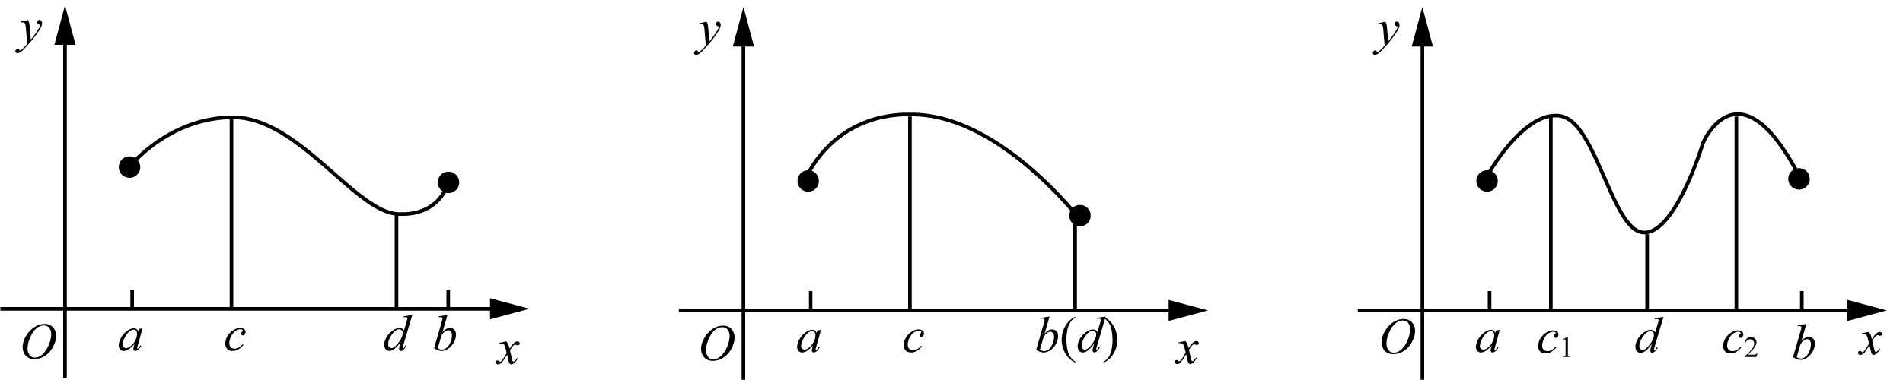
My learning experience about this theorem is: (1) Although the absolute extreme value of a closed interval can certainly be reached, it is not necessarily unique; (2) The two conditions for the existence of the theorem, "continuity" and "closed interval", are indispensable.
The figure below shows the situation where the two conditions of continuity and interval closure are missing respectively, and the extreme value theorem does not hold.
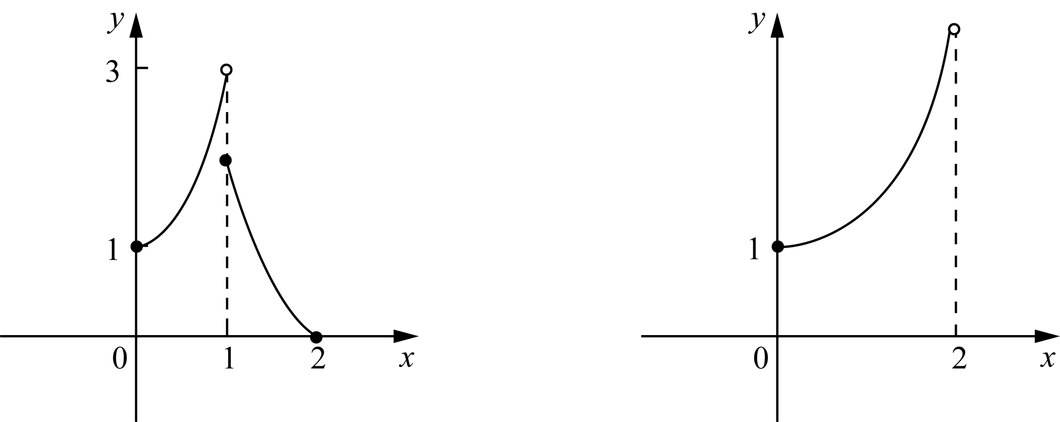
As the figure shows, the function on the left has no maximum value, and the function on the right has neither a maximum nor a minimum. The reason is that the left function is not continuous, and the domain interval on the right is not closed.
With the existence question settled, the next task is to find methods for locating extreme points from their characteristics. For a continuous function on a closed interval, global extreme points exist. In general, global extreme points are selected from local extreme points, so finding local extreme points comes first.

88 Play with calculus

Urgency aside, what does a local extreme point look like? Please see the theorem:
Fermat's Theorem
If point c is a function$f(x)$the local extreme point of , and$f′(c)$exists, then:
$f'(c) = 0$
Proof: Let’s assume first$f(c)$yes$f(x)$The local maximum and minimum values ​​of can also be proved in the same way.$f(c)$is a local maximum, which means: in a small area containing c, the following inequality holds:
$f(x) ≤ f(c)$
So, we have:
$f′(c^{−}) = \lim_{h→0⁻}\frac{f(c+h)−f(c)}{h} ≥ 0$
In the above formula, since the numerator is not positive and the denominator is negative, therefore$f′(c) ≥ 0$. In the same way, we have:
$f′(c^{+}) = \lim_{h→0⁺}\frac{f(c+h)−f(c)}{h} ≤ 0$
So far, we have reached the conclusion that one side of the left and right derivatives of the function at point c is non-negative and the other side is non-positive. now that$f′(c)$exists, its left and right derivatives must be equal. Then there is only:$f′(c) = 0$。
Note: Fermat's theorem tells us only that if the derivative exists at a local extreme point, then that derivative is 0. It does not say that derivatives are 0 at all local extreme points. Why? Because at some local extreme points, the derivative does not exist. Points where the derivative does not exist, together with points where the derivative is 0, are collectively called critical points of the function.
After working hard to get here, we finally have a method for finding extreme values. First, find the critical points of the function, namely points where the derivative does not exist or equals 0; second, compare function values at the interval endpoints and at the critical points to determine global and local extreme values.
The reason we compare function values at interval endpoints separately is that, although an endpoint does not meet the definition of a local extreme point, it can still be a global extreme point. For example, a strictly monotonic function attains global extreme values at endpoints and has no local extreme points inside the interval.
So how do we judge whether a hard-won critical point is a local maximum or a local minimum? To solve this, we call in our old friend, the derivative. As introduced in the previous chapter, the sign of the derivative at a point determines whether the function is rising or falling there.

Chapter 4 | What is the use of derivatives? 89

It is not difficult to deduce that if the derivative of a function is positive within a certain interval, then the function is an increasing function in this interval. On the contrary, if the derivative is negative, the function is a decreasing function.
Of course, we can also say it this way: the sign of the tangent slope determines whether the function is increasing or decreasing.
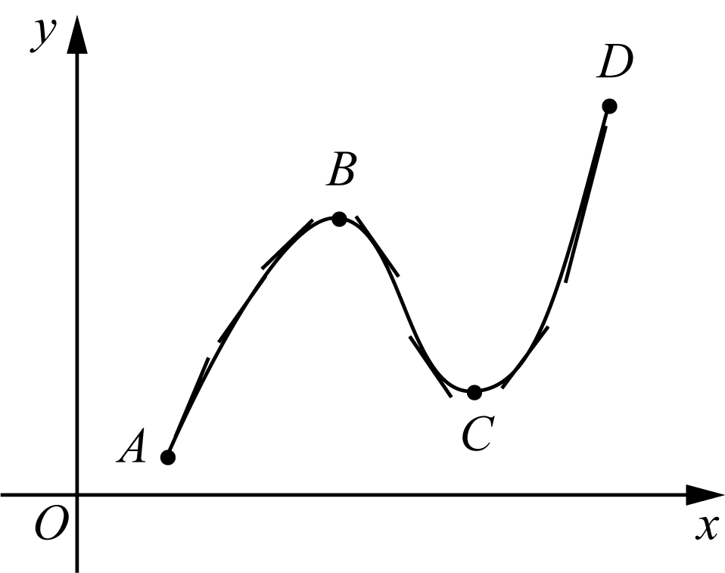
As shown above, the function is increasing on segments AB and CD, where the tangent slope, that is, the derivative, is positive. On segment BC, the derivative is negative, so the function is decreasing there.
Clearly, the derivative at points B and C is 0; that is, B and C are both relative extreme points of the function.
When the function passes through B, its derivative goes through a process from positive to zero and then to negative. Correspondingly, the function changes from increasing to decreasing. Therefore, point B is a relative maximum point.
When the function passes through point C, its derivative undergoes a process from negative to zero, and then to positive. Correspondingly, the function changes from a decreasing function before point C to an increasing function after point C. Therefore, point C is the relative minimum point of the function.
Conclusion: if the derivative around a critical point changes from positive to negative, that critical point is a local maximum. Conversely, if the derivative changes from negative to positive, that critical point is a local minimum.
At this point, the routine for finding extreme values is basically clear. Now let us apply the skills we just learned and see the effect.

Example 4-5)Find function$f(x) = 2x^{3} − 3x^{2} − 12x$The absolute extreme value in the interval [−2, 3].
Solution: Let us follow the standard routine and first find the critical points:
$f'(x) = 6x² − 6x − 12 = 6(x² − x − 2) = 6(x − 2)(x + 1)$
It follows that 2 and -1 are critical points of the function. Comparing function values at critical points and endpoints, we find:
$f(−1) = 7, f(2) = −20, f(−2) = −4, f(3) = −9$
therefore:
$f_{max} = f(−1) = 7, f_{min} = f(2) = −20$
The function of this question is shown in the figure below:
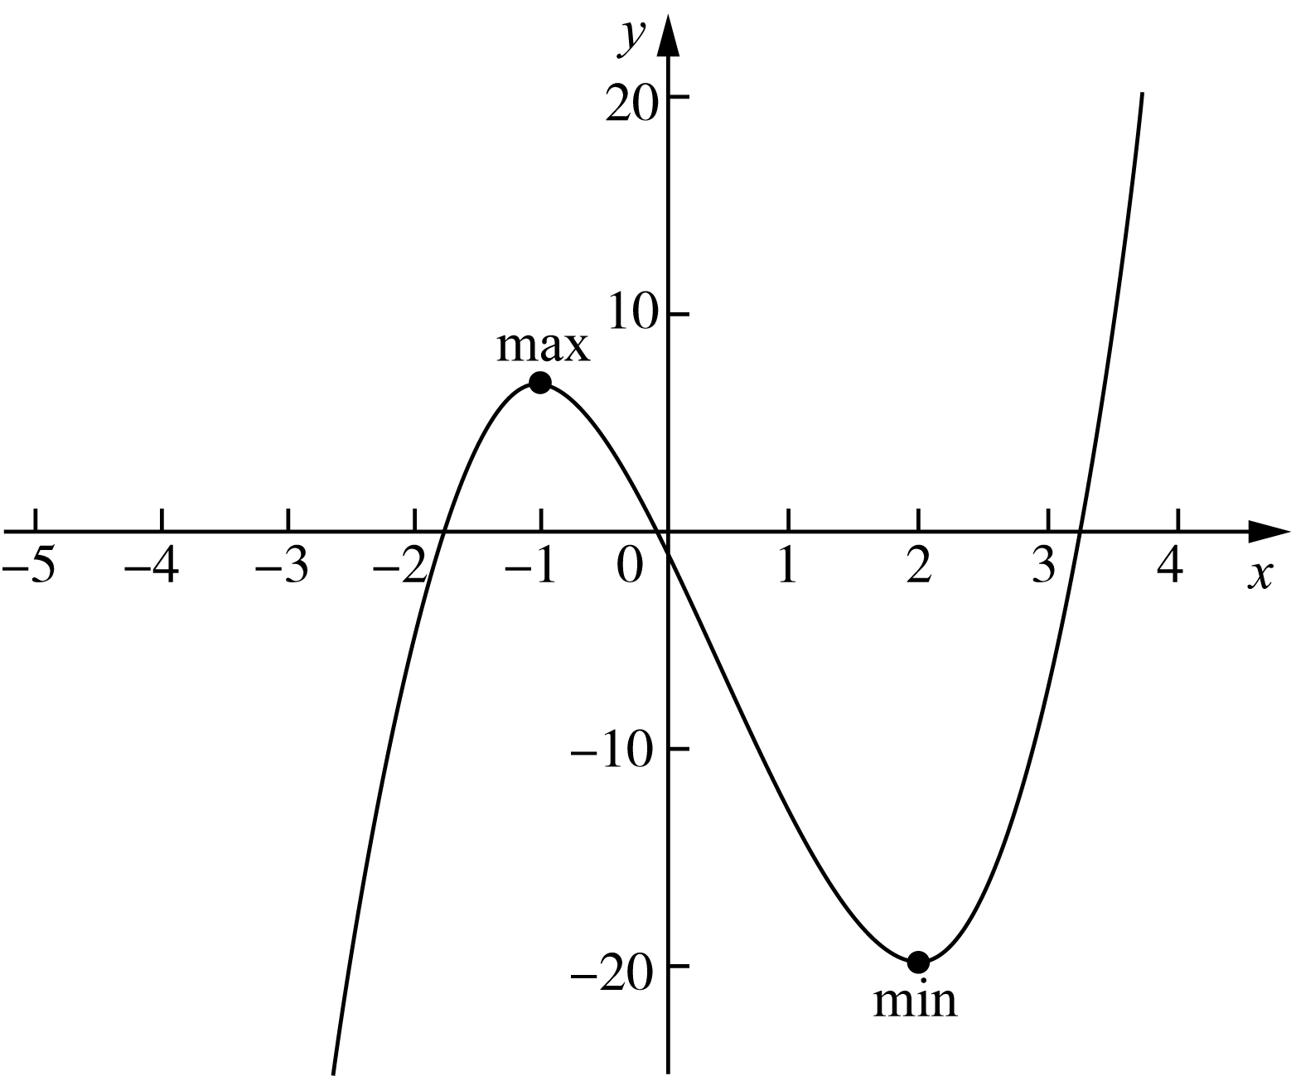

90 Play with calculus

Example 4-6)Find the function$f(x) = x⁴ − 8x²$All extreme points of and corresponding function values.
Solution: First find the critical point:
$f'(x) = 4x³ − 16x = 4x(x² − 4) = 4x(x + 2)(x − 2)$
The critical points are −2, 0, 2.
Next, examine the positive and negative derivatives around the critical point. Observation shows that: to the left of point −2, the derivative is negative; on (−2, 0), the derivative is positive; on (0, 2), the derivative is negative; to the right of point 2, the derivative is positive.
It can be seen that points −2 and 2 are the relative minimum points of the function, and point 0 is the relative maximum point of the function. The function values ​​are:$f(−2) = f(2) = −16$，$f(0) = 0$。
A closer look shows that: function$f(x)$There is no absolute maximum, but there is an absolute minimum. The relative minimum in this question happens to be the absolute minimum. By extension, all 4th degree functions have no absolute maximum, but there must be an absolute minimum. Of course, except for the case of closed intervals.
The graph of this question is shown below:
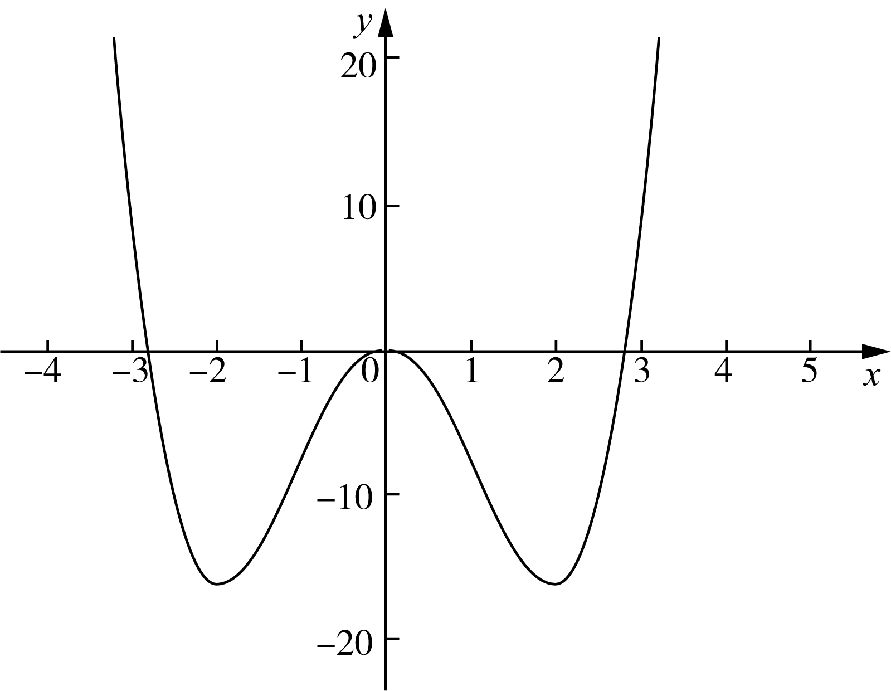

Chapter 4 | What is the use of derivatives? 91

4.3 Linear approximation
As introduced earlier, a calculus way of handling curves is divide and conquer: split a curve into many small pieces and treat each piece as a line segment. Of course, this is not exact. But as the number of pieces tends to infinity, this line-segment treatment approaches the truth.
So what line should we choose as an approximate representative of the curve? Since the local trend of a curve at a point is given by the tangent direction, it is natural to use the tangent line at that point to approximate the curve. Generally, the closer you are to that point, the better the approximation.
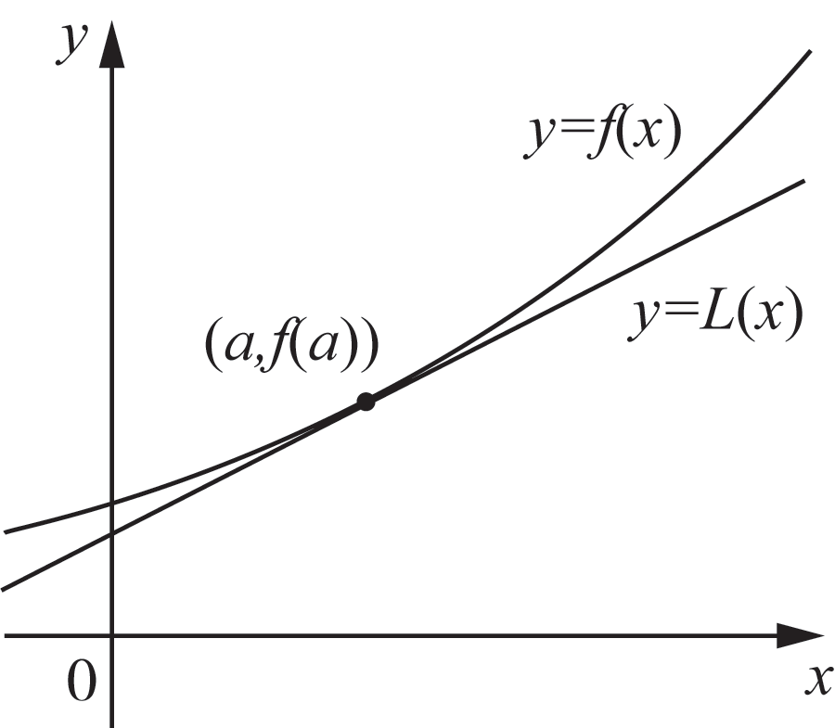
As shown in the figure above, the so-called linear approximation means that it is approximately represented by a linear function near point a.$f(x)$. The equation of the tangent line passing through point a is:
$y = f(a) + f'(a)(x − a)$
Therefore, the linear approximation near point a is:
$L(x) = f(a) + f'(a)(x − a)$
Linear approximation is concise and practical. Approximation tools based on quadratic or higher-order functions are certainly more accurate, but they require much more effort. So although linear approximation is not perfect, it is very useful.
Let's take an example to explain linear approximation.

Example 4-7)Find function$f(x) = \sqrt[3]{x}$exist$x = 27$linear approximation at and use it to estimate$\sqrt[3]{28}$(accurate to four decimal places), compare this estimate with the exact value.
Solution: From the meaning of the question, we know that f(27) = 3, and the derivative of the function is:
$f'(x) = \frac{1}{3\sqrt[3]{x^{2}}}, f'(27) = \frac{1}{3\sqrt[3]{{27}^{2}}} = \frac{1}{27}$

92 Play with calculus

Therefore, the required linear approximation is:
$L(x) = 3 + \frac{1}{27}(x − 27)$
$∴ L(28) = 3 + \frac{1}{27} ≈ 3.037$
$∴ ∛28 ≈ 3.0370$
On the other hand, using a calculator directly calculates:$∛28 ≈ 3.0366$. It can be seen that the estimated value is slightly larger than the precise value. After calculation, it can be seen that the accuracy$< 1.3 × 10⁻⁴$。
Now let's connect two knowledge points: linear approximation and differential calculus. Let's look at the diagram introducing function differentials:
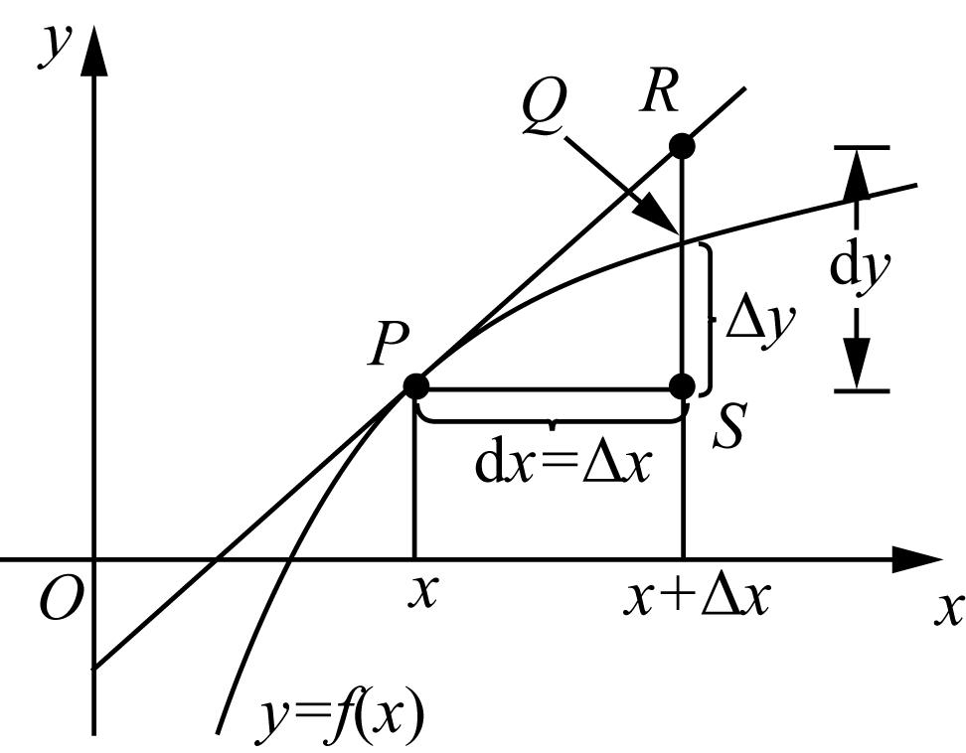
We know that the linear approximation of point a is:
$L(x) = f(a) + f'(a)dx = f(a) + dy$
Its corresponding point is R. And the exact value is:
$y = f(x) + Δy$
Its corresponding point on the graph is Q. The difference between the approximate value and the exact value is (dy - Δy). Obviously, the smaller dx is, the smaller this error is.
Linear approximation does not look complicated, but it is not always convenient. With rapid advances in computing, some of its direct practicality has decreased. Still, we present it in a separate section for two reasons: first, this method of simplifying complex problems is a basic method of calculus and also guides daily work; second, this seemingly simple method was once extremely effective and was built by many predecessors. We salute them.

Chapter 4 | What is the use of derivatives? 93

4.4 Crossing the river by feeling for the stones - Newton's method
When it comes to linear equations of one variable, many primary school students may be able to solve them decently. As for the quadratic equation, almost every high school student can write its root formula. But what about something a little more complicated? For example:
$ax³ + bx² + cx + d = 0$
A little dizzy, right? What if it was more complicated? For example:
$2x³ − 3x·sin(x) − 5lnx = 0$
Who is asking you to write a closed-form formula for this kind of equation? Don't worry: if you insist on writing such a root formula, not only can you not do it, you also will not find a mathematician who can do it in general. Most equation problems in applied sciences do not have explicit root formulas.
Mathematicians long ago discovered that many equations do not yield exact solutions. But they were not discouraged. If an exact solution is unavailable, we seek an approximate one by every reasonable means. Taking a step back, accepting imperfection, and reconciling with reality is also a kind of wisdom.
Newton adopted a very elegant method for finding approximate solutions of equations. This is a standard calculus idea: use linear methods to solve nonlinear problems.
The idea is as follows:
1) As shown in the figure on the right, assuming that our task is to find$f(x)$The root r. We who have no clue can only guess an x₁ first. Of course, it is almost certain that x₁ is not the r we require.
2) Next, we find the curve at the point$x₁$The tangent line L. Since it is a straight line, we can easily find the intersection point of the straight line L and the x-axis$x₂$。
3) Naturally, x₂ is not r with high probability. However, since the tangent direction is the minor trend of the function, it represents the curve at point x₁$f(x)$direction. Thus we know that although x₂ is not r, it should be closer to r than x₁.
4) Find the point of the curve$x₂$tangent to , and find its intersection with the x-axis$x₃$。$x₃$Compare$x₂$closer to r.
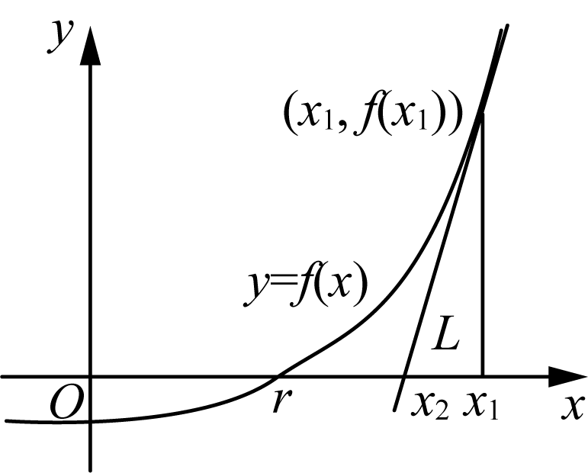
5) Repeat the above steps to get$x₁, x₂, x₃, …，xₙ, …$
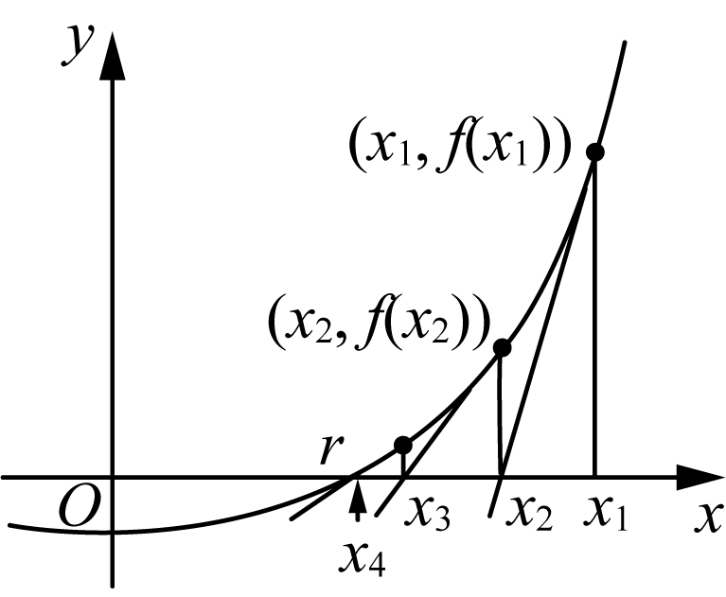

94 Play with calculus

It is easy to see from the picture above:
$f'(x₁) = \frac{f(x₁)}{x₁ − x₂}$
$f'(x₂) = \frac{f(x₂)}{x₂ − x₃}$
By extension:
$f'(xₙ) = \frac{f(xₙ)}{xₙ − xₙ₊₁}$
Right now:
$xₙ₊₁ = xₙ − \frac{f(xₙ)}{f'(xₙ)}$
7) Conclusion: The larger the value of n, the closer xₙ is to r. That is:
$\lim_{n→∞}xₙ = r$
Don't feel intimidated when you see a limit. This mathematical idea is worth pondering. Next, let us apply what we have learned.

Example 4-8)from$x₁ = 2$Let’s start and find the equation$x³ − 2x − 5 = 0$Approximate value of the root of (accurate to four decimal places).
Solution: Assume$f(x) = x³ − 2x − 5$
$∴ f′(x) = 3x² − 2$
So, following Newton's method, we have:
$xₙ₊₁ = xₙ − \frac{xₙ³ − 2xₙ − 5}{3xₙ² − 2}$
thus:
$x₂ = 2 − \frac{2³ − 2×2 − 5}{3×2² − 2} = 2.1$
$x₃ = 2.1 − \frac{2.1³ − 2×2.1 − 5}{3×2.1² − 2} ≈ 2.0946$
How accurate is x₃? Use a calculator to calculate:$f(2.0946) ≈ 5.4 × 10⁻⁴$. It can be seen that the accuracy of x₃ is quite impressive. So, why this example? Remember, this question is the original question in Mr. Newton’s paper introducing Newton’s method!
Although Newton's method is very easy to use, if it is used in a haphazard way, sometimes it will lead to mistakes.

Chapter 4 | What is the use of derivatives? 95

... and cannot achieve the desired effect. Please see the figure below:
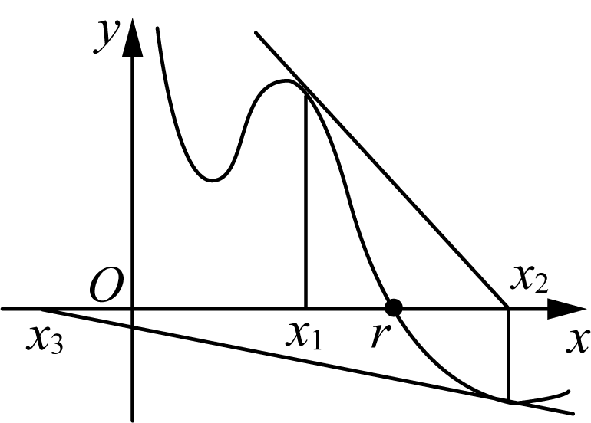
$x₁$It still looks like that, but since$x₂$From now on, I will gradually drift away from r. Why? Because the first step in Newton's method,$x₁$The choice is a technical job!
Just like the example in the master's manuscript, he chose$x₁ = 2$, why not choose 0, 1, −1? Just compare it and you will know. Obviously,$f(0) = −5，f(1) = −6，f(−1) = −4，而 f(2) = −1$. Even if you were given a choice, you would choose the function value 2 closest to 0 as$x₁$Bar.
The idea of Newton's method can be summarized by a classic saying: cross the river by feeling for the stones. But which stone to touch first is a matter of wisdom.
Today, with AI technology steadily developing, Newton's method has strong practical significance. Many advanced student calculators can solve unconventional equations, and their core principle is often Newton's method.
Let's take another example to become familiar with the process.

Example 4-9)Find equations using Newton's method$cos x − sin x = x$The root of is required to be accurate to four decimal places.
Solution: Let’s draw first$f(x) = cos x − sin x$as well as$g(x) = x$Sketch of:
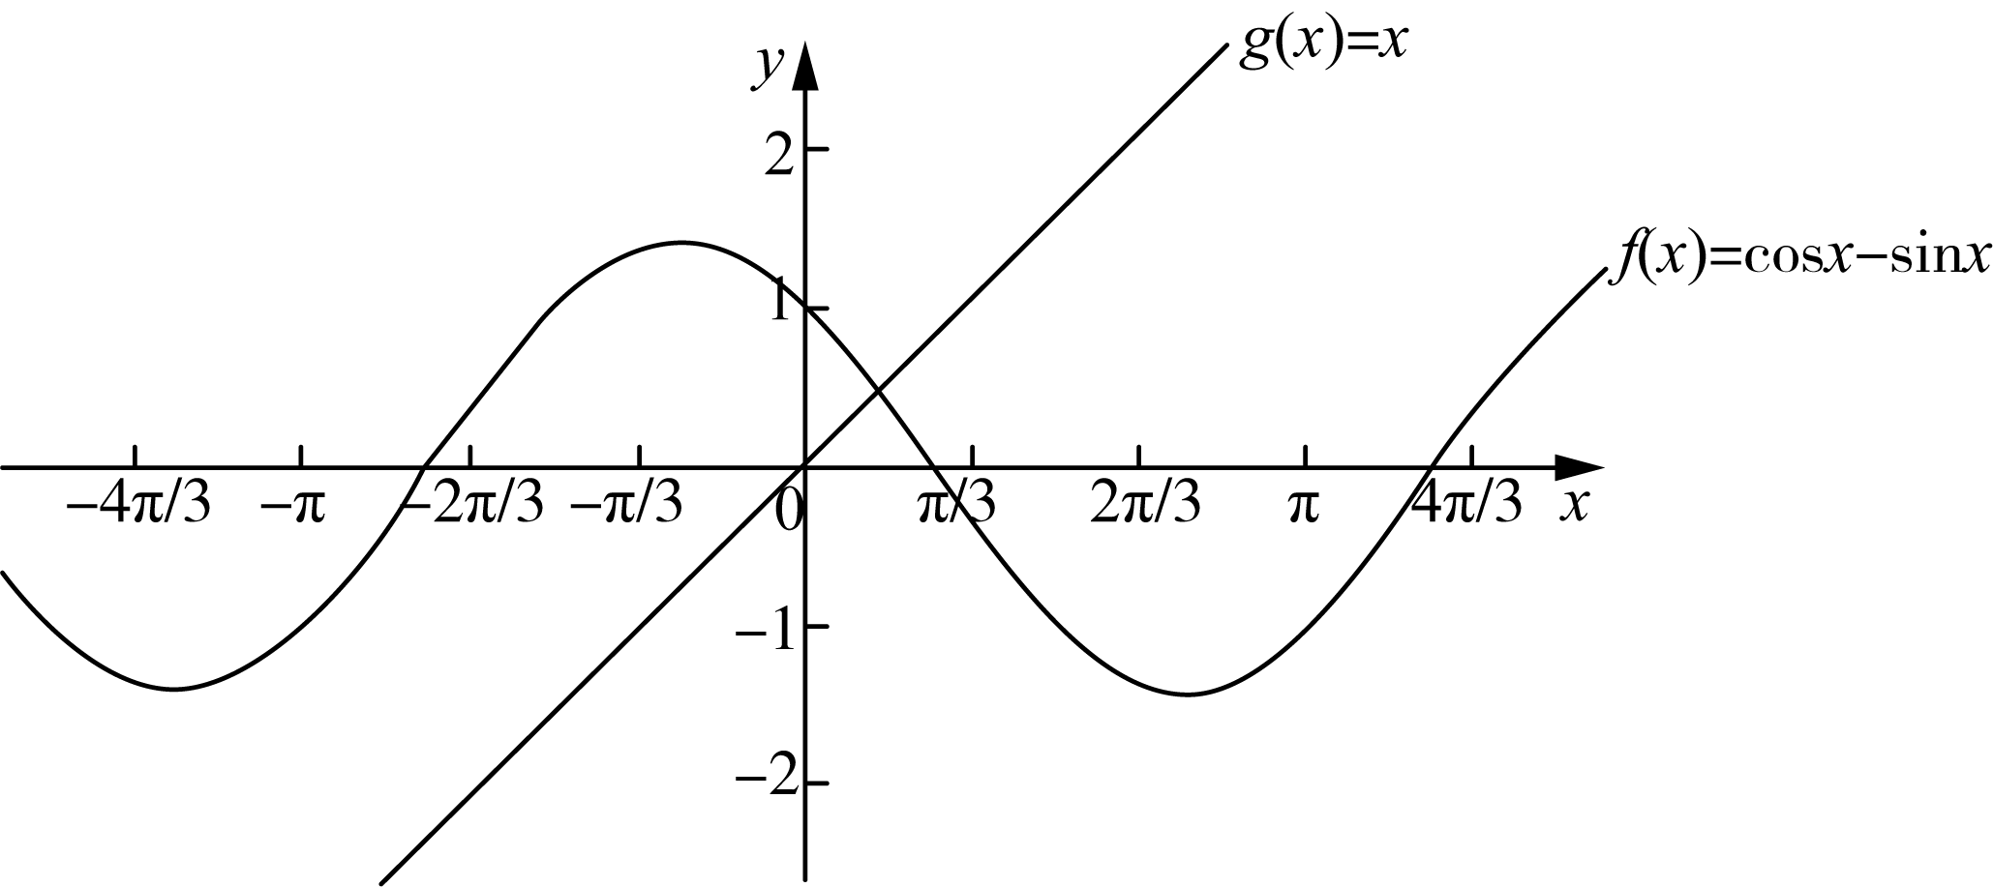
As can be seen from the figure, the two lines intersect roughly where x is less than 1. Therefore we choose$x₁ = 0.75$to find the equation$h(x) = cos x − sin x − x = 0$of roots.
because$h′(x) = −sin x − cos x − 1$,so:
$xₙ₊₁ = xₙ − \frac{cos xₙ − sin xₙ − xₙ}{−sin xₙ − cos xₙ − 1}$

96 Play with calculus

Bundle$x₁ = 0.75$Substituting into the above formula and calculating in sequence, we can get:
$x₂ = 0.159965$
$x₃ = 0.456646$
$x₄ = 0.456625$
because$x₃、x₄$The first four decimal places of have overlapped, so the root we require is:$x = 0.4566$。
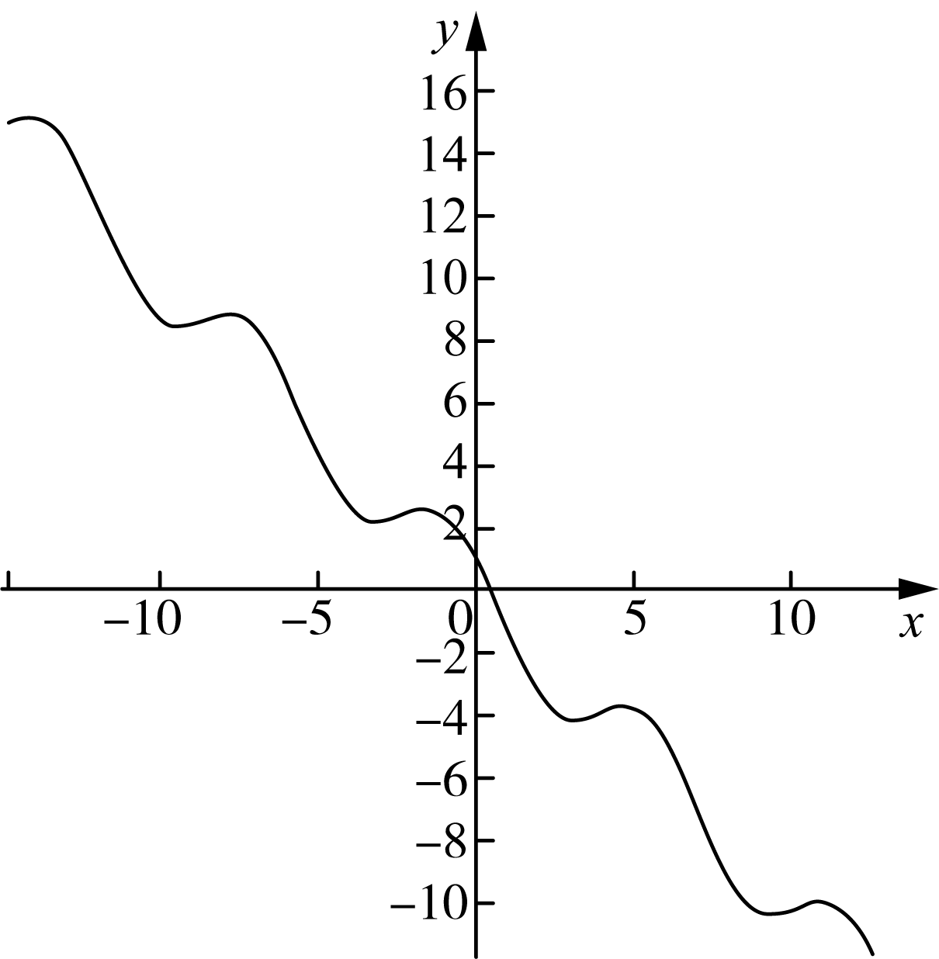
At this point, derivatives have appeared in many applications. Let us see what else derivatives are used for.

4.5 Mean value theorem and the shape of function graphs
In studying functions, it is very helpful to grasp the shape of the graph accurately. As the local trend indicator of a function, the derivative naturally plays a key role in graph shape. Understanding this helps us grasp the overall behavior of a function.
First, let me introduce:
Rolle's Theorem
hypothesis function$f(x)$satisfy:
1) Continuous in the interval [a, b]
2) Differentiable in the interval (a, b)
3）$f(a) = f(b)$
Then, there must be a real number c on the interval (a, b) such that:
$f'(c) = 0$
Proof of theorem: we can prove Rolle's theorem by considering three cases.

Chapter 4 | What is the use of derivatives? 97

Case 1: If for any x value on the interval [a, b], there is$f(x) = f(a) = f(b)$, then the image of the function f(x) is a straight line parallel to the x-axis. At this time, the tangent of any point that is derivable in the interval (a, b) is parallel to the x-axis. Just find any point c and it will satisfy:$f′(c) = 0$。
Case 2: If the function value of a certain point in the interval (a, b) is greater than the function value of the endpoint, then according to the extreme value theorem, there must be a point c in the interval (a, b), such that$f(c)$is the maximum value of function f(x) on [a, b]. By definition, this$f(c)$It is also a relative maximum value, and f(x) is differentiable at point c. Therefore, according to Fermat’s theorem, we know:$f′(c) = 0$。
Case 3: If the function value of a certain point in the interval (a, b) is smaller than the function value of the endpoint, according to the proof method of case 2, we can also get the conclusion: there is a point c in the interval (a, b), which satisfies:$f′(c) = 0$。
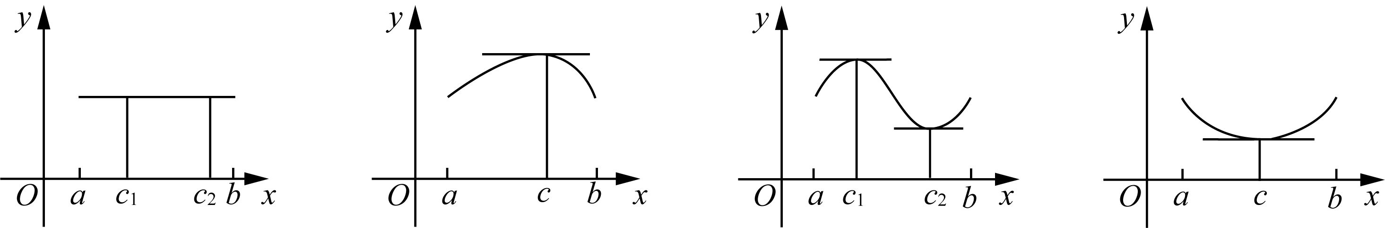
The figure above shows several cases where Rolle's theorem holds. Geometrically, when endpoint function values are equal, there exists a point c in (a, b) where the tangent line is parallel to the x-axis.
Since endpoint function values are equal, the line connecting the endpoints is also parallel to the x-axis. Rolle's theorem is equivalent to saying there is a point c in (a, b) where the tangent line is parallel to that endpoint secant line. Naturally we ask: does this still hold when endpoint values are not equal? The answer is yes.
Lagrange's Mean Value Theorem
hypothesis function$f(x)$satisfy:
1) Continuous in the interval [a, b]
2) Differentiable in the interval (a, b)
Then, there must be a real number c on the interval (a, b) such that:
$f'(c) = \frac{f(b) − f(a)}{b − a}$
Theorem proof idea: since Rolle's theorem has just been proved, and the right side of the formula we need is an endpoint-interval expression,

98 Play with calculus

The slope of the connecting line. Therefore, we specifically want to find a function that is both related to the endpoint and$f(x)$related, and preferably the function values ​​at both endpoints are equal.
If the function$f(x)$The difference between the y value on the straight line and the endpoint connecting line is defined as a new function$g(x)$, then the endpoint value of this new function must be 0. How about applying Rolle's theorem to it?
We know: Connect two endpoints$(a, f(a))$、$(b, f(b))$The straight line equation of is:
$y = f(a) + \frac{f(b) − f(a)}{b − a}(x − a)$
So, we have:
$g(x) = f(x) − \left(f(a) + \frac{f(b) − f(a)}{b − a}(x − a)\right)$
What are the characteristics of this new g(x)? It is not only continuous in the interval [a, b], but also differentiable in the interval (a, b), and more importantly:$g(a) = g(b) = 0$, now the conditions for the establishment of Rolle's theorem are complete. Therefore, in the interval (a, b), there must be a point c such that:$g′(c) = 0$. Substituting this conclusion into the above definition:
$g'(c) = f'(c) − \frac{f(b) − f(a)}{b − a} = 0$
$∴ f'(c) = \frac{f(b) − f(a)}{b − a}$
In this theorem proving process, functions are tailored to apply Rolle's theorem$g(x)$The technique is a common technique used by mathematical masters in the past generations in their creative work, and it has a very high technical content.
The algebraic meaning of the mean value theorem is that there is a point c on the interval (a, b) such that the function$f(x)$The instantaneous rate of change at point c is equal to the function$f(x)$The average rate of change over the entire interval [a, b].
The geometric meaning of the mean value theorem is that there is a point c in (a, b) such that the tangent line at c is parallel to the line connecting the endpoints. Please refer to the figure below:
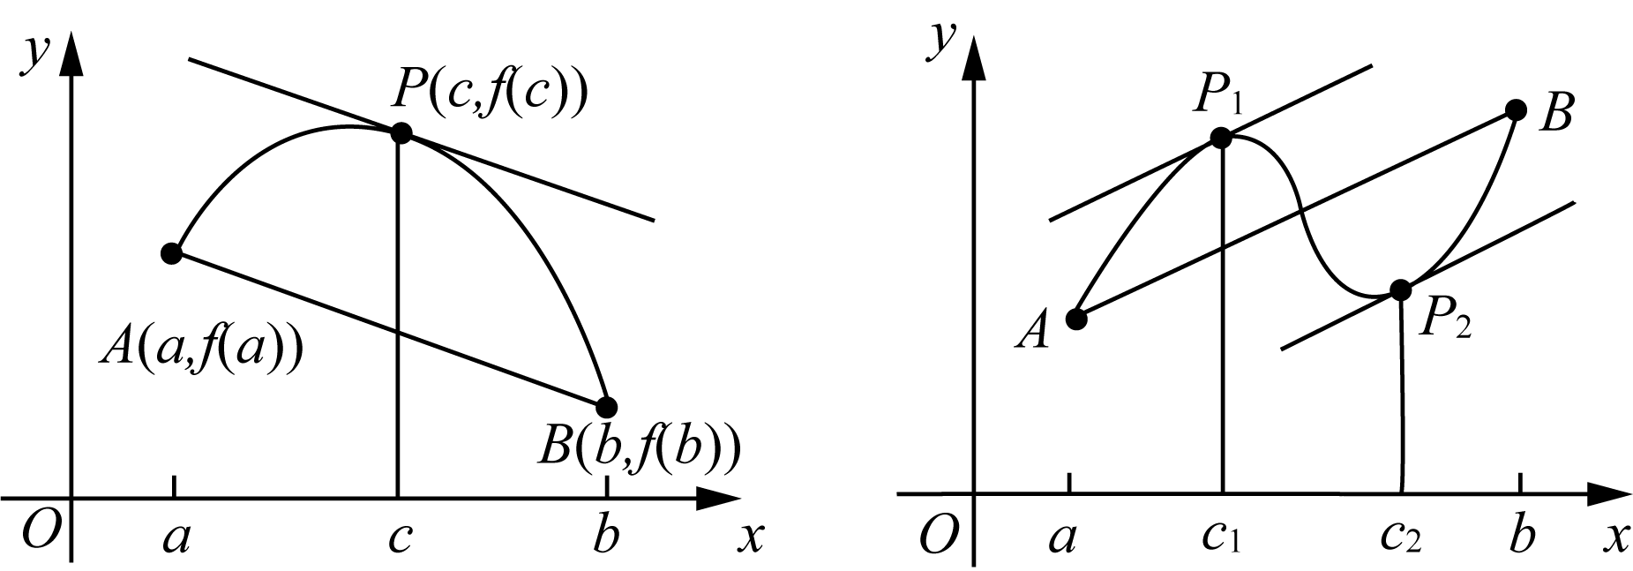
As shown above, the left figure has one point c satisfying the mean value theorem, while the right figure has two such points c.

Chapter 4 | What is the use of derivatives? 99

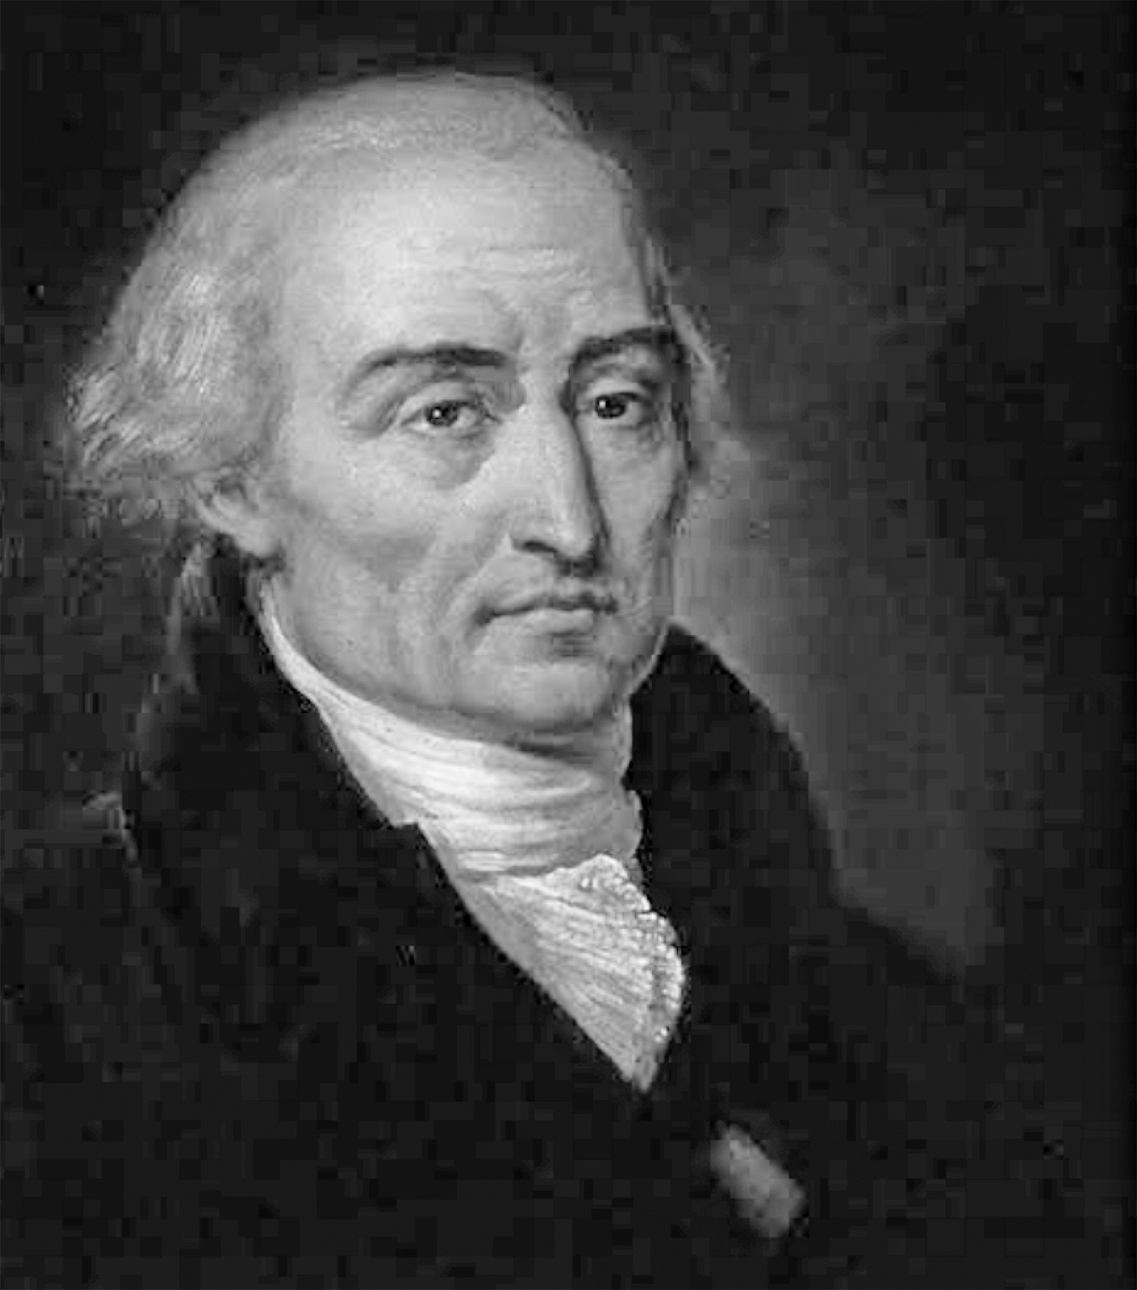
Take two problems to get a feel for it:

Example 4-10)Verification function$f(x) = 2x² − 3x + 1$The mean value theorem is satisfied on the interval [0, 2].
Solution: Our task is to find a c on the interval [0, 2] such that:
$f'(c) = \frac{f(2) − f(0)}{2 − 0} = 1$
Note:$f′(x) = 4x − 3$, so as long as the following equation about c has a solution, our task is completed:
$4c − 3 = 1$
The above equation obviously has a solution: c = 1.
Sometimes the problem can be presented in a twisted form. Please see the next example.

Example 4-11)It is known that the whole region differentiable function$f(x)$,satisfy$f′(x) ≤ 9$and$f(1) = −8$. beg$f(3)$The maximum possible value.
Solution: According to the mean value theorem, we know that on the interval (1, 3), there must be a point c such that:
$f'(c) = \frac{f(3) − f(1)}{3 − 1}$
And because$f′(x) ≤ 9$,so:
$\frac{f(3) − f(1)}{3 − 1} ≤ 9$

100 Play with calculus

have to:$f(3) + 8 ≤ 18$,Right now$f(3) ≤ 10$. Therefore, what is sought$f(3)$The maximum possible value is 10.
On the one hand, we can prove Lagrange's theorem through Rolle's theorem; on the other hand, Rolle's theorem can be viewed as a special case of Lagrange's theorem. In fact, Lagrange's theorem itself can be seen as a special case of another theorem, namely Cauchy's mean value theorem.
Cauchy's mean value theorem
Let function$f(x)、g(x)$is continuous in [a, b], (a, b) is differentiable, and$g′(x) ≠ 0$, then there must be a$c ∈ (a, b)$satisfy:
$\frac{f(b) − f(a)}{g(b) − g(a)} = \frac{f'(c)}{g'(c)}$
Cauchy's mean value theorem can also be derived via Rolle's theorem through the proof of Lagrange's theorem. In practice, applications of Cauchy's mean value theorem often involve curves given by the following parametric equations:
$x = x(t), t ∈ (a, b)$
$y = y(t)$
Therefore, Lagrange's theorem and Cauchy's mean value theorem can both be seen as generalizations and developments of Rolle's theorem. In many exams, Cauchy's theorem is not tested frequently, so for now it is enough to know its statement.
Rolle's theorem and Lagrange's theorem both describe, to some extent, graph behavior on an interval, such as tangent direction. From the sign of the derivative on an interval, we can judge whether the function is increasing or decreasing there.
However, they are also increasing functions. The two increasing functions in the figure$f(x)$and$g(x)$There is a clear difference:
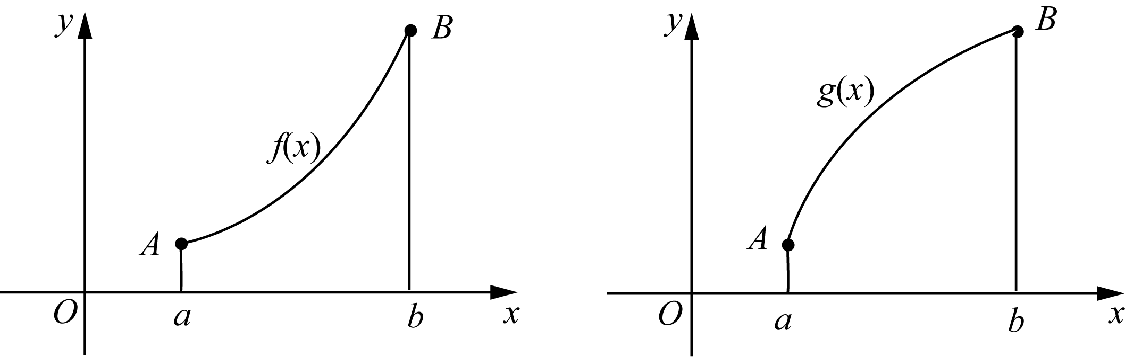
We usually call the left upward-opening shape in the figure above a convex shape, while the right shape opens downward.

Chapter 4 | What is the use of derivatives? 101

The figure is called a convex figure. Expressed in mathematical jargon: function$f(x)$Convex under the interval (a, b), the function$g(x)$Convex on the interval (a, b).
It is worth noting that Chinese and Western expressions for graph concavity/convexity differ. In Chinese usage, we focus on which side bulges. In Western usage, the focus is the opening direction, which is opposite to the direction of "bulging up." Therefore, what we call an upward-convex function is often called Concave Down in English, while a downward-convex function corresponds to Concave Up.
A clear geometric interpretation is this: for upward-convex functions, tangent lines lie above the graph; for downward-convex functions, tangent lines lie below the graph.
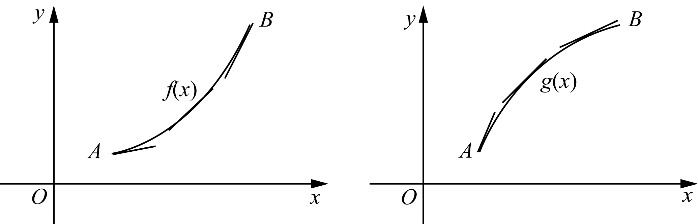
So how do we determine whether a function graph is upward-convex or downward-convex? The key tool is the second-derivative test.
If in the interval (a, b), the function f(x) satisfies:$f″(x) > 0$, then the function f(x) is convex in this interval; if in the interval (a, b), the function f(x) satisfies:$f″(x) < 0$, then the function f(x) is convex on this interval.
This discrimination method can be proved with the help of the mean value theorem. Due to space limitations, this book will not introduce it in detail.
With the second-derivative test, we gain a new way to analyze extreme value problems. Based on the sign of the second derivative, we can easily draw the following conclusion:
if function$f(x)$The second derivative of is continuous near point c, then:
1) if$f′(c) = 0$，$f″(c) > 0$,but$f(c)$Must be the relative minimum value of the function;
2) if$f′(c) = 0$，$f″(c) < 0$,but$f(c)$It must be the relative maximum value of the function.
The above conclusion is very intuitive geometrically. Now briefly explain the first case, since the second derivative is positive, the curve is convex downward. Therefore, the tangent line of the function near point c is below the function graph, and since the tangent line of the function at point c is a horizontal tangent line, so$f(c)$It becomes the relative minimum value of the function.

102 Play with calculus

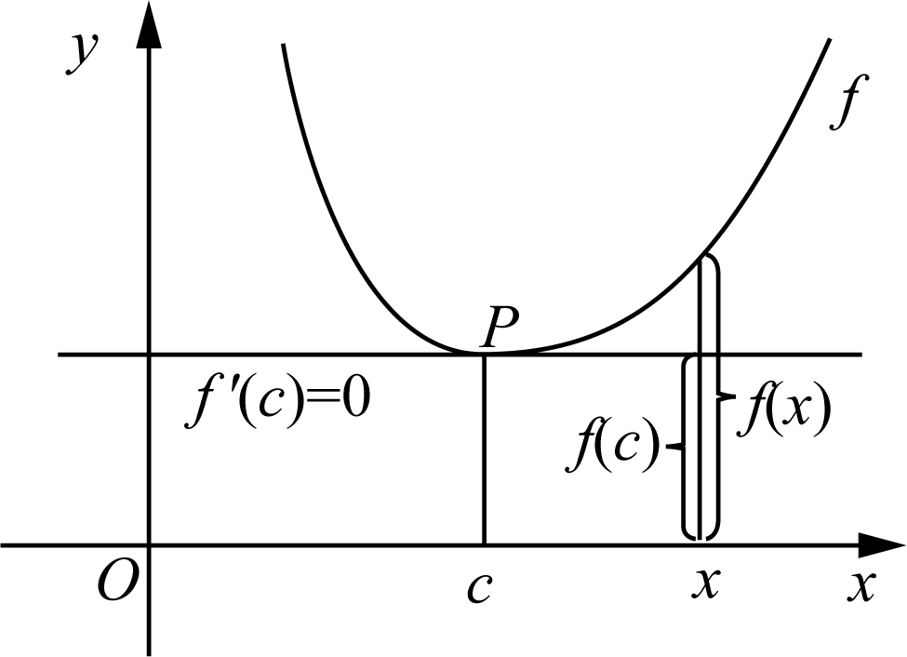
On the one hand, if the function is downward-convex, the tangent line lies below the graph, and the extreme point is a relative minimum, which is consistent. On the other hand, if the function is upward-convex, the tangent line lies above the graph, and the extreme point is a relative maximum, which is also consistent.
To view concavity from a broader perspective, note another fact: the secant line connecting any two points of an upward-convex function lies below the graph. Conversely, for a downward-convex function, the secant line lies above the graph.
After this section, when finding extreme values, we can either use sign changes of the first derivative around critical points to determine whether an extreme point is a maximum or minimum, or directly infer the nature of the extreme point from the sign of the second derivative.
Now, we can look at the familiar quadratic function$y = ax² + bx + c$Here’s a more advanced summary:
Depend on$y′ = 0$, the critical point of y can be found to be$\frac{−b}{2a}$（$a ≠ 0$). So, when$a > 0$time, due to$y″ = 2a > 0$, y is the minimum value at the critical point; otherwise, when$a < 0$time, due to$y″ = 2a < 0$, y is the maximum value at the critical point.
Please see examples.

Example 4-12)known function$f(x)$Derivative of$f′(x) = (x − 1)eˣ$, find the critical point of the function, and explain the properties of the critical point.
Solution: You might as well use the old routine and set the derivative to 0, you can get$f(x)$The critical point is 1 and unique.
Solution 1: When$x < 1$hour,$f′(x) = (x − 1)e^{x} < 0$, so the function f(x) is a decreasing function; when$x > 1$hour,$f′(x) = (x − 1)e^{x} > 0$, so the function f(x) is an increasing function.
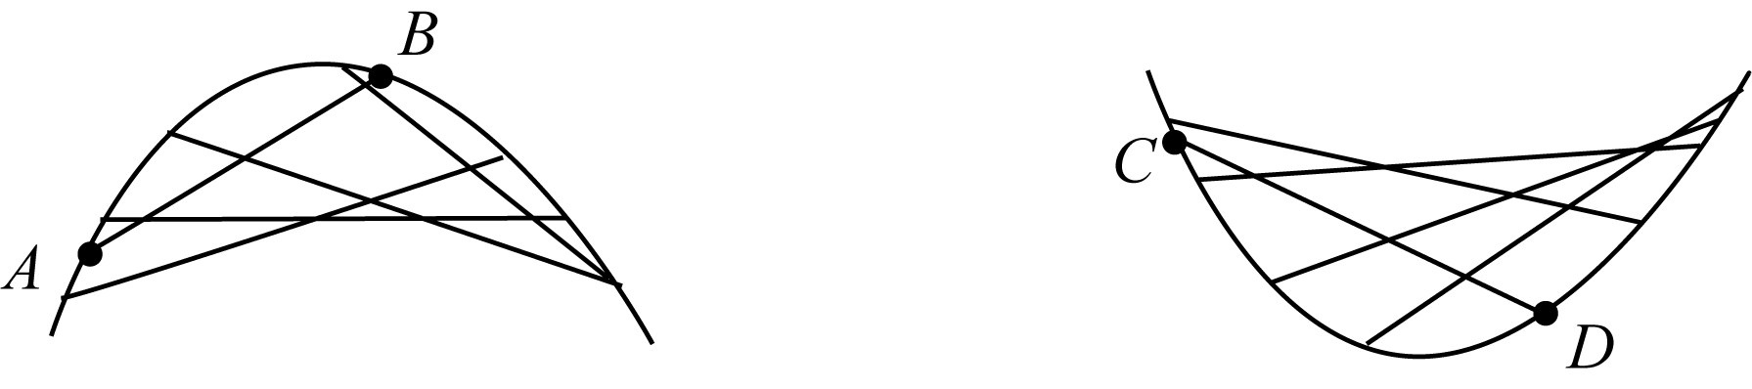

Chapter 4 | What is the use of derivatives? 103

So the critical point c = 1 is the minimum point.
Solution 2: Find the second derivative to get$f″(x) = xe^{x}$,so$f″(1) = e > 0$. Therefore, point 1 is the minimum point.
Interesting? There is another concept about graph concavity and convexity that I'd like to introduce now.
Point of Inflection
if function$f(x)$The second derivative of is a continuous function and has different signs around point a, then point a is called a function$f(x)$the turning point.
Learning notes on the inflection point concept:
1) The function around the inflection point changes from an upward convex function to a downward convex function or vice versa;
2) The second derivative of the inflection point is either 0 or does not exist.
We learned critical points before, and now we have inflection points. Compare them: a critical point is where the derivative equals 0 or does not exist, and it is a candidate extreme point. An inflection point is where the second derivative changes sign. Note, however, that having second derivative equal to 0 or not existing is only a necessary condition for being an inflection point, not a sufficient condition. Just as continuity is necessary for differentiability, but not sufficient.
At this point, we can describe graph direction near a point more clearly. Graph evolution is a bit like basic Chinese calligraphy strokes. In essence, function graphs are built from basic forms: straight rise (fall), curved rise (fall), and transitions between concave-down and concave-up behaviors.
With derivatives, we can understand basic function behavior such as increasing/decreasing and concavity/convexity. If we also consider asymptotes, we can sketch more realistic graphs even for complex functions.
Based on what you have learned, here are standard actions for drawing a decent function graph:
1) Pay attention to the function domain;
2) Find the intersection point of the function and the coordinate axis;
3) Pay attention to parity, which is symmetry;
4) Observe whether there is an asymptote;
5) Find the relative extreme points;
6) Pay attention to the increase and decrease of functions and the concavity and convexity.

Example 4-13) Sketch the graph of the following function:
$y = f(x) = \frac{3x²}{2x² − 5}$

104 Play with calculus

Solution: First pay attention to the following five points:
1) The domain of the function is$x ≠ ±\frac{\sqrt{10}}{2}$。
2) Obviously, the intersection of the function and the coordinate axis is the origin.
3) Due to$f(−x) = f(x)$, so the function is an even function, symmetric about the y-axis.
4) Because:
$\lim_{x→∞}f(x) = \frac{3}{2}$
Therefore, the function has a horizontal asymptote$y = \frac{3}{2}$. And because:
$\lim_{x→{\frac{\sqrt{10}}{2}}^{+}}f(x) = +∞, \lim_{x→{\frac{\sqrt{10}}{2}}^{−}}f(x) = −∞$
Therefore, the function has two vertical asymptotes:$x = ±\frac{\sqrt{10}}{2}$。
5) Find the critical point,$f′(x) = 0$：
$f'(x) = \frac{−30x}{{\left(2x² − 5\right)}^{2}}$
$∴ x = 0$
It can be seen that the 0 point is the function$f(x)$is the only critical point. It is not difficult to know from observation that the derivative of the function changes from positive to negative at this point, which means that point 0 is the relative maximum point of the function.
Next, study the concavity and convexity:
The first step is to find the second derivative:
$f''(x) = \frac{180x² + 150}{{\left(2x² − 5\right)}^{3}}$
In the second step, in the interval ($−\frac{\sqrt{10}}{2}$, $\frac{\sqrt{10}}{2}$)，$f″(x) < 0$, so the function f(x) is an upward convex function;

Chapter 4 | What is the use of derivatives? 105

And in the interval (−∞,$−\frac{\sqrt{10}}{2}$) and ($\frac{\sqrt{10}}{2}$, +∞)，$f″(x) > 0$, so the function is a downward convex function.
To sum up, we can draw the graph of this function, roughly as follows:
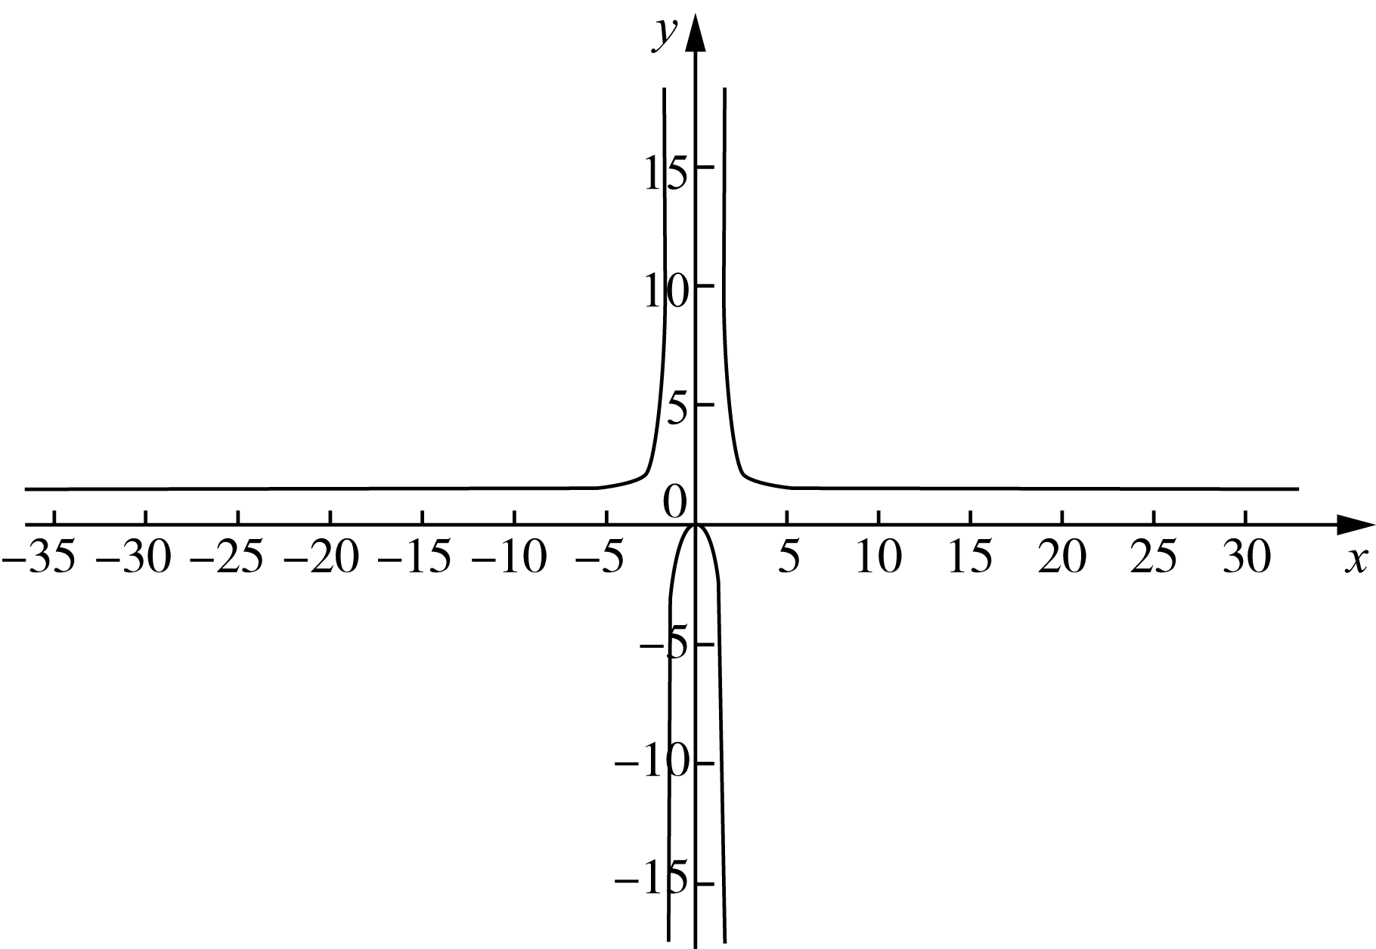

4.6 The way to find roots - Antiderivative
When we describe someone as very familiar with a text, we say they know it by heart. If you are given the derivative formula of a function and can "recite it backward," you are essentially identifying the original function from its derivative. In other words, if you see an "unclaimed" derivative, you can quickly answer: whose derivative is this? In calculus, this is a basic ability.
For example, according to the formula$(x²)′ = 2x$, you can easily say$2x$yes$x²$the derivative of.
Since the root-finding action of finding the original function based on the derivative is completely opposite to the process of derivation, it has an evocative name - antiderivative.
For example, when saying$2x$yes$x²$When using derivatives, it is equivalent to saying:$x²$yes$2x$antiderivative of .
Generally speaking, we describe$F(x)$yes$f(x)$When antiderivative, it refers to:
$F'(x) = f(x)$
If you are proficient in derivatives, you will naturally know that not only$(x²)′ = 2x$, all shapes like$x² + C$(where C is a constant), its derivatives are all$2x$. In other words, the function$2x$The antiderivative of is not unique. Therefore, our previous sentence should be changed to: function$2x$is a function$x² + C$the derivative of.

106 Play with calculus

Obviously, here$x² + C$Not a function, but a set of functions. Thus, the following conclusion is self-evident.
if, function$F(x)$and$G(x)$All$f(x)$The antiderivative of , then:
$F(x) − G(x) = C，其中 C 为常数$
Example 4-14)Find function$xⁿ$antiderivative of$F(x)$, where n is a real number.
Solution: We have to do it in two steps.
First, if$n = −1$,because$(ln x)′ = \frac{1}{x}$,so$ln x + C$is the antiderivative sought;
Secondly, if$n ≠ −1$,because:
$\left(\frac{x^{n+1}}{n+1}\right)′ = xⁿ$
so$\frac{x^{n+1}}{n+1} + C$is the desired antiderivative. Right now:
$F(x) = \left(ln x + C (n = −1)\right)$
$F(x) = \frac{x^{n+1}}{n+1} + C (n ≠ −1)$
Although we have been saying that the antiderivative of a function usually refers to a set of functions, if certain constraints are added, a definite function can generally be obtained.

Example 4-15)Known:$f″(x) = 2x^{3} + 3x^{2} − 4x + 5$，$f(0) = 2$，$f′(1) = 0$, find the function$f(x)$。
Solution: We know,$f′(x)、f(x)$They are:
$f'(x) = 2 \frac{x^{4}}{4} + 3 \frac{x^{3}}{3} − 4 \frac{x^{2}}{2} + 5x + C₁$
$= \frac{1}{2}x^{4} + x^{3} − 2x^{2} + 5x + C₁$
$f(x) = \frac{1}{10}x^{5} + \frac{1}{4}x^{4} − \frac{2}{3}x^{3} + \frac{5}{2}x^{2} + C₁x + C₂$
Bundle$f(0) = 2，f′(1) = 0$Substituting into the above equation, we get:
$C₂ = 2$
$\frac{1}{10} + \frac{1}{4} − \frac{2}{3} + \frac{5}{2} + C₁ + C₂ = 0$
Solving the equation gives:
$C₁ = −\frac{251}{60}$
$C₂ = 2$
$∴ f(x) = \frac{x^{5}}{10} + \frac{x^{4}}{4} − \frac{\left(2x^{3}\right)}{3} + \frac{\left(5x^{2}\right)}{2} − \frac{251}{60}x + 2$

Chapter 4 | What is the use of derivatives? 107

To make this section easier to practice, I have pulled out basic functions and their corresponding antiderivatives for you to master. Feel free to keep them handy.

function | antiderivative
$x^{n} (n ≠ −1)$ | $\frac{x^{n+1}}{n+1}$
$\frac{1}{x}$ | $ln|x|$
$e^{x}$ | $e^{x}$
$sin x$ | $−cos x$
$cos x$ | $sin x$
$\sec^{2} x$ | $tan x$
$sec x · tan x$ | $sec x$
$\frac{1}{\sqrt{1 − x^{2}}}$ | $arcsin x$
$\frac{−1}{\sqrt{1 − x^{2}}}$ | $arccos x$
$\frac{1}{1 + x^{2}}$ | $arctan x$

There are ten "King Kong" formulas in total. As long as you can recite them fluently, you will move confidently in the world of antiderivatives.
In the following chapters, you will see that these seemingly ordinary antiderivatives have powerful applications.
Next, let us meet the definite integral. Of course, before setting out, first consolidate your learning with exercises.

108 Play with calculus

Exercise 4
4-1) Find the critical points of the following functions:
（1）$y = x⁴ + x³ + x² + 1$；
（2）$y = |x² − 1|$；
（3）$y = \frac{x − 1}{x + 1}$；
（4）$y = 2cos x + sin²x$。

4-2) Find the absolute extreme value of the following function in the specified interval:
（1）$y = x³ − 2x² − x + 1，x ∈ [0, 5]$；
（2）$y = 5 + 6x − x²，x ∈ [0, 8]$；
（3）$y = 2x³ − 3x² − 12x + 1，x ∈ [−2, 3]$；
（4）$y = \frac{x}{x^{2} + 1}，x ∈ [0, 3]$；
（5）$y = x\sqrt{4 − x^{2}}，x ∈ [1, 2]$；
（6）$y = x + cos(x)，x ∈ [−\frac{π}{2}, \frac{π}{2}]$。

4-3) Use the linear approximation method to estimate the following values:
（1）$(2.999)⁴$；
（2）$sin 1°$；
（3）$∛1001$。

4-4) Use Newton's method to find the roots of each of the following equations (accurate to 6 decimal places):
（1）$3cos x = 2x + 1$；
（2）$eˣ = x² − 1$；
（3）$cos(x² − 1) = x$。

4-5) Please verify that the following functions satisfy Lagrange's mean value theorem in the specified interval:
（1）$f(x) = 2x³ − 3x + 1，x ∈ [0, 2]$；
（2）$f(x) = ln x，x ∈ [1, 3]$。

4-6）Proof: Eq.$x³ − 15x + c = 0$In the interval [−2, 2], there is at most one root.

4-7）if$f(1) = 10$，$f′(x) > 2$(1 < x < 4), please$f(4)$Is there a lower limit?

4-8) For each of the following functions: a) find the increasing and decreasing intervals; b) find the relative extreme values; c) find the inflection points and the upward- or downward-convex intervals.
（1）$y = x³ − 12x + 3$；
（2）$y = −x³ + 2x² + 2$；
（3）$y = (x + 1)⁵ − 5x − 2$；
（4）$y = \sqrt{6 − x}$；
（5）$y = 2cos x + cos²x，x ∈ (0, 2π)$。

4-9) Find the antiderivative of each of the following functions:
（1）$y = 2x³ − 3x² + x + 1$；
（2）$y = \frac{x^{2} + x + 2}{x}$；
（3）$y = 4sec²x − 5sin x$；
（4）$y = eˣ$。

