Error w/ TF1:

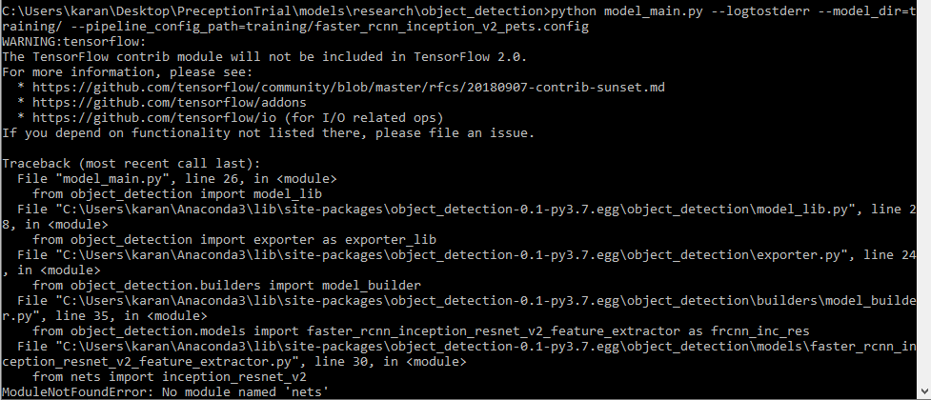

* Copy folder nets from research/slim/ to research/objected detection
* Run setup.py build and then setup.py install in research folder and then run again.

Error w/ TF2:

* Before tf_slim:

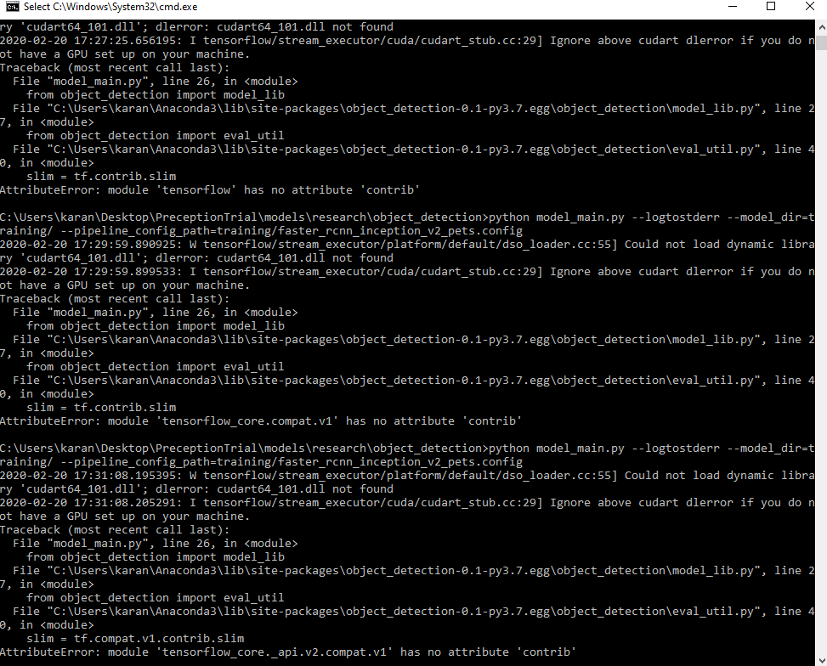

* Solution steps:
  + Eval_util.py:
    - Comment line 40
    - Change line 327
      * from (with tf.contrib.slim.queues.QueueRunners(sess):)
      * to (with tf.estimator.experimental.slim.queues.QueueRunners(sess):)

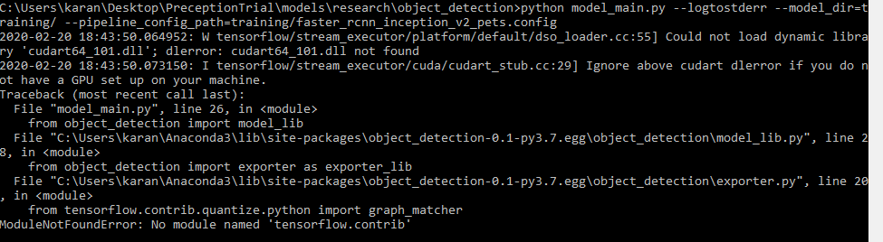

* Solution steps:
  + Exporter.py
    - Change line 20 from (from tensorflow.contrib.quantize.python import graph_matcher) to (from tensorflow.estimator.experimental.quantize.python import graph_matcher)
    - Comment line 30
    - Change line 527
      * from (tf.contrib.tfprof.model_analyzer.TRAINABLE_VARS_PARAMS_STAT_OPTIONS))
      * to (tf.estimator.experimental.tfprof.model_analyzer.TRAINABLE_VARS_PARAMS_STAT_OPTIONS))
    - Change line 528
      * from (tfprof_flops_option = tf.contrib.tfprof.model_analyzer.FLOAT_OPS_OPTIONS)
      * to (tfprof_flops_option = tf.esitmator.experimental.tfprof.model_analyzer.FLOAT_OPS_OPTIONS)
    - change line 537 (similar to above)
    - change line 541 (similar to above)

**DID NOT WORK**

* After tf_slim install

