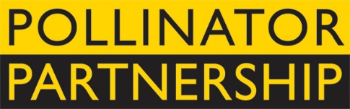 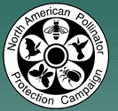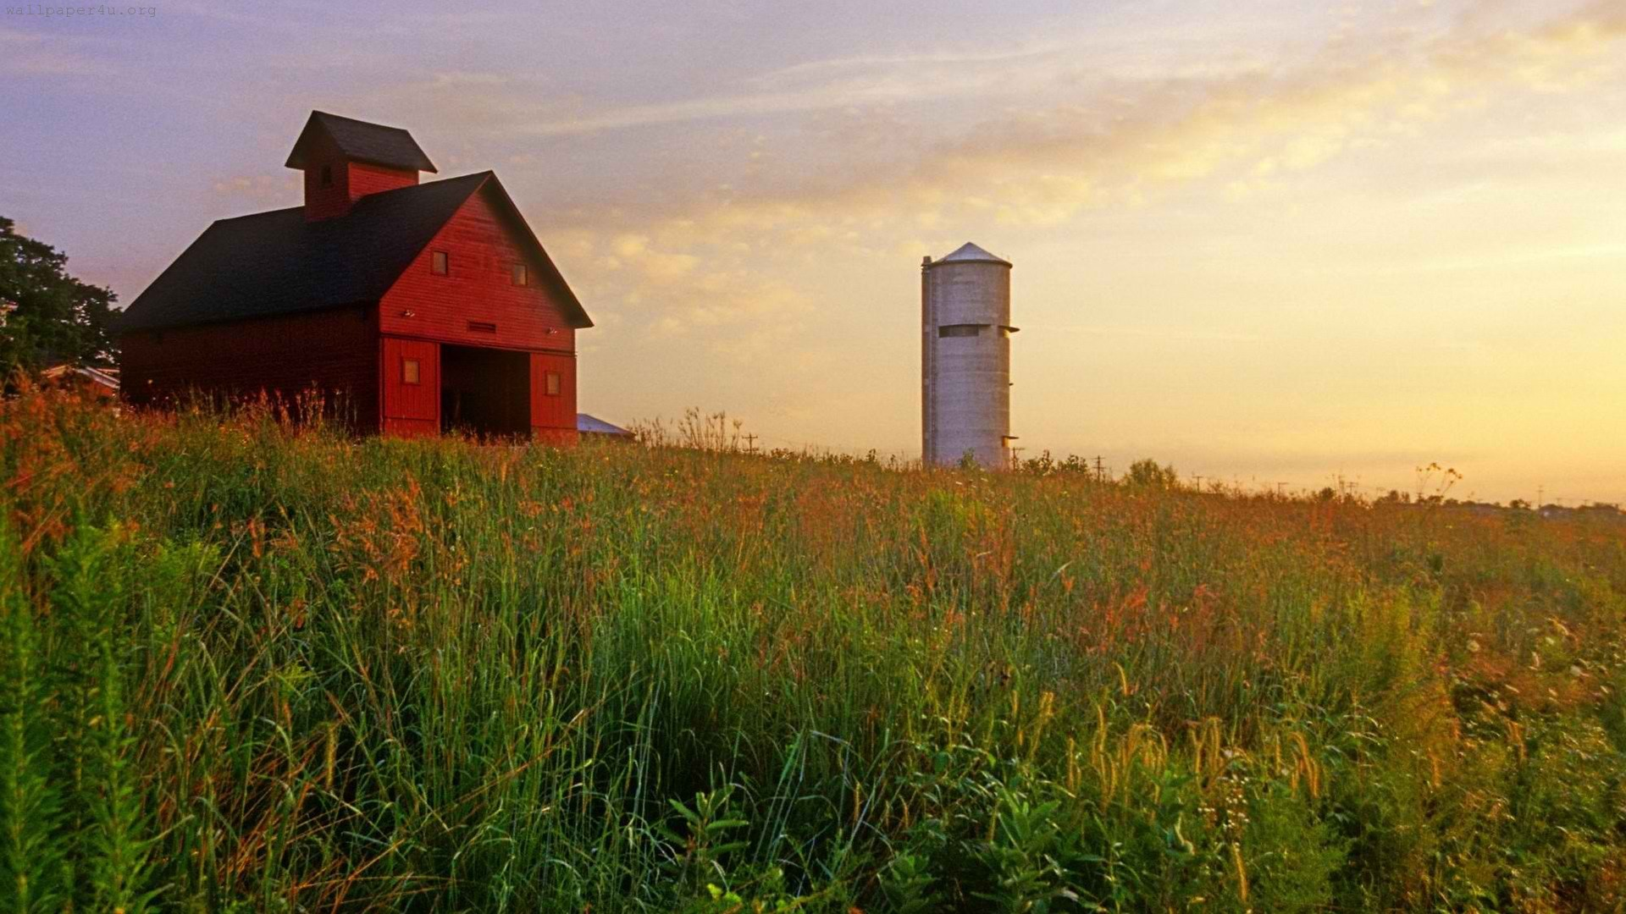

**Pollinator Advocate Award**

The North American Pollinator Protection Campaign (NAPPC) and the Pollinator Partnership (P2) are pleased to solicit nominees for the 2016 Pollinator Advocate Award, recognizing an individual or organization that has contributed significantly to pollinator species protection and conservation in Canada, the United States, and Mexico.

This award recognizes individuals and/or organizations that have contributed significantly to pollinator species protection and conservation and to public education resulting in increased awareness of the importance of pollination. NAPPC, through its recognition and appreciation of these individuals and organizations, encourages their activities and hopes to catalyze future actions on behalf of pollinators. All activities that contribute significantly toward pollinator conservation will be considered, including, but not limited to, on-the-ground projects, educational programs, development of policies and partnerships, research on pollinators, or management activities that promote pollinators. Please note: NAPPC partners are not eligible. You can submit more than one nomination.

The recipients of the 2016 award will be recognized during an evening reception that opens the 16th Annual North American Pollinator Protection Campaign Conference on Tuesday, October 18, 2016 from 6:00 pm to 8:00 pm in Riverdale, MD, or in their hometown if they are unable to attend.

Previous award winners include Sustainable.TO (Canada), The America Bee Project (USA), and Dr. Pablo Jaramillo (Mexico). Through recognition and appreciation of these individuals and organizations, we hope to encourage their conservation stewardship and catalyze future actions on behalf of pollinators. Visit <http://www.pollinator.org/awards.htm> to learn more.

To complete your nomination, please return the attached form to Vicki Wojcik at the Pollinator Partnership by deadline of **Friday August 12, 2016**. Awardees will be notified no later than Wednesday August 31, 2016 to allow for travel arrangements.

Forms can be sent as an e-mail attachment to **vw@pollinator.org** (please put “Pollinator Advocate Award” as the subject line) or faxed to 415-362-3070 or mailed to 423 Washington Street 5th floor, San Francisco CA, 94111.

The North American Pollinator Protection Campaign (NAPPC’s mission is to encourage the health of resident and migratory pollinating animals in North America. NAPPC partners gather from throughout the North American continent and beyond to: Raise public awareness and education and promote constructive dialogue about pollinators’ importance to agriculture, ecosystem health, and food supplies; encourage collaborative, working partnerships among participants and with federal, state and local government entities and strengthening the network of associated organizations working on behalf of pollinators; promote conservation, protection and restoration of pollinator habitat; and document and support scientific, economic and policy research - creating the first-ever, international data bank (library) of pollinator information.

The Pollinator Partnership (P2) is a nonprofit organization with a mission is to promote the health of pollinators, critical to food and ecosystems, through conservation, education, and research. Signature initiatives include the NAPPC (North American Pollinator Protection Campaign), National Pollinator Week, and the Ecoregional Planting Guides. One of P2’s strategies is to improve the health and survival of all species by promoting the importance and wonder of pollinators, and by protecting their habitats.

**Pollinator Advocate Award Nomination Form**

Please return the attached form to Vicki Wojcik at the Pollinator Partnership by **Friday August 12, 2016.** Forms can be sent as an e-mail attachment to vw@pollinator.org (please put “Pollinator Advocate Award” as the subject line) or faxed to 415-362-3070.

My Name: ­­­­­­­­­­­­­­­­­­­­­­­­­­­­_____________________________________________________________________

My E-mail:_________________________________________Phone:­­­­­­­­­­­­­­­­­_______________________

I wish to nominate the following person or organization for the NAPPC Pollinator Advocate Award:

Nominee’s Name*:_______________________________________________________________

Title*:_________________________________________________________________________

Organization:___________________________________________________________________

Nominee E-mail*:___________________________________ Phone*:______________________

Nomination Narrative (*Attach a separate sheet if needed or insert narrative into this document. If nominating an individual you may also attach a CV or resume. While we do want to learn as much as possible about each nominee, please restrict applications to a maximum of 4 pages):*

1. Please provide some background information about the person or organization.

2. Describe or list the contributions of the person or organization to pollinator protection and conservation and/or public education to increase pollinator awareness.

3. Describe the impact that this person or organization has had on pollinator conservation locally, regionally, or globally.