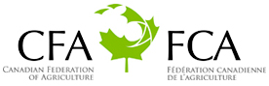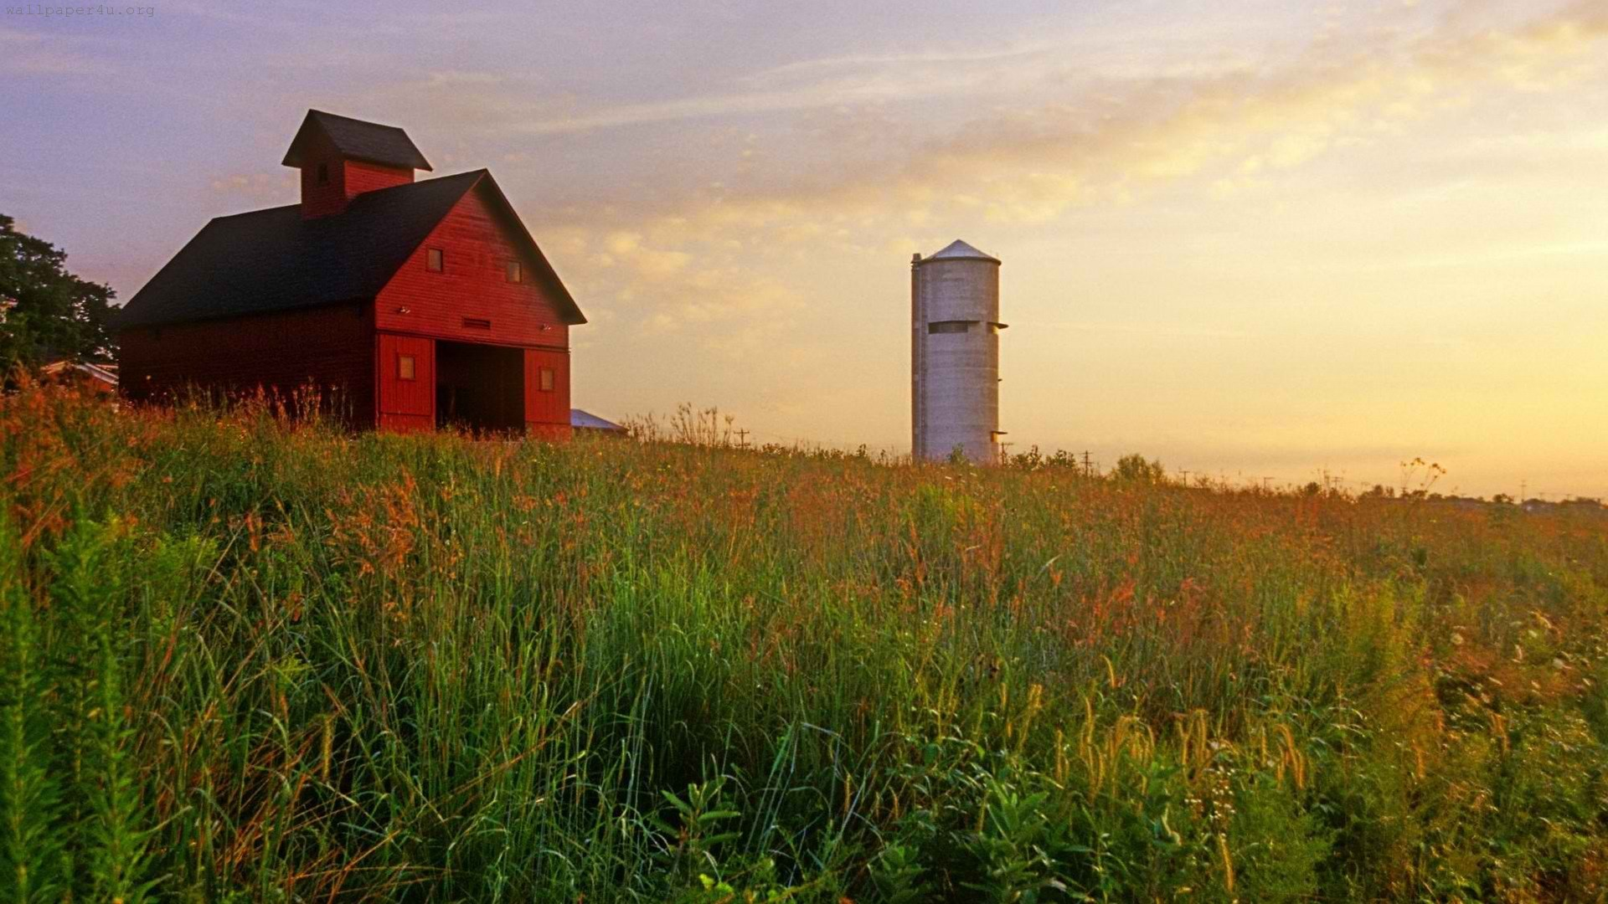

**Canadian Farmer-Rancher**

**Pollinator Conservation Award**

The Canadian Federation of Agriculture (CFA), Canadian Forage and Grassland Association (CFGA), and Pollinator Partnership (P2) are pleased to solicit nominees for the 2016 Canadian Farmer-Rancher Pollinator Conservation Award, recognizing an individual or family in the farm and ranch community in Canada who has contributed significantly to pollinator species protection and conservation.

With pollinators providing one of three bites of food that we eat and nearly $2B to the Canadian agricultural economy, care and concern for their survival is essential to our own survival. Pollinator Conservation Award winners support pollinators on their lands, engage in research and experimentation to increase our understanding of pollinator management techniques, work with community and government groups, and serve as advocates for these little, but hard-working, species that maintain our agricultural and natural landscapes.

The recipients of the 2016 award will be recognized during an evening reception that opens the 16th Annual North American Pollinator Protection Campaign Conference at the USDA-APHIS, Tuesday October 18, 2016 from 6:00 pm to 8:00 pm in Riverdale, MD, or in their hometown if they are unable to attend.

Previous award winners include the Coen Family of Grass Roots Family Farm from Ferintosh, Alberta; Bryan and Cathy Gilvesy of Y U – Ranch in Tilsonburg ON; and Don and Marie Ruzicka of Sunrise Ranch in Killam AB. Through recognition and appreciation of these individuals and organizations, we hope to encourage their conservation stewardship and catalyze future actions on behalf of pollinators. Visit <http://www.pollinator.org/awards.htm> to learn more.

To complete your nomination, please return the attached form to Vicki Wojcik at the Pollinator Partnership by deadline of **Friday August 12, 2016**. Awardees will be notified no later than Wednesday August 31, 2016 to allow for travel arrangements.

Forms can be sent as an e-mail attachment to **vw@pollinator.org** (please put “Farmer-Rancher Pollinator Conservation Award” as the subject line) or faxed to 415-362-3070 or mailed to 120 Homewood Ave. Unit 3607 Toronto, Ontario M4Y 2J3.

Founded in 1935 to provide Canada's farmers with a single voice in Ottawa, the CFA is the country's largest farmers' organization. Its members include provincial general farm organizations as well as national and inter-provincial commodity organizations from every province. Through its members, CFA represents over 200,000 Canadian farmers and farm families.

**The CFGA is the national voice for producers whose livelihoods are dependent upon forage/grassland production. It is committed to promoting sustainable management and addressing production issues and trade barriers.**

P2 works to promote widespread collaborative stewardship practices on open and working lands, within institutions, and among individuals. One of P2’s strategies is to improve the health and survival of all species by promoting the importance and wonder of pollinators, and by protecting their habitats.

**Canadian Farmer-Rancher**

**Pollinator Conservation Award Nomination Form**

Please return the attached form to Vicki Wojcik at the Pollinator Partnership by **Friday August 12,, 2016**. Forms can be sent as an e-mail attachment to vw@pollinator.org (please put “Farmer-Rancher Pollinator Conservation Award” as the subject line) or faxed to 415-362-3070.

**Supporter’s Information:**

**Name:**

**Organization, if applicable:**

**E-mail:** **Phone:**

I wish to nominate the following individual or family in the farm and ranch community for the Canadian Farmer-Rancher Pollinator Conservation Award:

**Nominee’s Name:**

**Farm/Ranch:**

**E-mail:** **Phone:**

Nomination Narrative (Please provide a narrative or recommendation letter that speaks to the three points listed below. You may use this word document or attach separate sheets. Please keep submission at a maximum of 4 pages, not including and images or representative materials):

1. Briefly describe nominees and their farm or ranch operation (location, size, crop, community).

2. Describe the contributions of the individual or family farmer/rancher to pollinator protection and conservation on working and wild lands, including but not limited to “on-the-ground” pollinator conservation, best management practices, landscape management techniques, etc.

3. Describe the contribution of individual or family farmer/rancher to the development of conservation partnerships, research partnership, demonstration projects that promote pollinator awareness and conservation, community and social/political actions that promote and protect pollinators, etc.