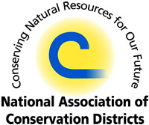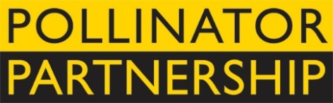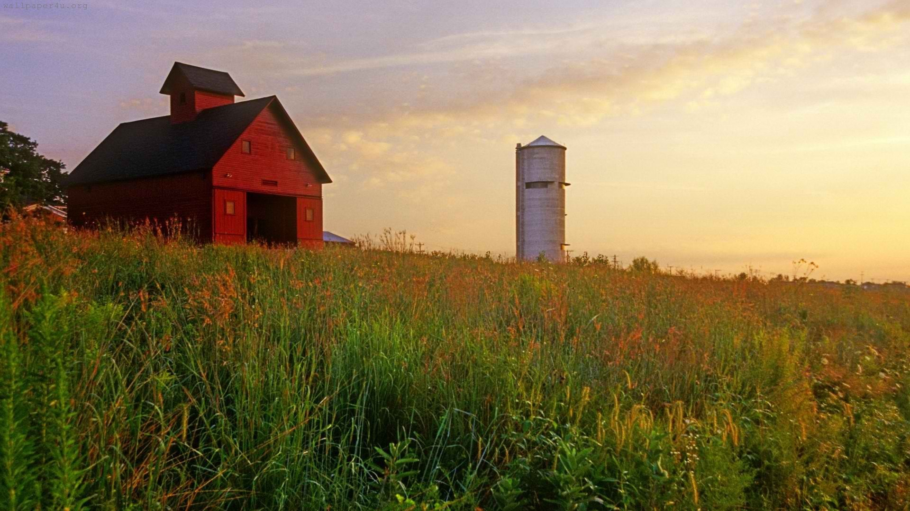

**NAPPC Farmer-Rancher**

**Pollinator Conservation Award**

The National Association of Conservation Districts (NACD) and Pollinator Partnership (P2) are pleased to solicit nominees for the 2016 Farmer-Rancher Pollinator Conservation Award, recognizing an individual or family in the farm and ranch community who has contributed significantly to pollinator species protection and conservation.

With pollinators providing one of three bites of food that we eat and nearly $16B to the US agricultural economy, care and concern for their survival is essential to our own survival. Pollinator Conservation Award winners support pollinators on their lands, engage in research and experimentation to increase our understanding of pollinator management techniques, work with community and government groups, and serve as advocates for these little, but hard-working, species that maintain our agricultural and natural landscapes.

The recipients of the 2016 award will be recognized during an evening reception that opens the 16th Annual North American Pollinator Protection Campaign Conference at the USDA-APHIS on Tuesday, October 18, 2016 from 6:00 pm to 8:00 pm in Riverdale, MD, or in their hometown if they are unable to attend.

Previous award winners include Heikes Family Farm from Vermillion, SD; Josiah and Valer Austin of El Coronado Ranch and Cuenca de los Ojos; and Mark Wagoner of Wagoner Touchet Farms in Washington. Through recognition and appreciation of these individuals and organizations, we hope to encourage their conservation stewardship and catalyze future actions on behalf of pollinators. Visit <http://www.pollinator.org/awards.htm> to learn more.

To complete your nomination, please return the attached form to Vicki Wojcik at the Pollinator Partnership by deadline of **Friday August 12, 2016**. Awardees will be notified no later than Wednesday August 31, 2016 to allow for travel arrangements.

Forms can be sent as an e-mail attachment to **vw@pollinator.org** (please put “Farmer-Rancher Pollinator Conservation Award” as the subject line) or faxed to 415-362-3070 or mailed to 423 Washington Street 5th floor, San Francisco CA, 94111.

The National Association of Conservation Districts (NACD) is the nonprofit organization that represents America’s 3,000 conservation districts and the 17,000 men and women who serve on their governing boards. Conservation districts are local units of government established under state law to carry out natural resource management programs at the local level. Districts work with millions of cooperating landowners and operators to help them manage and protect land and water resources on all private lands and many public lands in the United States.

The Pollinator Partnership (P2) is a nonprofit organization with a mission is to promote the health of pollinators, critical to food and ecosystems, through conservation, education, and research. Signature initiatives include the NAPPC (North American Pollinator Protection Campaign), National Pollinator Week, and the Ecoregional Planting Guides. One of P2’s strategies is to improve the health and survival of all species by promoting the importance and wonder of pollinators, and by protecting their habitats.

**Farmer-Rancher**

**Pollinator Conservation Award Nomination Form**

Please return the attached form to Vicki Wojcik at the Pollinator Partnership by **Friday August 12, 2016**. Forms can be sent as an e-mail attachment to vw@pollinator.org (please put “Farmer-Rancher Pollinator Conservation Award” as the subject line) or faxed to 415-362-3070.

**Supporter’s Information:**

**Name:**

**Organization, if applicable:**

**E-mail:** **Phone:**

I wish to nominate the following individual or family in the farm and ranch community for the Farmer-Rancher Pollinator Conservation Award:

**Nominee’s Name:**

**Farm/Ranch:**

**E-mail:** **Phone:**

Nomination Narrative (Please provide a narrative or recommendation letter that speaks to the three points listed below. You may use this word document or attach separate sheets. Please keep submission at a maximum of 4 pages, not including and images or representative materials):

1. Briefly describe nominees and their farm or ranch operation (location, size, crop, community).

2. Describe the contributions of the individual or family farmer/rancher to pollinator protection and conservation on working and wild lands, including but not limited to “on-the-ground” pollinator conservation, best management practices, landscape management techniques, etc.

3. Describe the contribution of individual or family farmer/rancher to the development of conservation partnerships, research partnership, demonstration projects that promote pollinator awareness and conservation, community and social/political actions that promote and protect pollinators, etc.