HelloWorld with JenkinsFile

**Step 1 : Login to Jenkins ->** [**http://localhost:8080**](http://localhost:8080)

**Step 2 :**

After logging in to Jenkins click on the "New Item" menu option:

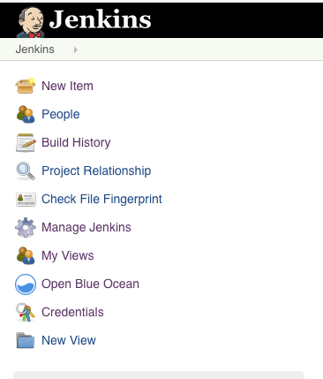

Type in the name of the Jenkins Pipeline (simple-pipeline in our case).

Click on the "Pipeline".

Then press the "OK" button. (It will be disabled until you select a project-type)

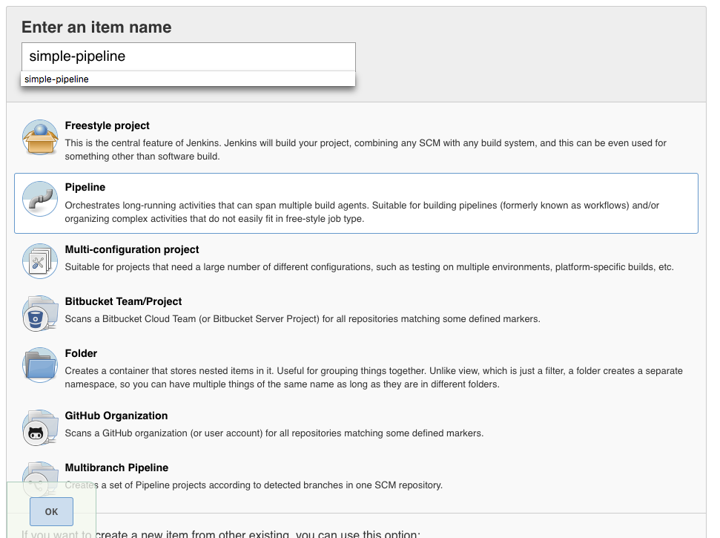

It will take you directly to the "Configuration" page of the project that looks like this:

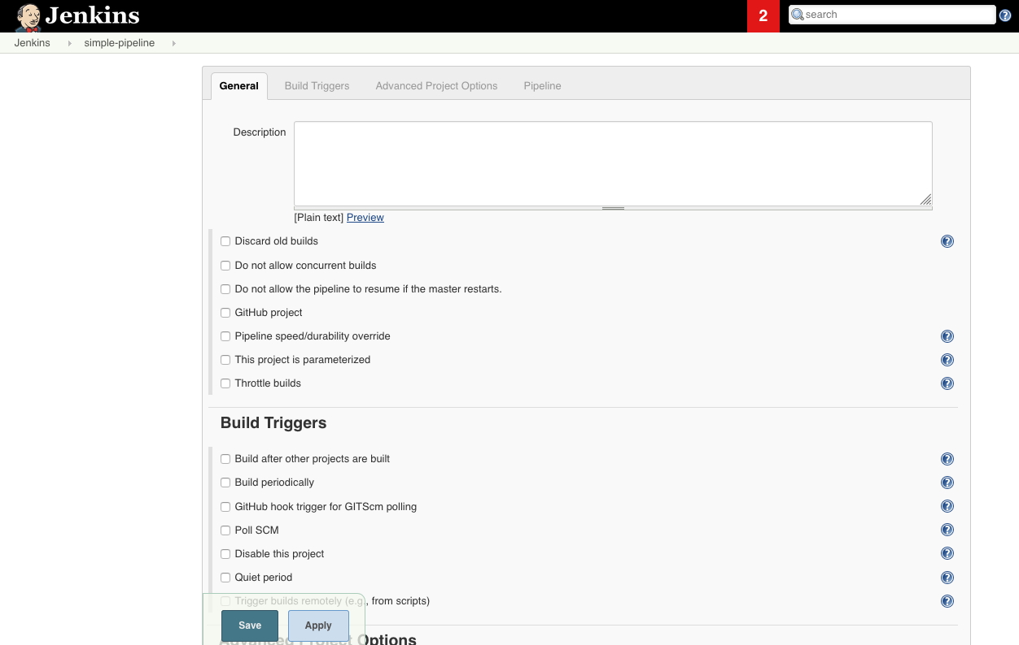

Scroll down to the section called "Pipeline", paste the following code:

pipeline {

agent { label 'master' }

stages {

stage('build') {

steps {

echo "Hello World!"

}

}

}

}

It will look like this:

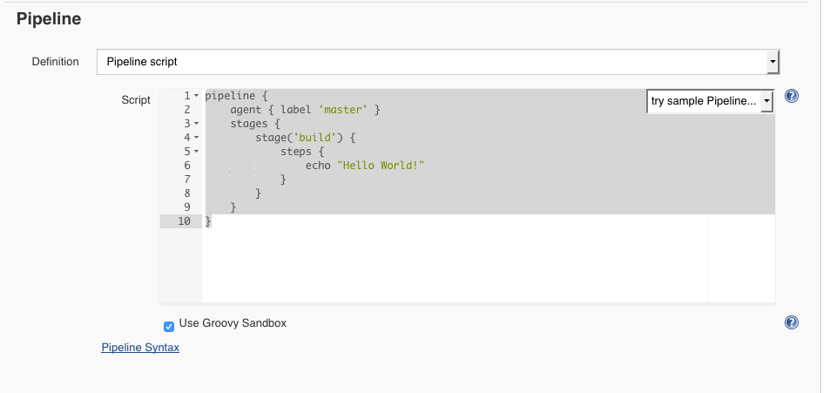

Click on "Save".

It will take to the menu of the specific project:

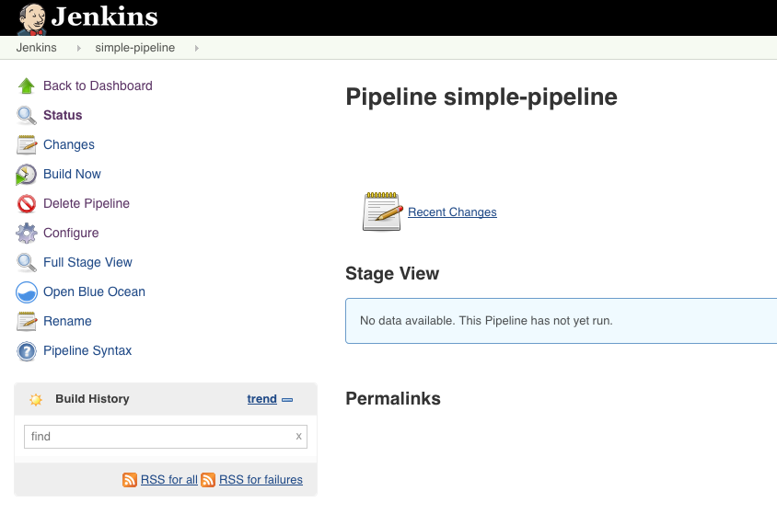

Click on the "Build Now" button. It will start running the pipeline and within a few seconds you'll see an indicator of your first job being successful (blue dot on the left hand side).

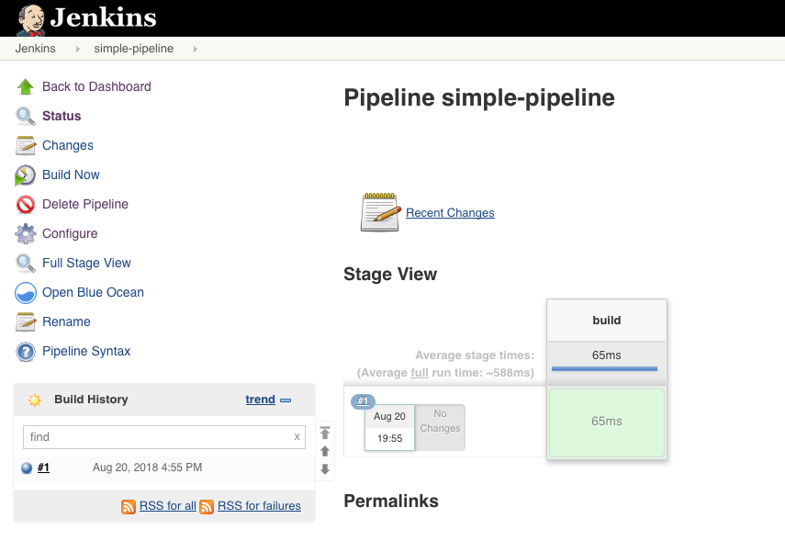

If you click on that blue dot on the left hand side it will take you to the "Console Output" that looks like this:

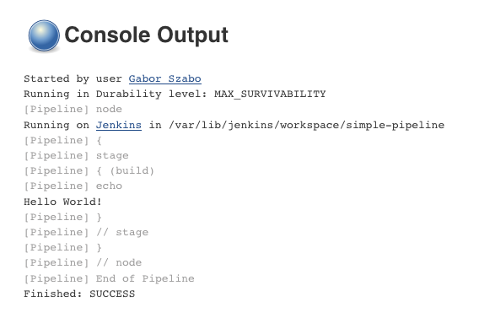

**Step 3 : Taking JenkinsFile from SCM**

Fork repository : <https://github.com/jenkins-docs/simple-java-maven-app>

-----------------------------------------------------------------

Option 1 :

Git clone <forked-repo-ssh-url>

Add Jenkinsfile :

cd simple-java-maven-app

sudo vi Jenkinsfile

Add following content :

pipeline {

agent { label 'master' }

stages {

stage('build') {

steps {

echo "Hello World!"

}

}

}

}

git status

git add .

git commit -m “adding jenkinsfile”

git push origin master

----------------------------------------------------------------------------------

Option 2 :

Create Jenkinsfile on the Github UI

Add file → Jenkinsfile → Add following content

pipeline {

agent { label 'master' }

stages {

stage('build') {

steps {

echo "Hello World!"

}

}

}

}

Commit the changes.

-----------------------------------------------------------------------------------------

Change pipeline definition to Pipeline Script from SCM

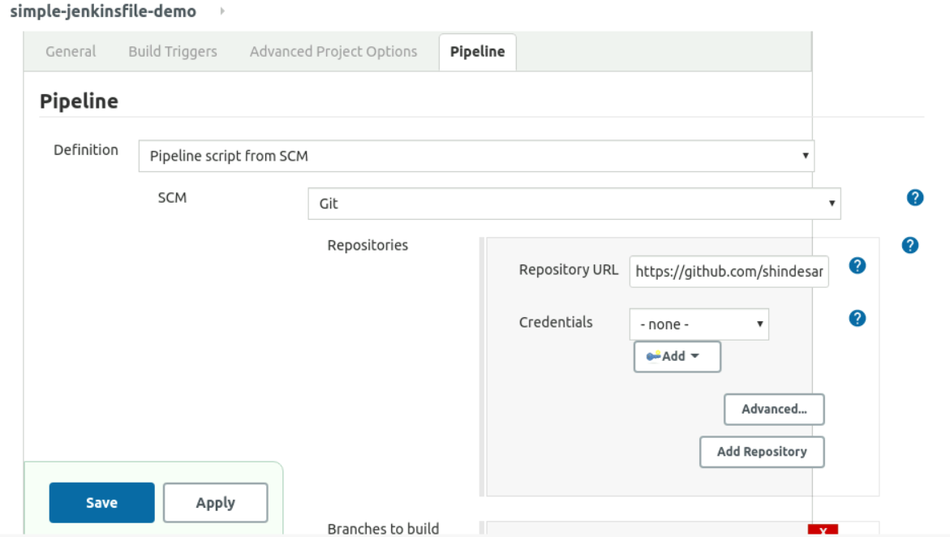

Update repository url to your forked github repository :

<https://github.com/shindesanket/simple-java-maven-app.git> ( Make sure it is your own forked repo )

Keep Credentials as None and Save.

Click on Build now and check console output. This time build has used Jenkinsfile present in SCM.