Effat University · Computer Science Department

CS3151 Software Engineering

Lab 3: From Personas & Requirements to Use Cases and UML
Project: GPA Calculator & Prediction System

Team name | MyGPA
Team members | Kareem Sayed S24109147  Mohammed Rahil Ahmed S24108924  Muhamed Shakir S24109210
Instructor | Dr. Passent Elkafrawy
Term | Fall 2026
Submission file | MyGPA_UML_Lab.pdf
Inputs used | Feasibility Study (25 Sep 2026); Lab 2 Personas, persona–feature mapping and user stories

Contents
- Step 0 – Warm-up: verbs, nouns and requirements
- D1 – Actors, goals, Use Case List (MoSCoW) and traceability
- D2 – Brief use cases (all) and two fully dressed use cases (UC2, UC4)
- D3 – Use Case Diagram
- D4 – Activity Diagram (UC4 What-If Prediction)
- D5 – Sequence Diagram (UC2 main success scenario)
- D6 – Domain Model (Class Diagram)
- D7 – Consistency checklist and peer-review sheet
- Extensions – State Machine (RiskFlag) and System Sequence Diagram (failed target)
- Appendix – PlantUML sources

Step 0 – Warm-up: Personas, Requirements, Verbs and Nouns
The two personas from Lab 2 are the Undergraduate Student (20, BSc Computer Science, phone-first, wants to hit a 3.5 target to keep a scholarship) and the Academic Advisor (45, PhD, advises 60 students, desktop, needs to spot at-risk advisees fast). The Feasibility Study adds an administrative need (advisor-to-advisee mapping, institution-specific grading scales), SSO login, an optional SIS import and automatic at-risk notifications. The ten most important requirements/user stories used throughout this lab are:

# | Requirement / user story (source) | Verbs (actions) | Nouns (entities)

R1 | Enter courses, credit hours and grades | enter, edit, delete | Course, CreditHours, Grade, Semester
R2 | Semester GPA calculation | Calculate, Use, Match | SemesterGPA, QualityPoints
R3 | Cumulative GPA tracking and trend across semesters | track, view, plot | CumulativeGPA, GPASnapshot, Trend
R4 | What-if: grades needed to reach a target GPA (Persona 1, Story 2) | predict, compare, save | WhatIfScenario, TargetGPA, Prediction
R5 | Next-semester GPA prediction | predict, project | Prediction, AcademicRecord
R6 | Retake / repeated-course handling per policy | mark, replace, average | CourseRecord, AcademicPolicy
R7 | Advisor sees advisees' GPA history and trends (Persona 2, Story 2) | review, view | Advisor, Advisee, GPASnapshot
R8 | At-risk flagging below threshold and notification | flag, notify, acknowledge | RiskFlag, Notification, Threshold
R9 | Sortable/filterable roster; exportable reports (Persona 2, Story 1) | sort, filter, export | Roster, AdvisingReport
R10 | Role-based, read-only advisor access; SSO login; admin maintains assignments and scales | log in, assign, configure | User, Role, AdvisingAssignment, GradingScale

D1 – Actors, User Goals and Use Case List

Step 1 – Actor cards
External actors include human roles, external systems and a timer. Graduate and Undergraduate Student are specialisations of the abstract actor Student because they perform the same use cases but are governed by different grading scales.

Actor | Description | Triggers / Interests | Challenges | Notes / Persona
Student (abstract) | Authenticated end user who records grades and plans GPA | Wants fast, accurate GPA and a clear path to a target GPA | Manual calculation is error-prone; retake and credit-hour rules are confusing | Generalises Undergraduate and Graduate Student
Undergraduate Student | Student on the undergraduate grading scale | Keep scholarship/honours, avoid probation, quick “what-if” before registration | Mostly on a phone between classes; late-night use during exams | Persona 1 (20, BSc CS)
Graduate Student | Student on the graduate grading scale | Same goals; graduate pass mark and scale | Different scale/policy to configure | Lab 2 user group (no separate persona)
Academic Advisor | Staff member advising  ~60 students; read-only on advisee data | Spot at-risk advisees early, review trends, recommend realistic course loads | Data scattered across spreadsheets/portals; no trend view; manual recomputation | Persona 2 (45, PhD); desktop
System Administrator | University/IT staff who maintain reference data | Correct advisor mapping, correct grading scales and thresholds | Wrong mapping would expose data to the wrong advisor | Derived from Feasibility Study §3  (advisor-advisee mapping)
Scheduler (Timer) | Internal time trigger (nightly job) | Re-evaluate all students without human action | Must not miss a flag; must not spam advisors | Derived from “automatic flag” requirement

Actor | Description | Triggers / Interests | Challenges | Notes / Persona
University SSO (system) | Identity provider | Verify identity and role | May be unavailable → fallback login | Feasibility Study §3

SIS (system) | University student information system | Provide official courses/grades (read-only) | Access may not be granted; formats differ | Optional import, Feasibility Study §3
Email / Notification Service (system) | External delivery service | Deliver at-risk alerts | Delivery failures, delays | Used by UC11

User goals per actor (what success looks like)
- Student: “I see my correct semester and cumulative GPA in seconds, and I know exactly what grades I need to reach 3.5.”
- Advisor: “I open one screen, see which of my 60 advisees are below 2.0, and understand each one’s trend and projection before the meeting.”
- Administrator: “Every student is linked to the right advisor and every calculation uses the current official scale and policy.”
- Scheduler: “Every student’s risk status is up to date each night without manual action.”
- SSO / SIS / Email Service: each is satisfied when its request (identify, supply records, deliver message) is handled correctly and securely.
Step 2 – Use Case List (goal-level, Verb + Noun, MoSCoW)
ID | Use Case Name | Primary Actor | Goal / Outcome | Priority
UC1 | Log In | Student / Advisor / Administrator | Authenticated session with the correct role | M
UC2 | Calculate Semester GPA | Student | Semester GPA (projected or final) computed and saved | M
UC3 | View Cumulative GPA & Trend | Student | Understand overall standing across all semesters | M
UC4 | Run What-If Prediction | Student | Know the grades needed to reach a target GPA (or the effect of a changed grade) | M
UC5 | Predict Next-Semester GPA | Student (also used by UC9 and UC10) | Projected GPA for next term from current performance and planned credits | S
UC6 | Apply Retake Policy | Student | Repeated courses counted according to university policy | S
UC7 | Import Grades from SIS | Student (secondary actor: SIS) | Courses and grades loaded automatically instead of manual entry | C
UC8 | View Advisee Roster | Academic Advisor | See all assigned advisees with GPA and risk status; sort and filter | M
UC9 | Review Advisee GPA Profile | Academic Advisor | Review one advisee's GPA history, trend and predicted GPA in one place | M
UC10 | Flag At-Risk Students | Scheduler (Timer) / system | Students with projected GPA below the threshold are flagged for advisor follow-up | M
UC11 | Send At-Risk Notification | System (secondary actor: Email Service) | Advisor is informed of a newly flagged advisee | M
UC12 | Export Advisee Report | Academic Advisor | Summary report (PDF/Excel) attached to the advising record | C
UC13 | Manage Advisor Assignments | System Administrator | Each student mapped to the correct advisor so advisors only see their own advisees | S

UC14 | Configure Grading Scale & Policies | System Administrator | Institution-specific scales  (undergraduate/graduate), retake rule and probation threshold maintained | S
UC15 | Modify Official Academic Records | Registrar | Out of scope: the system is not a replacement for the SIS and must never alter official records (Feasibility Study §2). | W
ID | Use Case Name | Primary Actor | Goal / Outcome | Priority
UC16 | Schedule Advising Meeting | Student / Advisor | Not required by either persona; belongs to a future release or the existing advising portal. | W
MoSCoW key: M = Must (core of the pilot), S = Should, C = Could, W = Won’t for now. Priorities follow the Lab 2 mapping: High → M, Medium → S, Low → C. UC15 and UC16 are deliberately excluded from the diagram.

Traceability matrix (use case → requirement → persona/user story)
Use case | Lab 2 feature / requirement | Persona · user story | Actor(s)
UC1 Log In | Role-based access; SSO login | Both personas | Student, Advisor, Admin, SSO
UC2 Calculate Semester GPA | Enter courses/credits/grades; automatic semester GPA; mobile quick entry | P1 · Story 1 | Student
UC3 View Cumulative GPA & Trend | Cumulative GPA tracking; visual trend | P1 · scenario (trend line) | Student
UC4 Run What-If Prediction | What-if target / required-grade prediction | P1 · Story 2 | Student
UC5 Predict Next-Semester GPA | Next-semester GPA prediction | P2 · Story 2 (prediction view) | Student, Advisor (via UC9), Scheduler (via UC10)
UC6 Apply Retake Policy | Retake / repeated-course handling | P1 pain point (retakes) | Student
UC7 Import Grades from SIS | Optional SIS integration (Feasibility §3) | — | Student, SIS
UC8 View Advisee Roster | Sortable/filterable list; at-risk flags | P2 · Story 1 | Advisor
UC9 Review Advisee GPA Profile | Advisee history and trends; predicted GPA; read-only | P2 · Story 2 | Advisor
UC10 Flag At-Risk Students | At-risk flagging below threshold | P2 · Story 1 | Scheduler
UC11 Send At-Risk Notification | Notifications/flags (Feasibility §2) | P2 goal (intervene early) | Email Service
UC12 Export Advisee Report | Exportable reports (PDF/Excel) | P2 scenario (exports report) | Advisor
UC13 Manage Advisor Assignments | Advisor sees only own advisees (Feasibility §3) | P2 (role permissions) | Administrator
UC14 Configure Grading Scale & Policies | Institution-specific scales; threshold; retake rule | P1/P2 (policy-correct results) | Administrator

D2 – Use Case Specifications

Step 3A – Brief use cases (all use cases)
Use Case | Primary Actor | Preconditions | Postconditions | Main Success Scenario (summary)

UC1 Log In | Student / Advisor / Ad ministrator | User has a university account; system reachable | Session created with role (Student, Advisor, Admin); unauthenticated users see nothing | User opens the app → system redirects to University SSO (or username/password fallback) → credentials verified → role-specific home page shown.
UC2 Calculate Semester GPA | Student | Student authenticated; grading scale for the student's level is available | Semester record saved; semester GPA and updated cumulative GPA stored; risk re-evaluation triggered | Student selects a semester → enters courses, credit hours and actual/expected grades → system validates, computes and displays semester GPA and cumulative preview → student saves.
UC3 View Cumulative GPA & Trend | Student | Student authenticated; at least one saved semester | Student has seen cumulative GPA, GPA by semester and a trend chart (no data changed) | Student opens dashboard → system retrieves GPA snapshots → displays cumulative GPA, per-semester GPA table and trend line chart.
UC4 Run What-If Prediction | Student | Student authenticated; baseline record exists (or entered manually); at least one ungraded course in the term | Prediction displayed; optionally saved as named scenario; official record unchanged | Student chooses Target-GPA mode → enters target → system computes required average grade points, checks achievability, and lists grade combinations that reach the target.
UC5 Predict Next-Semester GPA | Student  (also used by UC9 and  UC10) | Authenticated; cumulative record and planned credit load exist | Prediction (projected GPA, achievable range) produced and stored | System takes cumulative record and planned credits → assumes recent average performance → computes projected cumulative GPA → shows projection and range.
UC6 Apply Retake Policy | Student | A course in the semester is marked as a repeat; retake rule configured (replace / average) | Only the counted attempt contributes to GPA; earlier attempt kept in history | Student marks a course as a repeat → system finds earlier attempt → applies retake rule → recalculates and explains the change.
UC7 Import Grades from SIS | Student (secondary actor: SIS) | Student authenticated; SIS read access granted by the university | Imported courses pre-filled in the semester grid, marked as official | Student clicks Import → system requests records from SIS → maps courses/grades → pre-fills course grid for review.
UC8 View Advisee Roster | Academic Advisor | Advisor authenticated; advisor has assigned advisees | Roster displayed (read-only) for assigned advisees only | Advisor opens dashboard → system loads assigned advisees with current GPA and flags → advisor sorts/filters (e.g., GPA < 2.0).
UC9 Review Advisee GPA Profile | Academic Advisor | Advisor authenticated; advisee is assigned to this advisor | Profile displayed read-only; no data modified | Advisor selects an advisee → system shows semester history, trend chart, risk flag and predicted GPA (via UC5).
UC10 Flag At-Risk Students | Scheduler (Timer) / system | Academic policy (threshold, e.g. 2.0) configured; student records exist | RiskFlag created/update d/resolved per student; advisors notified of new flags (UC11) | Scheduler fires nightly (and after any saved semester) → system obtains each projected GPA (UC5) → compares with threshold → raises flag → sends notification (UC11).
UC11 Send At-Risk Notification | System (secondary actor: Email Service) | A RiskFlag was raised; advisor assignment exists | Notification recorded and delivered to the advisor's dashboard/email | System composes message with student name, GPA and projection → hands it to Email Service → records delivery status.
UC12 Export Advisee Report | Academic Advisor | Advisor authenticated; profile (UC9) is open | Report file generated and downloaded; contains only the advisor's advisee | Advisor chooses Export from profile → picks PDF or Excel → system generates report → file downloads.
UC13 Manage Advisor Assignments | System Adm inistrator | Administrator authenticated | Assignment created/cha nged/ended; access rules take effect immediately | Admin searches student → selects advisor → confirms → system stores AdvisingAssignment with start date.

Use Case | Primary Actor | Preconditions | Postconditions | Main Success Scenario (summary)
UC14  Configure  Grading Scale & Policies | System Adm inistrator | Administrator authenticated | New/updated scale or policy active for later calculations; previous values kept in audit log | Admin opens policy page → edits grade-point table / threshold / retake rule → system validates → saves and activates.

Step 3B – Fully dressed use case 1 (core / happy path)
Use Case | UC2 Calculate Semester GPA
Activity Name | Calculate and save semester GPA
Primary Actor | Student (Undergraduate or Graduate)
Stakeholders & Interests | Student – fast, correct GPA, usable on a phone; Advisor – saved data is accurate so trends can be trusted;  University – results are clearly marked as unofficial and personal data is protected; Administrator – calculations follow the configured grading scale.
Preconditions (Ip) | - Student is authenticated (UC1). 2) A grading scale and academic policy for the student’s level exist. 3) The system is online.
Postconditions (Op) / success guarantee | Semester GPA calculated and displayed; Semester and CourseRecords saved; a GPASnapshot  (semester and cumulative GPA) stored; cumulative GPA recalculated; risk evaluation triggered (UC10). Official SIS records are never modified.
Main Scenario (flow of control) | - Student selects “Calculate Semester GPA” and chooses a semester (existing or new).  - System displays the course entry grid (existing CourseRecords pre-filled).  - Student enters or edits each course: course code, credit hours, letter grade, and marks the grade as  actual or expected.  - System validates each row as it is entered (required fields, credit-hour range, grade exists in scale, no duplicate course code).  - Student requests calculation.  - System loads the grading scale for the student’s level and computes quality points and semester GPA = Σ(creditHours × gradePoints) ÷ Σ(gradedCreditHours).  - System displays semester GPA (labelled “Projected” if any grade is expected, otherwise “Final”), total credits and a cumulative GPA preview.  - Student saves the semester.  - System stores the semester and GPASnapshot, recalculates the cumulative GPA, triggers risk evaluation (UC10), confirms the save and refreshes the trend chart.
Extensions (alternatives) | 3a) Course is a repeat → «extend» UC6 Apply Retake Policy; GPA uses the counted attempt only.  3b) Student chooses “Import from SIS” → «extend» UC7; imported rows pre-fill the grid and return to step 3. 4a) Invalid input (blank/non-numeric credit hours, credit hours outside 0–6, unknown grade) → system highlights the field with a message; return to step 3.  4b) Duplicate course code in the same semester → system warns and offers to remove or merge; return to step 3.  4c) Course graded Pass/Fail, Withdrawn (W) or Incomplete (I) → excluded from GPA, credits shown separately; continue.  5a) No GPA-bearing credits (all courses excluded or grid empty) → “GPA cannot be computed” message; return to step 3.  6a) Grading scale cannot be loaded → system uses the last cached scale and shows a warning, or blocks calculation if none exists; error logged.  8a) Student discards instead of saving → nothing persisted; draft cleared.  8b) Session times out before saving → draft auto-saved server-side; after re-login (UC1) the draft is restored at step 3.  9a) Save fails (database error) → system shows an error and keeps data in the form so the student can retry.
Special Requirements (NFR) | Accuracy: GPA to 2 decimals, round-half-up, verified by unit tests (Feasibility §6, QA).  Performance: calculation < 1 s for up to 10 courses; save < 2 s. Usability: mobile-first, usable from 360 px width, keyboard-friendly quick entry. Accessibility: WCAG 2.1 AA contrast and labels. Security/privacy: HTTPS only; a student can read and change only their own record; GPA is sensitive data (Feasibility §5). Availability: target ≥ 99% during exam and registration periods.
Constraints | Result is labelled “unofficial”; the system never writes to the SIS; default 4.0 scale unless changed by the Administrator (UC14); stack is a web app with a relational database (React + Node/Flask, Feasibility §3); manual entry is the fallback when SIS access is not granted.
Open Issues | - Exact Effat University treatment of repeated courses (replace vs average) – confirm with the registrar. 2) Are Pass/Fail and transfer credits counted toward cumulative credits? 3) Should expected grades be stored in a separate “planned” state until finalised?

Step 3B – Fully dressed use case 2 (complex / alternate-flow heavy)
Worked check of the formula (used in UC4 and the extension SSD): cumulative GPA 3.20 over 60 credits gives QPdone
= 192. With 15 credits remaining, Target 3.50 → Req = (3.50 × 75 − 192) ÷ 15 = 4.70 (impossible; best case = (192 + 60) ÷
75 = 3.36). Target 3.30 → Req = (3.30 × 75 − 192) ÷ 15 = 3.70 (possible, e.g. A- in every course).

Use Case | UC4 Run What-If Prediction
Activity Name | Determine grades needed to reach a target GPA
Primary Actor | Student (Undergraduate or Graduate)
Stakeholders & Interests | Student – knows exactly which grades are needed and whether the goal is realistic; Advisor – the same engine gives consistent predictions in UC9; University – predictions are clearly marked as estimates, not guarantees; Administrator – policies (retake, scale) are applied correctly.
Preconditions (Ip) | 1) Student authenticated (UC1). 2) A baseline academic record exists (completed credits and quality points) or the student can enter it manually. 3) The current/planned semester has at least one course with credit hours.
Postconditions (Op) / success guarantee | Required average grade points and at least three grade combinations (or an  “unattainable/secured” result) are displayed; the scenario may be saved under a name; the student’s official record, GPASnapshots and risk flags are never changed by a what-if.
Main Scenario (flow of control) | 1) Student opens What-If and selects mode “Target GPA”. 2) System in parallel loads the baseline record (completed credits C , quality points done QP ) and the active grading scale and policy.  done  - System displays the baseline and the remaining (ungraded) courses with credit hours C . rem  - Student enters a target cumulative GPA T (for example 3.50) and locks already-graded courses.  - System validates T (between 0 and the maximum grade point).  - System computes the required average grade points on the remaining credits: Req = (T × (C + C ) − QP ) ÷ C . done  rem done rem  - System checks achievability (Req ≤ maximum grade point) and that the target is not already secured.  - System generates at least three combinations of letter grades for the remaining courses whose weighted average ≥ Req, ranked from most balanced to most demanding. 9) System displays Req, the combinations, resulting GPA and the formula (“Show calculation”), labelled as an unofficial estimate.  - Student adjusts the target or grades; system repeats steps 4–9 as needed.  - Student saves the scenario with a name; system stores it and confirms.
Extensions (alternatives) | 2a) Baseline cannot be loaded → student enters cumulative GPA and credits manually; continue at step 3. 2b) Grading scale cannot be loaded → use cached scale with a warning, else block and show error.  4a) Target already secured even with the lowest passing grades → system reports “already secured” and the minimum grades needed to keep it; end of calculation.  5a) Target invalid (blank, negative, above scale maximum) → error message; return to step 4. 6a) No ungraded credits remain (C = 0) → system shows the final GPA, explains the target rem  cannot be influenced, and offers UC5 (next semester).  7a) Req > maximum grade point (e.g. target 3.50 with 3.20 over 60 credits and 15 credits remaining needs 4.70) → system shows “unattainable”, the maximum achievable GPA (3.36), and suggestions: retake low grades (UC6), add credits next term (UC5), or lower the target. 7b) Req is attainable only with near-top grades (Req ≥ 3.7) → system adds a “high effort” warning to the result.  8a) Baseline contains repeated courses → «extend» UC6 applies the retake policy before computing. 8b) Course is Pass/Fail or Withdrawn → excluded from calculation.  11a) Save fails → error message; result stays on screen for retry.  *a) Session times out → student re-authenticates (UC1); unsaved scenario is lost, saved ones remain.
Special Requirements (NFR) | Determinism: identical inputs always give identical results and match the advisor’s view (UC9). Accuracy: 2-decimal results, formulas unit-tested at boundaries. Performance: result < 1 s after the target is entered. Transparency: formula visible on request. Usability:  mobile-friendly sliders/pickers for grades. Privacy: scenarios are private to the owner. Security: HTTPS, session authentication.
Constraints | “Prediction” is deterministic arithmetic (weighted averages) – no machine learning in the pilot (Feasibility §3: low technical risk). Predictions are limited to the current/planned semester and one future term. Scenarios never write to official records.

Open Issues | 1) Persona 1 asks for required exam marks, which needs assessment weights per course – deferred; the pilot works at letter-grade level. 2) What counts as “minimum passing grade” for graduate students. 3) Maximum number of saved scenarios per student. 4) Rounding of required grade points for display (nearest 0.01 vs. nearest letter).

D3 – Use Case Diagram
The system boundary contains the 14 in-scope use cases (UC1–UC14). Primary actors are on the left; secondary (external system) actors are on the right. «include» is used only where behaviour is mandatory and shared (UC9 and UC10 both need the prediction from UC5; UC10 always sends a notification). «extend» is used for optional behaviour (retake handling, SIS import, report export). Actor generalisation shows that Undergraduate and Graduate Students share the Student use cases.
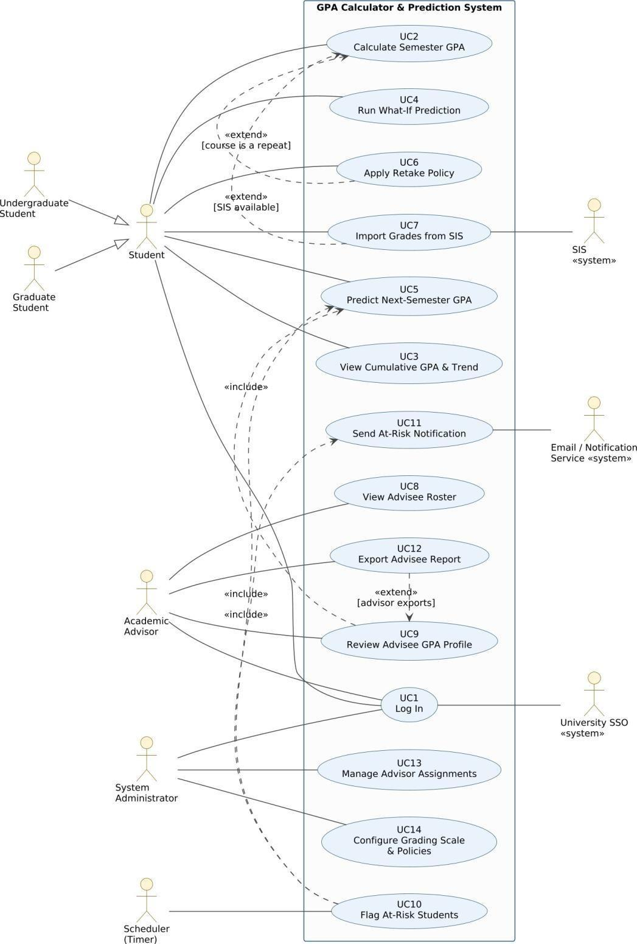
Figure D3 – Use Case Diagram: GPA Calculator & Prediction System

D4 – Activity Diagram: UC4 Run What-If Prediction
UC4 is the most complex use case: it has the most alternative flows, a data-dependent calculation and parallel work. The diagram uses two swimlanes (Student, System). Concurrency: baseline and grading scale are loaded in parallel (fork/join at MSS step 2), and rendering the result runs in parallel with keeping a session draft (step 9). Guards are labelled with the same codes as the use case extensions (2a, 4a, 5a, 6a, 7a, 7b, 8a, 11a), so the diagram can be checked against the specification directly. The repeat loop models step 10.
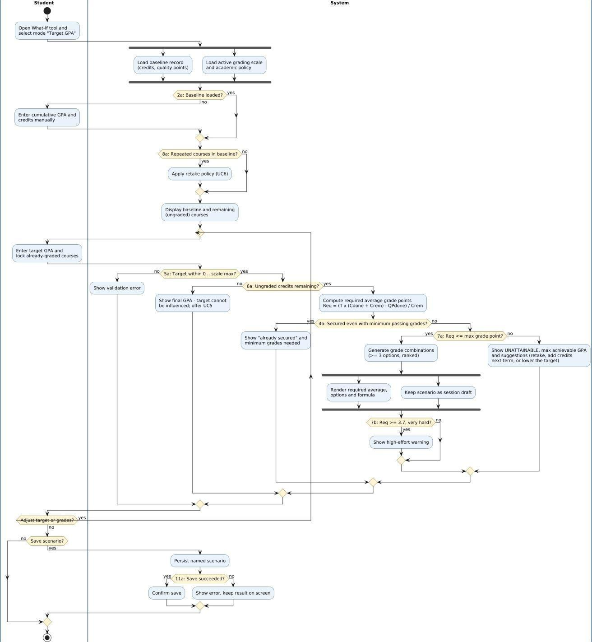

Figure D4 – Activity Diagram for UC4 Run What-If Prediction
CS3151 · Lab 3 UML · GPA Calculator & Prediction System

D5 – Sequence Diagram: UC2 Main Success Scenario
Elaborates the main success scenario of UC2 Calculate Semester GPA. Message numbers carry the matching MSS step tag (1–9). Student is the actor; UI is the web front end; GPAService orchestrates the calculation; AcademicRecord and GradingScale are domain objects from D6; RiskEvaluator is the asynchronous hook to UC10.

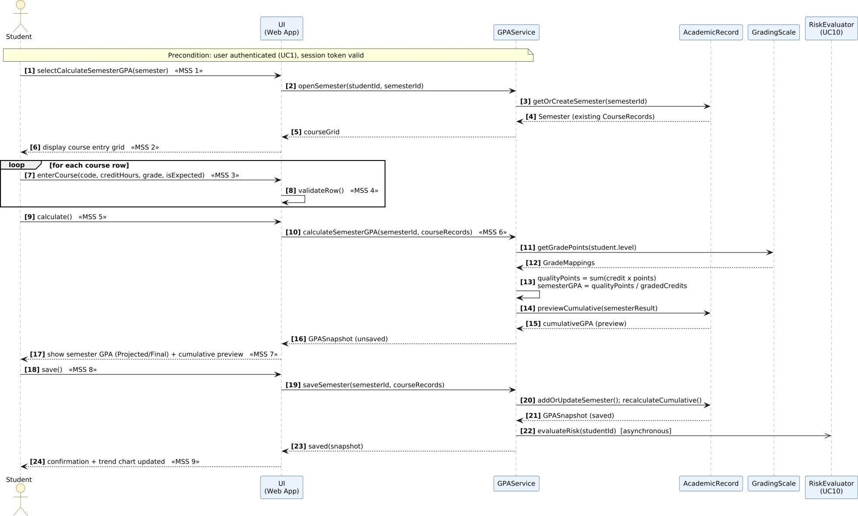
Figure D5 – Sequence Diagram for UC2 (main success scenario)

Page 12
MSS step ↔ message alignment (UC2)
MSS step | Message(s) in the sequence diagram
1 Select semester | selectCalculateSemesterGPA(semester); openSemester(); getOrCreateSemester()
2 Display grid | courseGrid returned; “display course entry grid”
3 Enter courses | enterCourse(code, creditHours, grade, isExpected) inside loop
4 Validate rows | validateRow() (self-message on UI)
5 Request calculation | calculate()
6 Compute GPA | calculateSemesterGPA(); getGradePoints(level); qualityPoints / gradedCredits; previewCumulative()
7 Display result | “show semester GPA + cumulative preview”
8 Save | save(); saveSemester(); addOrUpdateSemester(); recalculateCumulative()
9 Confirm / trigger risk check | evaluateRisk(studentId) (async); saved(snapshot); “confirmation + trend chart updated”

D6 – Domain Model (Class Diagram)
The domain model captures real-world concepts from the personas and use cases, not database tables or UI screens. Key decisions: (1) AcademicRecord is the aggregate owned by a Student; Semesters and CourseRecords are composed inside it.
(2) AdvisingAssignment is an association class between Advisor and Student so that an advisor sees only assigned advisees and history of reassignments is kept. (3)
GradingScale and AcademicPolicy are configurable concepts (UC14) – grade points are not hard-coded. (4)
WhatIfScenario, Prediction and RiskFlag are separate from official data, which guarantees what-ifs never alter the record.
- The roster is a view over Student, GPASnapshot and RiskFlag, so it is not a class. External systems (SIS, SSO, Email Service) are actors, not domain classes.
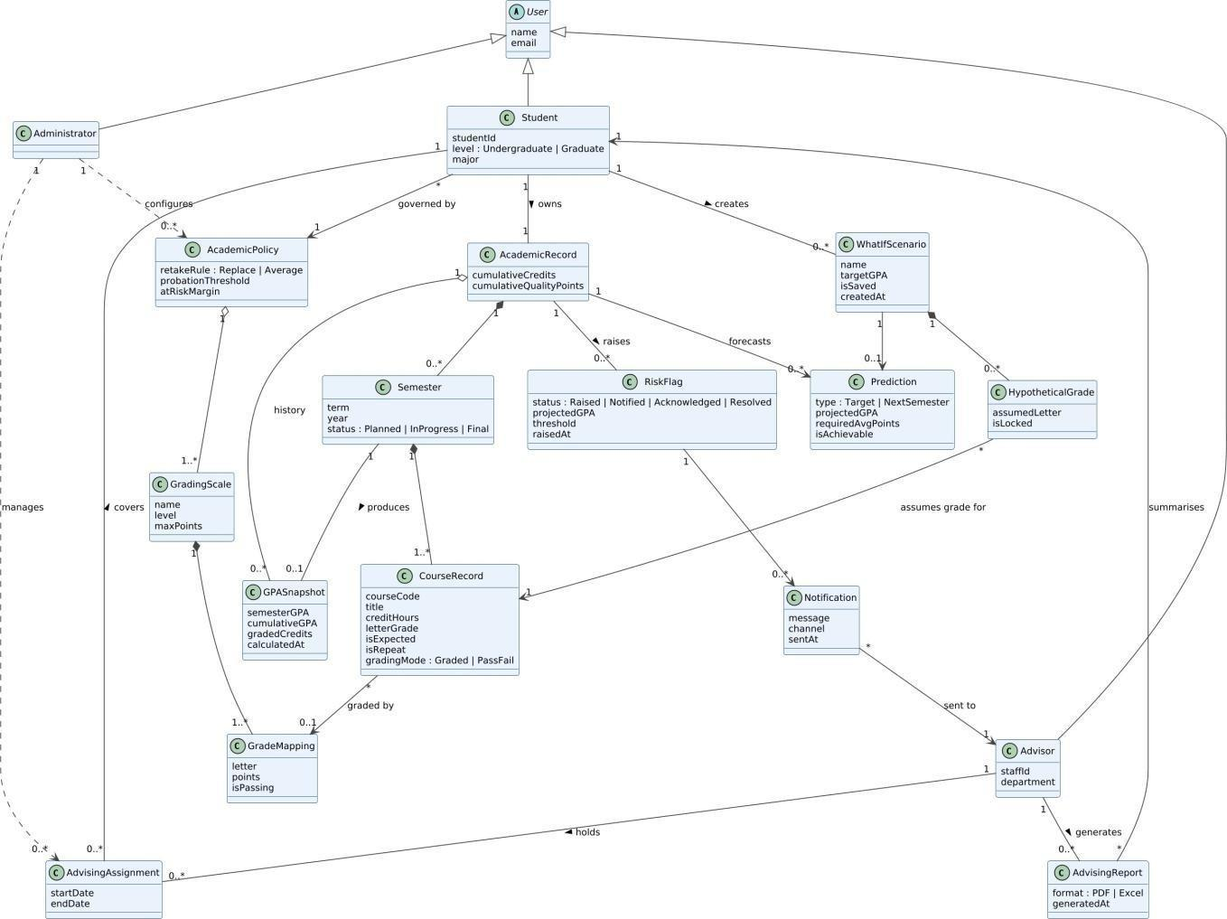
Figure D6 – Domain Model (UML class diagram)

Multiplicity rationale
  - A Student owns exactly one AcademicRecord (1–1) containing 0..* Semesters; each Semester has at least one CourseRecord (1..*).
  - An Advisor holds 0..* AdvisingAssignments; each assignment covers exactly one Student, so a student can have history of advisors over time.
  - A GradingScale has 1..* GradeMappings (letter → points, passing flag); a CourseRecord is graded by 0..1 mapping (0 while no grade is entered).
  - A WhatIfScenario has 0..* HypotheticalGrades and 0..1 Prediction; a RiskFlag may generate 0..* Notifications addressed to exactly one Advisor each.

D7 – Consistency Checklist and Peer-Review Sheet

Step 7 – Consistency checklist (completed by the team)
Check | Evidence | Status
Every use case is traceable to at least one actor and appears in the Use Case  Diagram | UC1–UC14 each have an actor (D1 list, traceability table) and appear in D3. UC15–UC16 are “Won’t” and intentionally excluded. | ✓
Sequence messages align with the MSS steps | Table “MSS step ↔ message alignment” in D5 maps all nine UC2 steps to messages. | ✓
Activity diagram branches match Extensions/guards | D4 guards are coded 2a, 4a, 5a, 6a, 7a, 7b, 8a, 11a – identical to UC4 extension numbers; forks match MSS steps 2 and 9; loop = step 10.  (2b, *a are system-level and not drawn.) | ✓
All domain classes appear in at least one use case/sequence; names consistent | See class–use case table below. | ✓
Non-functional constraints appear as notes where relevant | NFRs recorded in both fully dressed use cases (accuracy, < 1 s response, HTTPS/privacy, mobile-first, WCAG); D5 note states the authentication precondition; unofficial label and read-only rule appear as constraints. | ✓
Names consistent across artifacts | Same terms everywhere: Student, Academic Advisor, Semester, CourseRecord, GPASnapshot, GradingScale, RiskFlag, WhatIfScenario, Prediction. | ✓
Personas covered by actors | Persona 1 → Undergraduate Student; Persona 2 → Academic Advisor; Feasibility roles → Administrator, SSO, SIS, Email Service, Scheduler. | ✓
Priorities follow Lab 2 | Lab 2 High → Must, Medium → Should, Low (exports) → Could. | ✓
Class ↔ use case coverage
Domain class | Used in
User, Student | UC1–UC7 (Student); all UCs authenticate a User
Advisor | UC8, UC9, UC11, UC12
Administrator | UC13, UC14, UC1
AdvisingAssignment | UC8, UC9, UC13
AcademicRecord | UC2, UC3, UC4, UC5, UC6, UC10 (D5 lifeline)
Semester, CourseRecord | UC2, UC4, UC6, UC7 (D5)
GPASnapshot | UC2, UC3, UC9 (D5 result object)
GradingScale, GradeMapping | UC2, UC4, UC14 (D5 lifeline)
AcademicPolicy | UC6, UC10, UC14
WhatIfScenario, HypotheticalGrade | UC4
Prediction | UC4, UC5, UC9, UC10
RiskFlag, Notification | UC10, UC11, UC8, UC9 (RiskEvaluator in D5)
AdvisingReport | UC12

Step 8 – Peer-review sheet
Instructions: swap this PDF with another team. The “Self-check” column was completed by the authoring team; the reviewing team fills in the “Peer review” column and comments.

Peer-review checklist item | Self-check | Peer review (✓ /  ✗) | Reviewer comments
Actors cover all personas and external systems | ✓ | ✓ | All relevant actors and external systems are covered.
Use case names are goal-level and unambiguous | ✓ | ✓ | Use cases are clear, specific, and goal oriented.
Includes/extends used sparingly and correctly | - (3 include, 3 extend) |  | Include/extend relationships are used appropriately.
Activity/Sequence diagrams match narratives |  |  | The diagrams are consistent with the described narratives.

Peer-review checklist item | Self-check | Peer review (✓ /  ✗) | Reviewer comments
Class diagram avoids UI/DB details; multiplicities make sense |  |  | The class diagram focuses on the main domain classes and uses reasonable multiplicities.
Clear pre/post-conditions and success guarantees |  |  | Preconditions, postconditions, and success conditions are clearly  defined.
Consistency across all artifacts |  |  | The different diagrams and artifacts are consistent with each other.
Clarity, readability and professional style |  |  | The work is clear, readable, and presented professionally.

Reviewing team | Group 4 section 1
Reviewer names | Ali Ahmed / Mohammed Guail / Abdulrahman AlShalhoub
Date | 10/7/26
Overall feedback / actions taken | The project is generally well-organized, coherent, and consistent. The requirements are met by the use cases, diagrams, and class models. The artifacts are presented in a professional manner and are readable. There were no significant problems found. Additional information could be added where needed, and relationships and multiplicities could be double-checked for  consistency.

Optional Extensions (+5 pts each)

Extension 1 – State Machine Diagram: RiskFlag lifecycle
A RiskFlag is raised by UC10 when the projected GPA falls below the probation threshold. It is Notified to the advisor (UC11), may receive reminders, is Acknowledged by the advisor, and is automatically Resolved whenever the student’s projected GPA recovers to the threshold or above.
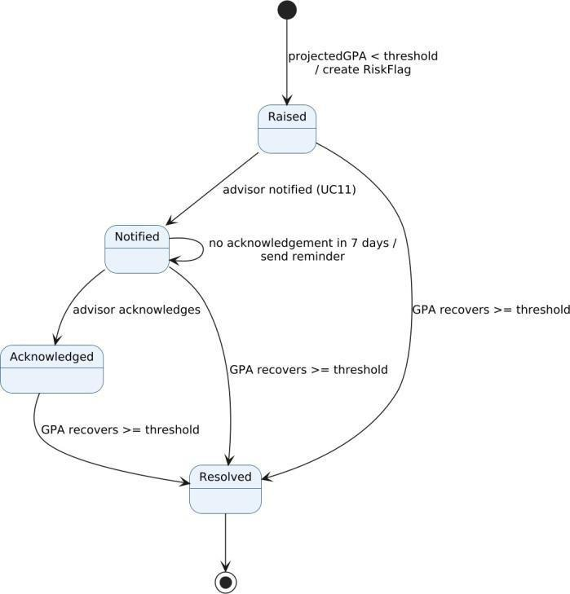
Figure E1 – State machine for RiskFlag

Extension 2 – System Sequence Diagram: UC4 alternative flow 7a (target unattainable)
The system is treated as a black box. With cumulative GPA 3.20 over 60 credits and 15 credits remaining, a target of 3.50 requires an average of 4.70 grade points. The system reports it as unattainable with the maximum achievable GPA (3.36) and suggestions; when the student lowers the target to 3.30 the required average becomes 3.70 and grade combinations are returned.

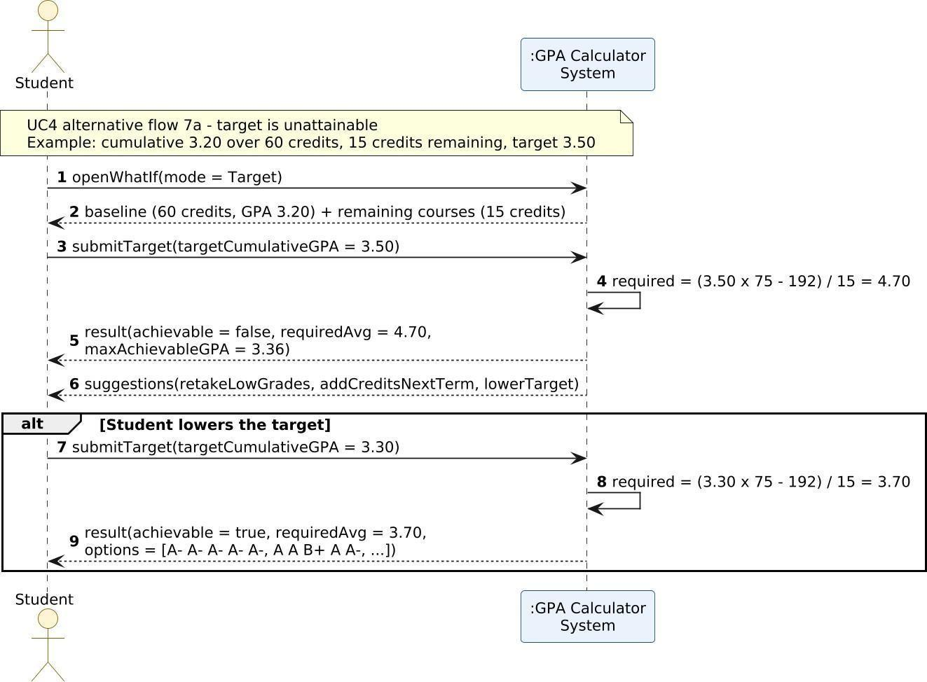
Figure E2 – System Sequence Diagram for the failed-target alternative flow

Appendix – PlantUML Sources
The sources below reproduce each diagram (skinparam styling lines omitted for brevity in the printed copy; full .puml files are provided separately).

D3 Use Case Diagram
@ s t a r t u m l
l e f t t o r i g h t d i r e c t i o n
a c t o r " U n d e r g r a d u a t e \ n S t u d e n t " a s U G a c t o r " G r a d u a t e \ n S t u d e n t " a s G R a c t o r " S t u d e n t " a s S T
a c t o r " A c a d e m i c \ n A d v i s o r " a s A D a c t o r " S y s t e m \ n A d m i n i s t r a t o r " a s A M a c t o r " S c h e d u l e r \ n ( T i m e r
) " a s T M
r e c t a n g l e " G P A C a l c u l a t o r & P r e d i c t i o n S y s
t e m " { u s e c a s e " U C 1 \ n L o g I n " a s U C 1
u s e c a s e " U C 2 \ n C a l c u l a t e S e m e s t e r G P A " a s U C 2 u s e c a s e " U C 3 \ n V i e w C u m u l a t i v e G P A & T r e n d " a s U C 3 u s e c a s e " U C 4 \ n R u n W h a t - I f P r e d i c t i o n " a s U C 4 u s e c a s e " U C 5 \ n P r e d i c t N e x t - S e m e s t e r G P A " a s U C 5 u s e c a s e " U C 6 \ n A p p l y R e t a k e P
o l i c y " a s U C 6 u s e c a s e " U C 7 \ n I m p o r t G r a d e s f r
o m S I S " a s U C 7 u s e c a s e " U C 8 \ n V i e w A d v i s e e R
o s t e r " a s U C 8 u s e c a s e " U C 9 \ n R e v i e w A d v i s e e G P A P r o f i l e " a s U C 9 u s e c a s e " U C 1 0 \ n F l a g A t - R i s k S t u d e n t s " a s U C 1 0 u s e c a s e " U C 1 1 \ n S e n d A t - R i s k N o t i f i c a t i o n " a s U C 1 1 u s e c a s e " U C 1 2 \ n E x p o r t A d v i s e e R e p o r t " a s U C 1 2 u s e c a s e " U C 1 3 \ n M a n a g e A d v i s o r A s s i g n m e n t s " a s U C 1 3
u s e c a s e " U C 1 4 \ n C o n f i g u r e G r a d i n g S c a l e \ n & P o l i c i e s " a s U C 1 4 }
a c t o r " U n i v e r s i t y S S O \ n < < s y s t e m > > " a s S S O a c t o r " S I S \ n < < s y s t e m > > " a s S I S
a c t o r " E m a i l / N o t i f i c a t i o n \ n S e r v i c e < < s y s t e m > > " a s E M

U G - - | > S T G R - - | > S T

S T - - U C 1 A D - - U C 1 A M - - U C 1 S T - - U C 2 S T - - U C 3 S T - - U C 4 S T - - U C 5 S T - - U C 6 S T - - U C 7 A D - - U C 8 A D - - U C 9
A D - - U C 1 2 A M - - U C 1 3 A M - - U C 1 4
T M - - U C 1 0

U C 1 - - S S O U C 7 - - S I S U C 1 1 - - E M

U C 6 . > U C 2 : < < e x t e n d > > \ n [ c o u r s e i s a r e p e a t ] U C 7 . > U C 2 : < < e x t e n d > > \ n [ S I S a v a i l a b l e ]
U C 1 2 . > U C 9 : < < e x t e n d > > \ n [ a d v i s o r e x p o r t s ] U C 9 . > U C 5 : < < i n c l u d e > >
U C 1 0 . > U C 5 : < < i n c l u d e > > U C 1 0 . > U C 1 1 : < < i n c l u d e > > @ e n d u m l

D4 Activity Diagram
@ s t a r t u m l | S t u d e n t |
s t a r t
: O p e n W h a t - I f t o o l a n d s e l e c t m o d e " T a r g e t G P A "
;
| S y s t e m
| f o r k
: L o a d b a s e l i n e r e c o r d
( c r e d i t s , q u a l i t y p o i n t s
) ; f o r k a g a i n
: L o a d a c t i v e g r a d i n g s c a l e a n d a c a d e m i c p o l i c y ;
e n d f o r k
i f ( 2 a : B a s e l i n e l o a d e d ? ) t h e n ( n o )
| S t u d e n t |
: E n t e r c u m u l a t i v e G P A a n d c r e d i t s m a n u a l l y ;
| S y s t e m
| e l s e ( y e s
) e n d i f
i f ( 8 a : R e p e a t e d c o u r s e s i n b a s e l i n e ? ) t h e n ( y e s )
: A p p l y r e t a k e p o l i c y ( U C 6
) ; e l s e ( n o ) e n d i f
: D i s p l a y b a s e l i n e a n d r e m a i n i n g ( u n g r a d e d ) c o u r s e
s ; r e p e a t
| S t u d e n t |
: E n t e r t a r g e t G P A a n d l o c k a l r e a d y - g r a d e d c o u r s e s ;
| S y s t e m | i f ( 5 a : T a r g e t w i t h i n 0 . . s c a l e m a x
? ) t h e n ( n o )
: S h o w v a l i d a t i o n e r r o r ; e l s e ( y e s ) i f ( 6 a : U n g r a d e d c r e d i t s r e m a i n i n g ? ) t h e n ( n o )
: S h o w f i n a l G P A - t a r g e t c a n n o t b e i n f l u e n c e d ; o f f e r U C 5 ;
e l s e ( y e s )
: C o m p u t e r e q u i r e d a v e r a g e g r a d e p o i n t s R e q = ( T x ( C d o n e + C r e m ) - Q P d o n e ) / C r e m ;
i f ( 4 a : S e c u r e d e v e n w i t h m i n i m u m p a s s i n g g r a d e s ? ) t h e n ( y e s )
: S h o w " a l r e a d y s e c u r e d " a n d m i n i m u m g r a d e s n e e d e
d ;
e l s e ( n o )
i f ( 7 a : R e q < = m a x g r a d e p o i n t ? ) t h e n ( y e s )
: G e n e r a t e g r a d e c o m b i n a t i o n s ( > = 3 o p t i o n s , r a n k e d ) ;
f o r k
: R e n d e r r e q u i r e d a v e r a g e , o p t i o n s a n d f o r m u l a
;
f o r k a g a i n
: K e e p s c e n a r i o a s s e s s i o n d r a f t ; e n d f o r k
i f ( 7 b : R e q > = 3 . 7 , v e r y h a r d ? ) t h e n ( y e s )
: S h o w h i g h - e f f o r t w a r n i n g ; e l s e ( n o ) e n d i f
e l s e ( n o )
: S h o w U N A T T A I N A B L E , m a x a c h i e v a
b l e G P A a n d s u g g e s t i o n s ( r e t a k e , a d d
c r e d i t s n e x t t e r m , o r l o w e r t h e t a r g e t ) ; e n d i f e n d i f
e n d i f e n d i f
| S t u d e n t | r e p e a t w h i l e ( A d j u s t t a r g e t o r g r a d e s ? ) i s ( y e s ) n o t ( n o ) i f ( S a v e s c e n a r i o ? ) t h e n ( y e s )
| S y s t e m |
: P e r s i s t n a m e d s c e n a r i o ;
i f ( 1 1 a : S a v e s u c c e e d e d ? ) t h e n ( y e s )
: C o n f i r m s a v e ; e l s e ( n o )
: S h o w e r r o r , k e e p r e s u l t o n s c r e e n ; e n d i f
e l s e ( n o
) e n d i f
| S t u d e n t | s t o p
@ e n d u m l

D5 Sequence Diagram
@ s t a r t u m l
a u t o n u m b e r " < b > [ 0 ] " a c t o r S t u d e n t
p a r t i c i p a n t " U I \ n ( W e b A p p ) " a s U I p a r t i c i p a n t " G P A S e r v i c e " a s G S p a r t i c i p a n t " A c a d e m i c R e c o r d " a s A R
p a r t i c i p a n t " G r a d i n g S c a l e " a s S C p a r t i c i p a n t " R i s k E v a l u a t o r \ n ( U C 1 0 ) " a s R E
n o t e o v e r S t u d e n t , G S : P r e c o n d i t i o n : u s e r a u t h e n t i c a t e d ( U C 1 ) , s e s s i o n t o k e n v a l i d
S t u d e n t - > U I : s e l e c t C a l c u l a t e S e m e s t e r G P A ( s e m e s t e r ) < < M S S 1 > > U I - > G S : o p e n S e m e s t e r ( s t u d e n t I d , s e m e s t e r I d )
G S - > A R : g e t O r C r e a t e S e m e s t e r ( s e m e s t e r I d ) A R - - > G S : S e m e s t e r ( e x i s t i n g C o u r s e R e c o r d s ) G S - - > U I : c o u r s e G r i d
U I - - > S t u d e n t : d i s p l a y c o u r s e e n t r y g r i d < < M S S 2 >
> l o o p f o r e a c h c o u r s e r o w
S t u d e n t - > U I : e n t e r C o u r s e ( c o d e , c r e d i t H o u r s , g r a d e , i s E x p e c t e d ) < < M S S 3 > > U I - > U I : v a l i d a t e R o w ( ) < < M S S 4 > > e n
d
S t u d e n t - > U I : c a l c u l a t e ( ) < < M S S 5 > >
U I - > G S : c a l c u l a t e S e m e s t e r G P A ( s e m e s t e r I d , c o u r s e R e c o r d s ) < < M S S 6 > > G S- > S C : g e t G r a d e P o i n t s ( s t u d e n t . l e v e l )
S C - - > G S : G r a d e M a p p i n g s
G S - > G S : q u a l i t y P o i n t s = s u m ( c r e d i t x p o i n t s ) \ n s e m e s t e r G P A = q u a l i t y P o i n t s / g r a d e d C r e d i t s G S - > A R : p r e v i e w C u m u l a t i v e ( s e m e s t e r R e s u l t )
A R - - > G S : c u m u l a t i v e G P A ( p r e v i e w ) G S - - > U I : G P A S n a p s h o t ( u n s a v e d )
U I - - > S t u d e n t : s h o w s e m e s t e r G P A ( P r o j e c t e d / F i n a l ) + c u m u l a t i v e p r e v i e w < < M S S 7 > > S t u d e n t - > U I : s a v e ( ) < < M S S 8 > >
U I - > G S : s a v e S e m e s t e r ( s e m e s t e r I d , c o u r s e R e c o r d s )
G S - > A R : a d d O r U p d a t e S e m e s t e r ( ) ; r e c a l c u l a t e C u m u l a t i v e ( ) A R - - > G S : G P A S n a p s h o t ( s a v e d )
G S - > > R E : e v a l u a t e R i s k ( s t u d e n t I d ) [ a s y n c h r o n o u s ] G S - - > U I : s a v e d ( s n a p s h o t )
U I - - > S t u d e n t : c o n f i r m a t i o n + t r e n d c h a r t u p d a t e d < < M S S 9 >
> @ e n d u m l

D6 Domain Model
@ s t a r t u m l
a b s t r a c t c l a s s U s e r { n a m e e m a i l
}
c l a s s S t u d e n t
{ s t u d e n t I d
l e v e l : U n d e r g r a d u a t e | G r a d u a t e m a j o r
}
c l a s s A d v i s o r { s t a f f I d
de p a r t m e n t
}
c l a s s A d m i n i s t r a t o r
c l a s s A d v i s i n g A s s i g n m e n t { s t a r t D a t e
e n d D a t e
}
c l a s s A c a d e m i c R e c o r d { c u m u l a t i v e C r e d i t s
c u m u l a t i v e Q u a l i t y P o i n t s
}
c l a s s S e m e s t e
r { t e r m y e a r
s t a t u s : P l a n n e d | I n P r o g r e s s | F i n a l
}
c l a s s C o u r s e R e c o r d { c o u r s e C o d e t i t l e
c r e d i t H o u r s l e t t e r G r a d e i s E x p e c t e d i s R e p e a t
g r a d i n g M o d e : G r a d e d | P a s s F a i l
}
c l a s s G P A S n a p s h o t { s e m e s t e r G P A c u m u l a t i v e G P A g r a d e d C r e d i t s c a l c u l a t e d A t
}
c l a s s G r a d i n g S c a l e { n a m e
l e v e l
m a x P o i n t s
}
c l a s s G r a d e M a p p i n g { l e t t e r
p o i n t s
i s P a s s i n g
}
c l a s s A c a d e m i c P o l i c y { r e t a k e R u l e : R e p l a c e | A v e r a g e
p r o b a t i o n T h r e s h o l d a t R i s k M a r g i n
}
c l a s s W h a t I f S c e n a r i o { n a m e
t a r g e t G P A i s S a v e d
c r e a t e d A t
}
c l a s s H y p o t h e t i c a l G r a
d e { a s s u m e d L e t t e r i s L o c k e d
}
c l a s s P r e d i c t i o n { t y p e : T a r g e t | N e x t S e m e s t e r p r o j
e c t e d G P A r e q u i r e d A v g P o i n t s i s A c h i e v a b l e
}
c l a s s R i s k F l a g { s t a t u s : R a i s e d | N o t i f i e d | A c k n o w l e d g e d | R e s o l v e d p r o j e c t e d G P A
t h r e s h o l d r a i s e d A t
}
c l a s s N o t i f i c a t i o n { m e s s a g e c h a n n e l
s e n t A t
}
c l a s s A d v i s i n g R e p o r t { f o r m a t : P D F | E x c e l
g e n e r a t e d A t
}

U s e r < | - - S t u d e n t U s e r < | - - A d v i s o r
U s e r < | - - A d m i n i s t r a t o r

A d v i s o r " 1 " - - " 0 . . * " A d v i s i n g A s s i g n m e n t : h o l d s >
A d v i s i n g A s s i g n m e n t " 0 . . * " - - " 1 " S t u d e n t : c o v e r s >
A d m i n i s t r a t o r " 1 " . . > " 0 . . * " A d v i s i n g A s s i g n m e n t : m a n a g e s A d m i n i s t r a t o r " 1 " . . > " 0 . . * " A c a d e m i c P o l i c y : c o n f i g u r e s

S t u d e n t " 1 " - - " 1 " A c a d e m i c R e c o r d : o w n s > A c a d e m i c R e c o r d " 1 " * - - " 0 . . * " S e m e s t e r
S e m e s t e r " 1 " * - - " 1 . . * " C o u r s e R e c o r d
S e m e s t e r " 1 " - - " 0 . . 1 " G P A S n a p s h o t : p r o d u c e s >
A c a d e m i c R e c o r d " 1 " o - - " 0 . . * " G P A S n a p s h o t : h i s t o r y

C o u r s e R e c o r d " * " - - > " 0 . . 1 " G r a d e M a p p i n g : g r a d e d b y G r a d i n g S c a l e " 1 " * - - " 1 . . * " G r a d e M a p p i n g
A c a d e m i c P o l i c y " 1 " o - - " 1 . . * " G r a d i n g S c a l e
S t u d e n t " * " - - > " 1 " A c a d e m i c P o l i c y : g o v e r n e d b y

S t u d e n t " 1 " - - " 0 . . * " W h a t I f S c e n a r i o : c r e a t e s > W h a t I f S c e n a r i o " 1 " * - - " 0 . . * " H y p o t h e t i c a l G r a d e
H y p o t h e t i c a l G r a d e " * " - - > " 1 " C o u r s e R e c o r d : a s s u m e s g r a d e f o r W h a t I f S c e n a r i o " 1 " - - > " 0 . . 1 " P r e d i c t i o n
A c a d e m i c R e c o r d " 1 " - - > " 0 . . * " P r e d i c t i o n : f o r e c a s t s

A c a d e m i c R e c o r d " 1 " - - " 0 . . * " R i s k F l a g : r a i s e s > R i s k F l a g " 1 " - - > " 0 . . * " N o t i f i c a t i o n
N o t i f i c a t i o n " * " - - > " 1 " A d v i s o r : s e n t t o
A d v i s o r " 1 " - - " 0 . . * " A d v i s i n g R e p o r t : g e n e r a t e s > A d v i s i n g R e p o r t " * " - - > " 1 " S t u d e n t : s u m m a r i s e s @ e n d u m l

E1 State Machine
@ s t a r t u m l
[ * ] - - > R a i s e d : p r o j e c t e d G P A < t h r e s h o l d \ n / c r e a t e R i s k F l a g R a i s e d - - > N o t i f i e d : a d v i s o r n o t i f i e d ( U C 1 1 )
N o t i f i e d - - > N o t i f i e d : n o a c k n o w l e d g e m e n t i n 7 d a y s / \ n s e n d r e m i n d e r N o t i f i e d - - > A c k n o w l e d g e d : a d v i s o r a c k n o w l e d g e s
R a i s e d - - > R e s o l v e d : G P A r e c o v e r s > = t h r e s h o l d
N o t i f i e d - - > R e s o l v e d : G P A r e c o v e r s > = t h r e s h o l d
A c k n o w l e d g e d - - > R e s o l v e d : G P A r e c o v e r s > = t h r e s h o l d R e s o l v e d - - > [ * ]
@ e n d u m l

E2 System Sequence Diagram
@ s t a r t u m l a u t o n u m b e r a c t o r S t u d e n t
p a r t i c i p a n t " : G P A C a l c u l a t o r \ n S y s t e m " a s S
n o t e o v e r S t u d e n t , S : U C 4 a l t e r n a t i v e f l o w 7 a - t a r g e t i s u n a t t a i n a b l e \ n E x a m p l e : c u m u l a t i v e 3 . 2 0 o v e r 6 0 c r e d i t s , 1 5 c r e d i t s r e m a i n i n g , t a r g e t 3 . 5 0
S t u d e n t - > S : o p e n W h a t I f ( m o d e = T a r g e t )
S - - > S t u d e n t : b a s e l i n e ( 6 0 c r e d i t s , G P A 3 . 2 0 ) + r e m a i n i n g c o u r s e s ( 1 5 c r e d i t s ) S t u d e n t - > S : s u b m i t T a r g e t ( t a r g e t C u m u l a t i v e G P A = 3 . 5 0 )
S - > S : r e q u i r e d = ( 3 . 5 0 x 7 5 - 1 9 2 ) / 1 5 = 4 . 7 0
S - - > S t u d e n t : r e s u l t ( a c h i e v a b l e = f a l s e , r e q u i r e d A v g = 4 . 7 0 , \ n m a x A c h i e v a b l e G P A = 3 . 3 6 ) S - - > S t u d e n t : s u g g e s t i o n s ( r e t a k e L o w G r a d e s , a d d C r e d i t s N e x t T e r m , l o w e r T a r g e t ) a l t S t u d e n t l o w e r s t h e t a r g e t
S t u d e n t - > S : s u b m i t T a r g e t ( t a r g e t C u m u l a t i v e G P A = 3 . 3 0 ) S - > S : r e q u i r e d = ( 3 . 3 0 x 7 5 - 1 9 2 ) / 1 5 = 3 . 7 0
S - - > S t u d e n t : r e s u l t ( a c h i e v a b l e = t r u e , r e q u i r e d A v g = 3 . 7 0 , \ n o p t i o n s = [ A - A - A - A - A - , A A B + A A - , . . . ] ) e n d
@ e n d u m l

