Z-ALGORITHM

ANALYSIS OF TIME COMPLEXITY

The time complexity of the Z Algorithm is O(n + m), where:

* n is the length of the text string,
* m is the length of the pattern string

Best case

The best case scenario, when the pattern is found at index 0 or the first position

* Let n is the length of the text string,
* Let m is the length of the pattern string

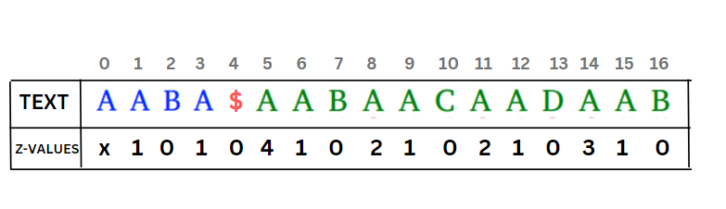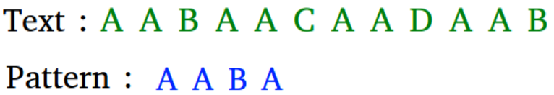

So it traverses (m+1) places ,O(m)

* Concatenating the pattern and text strings takes O(n + m) time.
* Constructing the Z-array for the concatenated string also takes O(n + m) time
* And to find the pattern in Z-aray ,traverses (m+1) places ,O(m)

So, the time complexity is O(m+n)

Worst Case

The worst case scenario, pattern not found

* Let n is the length of the text string,
* Let m is the length of the pattern string

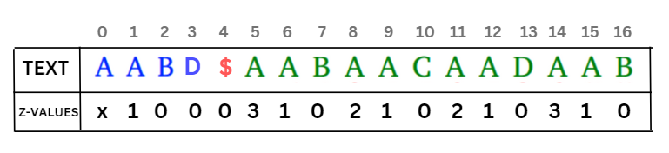

It traverses for (m+n) times so, time complexity is O(m+n)

* Concatenating the pattern and text strings takes O(n + m) time.
* Constructing the Z-array for the concatenated string also takes O(n + m) time
* And to find the pattern in Z-aray ,traverses (m+n) places ,O(m+n)

So, the time complexity is O(m+n)