Jobs

Contents
What is a Fabric Job 2
Job Types 3
User job 3
Broadway Job 3
Process Job 4
Interface Listener job 4
Batch (migrate) job 5
CDC Job 5
IIDFinder Job 5
Job’s Commands 5
How to start a Job? 5
Job Parameters 6
How to stop a Job? 6
Kill a Job 7
*The ps command returns all threads on the current node. Use ps all to list threads running across the entire cluster. 7
Restart Job 7
Resume Job 7
Update Job 8
Session scope 9
Fabric’s Jobs Mechanism 9
K2_JOBS table 10
Job Lifecycle 10
Job Lifecycle - User Action 11
JobsReconcile 12
Claiming Job Ownership 15
Jobs pool 15
JobsScheduler 15
JobsExecuter 16
Stopping a job 18
Killing a job 18
Restart a job 18
Resume a job 18
Job implementation 19
Abort Job 19
Job retries 19
Job output 20
Node Heartbeat 21
Jobs & Project Deployment 21
Jobs Actors 22
JobWait 22
StopJob 22
BroadwayJob: 23
Job Config 23
Config.ini 23
Node.id 24
ANY as affinity 24
Affinity range 24
JMX Stats 26

What is a Fabric Job

Fabric Jobs is a mechanism for running scripts or executables.
Once configured, Fabric creates asynchronous tasks (running threads) that execute specific commands, Broadway flows, or Java code at scheduled dates and times.

Job Types
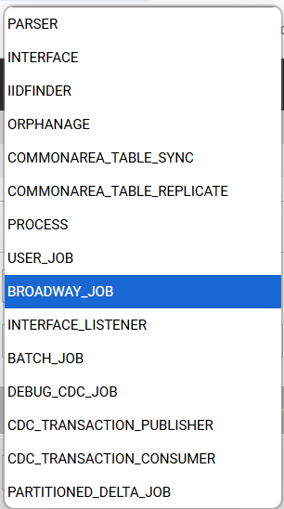

User job
A Java function defined under a specific LU type or in Shared Objects. The execution of the job is always tied to a specific LU type. If defined in Shared Objects, it can be executed across all LU types.
User job can be executed using the DbCommand Actor or the startJob command.
@desc("Test User Job")
@type(UserJob)
@out(name = "", type = String.class, desc = "")
public static String userJob1 (@desc("") int inputParameter) throws Exception {
…
}
}

Broadway Job
A Broadway flow defined in the Broadway GUI. It can be executed using the BroadwayJob Actor or the startJob command.

Process Job
Runs a script or executable stored on the Fabric server. It can be executed using the DbCommand Actor or the startJob command
Example execution command:
startjob process NAME='/opt/apps/fabric/workspace/project/echoArg.sh' UID='processJobtest' ARGS='{"0":"ARG 1 value","1":"ARG 2 value"}';
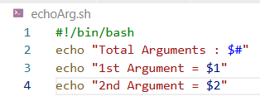 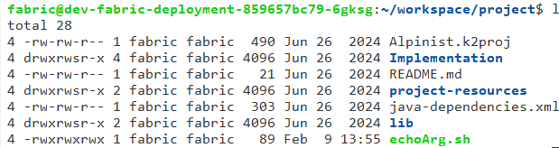

Interface Listener job
A listener to a storage (e.g., local file system) implemented by creating an Interface and a Broadway flow with the InterfaceListener Broadway Actor. Once the flow is executed (only needs to be executed once), a job will start with the following parameters:
- Type = INTERFACE_LISTENER
- Name = The Broadway flow attached to the InterfaceListener
- UID = The Interface name
🔹 If using the FileRead actor in the attached Broadway flow, set the parameters as external to receive inputs from the Interface Listener.
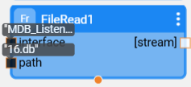

Batch (migrate) job
Created when executing a batch command. A job will start with the following parameters:
- Type = BATCH_JOB
- UID = The batch command

CDC Job
Will be covered in the CDC course.

IIDFinder Job
Not in use

Job’s Commands

How to start a Job?

✅ Using the startjob Command:
startjob user_job name='Customer.userJob1' args='{"loopsIterationCount":"2000"}' UID='uid_test';
✅ Using a Broadway Flow:
- DbCommand Actor – Select “fabric” interface and use the startJob command.
- BroadwayJob Actor – Used specifically for Broadway jobs.
✅ Using Java:
fabric().fetch("startjob user_job name='Customer.userJob1' args='{\"loopsIterationCount\":\"2000\"}' UID='uid_test'");
🔹 Example Java Method:
@desc("")
@out(name = "functionResult", type = String.class, desc = "")
public static Db.Row executeUserJob1(@desc("") String param1) throws Exception {
Db.Row results = fabric().fetch("startjob user_job name='Customer.userJob1'
args='{\"loopsIterationCount\":\"2000\"}' UID='uid_test'").firstRow();
return results;
}
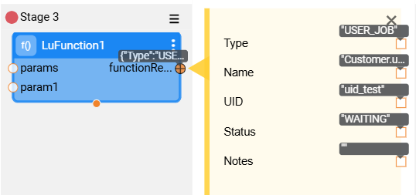

Job Parameters

STARTJOB <JOBTYPE> NAME='<name>' [UID='<uid>'] [AFFINITY='<affinity>'] [ARGS='<args>'] [EXEC_INTERVAL='<execInterval>'];
- Job Type – Specifies the type of job (e.g., BROADWAY, PROCESS, USER_JOB, etc.).
- UID – A unique identifier for the job. If not provided, Fabric will generate a new UID for each run.
  - Using a UID ensures that the job cannot be started multiple times simultaneously. Only one instance of a job with the same UID is allowed.
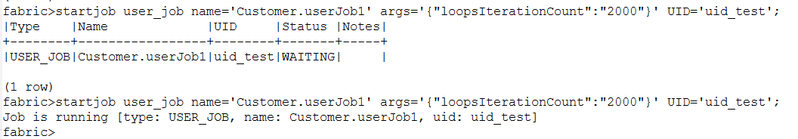
- Affinity – Restricts the job to run on specific nodes (more info in the Jobs Config section). Default value: {"Affinity":["ANY"]} – can run on any node.
- Args – A JSON string containing custom parameters for the job.
  - Example: args='{"first_param":"first_value","second_param":"second_value"}'
- EXEC_INTERVAL – Defines the job's execution schedule. If not provided, the job runs immediately and only once.
  - Timestamp: yyyy-MM-dd HH:mm:ss → Schedules a one-time execution.
  - Time Interval: HH:MM:SS → Runs the job at regular intervals.
  - Cron Expression: Uses the crontab format for complex scheduling.
    - Example: 23 0-20/2 03 12 2 → Runs at minute 23, every 2nd hour from 0 to 20, on the 3rd day of the month, and on Tuesday in December.

How to stop a Job?

- To stop a running job, use the STOPJOB command:
  - Stop all jobs of a specific type and name:
STOPJOB <JOBTYPE> NAME='<name>'
Stop all jobs matching the specified name and type.
  - Stop a specific job using its UID:
STOPJOB <JOBTYPE> NAME='<name>' UID='<uid>'
Stop only the job that matches the given UID.
- For BW flows, use the stopJob actor.

Kill a Job
If a job does not respond to the stopJob command (e.g., a long-running SELECT on a source database that does not respond to an abort request), you can forcefully terminate its thread using the kill command:
kill <node_id> <task_id>;
Use the ps command to identify the node and task ID.
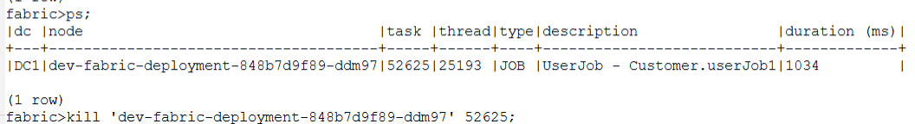

*The ps command returns all threads on the current node. Use ps all to list threads running across the entire cluster.

Restart Job
Stop and start a non-archived job.
- RESTARTJOB <JOBTYPE> NAME='<name>'
Restarts all matching Jobs with this name and type.
- RESTARTJOB <JOBTYPE> NAME='<name>' UID='<uid>'
Restarts a specific Job matching an UID.

Resume Job
Start a job that is already marked with archived=true
- RESUMEJOB <JOBTYPE> NAME='<name>' UID='<uid>'
Resumes a specific matching Job. This command applies only to an existing Job.

Update Job

To modify job parameters, use the UPDATEJOB command. You can update the following:
- Affinity – Restrict the job to specific nodes.
- Arguments – updates parameters.
- Execution Interval – Modify job scheduling.
- RESET_END_TIME (for recurring jobs only):
  - TRUE – Triggers the next execution immediately.
  - FALSE – Keeps the original schedule.
  - To convert a cron job into a one-time job, set EXEC_INTERVAL=''.
Command Syntax:
UPDATEJOB <jobType> NAME='<name>' [UID='<uid>'] [AFFINITY='<affinity>'] [ARGS='<args>'] [EXEC_INTERVAL='<execInterval>'] [RESET_END_TIME=true/false]

Monitoring Jobs – JOBSTATUS Command
Use the JOBSTATUS command to monitor job execution and status.
Command Variants:
- Retrieve active or past jobs:
JOBSTATUS [x days ago]
  - If no days are provided, returns all active (non-archived) jobs.
  - If days are specified, returns the status of jobs executed in the past X days, including archived jobs.
- Retrieve jobs by type:
JOBSTATUS <JOBTYPE>
  - Returns the status of all jobs matching the specified type.
- Retrieve a specific job by type, name, and UID:
JOBSTATUS <JOBTYPE> '<NAME>' WITH UID='<UID>'
  - Returns the status of the specified job.
Job Status Output:
- Type – Job type (e.g., user_job, process, Broadway).
- Name – Job name.
- UID – Unique identifier of the job.
- Status – Current job state.
- Creation Time – When the STARTJOB command was last executed.
- Start Time – Start time of the last run.
- End Time – End time of the last run.
- Affinity – Node restriction, if any.
- Is Archived – Automatically set to True if the job reaches a terminated, failed, or processed state.
- Next Run:
  - IN_PROCESS – "Already running."
  - WAITING – "Ready to be executed."
  - SCHEDULED – Timestamp of the next scheduled execution for recurring jobs.
- Ownership Candidates Num – Number of nodes eligible to execute the job based on affinity settings.
- Notes – Last recorded error message if the job failed.
- Node – The node currently handling the job.
- Tries – Number of retry attempts in case of failure.

Session scope

When a job is executed, Fabric automatically includes session scope variables in the job’s arguments. Any SET command executed within the session is added to the session_scope parameter of the job.
This means that when a Session Global is set and a job is run within the same session, the job will inherit these global values and operate accordingly.
For example, executing the following commands:
SET sync off;
SET auto_mdb_scope = true;
SET k2_ws.ALPINIST = 10;
Will result in the following job arguments:
{"session_scope":"{\"scope\":{\"EXECUTION_ID\":\"e03e1922-ccbe-42d1-94ce-9470412e578d\",\"k2_ws.ALPINIST\":\"10\",\"SYNC\":\"off\",\"AUTO_MDB_SCOPE\":\"true\",\"LOG_ID\":\"9404000000001753\"}}"}
execution_id – Used internally by Fabric along with log_id for log tracing.

Fabric’s Jobs Mechanism

K2_JOBS table
Each executed job adds a record to the k2System.k2_jobs table.
Key Columns:
- TYPE: Specifies the job type (BROADWAY_JOB, USER_JOB, COMMONAREA_TABLE_SYNC etc.
- NAME: The job name, including the associated LUT.
- UID : The unique identifier for the job
- AFFINITY: The node or DC (IP address) where the job can run on.
- ARCHIVED:
  - Automatically set to True when the job reaches a terminated, failed, or processed state.
  - If not specified, the default TTL (Time-to-Live) is used, set in config.ini (K2JOB_ARCHIVING_TIME_HOUR=720, equivalent to 30 days).
  - TTL applies at the row level when the job is archived.
- ARGUMENTS: Parameters passed to the job, including both session parameters and custom parameters.
- CREATION_TIME: Timestamp of the last startJob execution.
- EXECUTION_INTERVAL: Defined only for recurring jobs.
- STATUS: Current status of the job.
- Last Run Statistics:
- START_TIME: Timestamp when the job last started.
- END_TIME: Timestamp when the job last completed.
- ERROR_MSG: Error message from the last run, if applicable. (Not cleared even if a later run is successful?)
- OUTPUT: Stores job output if configured.
- TRIES: Number of retries (in case of failures).
- WORKER_ID: The node handling the job.
Job Execution with UID
If a job is started with a UID that already exists in k2_jobs (in PROCESSED status), the same record is updated instead of creating a new one.
We can but there is a bug – open ticket

Job Lifecycle

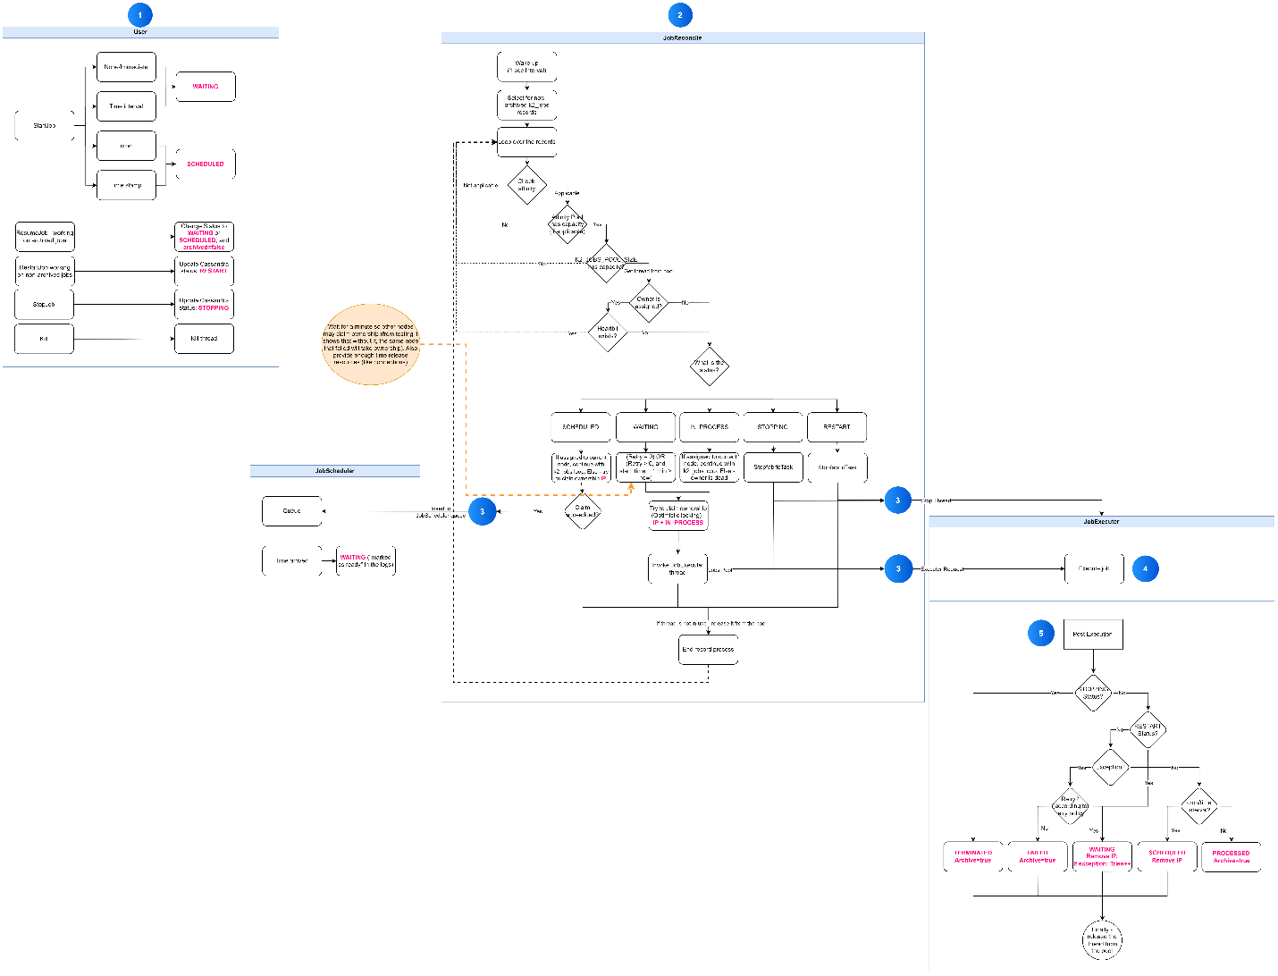

Job Lifecycle - User Action

- A user starts a new job using the startJob command.
- The startJob command creates a record in k2System.k2_jobs within the system database, setting the status based on the Schedule parameter:
  - WAITING → If Schedule is Empty, Immediate, or Time Interval.
  - SCHEDULED → If Schedule is Cron or Timestamp.
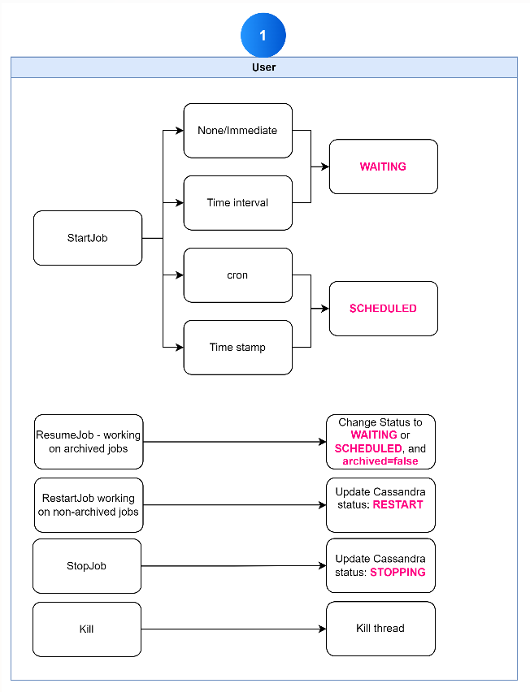

JobsReconcile
JobReconcile is a Fabric component responsible for executing and terminating jobs. It runs on every Fabric node and performs the following tasks:
- Runs at 1-second intervals.
- Fetches all active jobs (Archived = false) from k2_jobs.
- Processes each job sequentially:
  - Affinity Check:
    - If affinity is set and applies to the current node and pool is available continue processing.
    - Otherwise → skip the record.
  - Check Job’s Pool Size
    - If K2JOBS_POOL_SIZE still have capacity – initiate a thread from the pool
    - Otherwise → skip the record.
  - Node Assignment Check:
    - If no node is assigned → continue processing.
    - If assigned → If assigned to current node, continue. Otherwise check if the node is alive:
      - If alive → skip the record.
      - If dead → continue processing.
  - Status-Based Execution:
    - WAITING →
      - Job is ready for execution. A node should claim ownership and execute it.
      - If tries > 0 (meaning the job has failed), the node must wait 1 minute before reclaiming it. This delay allows resources to be released and gives other nodes a chance to claim the job. *Tests have shown that without this 1-minute delay, the failing node would immediately reclaim it again.
      - Logs when job is executed:
INFO 2025-01-27 21:55:21,616 [LID570400000000000f] [JobsReconcile] c.k.c.j.JobsReconcile - 'USER_JOB.Customer.userJob6.uid_test6' is now IN_PROCESS by dev-fabric-deployment-848b7d9f89-ddm97
    - SCHEDULED → Job is set to run at a specific time. The process depends on ownership:
      - If unassigned or assigned to a dead node, a new node should claim ownership (update worker_id in Cassandra).
Current node will try to claim the job, and is succeeded – send it to the JobScheduler to monitor it and move it to WAITING status when the time comes.
      - If assigned to the current node, it is already being watched by JobScheduler, so it is skipped.
    - IN_PROCESS → If the job is assigned to current node, skip the record. Otherwise - the job has started execution, but the assigned node is dead. A new node should claim ownership and execute it.
    - STOPPING → The user has executed stopJob. JobReconcile stops the corresponding JobExecuter thread. The JobExecuter post-execution process then changes the status to TERMINATED.
    - RESTART → JobReconcile stops the matching JobExecuter thread, waits for it to stop, then sets the job status to WAITING.
    - If the initialed thread from the pool is not in use

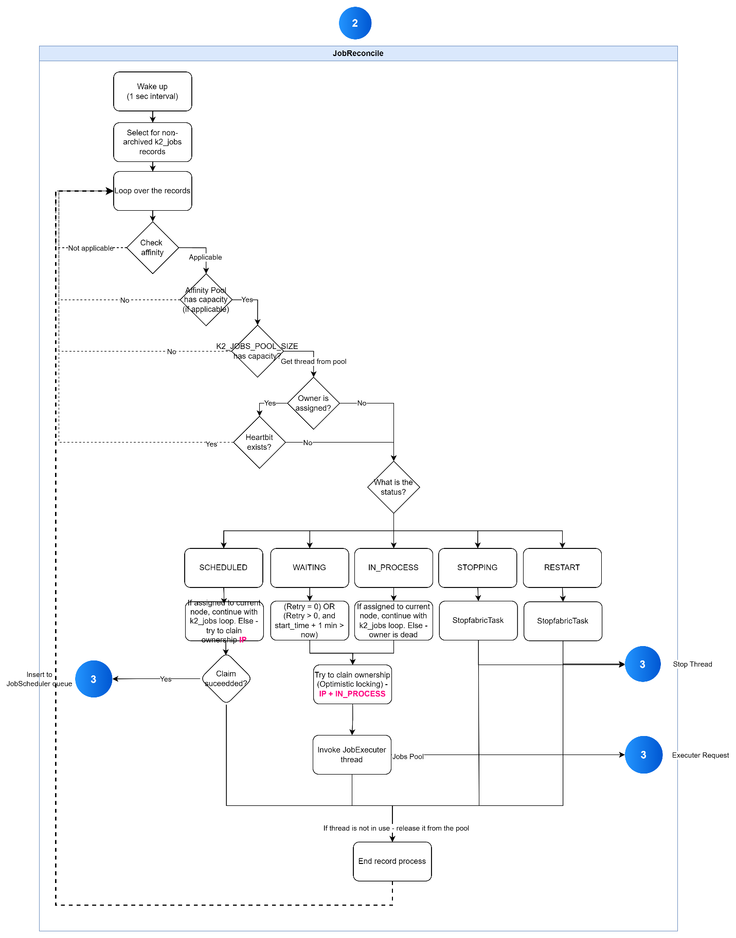

Claiming Job Ownership
A job becomes available for ownership by a node in the following cases:
- WAITING – The job is ready for execution.
- SCHEDULED – The job is set to run at a specific time but requires an active node to execute it.
- IN_PROCESS – The job was running, but the assigned node is no longer available.
To claim ownership, JobReconcile updates its IP in the worker_id column of the k2_jobs table. Fabric ensures that only one node can claim ownership at a time by using a lightweight transaction, preventing conflicts.

Example Log Entry for Successful Ownership Claim:

INFO 2025-01-27 20:56:31,218 [LID570400000000000f] [JobsReconcile] c.k.c.j.JobsReconcile - dev-fabric-deployment-848b7d9f89-ddm97 is managed to claim ownership on cron job 'COMMONAREA_TABLE_SYNC.COMMONAREA_TABLE_SYNC.COMMONAREA_TABLE_SYNC_ref_crm.payment'
Note: When a node restarts, its worker ID is not deleted from the k2_jobs table, giving it precedence over other nodes for executing its assigned jobs.

Jobs pool
Each node maintains a pool of active jobs running on it.
- When a job thread starts, it is added to the jobs pool and removed once the thread terminates.
- The maximum number of concurrent jobs per node is defined in config.ini: K2JOBS_POOL_SIZE=25
- If the pool reaches its limit, the node cannot claim new jobs until a slot becomes available.

JobsScheduler
The JobScheduler is a Fabric component responsible for tracking a node’s scheduled jobs and moving them to WAITING when their execution time arrives.
It maintains a queue of scheduled jobs, received from JobReconcile, for monitoring.
When a job reaches its scheduled time, the following log entry is recorded:
INFO 2025-01-27 21:55:20,611 [LID5704000000000337] [InternalQueue-ref_crm.payment] c.k.c.j.JobsScheduler - cron job 'USER_JOB.Customer.userJob6.uid_test6' marked as ready
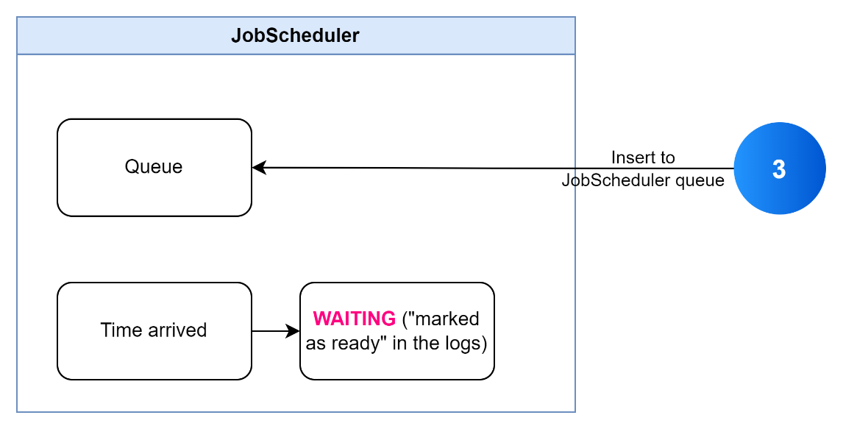

JobsExecuter
The JobExecuter is a thread initiated by JobReconcile, responsible for executing jobs and updating their status upon completion.
Once a job completes, the Post Execution method is triggered to handle status updates:
- STOPPING – If the job was stopped by a user (stopJob command), the status is updated to TERMINATED.
- RESTART – If the job was restarted (restartJob command) or a deployment occurred, the status is updated to WAITING, and the Owner is removed.
- Exception Raised – If the job was terminated by a kill command or encountered an exception:
  - If retries are allowed, the status is set to WAITING.
  - If no retries remain, the status is set to FAILED.
- Otherwise, the status, IP, and archived flag are updated according to the workflow below:
- 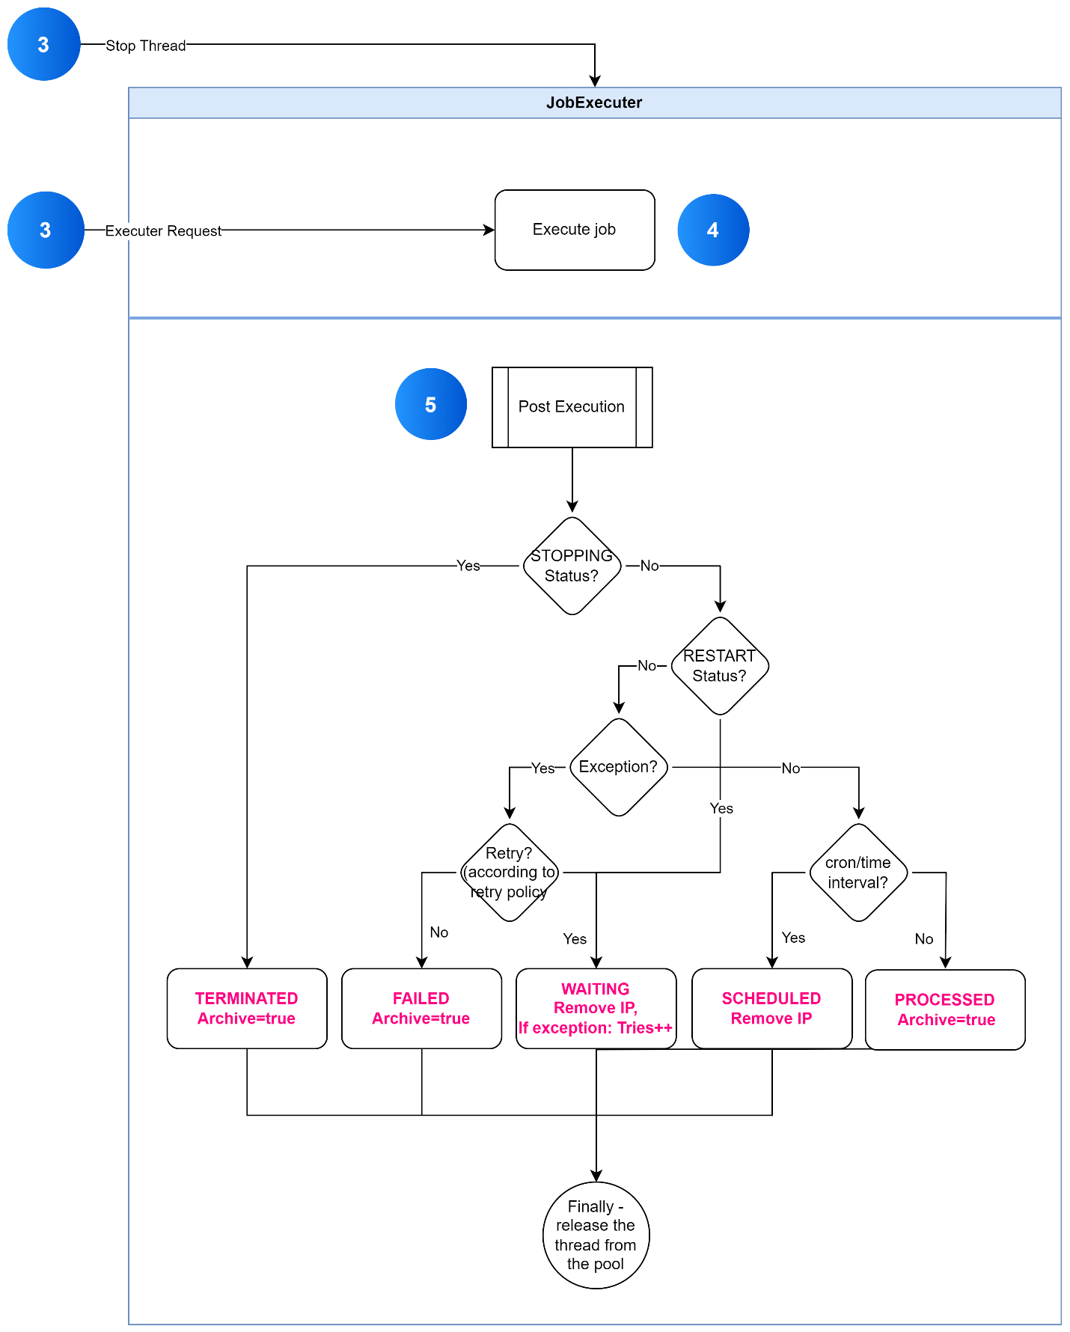

Stopping a job
Executing the stopJob command updates the job’s record to STOPPING status.
- JobReconcile detects the STOPPING status while scanning non-archived records and terminates the job’s thread.
- During post-execution, JobExecuter updates the job’s status to TERMINATED and sets archived = true.

Killing a job
Fabric’s ps and kill commands can be used to terminate a job’s thread if the stopJob command fails to stop it (e.g., when the job does not handle the abort process correctly).
- In such cases, the thread is forcefully terminated.
- The post_execution method detects the error message and updates the job status accordingly:
  - WAITING – If the restart count has not reached the threshold.
  - FAILED – If the restart count limit has been exceeded.
- The thread is then closed and removed from the job pool.

Restart a job
Executing the restartJob command updates the job’s record to RESTART status.
- JobReconcile detects the RESTART status while scanning non-archived records, stops the job’s thread, and updates the status to WAITING.
- A node will then claim ownership and execute the job.

Resume a job
Executing the resumeJob command updates the job’s record to WAITING or SCHEDULED (depending on its schedule) and sets archived = false. A JobReconcile instance will detect the job and claim ownership to execute it.

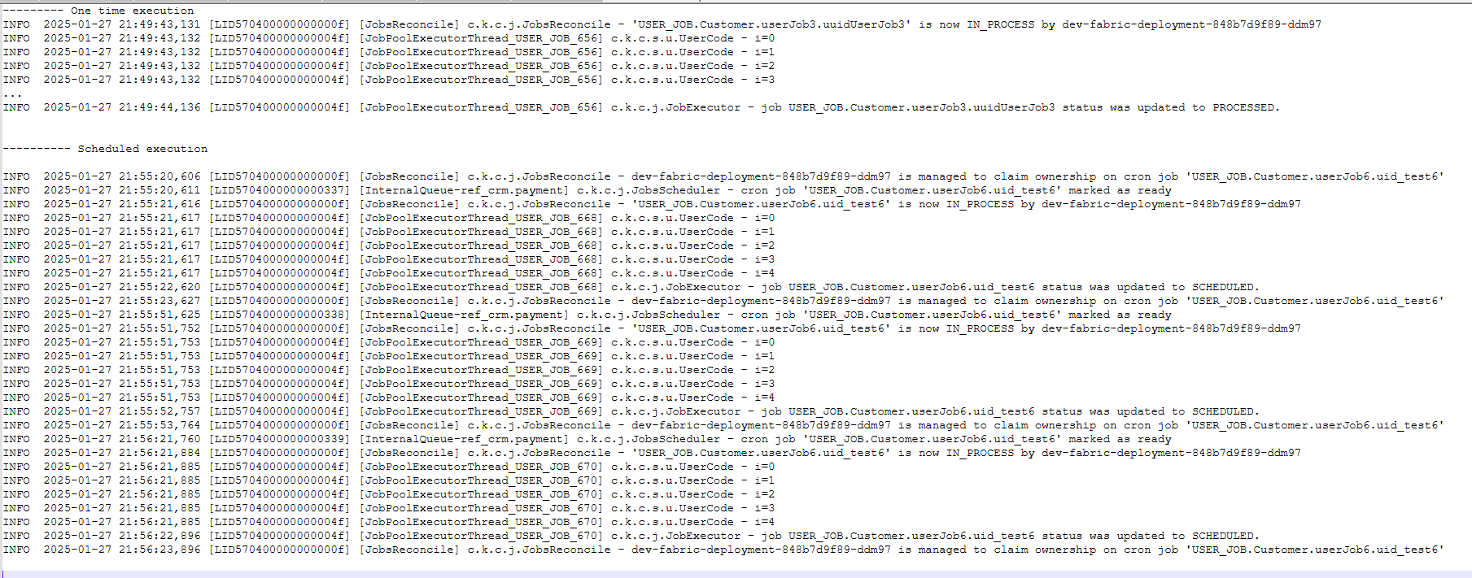

Job implementation

Abort Job
Use the built-in function to actively handle the stopJob command invoked by the user:
if (isAborted()) {
…Add custom logic as required…
throw new InterruptedException();
}
Note: When using BW flows, the Broadway mechanism automatically checks for abort signals between each stage. Explicit handling is typically required when subscribing to Kafka without using the Subscribe Broadway actor.

Job retries
By default, Fabric attempts to execute a failing job 10 times before marking it as FAILED.
To override the retry mechanism, use:
- Java Code:
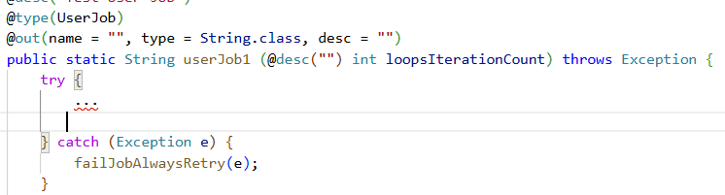
  - failJobRetryUntilMax(Throwable e) – Default behavior (retries until the max limit is reached).
  - failJobAlwaysRetry(Throwable e) – Forces the job to retry indefinitely, ignoring the retry limit.
  - failJobNoRetry(Throwable e) – Stops job execution immediately and prevents any retries.
- Broadway (BW) Flow:
  - Use ErrorHandler to catch exceptions and trigger a flow.
  - The flow should call a LU function to execute the following:
import com.k2view.cdbms.jobs.JobExecutor;
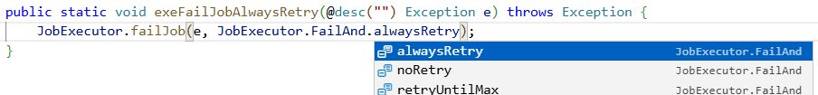
📌 Note: The e parameter contains the exception details, which are:
    - Logged in the system log file.
    - Stored in the k2_jobs.error_msg column.
    - Displayed when running the JobStatus command.

Job output
When a job returns a result, the output is stored in the k2_jobs.output column.
Note: In Broadway (BW), the output includes all parameters defined as External.
Example Output:[{"result":"Loop executed 500 times","result2":222}]

Node Heartbeat

Fabric provides multiple recovery mechanisms to ensure job execution continuity if a node fails. A heartbeat mechanism monitors each Fabric node, allowing jobs to be reassigned when necessary.
Each node updates its heartbeat in k2system.nodes with the following behavior:
- Every node updates its status in Cassandra every FABRIC_HEARTBEAT_INTERVAL_MS milliseconds (default: 5 seconds).
- A node is considered inactive if it misses FABRIC_HEARTBEAT_MISS updates (default: 12 misses).
- If a node stops updating its heartbeat, other nodes assume it is down and can claim its jobs. The failing node will also terminate all its active job threads.
Important Notes:
- Any job with affinity set exclusively to a failed node will not run and must be restarted manually.
- If a node restarts shortly before a scheduled job's execution, it takes precedence over other nodes for running that job. This is achieved by retaining the worker_id in the k2_jobs table before the restart.

Jobs & Project Deployment

- The deploy.flow can be used to start jobs automatically.
- Deploying a project restarts all running jobs associated with the deployed LUT, ensuring they run with the updated code.
- Recurring jobs that are not running at the time of deployment are not restarted.
- Broadway and User jobs restart automatically after deployment or a Fabric restart, while Parsers do not.

Soft Deploy
A soft deploy allows deployment without restarting jobs and can be used when:
- The new code does not contain any changes affecting the job logic.
- Recurring jobs can continue running and apply the new code only after their current execution completes.

Jobs Actors

JobWait
The JobWait actor waits for a specific job to complete or until a timeout occurs.
- Mandatory Input Parameters:
  - Job type
  - Job name
  - UID (The UID can be assigned during the startJob command and used here.)
- Output:
  - Parameters from the k2_jobs record.
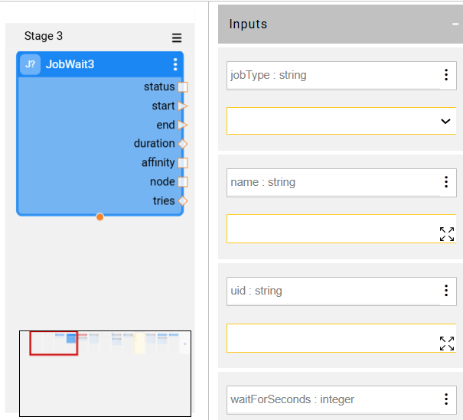

StopJob
The StopJob actor stops a running job and waits until it completes or a defined timeout is reached.
- Mandatory Input Parameters:
  - Job type
  - Job name
  - UID (The UID can be assigned during the startJob command and used here.)
- Output:
  - Job status

BroadwayJob:
BroadwayJob actor provides the ability to trigger a Fabric Job that will in turn execute another Broadway flow once or multiple times depending upon the configuration of the job.
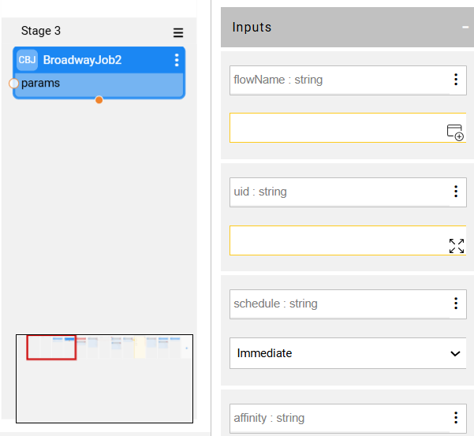

Job Config

Config.ini
JOBS section.
- K2JOBS_POOL_SIZE=25, defines the size of the thread pool for processing Fabric Jobs.
- K2JOB_ARCHIVING_TIME_HOUR=720, defines the time when to delete archived Job row in the k2_jobs table. Default is 720 hours (30 days).
- CLAIM_EXCEPTIONAL_INTERVAL_SEC=60, defines the wait interval before claiming a job with limited affinity, once the recommended pool size has been reached for this affinity (see section below).

Node.id
The node.id file, located in the config folder, is used to assign logical names to nodes. These logical names can be used to set affinity for specific jobs, ensuring that only nodes with the matching affinity can execute those jobs.
Affinity-Based Job Execution
For example, adding "HANDLE_MSG:5" to the node.id file of Node 1 and Node 2 allows these two nodes to execute up to 5 instances of jobs with the HANDLE_MSG affinity.
- Nodes without HANDLE_MSG in node.id or with HANDLE_MSG:0 cannot execute these jobs.
- If more than 10 jobs start simultaneously, each node will execute 5 jobs, while the remaining jobs will stay in WAITING status until a slot becomes available.

ANY as affinity
The ANY option is enabled by default for all nodes and applies only to jobs without a specific affinity.
Configuring ANY Affinity in node.id:
- Exclude a Node: Set ANY:0 to prevent a node from executing jobs without affinity.
- Limit Job Execution: Set ANY:<value> to define the maximum number of jobs a node can run concurrently.
- Default Behavior: If ANY is not specified in node.id, the node will automatically execute jobs without a specific affinity.

Affinity range
Affinity Range (Fabric 6.4.2 and later)
Fabric allows defining an affinity range in node.id, e.g.,
HANDLE_MSG:5 10
- 5 → Recommended maximum number of concurrent jobs.
- 10 → Absolute maximum number of concurrent jobs.
Defining a range can be used to cover of a dead node. See below recommendations.
How It Works:
- Nodes will prioritize staying within the recommended limit to allow other nodes to take jobs.
- If a node has reached its recommended limit but still tries to claim a new job, it must wait for a specific time before taking on additional jobs.
⏳ Claim Delay:
- This waiting time is controlled by the CLAIM_EXCEPTIONAL_INTERVAL_SEC parameter in config.ini (default: 60 seconds).
- During this time, other nodes with available slots get the first opportunity to claim jobs.
Handling Excess Jobs
If a node exceeds its recommended pool size, Fabric will:
- Stop & Release extra jobs running beyond the recommended limit.
- Allow Other Nodes with available slots to claim the stopped jobs.
To avoid immediate job restarts on the same node, a random delay is applied before restarting the job. This delay is controlled by:
- MIN_GIVE_UP_EXCEPTIONAL_MINUTES
- MAX_GIVE_UP_EXCEPTIONAL_MINUTES
These parameters can be configured in config.ini under the jobs section.
Important Notes:
- Set the minimum affinity value to match the required number of job instances; otherwise, jobs may continuously restart.
- This is especially critical for jobs consuming from Kafka, as each restart triggers a rebalance, temporarily halting consumption and reducing the overall consumption rate.

JMX Stats
Under the Transactions section:
- systemJobs – Displays the number of currently running jobs (total 0 indicates the job is not running).
- systemJobsExecution – Shows the total number of times the job has been executed.

