**Problem statement:** Web Based HR system

**Organization:** CART-GEEK

**Description:**

We have read all the instructions given. Almost every use case of the system can be implemented. We are planning to create a web app for your system using python. This website will consist of two major roles as follows:

1. **Employee**
   * Employee is generalized into two parts(based on this each one can perform certain things)
2. General employee:

* Can mark daily attendance and apply it for approval.
* Can log a meeting details if he had gone for a meeting for half day and then came to office in the other half.
* Can apply for reimbursements.
* Can apply for leaves
* Can get monthly updates about salary.
* Can update his/her profile details (Ex: Profile image, address, phone no etc)

1. Manager:

* All the task of general employee as she/he is also an employee
* Can get all the employee list based on his/her department
* Can approve attendance record of employee
* Can approve meeting record of employee
* Can approve reimbursement record of employee

1. **Admin**

* Super admin:
* Has full control on the site
* Can create certain role-based access for admins
* Admin:
* He is also an employee so can perform all employee related tasks.
* Has access to the list of all employees.
* Can create, view, update, delete Employee.
* Can provide login credentials to employee after employee creation.
* Can calculate monthly salary based on the parameters such as no of leaves, attendance record etc.
* Can send notifications to employees about certain events.

**Features of this system:**

* Secured system as we are going to use some security features to block cyber attacks like CSRF, SQL injection, Unauthorized access blocking etc.
* Interactive UX/UI design.
* Convenient for use and it can be extended with some more features in future (Ex: This web app can later be used to build APIs which can be consumed by mobile apps, added features like notification/news system etc.)

**Prototype/Wireframes:**

*Note:*

* *We are attaching some part of the wireframes only in this document for general idea, rest can be found on google drive link folder*
* *Employee will get different login panel and admin will get different panel looks will be almost* similar

**Login panel:**

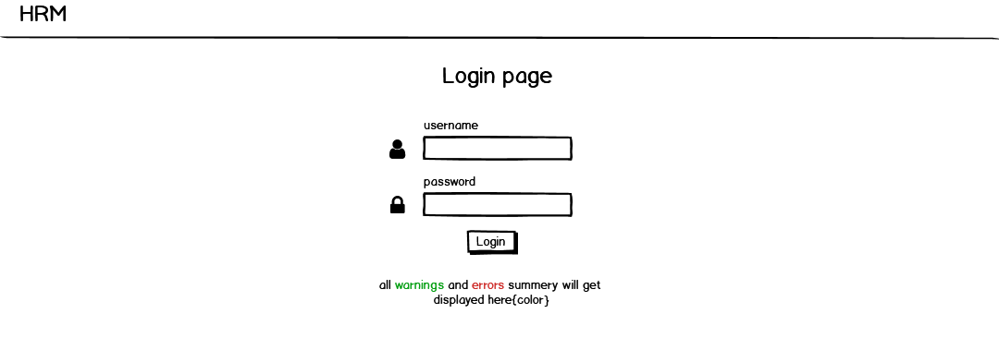

**Side menu:**

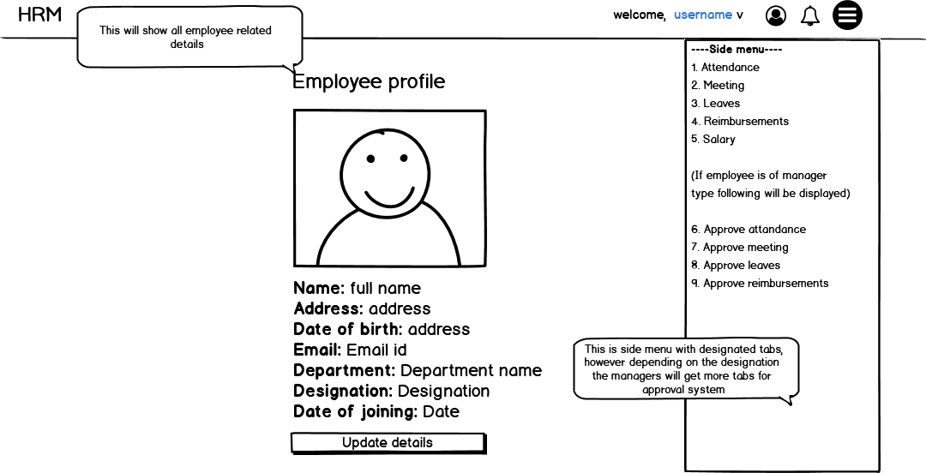

**General pages sample:**

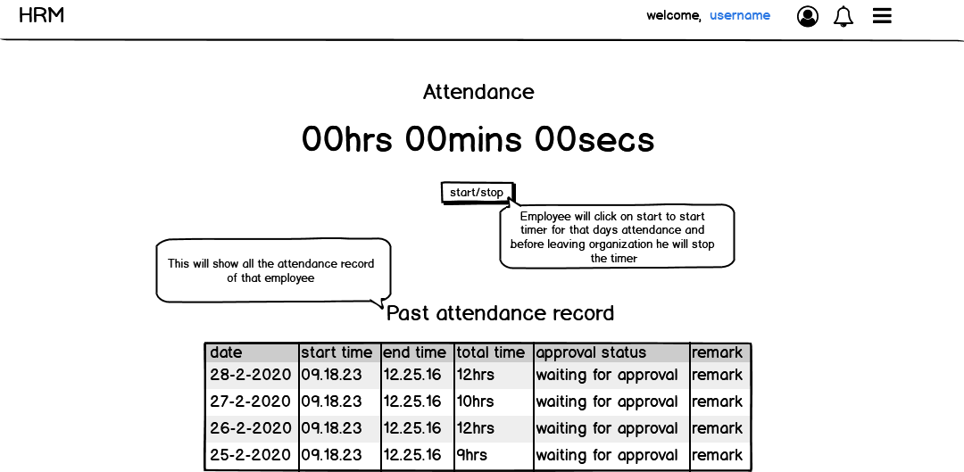

**Manager approval pages sample:**

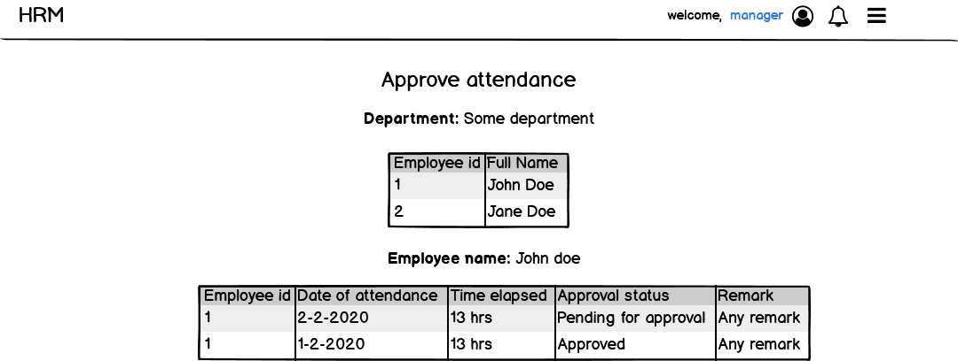

**Admin panel:**

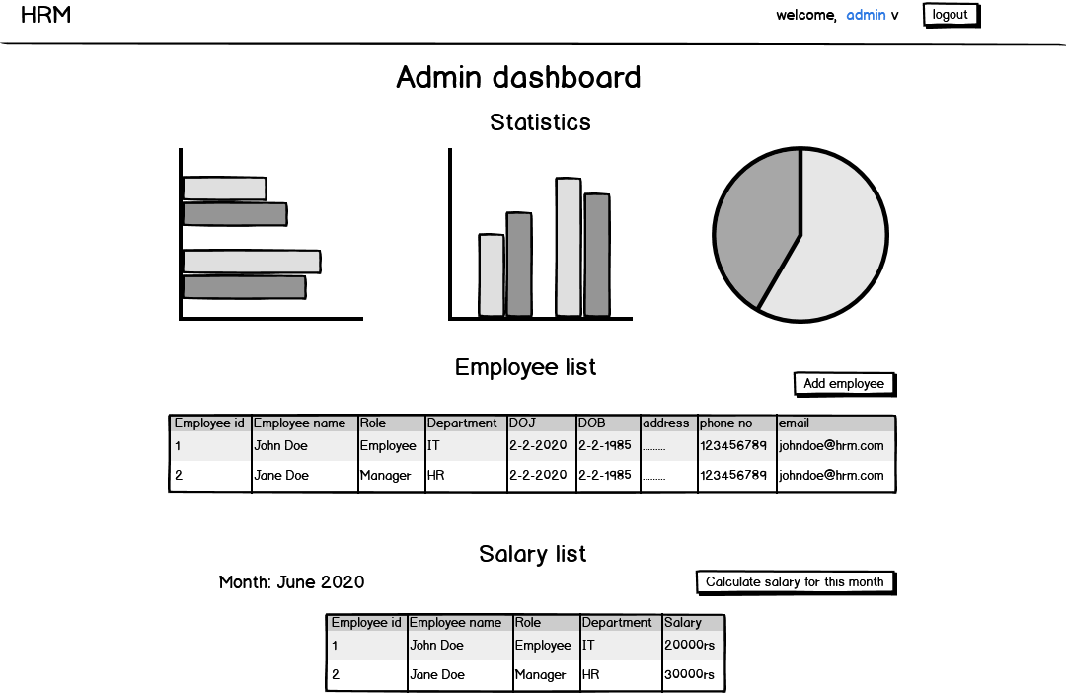

**Use case:**

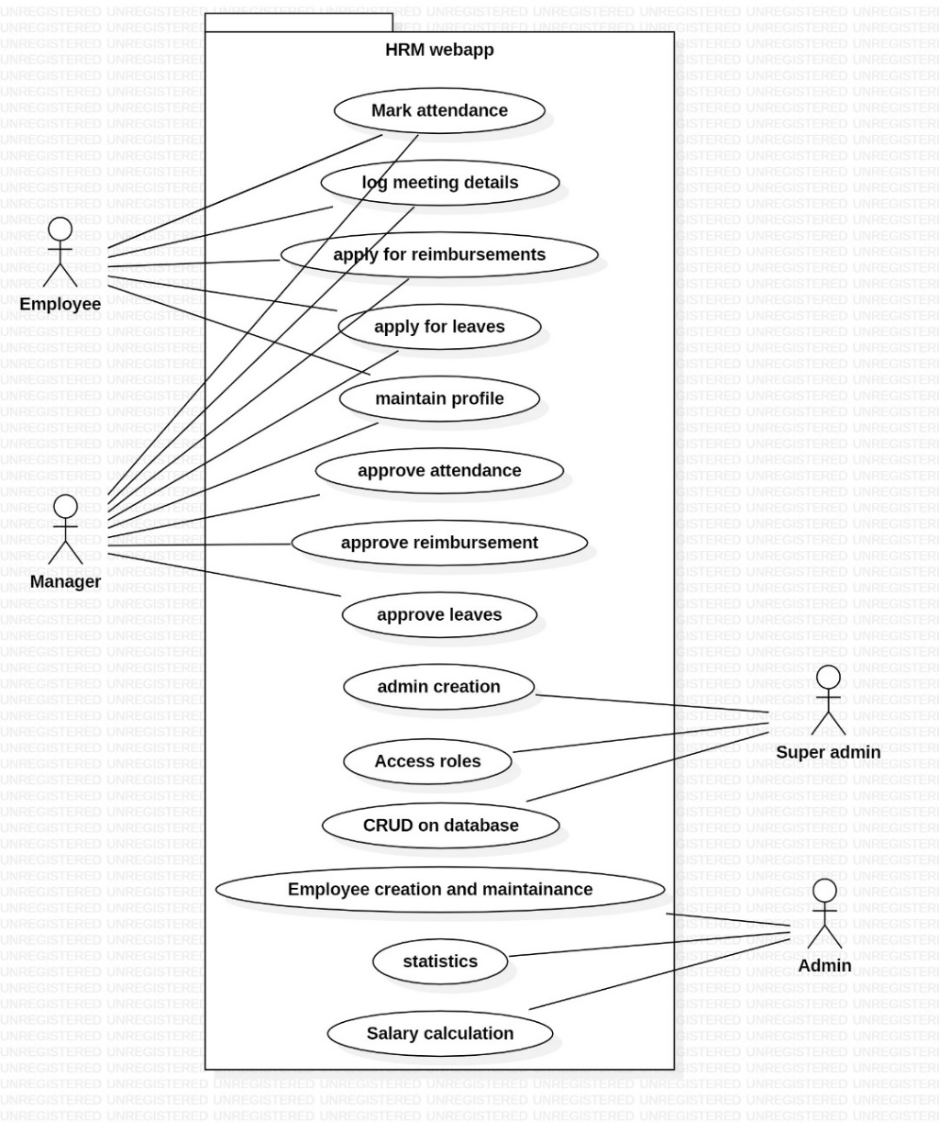

**Technology stack:**

**Frontend:**

* HTML, CSS, Vanilla JS
* Bootstrap
* jQuery

**Backend:**

* Django (python)

**Database:**

* SQLite(for development)
* MySQL(for production)