**Sensing Users’ Emotional Intelligence in Social Networks**

Now-a-days all users are using social networking sites to express their view and to identify users emotion from those views we can apply sentiment algorithms to detect whether user post is positive, negative or neutral. All existing techniques were just applying sentiment algorithm to detect users emotion but not apply Emotional Intelligence, to detect users sentiments such as depress state, swinging mood (shifting from positive to negative or vice versa), emotion fluctuation and social influence. To detect Emotional intelligence author applying four dimensions such as Self-Awareness, Self-Regulation, Self-Motivation and Social Relationship.

1. Self-Awareness can be calculated by finding all sentiment positive words intensities and if this value is high then it will be detected as awareness.
2. Self-Regulation can be calculated by dividing number of positive sentiment words with negative sentiment words and if resultant value greater than 0.5 then user is in swing mood.
3. Self-Motivation can be calculated by multiplying Self-Regulation value with 25 and if resultant value > 0.5 then user will be in depress state
4. Social relationship: Here we will find users number of followers, retweet and it will divide by total mood swings and if resultant value > 0.2 then it will consider as influential in social network else user is not having impact/influence on social media.

So by using above four dimensions we can sense emotions from user’s social networking post. To implement this paper author is using CHINA WEIBO SOCIAL DATASET but this dataset is in Chinese language so we cannot analyse this dataset because of language so I am using TWEETER dataset and this dataset is in JSON format and saved inside ‘Tweets’ folder and this folder contains 38 files and each file contains details of one tweeter user. Below is the dataset example of one user

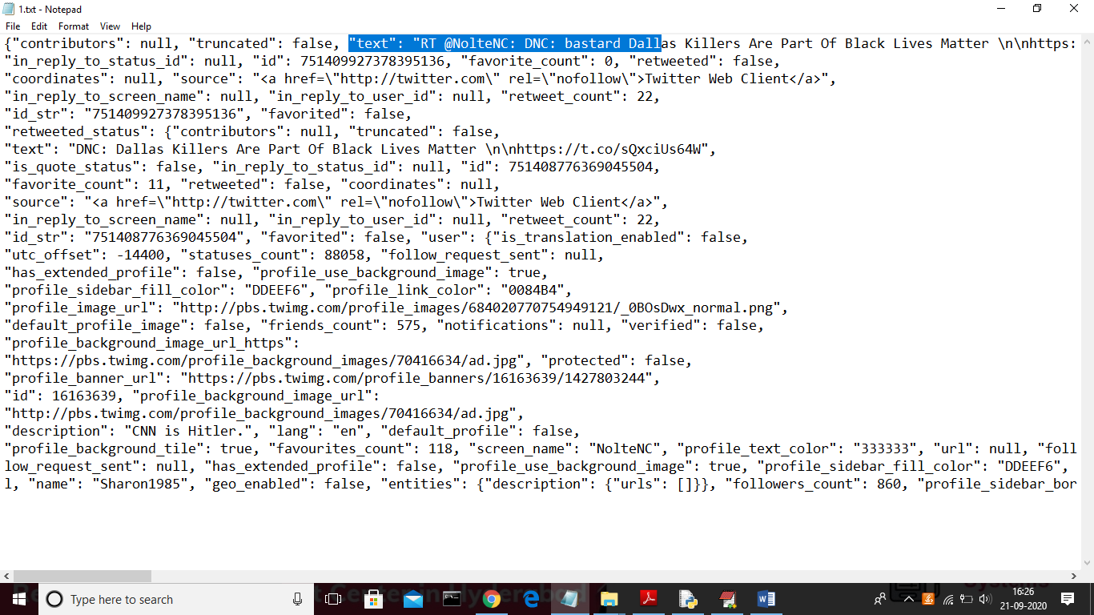

In above one user tweets file we can see all details such as tweet text, retweet count, favourites and many more. To identify sentiment we are using naïve Bayesian algorithm

To run project double click on ‘run.bat’ file to get below screen

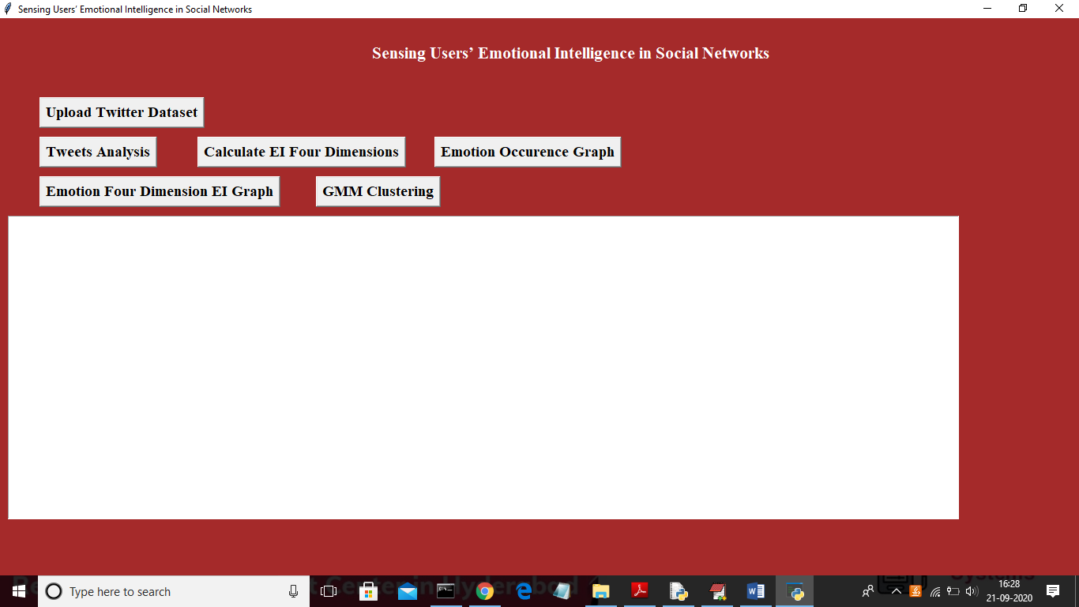

In above screen click on ‘Upload Twitter Dataset’ button to upload tweets dataset

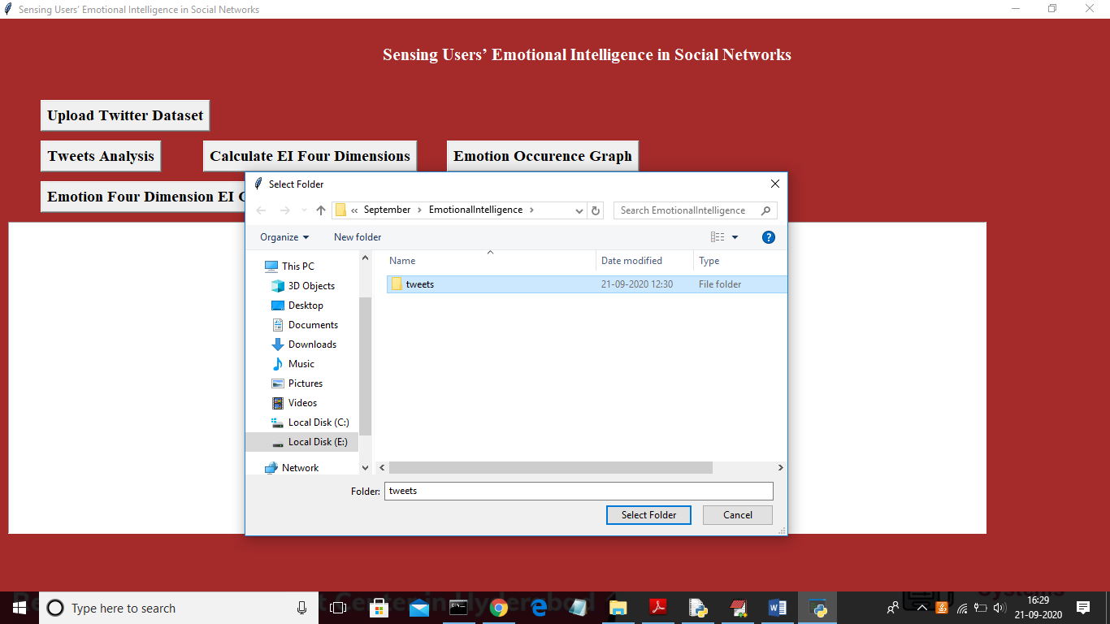

In above screen uploading ‘tweets’ folder and then click on ‘Select Folder’ to upload all tweets files and after uploading file will get below screen

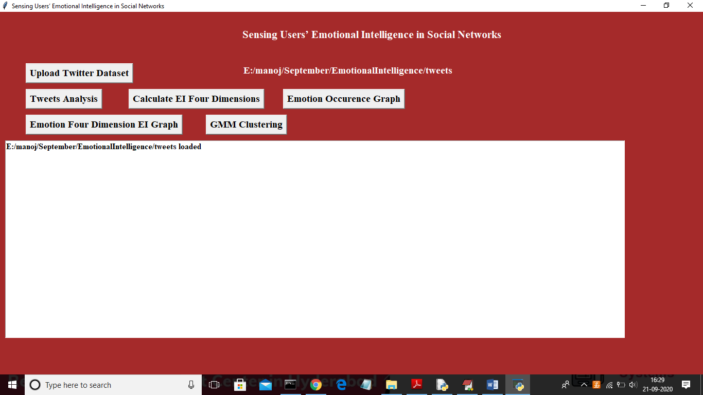

Now click on ‘Tweets Analysis’ button to extract all details from tweets such as username, followers, tweets text etc.

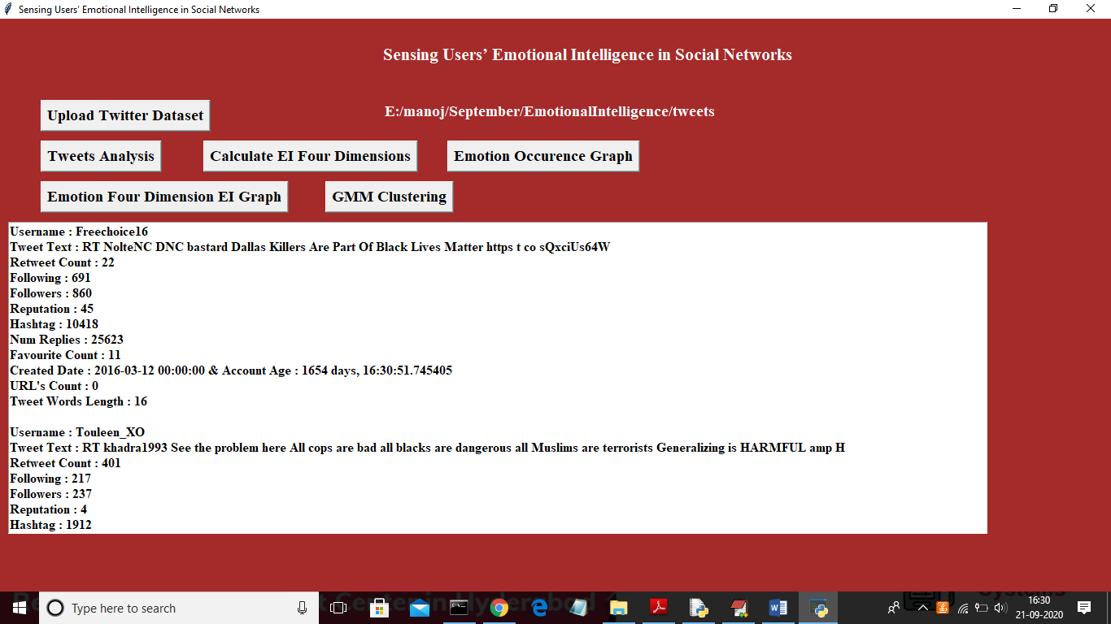

In above screen for each user we extracted all details and you can scroll down above screen to view all user’s details. See below screen with other user details.

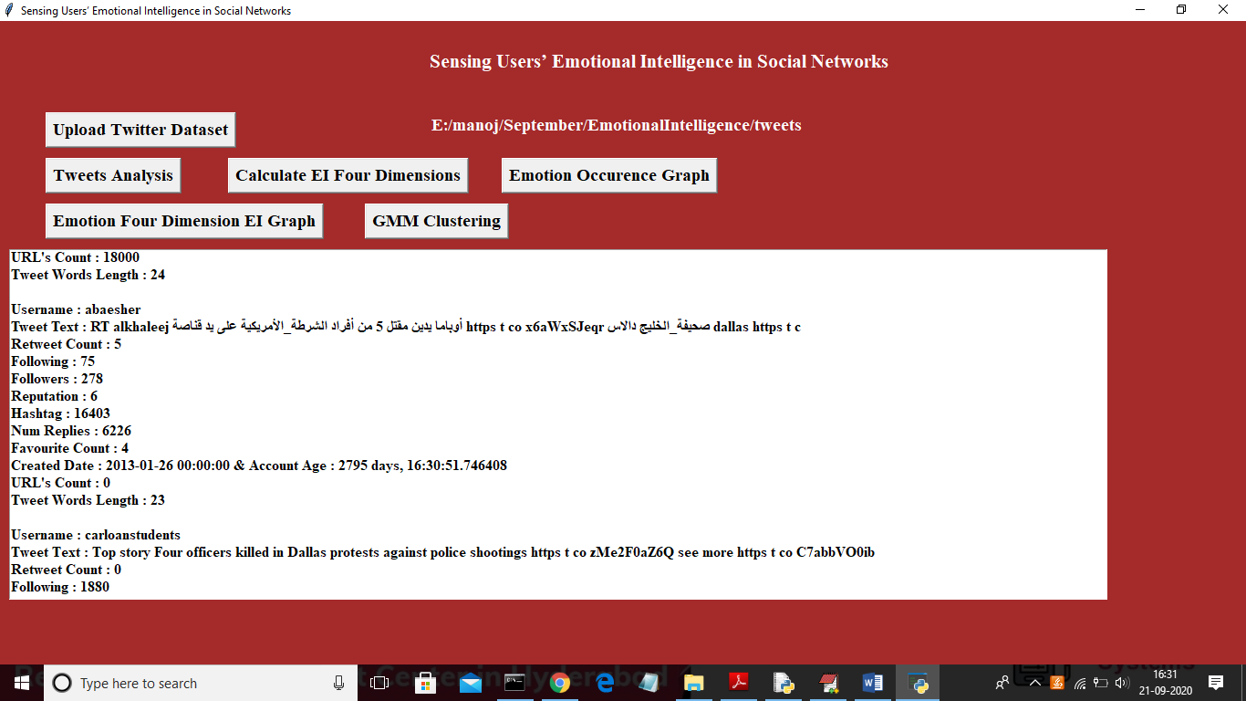

Now click on ‘Calculate EI Four Dimensions’ button to detect sentiments and to calculate user swings or depress mood

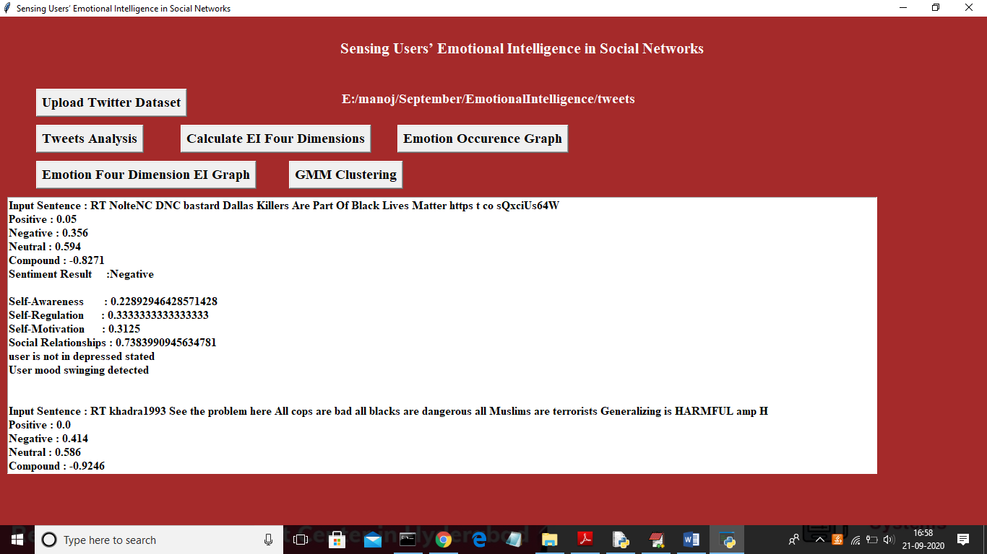

In above screen for each user tweet we got positive, negative, neutral and compound value with sentiment result and then using four dimension we calculated user mood. Now click on ‘Emotion Occurrence Graph’ button to get total positive, negative and neutral sentiments from dataset

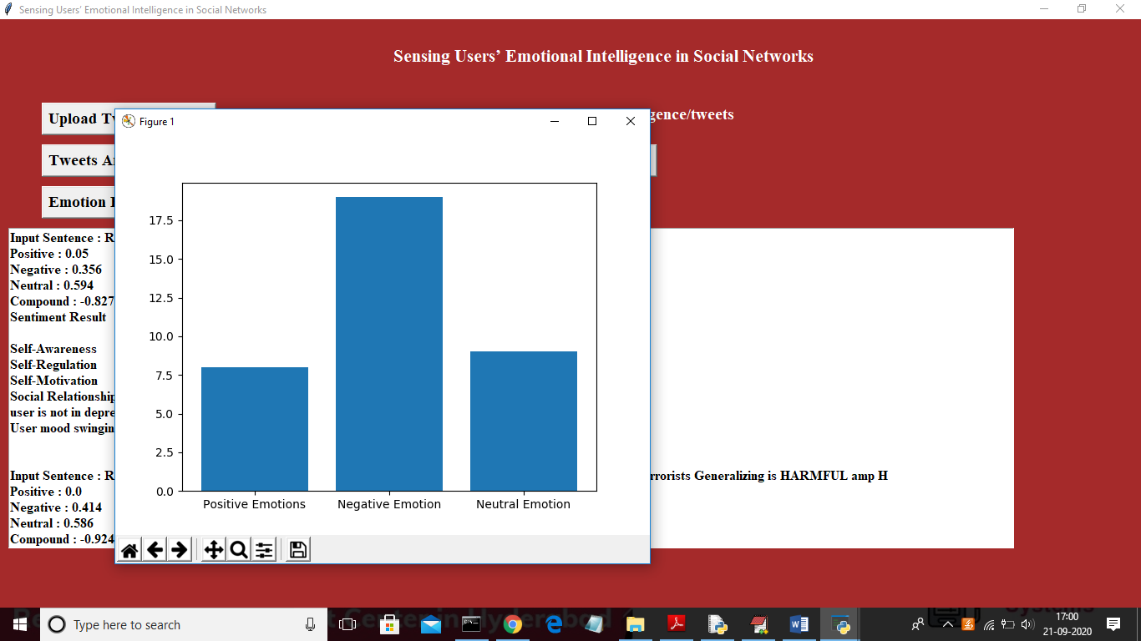

In above graph x-axis represents emotion type and y-axis represents number of occurrence of that emotion type. Now click on ‘Emotion Four Dimension EI Graph’ button to get all four dimensions calculation in graph for all users

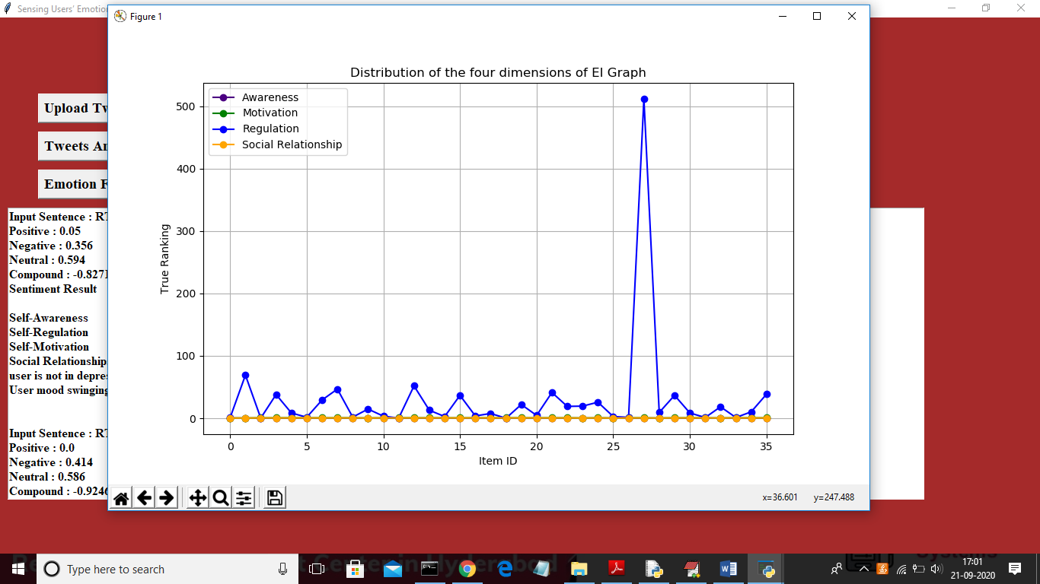

In above graph x-axis represents user id and y-axis represents values of four dimensions. In above graph indigo colour line refers to awareness, green line refers to motivation, blue line refers to regulation and yellow line refers to relationship. Now click on ‘GMM clustering’ button to cluster all users four dimensions values

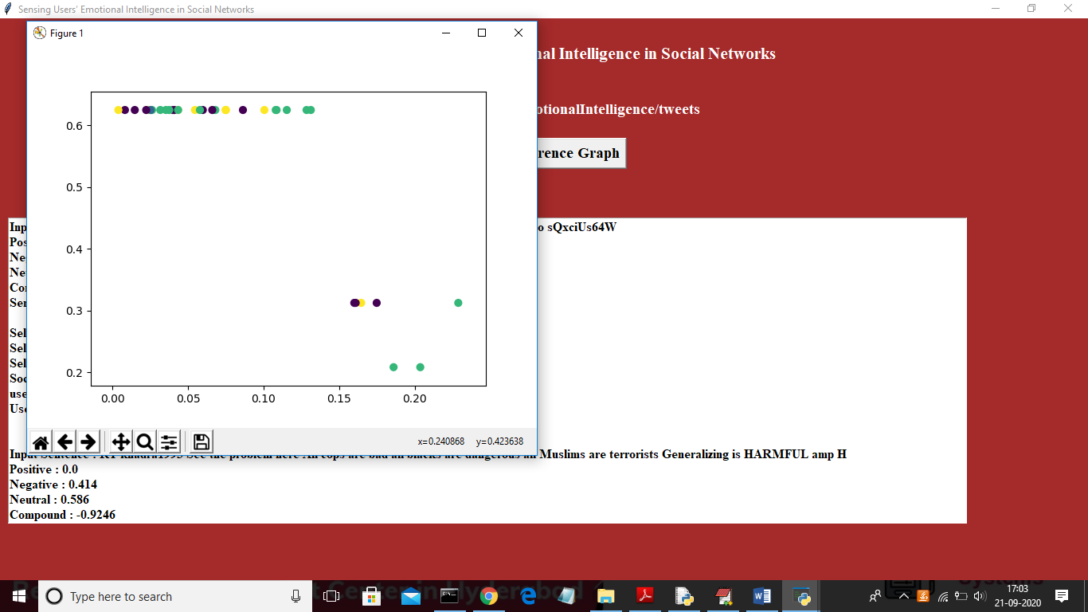

In above graph all circles with same colour is in one cluster and it contains 4 different colour circle for four different dimensions.