class04.R

kylealvarez

2022-10-06

# This is a comment  
x <- 1:50  
plot(x, sin(x))

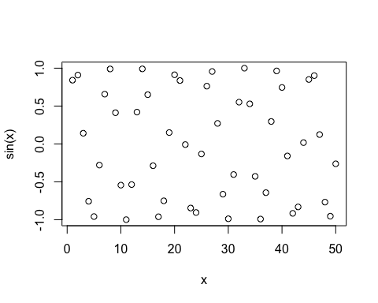

# Add more input arguments to get this how we want it   
plot(x, sin(x), type="l", col="red", lwd=3)

