**Indian Institute of Technology, Indore**

Solving 1-Dimensional Heat Equation in MPI

Proposal (CS 309)

Department of Computer Science and Engineering

Submitted by –

Bhor Verma (150001005) Dhruv Chadha (150001009)

Under the Guidance of **Dr. Surya Prakash**

**Introduction**

The **heat equation** is a parabolic partial differential equation that describes the distribution of heat (or variation in temperature) in a given region over time.

In 1-Dimension, the equation is –

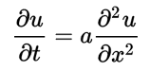

The domain of the solution is a semi-infinite strip of width L that continues indefinitely in time. The material property α is the thermal diffusivity.

One important method of solving the above equation is using Crank-Nicolson method, which is an implicit method, and as a result a system of equations for the φ must be solved at each time step.

**Algorithm:**

In numerical analysis, the **Crank–Nicolson method** is a finite difference method used for numerically solving the heat equation and similar partial differential equations. Approximate the time derivative with the backward difference approximation -

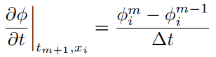

The central difference approximation is given as –

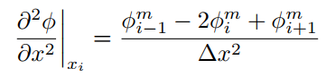

The right-hand side of the heat equation is approximated with the average of the central difference scheme evaluated at the current and the previous time step.

Hence the heat equation in 1-Dimension becomes –

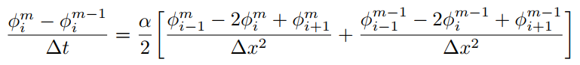

**Aim**

We will implement a parallel Crank Nicolson method for solving the 1-Dimensional heat transfer equation in MPI.

The Crank Nicolson method reduces down to solving a system of linear equations, which involves matrix inversion.

The boundary conditions and thermal conductivity will be used as input, and the temperature of required points will be given out as output.