**1A 2A 3B 4B 5B 6B 7B ← 8B → 1B 2B 3A 4A 5A 6A 7A 8A**

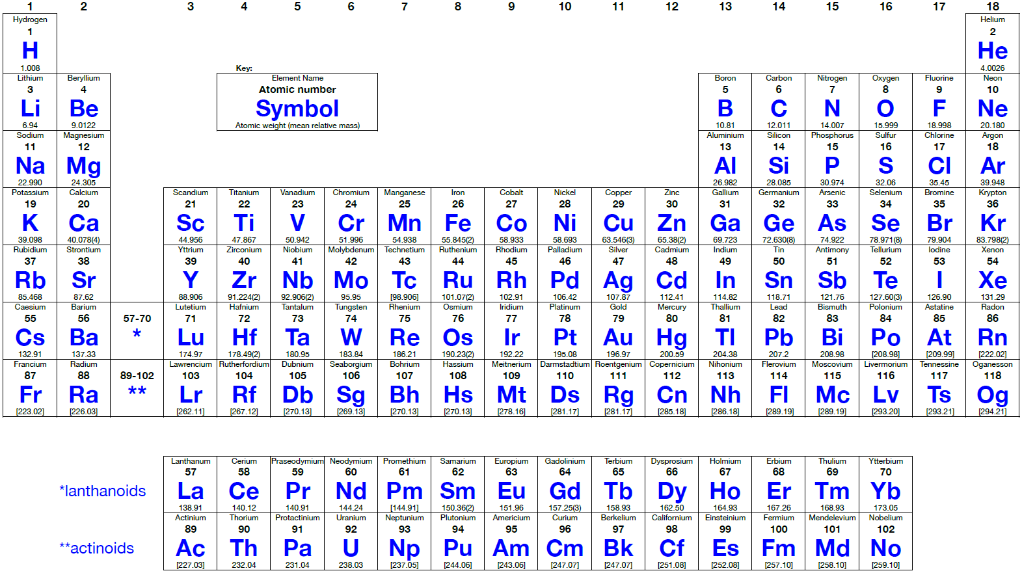

1

2

3

4

5

6

7

**Common Polyatomic Ions**

|  |  |  |  |  |
| --- | --- | --- | --- | --- |
| **(NO3)1- nitrate** | **(PO4)3- phosphate** | (ClO4)1 - **per**chlor**ate** | (CrO4)2- chromate | (OH)1- hydroxide |
| (NO2)1- nitrite | (PO3)3- phosphite | **(ClO3)1- chlorate** | (Cr2O7)2-  dichromate | (C2H3O2)1- acetate |
| **(SO4)2- sulfate** | (SiO3)2- silicate | (ClO2)1- chlor**ite** | (CN)1- cyanide | (BO3)3-  borate |
| (SO3)2- sulfite | **(CO3)2- carbonate** | (ClO)1- **hypo**chlor**ite** | (SCN)1- thiocyanate | (O2)2- peroxide |
| (HSO4)1- hydrogen sulfate  (bisulfate) | (HCO3)1- hydrogen carbonate  (bicarbonate) | (MnO4)1- permanganate | (S2O3)2- thiosulfate | **(NH4)1+ ammonium** |