# Identification of a Substance by Physical Properties

**Materials:** 10mL graduated cylinder (2) melting/boiling point set-up

small test tubes weighing paper *(see diagrams)*

plastic pipets ethyl alcohol toluene

hexane unknowns scoopula

**Objective:** To learn the use of physical properties such as solubility, density, boiling point, and melting point in identifying liquids and solids substances.

## INTRODUCTION: Every substance has a unique set of properties that allow us to differentiate one from another. These properties can be classified as either physical properties or chemical properties. Physical properties are those that can be determined or measured without changing the composition or identity of the substance. These properties include color, odor, taste, density, melting point, boiling point, conductivity, and hardness. Chemical properties tell us how a substance interacts with other substances. Such properties include reaction with oxygen (oxidation), chlorine, metals, etc. Determination of chemical properties results in the change of the identity of the substance. Scientists in the late 19th and early 20th century gathered data on the known chemicals to create reference books- *The CRC’s (Chemical Rubber Company’s) Handbook of Chemistry and Physics* and Lange’s *Handbook of Chemistry*.

Some properties, such as solubility, melting point, boiling point, and density are independent of the amount of substance being examined. These properties are known as **intensive properties** and are used to identify a substance. **Extensive properties** such as mass and volume depend on the amount of substance present and are not useful in the identification of a substance. In this experiment, we will use three properties to identify a liquid substance - solubility, density and boiling point.

The **solubility** of a solute (a dissolved substance) in a solvent (the dissolving medium) is the most important chemical principle underlying three major techniques you will study in organic chemistry laboratory - crystallization, extraction, and chromatography. The **solubility** of a substance is usually defined as the mass (g) of that substance which will dissolve in a fixed amount of solvent (usually 100g of a liquid) at a given temperature. Depending on its molecular structure, a solute will have different solubilities in different solvents.

For example, sodium chloride (table salt) is an ionic compound. It is soluble in polar solvents such as water, but insoluble in non-polar solvents such as hexane or toluene. Sodium chloride may only be slightly soluble in a solvent that has both polar and non-polar properties. Such a solvent is a weakly polar solvent.

In this experiment, we will use three solvents to compare solubilities: water (polar), hexane (non-polar), and ethanol (polar/nonpolar). The solubilities will be recorded as soluble (completely dissolved), slightly soluble (partially dissolved), or insoluble (not dissolved at all). We will use the following terms: “S” for soluble, “I” for insoluble, and “SS” for slightly soluble. If an organic liquid compound dissolves in a solvent, it is sometimes more appropriate to say that the compound and the solvent are **miscible** (mix homogeneously in all proportions). Likewise, if an organic liquid compound is insoluble in the solvent, then they are **immiscible** (do not mix and forms two liquid phases).

**Density** is defined as mass per unit volume. Mass is usually measured in g and volume in mL or cm3. Since two substances rarely have the same density, it is a useful physical property in order to identify unknown substances. “Heavy” elements such as lead and gold have high densities while elements that are “light in weight” typically have low densities. For most substances, the variation in density with temperature is negligible. It is usually expressed at 20°C, which is considered to be room temperature.

**Boiling point** is defined as the temperature at which the vapor pressure of a liquid becomes equal to the pressure at the surface of the liquid. Since pure substances have a distinct boiling points, boiling points are sometimes used to determine the purity of substances. A liquid gets converted in to its gaseous state when the temperature of the liquid reaches its boiling point. This is indicated by bubbles of its vapor rising in all parts

of the liquid. This is the temperature at which the pressure of the saturated vapor of the liquid is equal to the pressure of the atmosphere under which the liquid boils. Normally, boiling points are determined at standard pressure: 760 mm Hg (torr) or 1 atm. The boiling point of a liquid is sensitive to changes in atmospheric pressure and varies directly with it. A nomograph (set of scales for connected variables) to correct boiling points for pressures lower than 760 mm Hg is shown later in the lab.

The **normal melting point** of a solid is defined as the temperature at which the liquid and solid phases are in equilibrium at a 1atm. At this temperature, a solid is converted to liquid. This is an important property of solids. The melting point of solids, like the boiling point of liquids, is often used for the identification of substances.

Pure crystalline substances have clear, sharply defined melting points. During the melting process, all of the energy added to a substance is consumed as heat of fusion, and the temperature remains constant. A pure substance melts at a precisely defined temperature, characteristic of every crystalline substance and dependent only on pressure.

**SAFETY PRECAUTIONS**

* The liquids used in this experiment are flammable. The danger of fire is greatly reduced by the use of small samples but, it is not eliminated. Keep all liquid samples away from open flames.
* Avoid inhaling vapors from volatile liquids. The vapors from the liquids used in this experiment may be

irritating and can be toxic if you are exposed to them for long periods of time. Again this problem is minimized by using small amounts of the liquids.

* Avoid skin contact with the unknown liquids and solids. Some of the solids can be toxic or irritating.

## PROCEDURE: *One group at a lab table will complete data for the solid unknown while the other will work with the liquid unknown – the data will be shared.*

### Solubility

The solubility of naphthalene (ingredient in mothballs) and toluene will be demonstrated in water, hexane and ethyl alcohol will be demonstrated by the instructor. Record the results in the data table.

1) Add about 1 mL (20drops or 1cm) of each solvent to 2 sets of 3 small test tubes and set them in a rack.

2) Use your scoopula to add 2-3 crystals of your unknown solid to each one of the solvents in one set of test tubes. Use the “tap technique” to mix the solid with the solvents. Observe and record your results. NOTE: if you are not sure if something is soluble, let the tubes sit for several minutes and check them later. Remember cloudiness can indicate insolubility or slight solubility.

3) Now add 4-5 drops of your unknown liquid to the other set of tubes. Observe the drops as they enter the solvent. Again tap to mix. If the unknown first appears to mix with the solvent but then separates and forms layers it is insoluble. Record your results.

4) Empty the test tubes into the waste container and clean the tubes with a water and a few drops of alconox solution in the sink. Shake them dry and return them to the rack. (upside down if possible)

### Solid Density *See the instructor FIRST if you have solid unknown # 4 or #6!!!!*

1) “Tare/zero” a piece of weighing paper on the balance. Add about 1.5g of your solid unknown on to the paper and record the mass to the nearest ***0.01g***.

*Prepare a capillary tube with your solid sample at this point for the melting point procedure.*

2) Use a pipet or dropper bottle to carefully add about 5mL of a solvent in which your solid is *INSOLUBLE* to a clean, dry 10mL graduated cylinder. Read and record the initial volume to the nearest ***0.01mL***.

*Try to not get liquid on the walls of the cylinder so your solid will not adhere to them in the next step.*

3) Fold the weighing paper holding the unknown solid and carefully transfer it to the cylinder so that no material is lost. Carefully tap the sides of the cylinder with your scoopula to help “settle” the solid.

4) Read and record the final volume to the nearest ***0.01mL***. Empty the cylinder into the waste bucket and clean the cylinder.

**Liquid Density**

1) Weigh a clean, dry 10mL graduated cylinder to the nearest ***0.01g*** and record the mass.

2) Add between 5-6 mL of the unknown liquid to the graduated cylinder. Record the EXACT volume to the nearest 0.01mL in the data table.

3) Quickly weigh the cylinder and liquid to the nearest ***0.01g*** and record the mass.

4) Pour the liquid into LARGE test tube in the boiling point apparatus add a boiling chip to the tube and begin the boiling/melting point procedure as soon as possible. Clean the cylinder.

**Solid Melting Point/Liquid Boiling Point** *(one group does MP of solid other does BP of liquid)*

Solid 1) As shown by the instructor, take a capillary tube and gently tap the open end into the container of ***solid*** unknown to force about 0.5-1cm of your unknown into the tube. Drop the capillary tube (closed end down) into the glass tube to pack the sample into the bottom of the capillary tube. Repeat until you have 0.5 cm of sample in the bottom of the tube.

2) CAREFULLY attach the capillary to the end of the glass thermometer with the small rubber band. CLOSED end DOWN. (Loosen clamp to remove thermometer and split stopper together.)

3) Reattach the clamp/thermometer to the ring stand. Add **TAP** water to the 250mL beaker until it is 1-2cm above the sample in the capillary tube.

Liquid1) Make sure you have 3-5mL of your unknown liquid in the boiling point test tube with a boiling chip. Adjust the thermometer/stopper so the bulb of the thermometer is about 1cm above the surface of the liquid. Plug the slit in the stopper with a small piece of paper towel to help prevent evaporation. Make sure the end of the rubber tubing is in the sink. (vapor will drain to the sink)

2) Add tap water to the 250mL beaker until the level of the water is about 2cm above the liquid inside the test tube.

*BOTH* 1) Make sure that you are able to read the thermometer as you heat. Reposition if necessary.

2) Light the burner and begin to heat the beaker with a low flame from the. Stir the water with a stirring rod as you heat.

3) The moment the *SOLID* *begins* to melt record the temperature. Continue to watch the sample and record the temperature again when the sample is *completely* melted. (Range)

4) When the *LIQUID* boils you should see bubbles forming and releasing at the boiling chip. Boiling can start and end quickly due to the small sample size. The temperature should stop rising and become ***constant*** at this point. Record the temperature. ***Be careful – it is very easy to evaporate the sample and you will miss the boiling point if you are not observant.***

NOTE: The unknown melting points range from 43-90oC and boiling points range from 36-98oC.

5) Allow the apparatus to cool. Dispose of the capillary in the trash. Empty and remaining unknown liquid and boiling chip into the waste container. Do not wash the test tube.

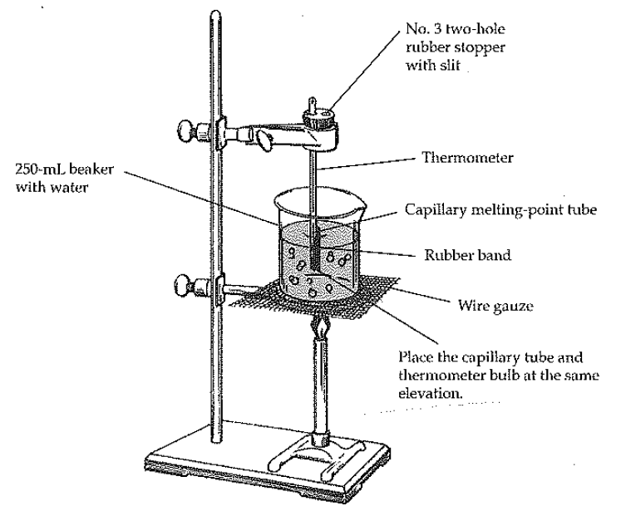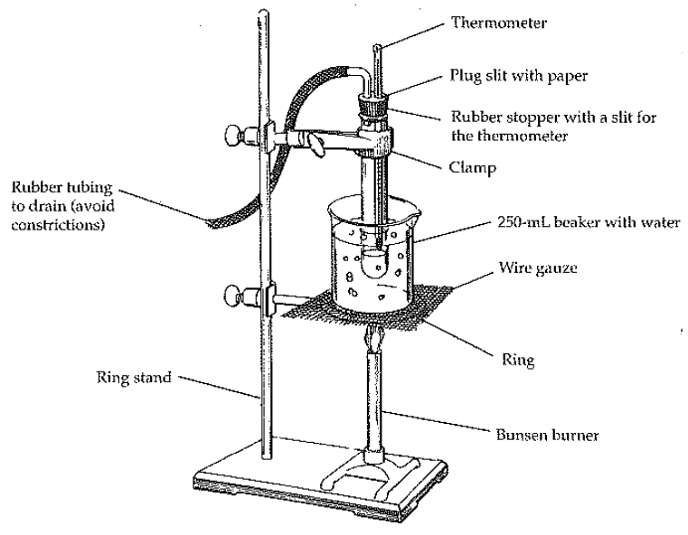

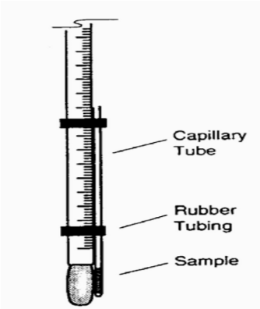

**Boiling Point Nomograph**



What would be the boiling point of ethyl alcohol at 650 mmHg if its normal boiling point is 78.3oC?

Solution: Draw a line connecting the normal boiling point to the pressure and then extend to the ∆T correction graph. Since the correction is 4.0oC, the observed boiling point at 650mmHg would be 4.0oC lower.

78.3oC - 4.0oC = 74.3oC

**Physical Properties of Pure Substances**

|  |  |  |  |  |  |  |
| --- | --- | --- | --- | --- | --- | --- |
|  | | | | **Solubility** | | |
| **Substance** | **Density**  **(g/mL)** | **Melting**  **Pt. (oC)** | **Boiling**  **Pt. (oC)** | **water** | **hexane** | **ethyl**  **alcohol** |
| acetone | 0.79 | -95 | 56 | S | S | S |
| benzophenone | 1.15 | 48 | 306 | I | S | S |
| bromoform | 2.89 | 8 | 150 | I | S | S |
| t-butyl alcohol | 0.79 | 25 | 83 | S | S | S |
| cadmium nitrate•4H2O | 2.46 | 59 | 132 | S | I | S |
| cylcohexane | 0.78 | 6.5 | 81.4 | I | S | S |
| p-dichlorobenzene | 1.46 | 53 | 174 | I | S | S |
| diphenyl | 0.99 | 70 | 255 | I | S | S |
| diphenylamine | 1.16 | 53 | 302 | I | S | S |
| ethyl acetate | 0.90 | -83.6 | 77.1 | SS | S | S |
| ethyl alcohol | 0.79 | -114 | 78 | S | S | S |
| hexane | 0.66 | -94 | 69 | I | S | S |
| isopropyl alcohol | 0.79 | -98 | 83 | S | S | S |
| lauric acid | 0.88 | 43 | 225 | I | S | S |
| magnesium nitrate•6H2O | 1.63 | 89 | 330 | S | I | S |
| methyl alcohol | 0.79 | -98 | 65 | S | I | S |
| methylene chloride | 1.34 | -97 | 40.1 | I | S | S |
| naphthalene | 1.15 | 80 | 218 | I | S | SS |
| pentane | 0.63 | -130 | 36 | I | S | S |
| n-propyl alcohol | 0.80 | -126 | 97 | S | S | S |
| sodium acetate•3H2O | 1.45 | 58 | 123 | S | I | SS |
| sodium thiosulfate•5H2O | 1.67 | 48 | 100 | S | I | I |
| stearic acid | 0.85 | 70 | 291 | I | S | SS |
| thymol | 0.97 | 52 | 232 | SS | S | S |
| toluene | 0.87 | -95 | 111 | I | S | S |
| zinc chloride | 2.91 | 283 | 732 | S | I | S |