# Separation of the Components of a Mixture

When two or more substances, that do not react chemically, are blended together, the result is a mixture. Most of the substances we encounter in everyday life, such as cement, wood, steel, and many other materials are mixtures. Mixtures as you know can be homogeneous or heterogeneous. The separation of the components of a mixture is a problem frequently encountered in chemistry. Often when a compound is prepared it must be isolated from excess reactants, additional products and other impurities. When one substance in the mixture predominates (far exceeds the amounts of the other components) this mixture is called an impure substance. Drinking water is a good example. The predominant component is H2O but depending on the source it can contain silt, dissolved solids substances such as salt, liquids and even gases. We usually have to “purify” out water to make it potable (drinkable), but we do not have to make it completely pure. Many simple techniques are used during the purification process such as filtration and extraction to more elaborate ones like distillation or reverse osmosis. The separation of mixtures is based on the fact that each component has a different set of physical and chemical properties. The components are pure substances which are either elements or compounds. Under the same conditions of pressure and temperature, the properties of every sample of a pure substance are identical. Each sample melts at the same temperature, boils at the same temperature, has the same solubility in a given solvent, etc. In mixtures, each substance retains these properties which allows them to be separated by physical means. Techniques used to separate mixtures rely on differences in the physical properties of the components. Techniques useful for the separation of mixtures include the following:

**DISTILLATION** is a process of separating the components of a liquid mixture by differences in boiling points. The mixture is boiled and then the vapors are separated through condensation. The condensed components can be further purified through additional distillations.

**EXTRACTION** is the removal of one substance from a mixture because of its greater solubility in a given solvent. After extraction the dissolved substance can be isolated through distillation (if liquid) or by evaporation of the solvent (if solid).

**FILTRATION** is the process of separating a solid from a liquid by the use of filter paper or other porous material.

**DECANTATION** is the pouring of a liquid from a solid-liquid mixture, leaving the solid behind. (Used when the solid are large and have a relatively high density.)

**CENTRIFUGATION** is the process of separating a suspended solid from a liquid by spinning the mixture at high speed. (Used when the solid particles are relatively small.)

**SUBLIMATION** is the process in which a solid passes directly the gaseous state without the appearance of the liquid state. Not many substances possess this characteristic under normal conditions. If one component of a mixture sublimates, this property may be used to separate it from the other components of the mixture. Iodine (I2), naphthalene (C10H8, mothballs), and dry ice (solid CO2) are some substances which sublime.

**CHROMATOGRAPHY** is the process of separating a mixture by the distribution of its components between two phases, one phase being stationary and the other phase moving. Some examples of chromatography are gas chromatography, paper chromatography, and thin-layer chromatography.

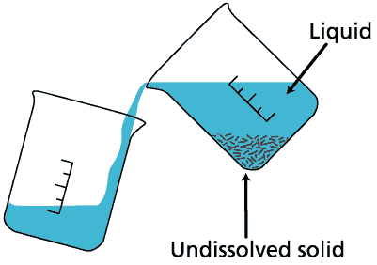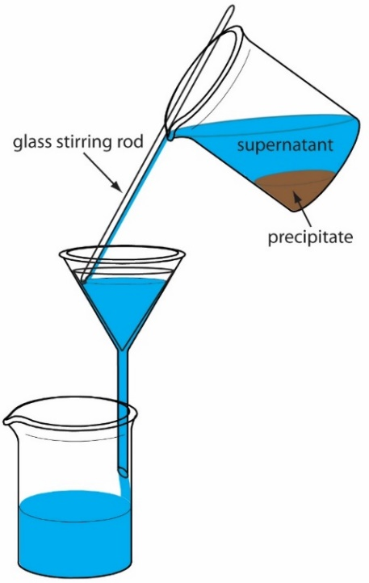

Simple decantation

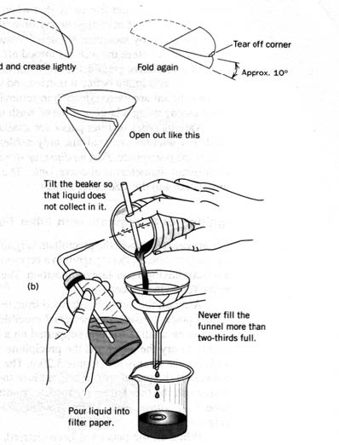 Decantation and Filtration

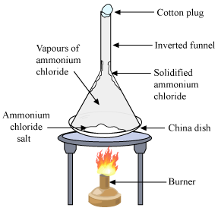

Filtration of a precipitate Sublimation

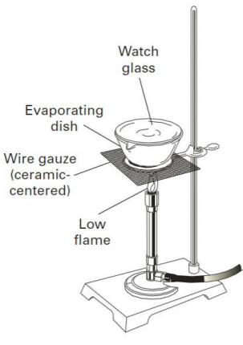(showing use of wash bottle to remove the precipitate) (showing recovery of the solid by deposition)

Evaporation

**Purpose:** In this experiment you will separate a three component mixture containing sodium chloride, ammonium chloride and white sand (silicon dioxide) into the pure individual components. The separation of the mixture will be based on differences in the physical properties of the three components listed below.

***Sodium chloride***: solubility in water (35.7g/100mL @ 20oC), melting point 801oC

***Ammonium chloride***: solubility in water (41.4g/100mL @ 20oC), sublimation point 338oC (ammonium chloride actually decomposes at this temperature into ammonia gas and hydrogen chloride gas but the gases quickly recombine in air to form solid NH4Cl – seen as white “fumes”)

***Sand (Silicon dioxide)***: solubility in water (0.012g/mL @ 20oC melting point 1,600 to 1,725 °C

**Procedure:** Obtain a 0.01g electronic balance and bring it to your station.

***Sublimation:*** Record the container number for the unknown mixture in the data table. Open the container to observe the mixture. Use your scoopula or glass stirring rod to break up any lumps in the mixture. Close the container and shake it hard. Ensure the mixture is uniform.

1) Determine the mass of a clean, dry, LARGE evaporating dish on the balance – record the mass to 0.01g in *BOTH* spots in the data table. Use your scoopula to add about 3g (less than) of the mixture to the dish. Record the mass of the sample & dish to 0.01g in the data table.

2) One partner should take the dish/sample, crucible tongs, and glass stirring rod to the fume hood. Use your tongs to place the dish on the hot plate. (2-3 groups can share a hot plate) Turn the hot plate to its highest setting. The other partner should get equipment ready for the other 2 procedures.

3) Within minutes you should observe white fumes coming out of your sample. (You may see a portion melting, but it will quickly turn to fumes.) Occasionally stir the mixture with the stirring rod. Some of the fumes may form a deposit on the rod or you may see white deposits on the upper sides of the dish. This deposit should eventually sublime. Some samples may take longer to sublime.

4) When no more fumes are visible and all deposits have sublimed, heat for a few more minutes. Use your crucible tongs to remove the dish from the hotplate and set it aside to cool. Check with your partner while it cools. Once the dish is cool to the touch (use heat sensitive paper), carry the dish back to your station. Determine and record the mass of the dish & contents.

***Extraction:***

1) Set up a ring stand, ring, wire gauze, and Bunsen burner.

2) Get a clean, dry, SMALL evaporating dish *AND* watch glass. Use the balance to determine its mass of *both* at once to the nearest 0.001g and record it in the data table.

3) Get about 30mL of *distilled* water in your graduated cylinder.

4) Pour about 15mL of the water into the LARGE evaporating dish. Stir it the contents and water with t stirring rod for a minute. Completely decant the solution into the small evaporating dish. (Do not allow the undissolved solid to come out of the LARGE dish).

5) Add another 10mL of water to the contents of the LARGE dish. Stir and decant again.

6) Repeat the extraction one more time with the remaining water. Place the LARGE dish in the drying oven with a small piece of paper towel under it with your initials on it. (The oven should be on about #4.)

7) Carefully place the SMALL dish containing the extraction solution on the wire gauze. Use your crucible tongs to place the watch glass on the dish with the concave side facing down. Light the Bunsen burner and begin to gently heat the dish to evaporate the solution. Use your hand to hold the bottom of the burner while you “brush” the bottom of the dish with the flame. Steam will eventually start to come out near the spout of the dish. Keep heating until most of the liquid is evaporated. You will begin to see crystals forming on the sides of the dish. Do not let the solution boil too rapidly or it will splatter out the spout. It is OK if splatter hits the watch glass. Continue heating until the dish and watch glass are completely dry and then allow it to cool.

8) While one partner evaporating the water from the solution, the other can check the progress of the sample in the oven. Stir the sample to ensure it is completely dry. Remove the dish from the oven with crucible tongs and allow it to cool to the touch. Determine the mass of the dish and contents. Record the mass. You should return the dish to the oven and allow it to dry for a few minutes and then remove it, allow it to cool and then weigh it again. (The masses should agree to within 0.001g.)

9) When the SMALL evaporating dish and watch glass are completely cool. Determine the mass of the dish and contents. If time allows: the dish, watch glass and contents could be heated again then cooled and weighed to ensure the contents being heated to dryness.

***Notes:*** The % of each component will vary from 15.0% to 55.0%. The majority of all unknowns will be sand, while sodium chloride will be the next highest percent and ammonium chloride will have the lowest value. Never weigh labware when it is hot. This can damage the scale, may affect the mass, and it is a safety concern. Be safe when heating – use the heat paper to check!

**Calculations**

The mass and percent of each component of the sample. (This may be included in the data table section.) Calculate the total mass and % of the original sample recovered (with careful technique the % should be close to 99%)*.* Obtain the actual % composition values for each component for your unknown from the instructor. Calculate the percent error for each value. *Part of your lab grade will be based on your success in obtaining accurate values.*

**Conclusion**

Briefly summarize your results by stating your experimental values and comparing them to the known values. Clearly discuss sources of error and how these sources relate to the results you obtained.

(Why were your values too high or too low?)

Explain how these errors could have been minimized in your procedures if you repeat the experiment.