**Isotopes and Mass Spectrometry**

***Why?*** In this activity we will address the questions:

* Are all atoms of an element identical and how do we know?
* How can data from mass spectrometry be used to identify the elements and the masses of individual atoms of a specific element.
* How can Data from mass spectrometry also demonstrate direct evidence of different isotopes from the same element?
* How can the average atomic mass be estimated from mass spectra.
* Explain how data from mass spectrometry supports or rejects early models of the atom.

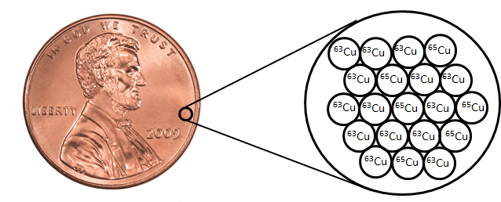**Prior Knowledge Model 1: Isotopes**

Magnified 1 billion times (x 109)

1. Does the sample contain identical atoms of copper?
2. Use the picture above to determine the percent of 63Cu in the sample. What is the percent of 65Cu?
3. a) What is the average atomic mass of copper on the periodic table? __________________ (amu)

b) Is it closer to 63 amu or 65 amu?

c) How does the information from the picture above explain the answer to the previous question?

|  |  |
| --- | --- |
| Isotope | % Abundance |
| 20Ne | 90.48 |
| 21Ne | 0.27 |
| 22Ne | 9.25 |

4. Consider the data given in the table. Determine the average mass of an element based on data table the isotopic abundance and the mass of each isotope.

5. There are two stable isotopes of calcium: Ca - 40 (39.96) and Ca - 46 (45.95). Using the average atomic mass of calcium from the periodic table, calculate the % abundance of each isotope of calcium.

**Model 2: Mass spectrometry**

**Information:**

Mass Spectrometry is a powerful analytical tool used to determine the following information.

- The elemental composition of a sample

- The masses of particles and of molecules

- Potential chemical structures of molecules by analyzing the fragments

- The identity of unknown compounds by determining mass and matching to known spectra

- The isotopic composition of elements in a sample

A mass spectrometer is a device for separating atoms and molecules according to their mass.

In a mass spectrometer, a substance is first heated in a vacuum and then ionized. The ions produced are accelerated through a magnetic field that separates ions of different masses. The height of each peak is proportional to the amount of each isotope present (i.e. it’s relative abundance). The m/z ratio for each peak is found from the accelerating voltage for each peak. Many ions have a +1 charge so that the m/z ratio is numerically equal to mass m of the ion.

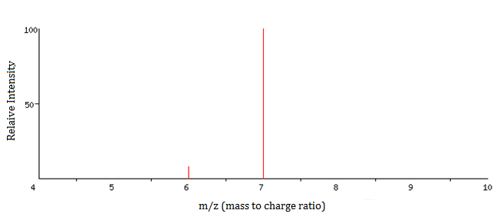

The graph below was produced when an element, lithium, was analyzed in a mass spectrometer. Use the graph to answer the questions below.

**Isotope mass Rel. Intensity**

6 amu 8

7 amu 100

Mass spectrum of Lithium

1. How many isotopes of Lithium exist?
2. What masses are present on the graph for the following

a) The mass of the most abundant isotope _______ b) The mass of the least abundant isotope. _______

1. Label the each peak with the nuclide symbol for each isotope
2. Without performing any calculations, predict the approximate atomic mass for lithium. Explain the basis for your prediction.
3. Now calculate the average atomic mass of the element from the mass spectrum data. The height of each peak is the relative intensity, not the % abundance. You will first need to calculate the % abundance and then the average atomic mass.

a) What is the relative intensity of each peak? Peak 1 = ____________ Peak 2 = ____________

b) What is the total relative intensity of the peaks? Total = __________

c) What is the % of the intensity of each peak? ($\%= \frac{Part}{Total} x 100$)

Peak 1% = __________

Peak 2% = __________

d) You’ve just determined the % abundance for each isotope of the element. Complete the table and calculate the average atomic mass of the element.

|  |  |  |
| --- | --- | --- |
| Isotope | Mass | % Abundance |
|  |  |  |
|  |  |  |

Average atomic mass = __________amu

1. The modern use of mass spectrometry provides another example of how experimental data can be used to test or reject a scientific model.

a) Does data from mass spectrometry demonstrate evidence which supports or contradicts Dalton’s early model of the atom? Explain.

b) How does data from mass spectrometry demonstrate direct evidence of different isotopes of the same element?

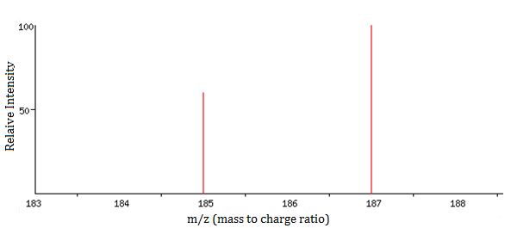

1. What element’s mass spectrum is represented below? Explain your answer.

**Model 3: Predicting Isotopic Abundances and Mass Spectrum**

Based on what you’ve learned, answer the following questions and check your answers using one of the following websites

1. [http://www.webelements.com](http://www.webelements.com/) Select the element of interest. Scroll to the bottom right of the page and click on “Isotopes” under the “Nuclear Properties” section.

2. <http://www.sisweb.com/mstools/isotope.htm> Enter in the formula of the element to generate its mass spectrum. (Note: formula entry is case sensitive; the first letter of the element must be capitalized will all others lower case.

1. a) What is the average atomic mass of Boron?

b) If there are two predominant isotopes of Boron on earth, 10B and 11B, which do you think is most abundant?

c) Make an estimate of the percentage of each isotope of Boron.

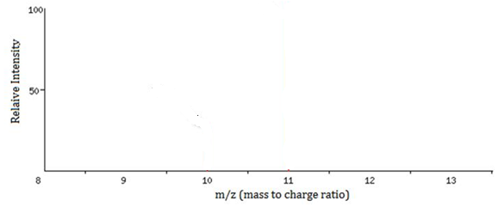

d) Draw a rough sketch for the mass spectrum of Boron. Label each axis and label each peak with the appropriate nuclide symbol

1. 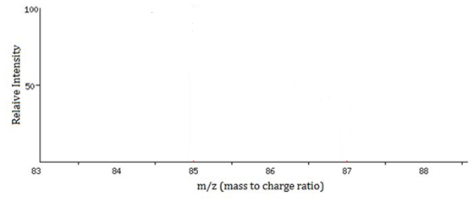There are two naturally occurring isotopes of rubidium, 85Rb and 87Rb. Use the process above to draw a rough sketch for the mass spectrum of rubidium.

**Exercises**

1. 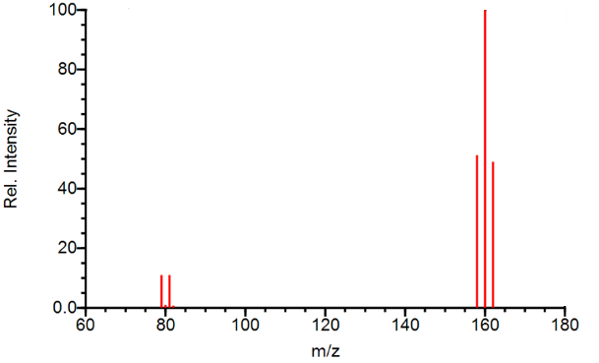The mass spectrum for elemental bromine is represented below. Label each peak with the appropriate nuclide symbols. Remember, not all elements exist as single atoms in nature.
2. 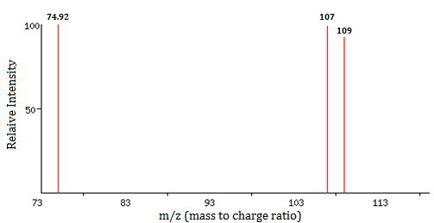 The mass spectrum represents a mixture of elements. What elements are present? Justify your answer.

(Check your answer using the websites listed above.)

|  |  |  |  |  |
| --- | --- | --- | --- | --- |
| *m/z* | 84 | 86 | 87 | 88 |
| Relative intensity | 0.68 | 11.94 | 8.48 | 100.00 |

1. The mass spectrum of strontium gives four peaks. Use the data to answer the following questions:

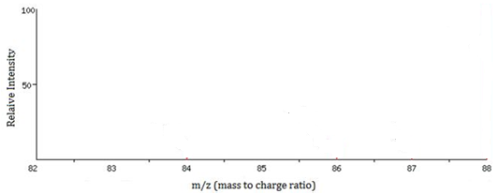a) Sketch the mass spectrum that would be obtained from naturally occurring strontium.

b) Label each peak on the mass spectrum with the appropriate nuclide symbols.

c) Calculate the average atomic mass of strontium in the sample rounded to two decimal places.

**Conclusions:**

1. Are all atoms of an element identical and how do we know?
2. How can data from mass spectrometry be used to identify the elements and the masses of individual atoms of a specific element.
3. How can data from mass spectrometry also demonstrate direct evidence of different isotopes from the same element?
4. How can the average atomic mass be estimated from mass spectra.
5. Explain how data from mass spectrometry has advanced our understanding of the atom.
6. List and briefly explain any other real world applications of mass spectrometry you can think of?